プロジェクト・レポート様式

本様式は、RCEポータルサイトを通じて提出するプロジェクト・レポートの様式（英語）に、日本語の仮訳を追記したものです。

Basic Information 基本情報
Title of project (should be concise and within approximately 25 words)
プロジェクト名（50字程度で簡潔にお願いします。）
Yokokashi
Submitting RCE
レポートを提出するRCE
RCE Yokohama Youth
Contributing organization(s) (Individual RCE member organizations – minimum of 2 contributing organizations)
活動に貢献している団体名（RCEに参加している団体-2団体以上が望ましい）
LOCAL GOOD YOKOHAMA
Focal point(s) and affiliation(s) (Name, organizational affiliation, e-mail)
活動の担当者（フォーカル・ポイント）と所属（名前、所属、Eメール）
Kawauchi Mizuki (RCE Yokohama Youth, wakamonorenmei@gmail.com)

Format of project (manuscript, PowerPoint, audiovisual)  プロジェクトで作成している成果物の形式（原稿、パワーポイント、オーディオビジュアル） |  |  |  | Facebook live, YouTube |  | Language of project  プロジェクトの言語 |  |  | Japanese
Date of submission (or update, if this is an update of an existing ESD project)  提出日（既に提出されたプロジェクトの更新である場合は、更新日） |  |  |  |  |  | 2023/02/24
Web link (of the case study or lead organization if available for more information)  ウェブサイトのリンク（事例または活動を主導する団体の詳細がある場合はそのリンク） |  |  |  | https://wakamonorenmei.jimdofree.com/  %E9%85%8D%E4%BF%A1%E7%95%AA%E7%B5%84/
Additional resources  追加資料 |  |  |  | https://www.youtube.com/watch?v=THqXEn63ryY
Does this project link to any education and/or sustainable development policy or policies? If yes, please provide the name of the policy or policies.
本プロジェクトは、教育や持続可能な開発に関する政策と関連していますか。関連がある場合、その政策の名称を記入してください。
If so, at what level is the policy operating (please place an “x” in the appropriate box or boxes)
*If more than one policy, please indicate which one is operating at which level
関連がある場合、該当する政策は以下のどのレベルで運用されていますか（該当する枠に「x」を記入してください）。
*複数の方針がある場合、どの方針がどのレベルで運用されているかを示してください。
Local  地域コミュニティ |  | Subnational  地方（州や県など） |  |  | National  国内 |  |  | International  国際

Geographical & Education Information 地理的・教育的な情報
Region (Africa, Americas, Asia-Pacific, Europe)
地域（アフリカ、南北アメリカ、アジア太平洋、ヨーロッパ）
Asia-Pacific
Country (where site(s) or activities described in the case study are located – if multiple, please list all participating countries)
国名（プロジェクトや事例が実践されている国を記載してください。複数に渡る場合は、すべての国を記載すること。）
Japan

Location(s) (subnational units and/or cities within the country or countries – leave blank if specific location(s) cannot be identified)
場所（州や県などの地方や都市名（国の下位単位）– 具体的な場所が特定できない場合は空白のままで結構です。）
Yokohama

Address of focal point institution for project
プロジェクトのフォーカルポイント機関の住所
Ecosystem(s) (please place an “x” in all appropriate boxes)
エコシステム（該当するすべての枠に「x」を記入してください。
Forest  森林 |  | Grassland  草原 |  | Agricultural  農業関連 |  | Fresh water  淡水 |  | Coastal  海岸
Dryland  乾燥地帯 |  | Mountain  山 |  | Urban/Peri-urban  都市部／準都市部 |  | Other (Please specify)  その他（具体的に） |  | Wetlands  湿地
Level of Education for intended audience (please place an “x” in all appropriate boxes)
対象者の教育レベル（該当するすべての項目に「x」を記入してください。）
Primary  初等教育 |  | Higher  高等教育 |  | TVET  技術教育 |  | Youth (Informal)  若者（非公式）
Secondary  中等教育 |  | Teacher Ed.  教員教育 |  | Community  地域社会 |  | Other (Please specify)  その他（具体的に）
Socioeconomic and environmental characteristics of the area (within 50-100 words)
地域の社会経済的・環境的特徴（100〜200字程度）
There are a lot of people who have conduct something to resolve some issues related to social and the environment in Yokohama. There are however, few actives connected to each other.

Description of sustainable development challenge(s) in the area the project addresses (Within 50-100 words)
プロジェクトが取り組む地域の持続可能な開発に関する課題の説明（100〜200字程度）
What is sustainability? Sustainability is that local people are always able to find hidden social issues by themselves, we think. To find them, it is important for residents to love their community. We have done some contents that hele to build community love and connection by our project.

Contents 内容
Note: The following fields are used for information about activities described in the project or the production of the project itself, and contents may vary depending on the nature of the case project. For example, a project about on-the-ground teaching or training may include the rationale, objectives etc. for the activities; a case study about an ESD-related policy may describe the policymaking process; or a toolkit may address particular practices used within ESD. Please make an effort to fill as many fields as possible. 注：以下の欄は、プロジェクトで記述された活動やプロジェクト成果物に関する情報を記載するためのものであり、内容はプロジェクトの性質によって異なる場合があります。例えば、現場での指導や研修に関するプロジェクトであれば、その活動の根拠や目的など、ESD関連の政策に関する事例あれば、政策決定プロセスを、ツールキット（教材など）であれば、ESDのにおける特定の実践を記載することが可能です。極力、多くの項目を記入するようお願いいたします。
Status (“ongoing” or “completed”)  実施状況（"進行中 "または "完了"） | ongoing |  | Period (MM/YY to MM/YY)  期間（月/年～月/年） |  | May/2020~
Rationale (why activities or policies described, or information shared through the educational practices/material are needed – within 100-200 words)
プロジェクト実施の根拠（本プロジェクトの活動や政策、または教育実践や教材を通じて共有される情報が必要な理由-200-400字程度）
Our community activities were heavily influenced by COVID-19. Before the pandemic, we had met with some organizations and people, active in Yokohama, through events related to the environment. However, these opportunities were drastically reduced due to the pandemic. From this experience, we realized that it was necessary to build connections online as well as in person. That’s why we have provided out information in the form of ‘Yokokashi’ and creating a space for meeting and discussing with people who are active in Yokohama.

Objectives (goals of activities or policies described teaching or learning outcomes – within 50-100 words)
目的（本プロジェクトの活動や政策の目標、期待される教育や学習の成果等-100-200字程度）
This objective is to build a connection with local people who live in Yokohama or love their community. The concept of this project is to connect to each other while having a night out in Yokohama. And we provide some information on topics related to from familiar stories to social and environmental issues.

Activities and/or practices employed (within 50-150 words)
目的達成のために行った活動や実践の内容（100-300字程度）
We have been broadcasting on Facebook Live and YouTube every Thursday at midnight since May,2020. we provide some information on topics related to from familiar stories to social and environmental issues. We broadcast only with our members, but recently we have been getting more and more interaction in the comments section with local people. And sometimes, we invite a person or organization that have conducted thinks related to sustainability in the city, and provide a discussion with them.

Size of academic audience (approximately how many learners did the material from this project reach?)
参加者の規模（本プロジェクトには何人参加しましたか？あるいは、教材は、およそ何人の学習者に利用されましたか？）
The maximum number of video views is 1000 or more.

Results (within 100-150 words)
プロジェクトの成果（200-300字程度）
We could meet people online who we had never met before, and recently we have been working together at face-to-face event. It is also an opportunity for us to talk regularly with them who we work with.

Lessons learned (factors in success or failure, challenges and opportunities – within 50-100 words)
得られた教訓（成功・失敗の要因、課題、機会など、100-200字程度）
We found that not only in-person events but also online events are possible and effective to connect with local people and exchange information. On the other hand, this challenges are to enhance the program that it can make many people enjoy, and improve the strategies related to publicity.

Key messages (‘elevator speech’ about project - within 50 words)
鍵となるメッセージ（プロジェクトの「エレベーター・スピーチ（主なメッセージを要点を簡潔にまとめたもの）」-100字程度）
Sustainability is that local people can find hidden social issues by themselves, we think. To find them, it is important for residents to love their community. We have been broadcasting some contents related to Yokohama on Facebook Live and YouTube in order to help them love their community.

Relationship to other RCE activities (if the project is related to any other RCE collaborative activities, regional plans, working groups, etc.)
他のRCE活動との関係（他のRCEとの協働による取組、国を超えた地域を対象とした計画やワーキンググループ等に該当する場合は、協働したRCEの名称および関係性についてご記入ください。）
Funding (any relevant information about or acknowledgement of funding of activities or projects described in the case study)
資金提供（ケーススタディに記載されている活動やプロジェクトの資金提供に関する関連情報または承認など）
Pictures (please include up to three pictures of the project sent through as individual high resolution JPEG files – 1.5-2.0 MB in size – 300dpi) 写真（高解像度のJPEGファイル（1.5〜2.0 MB、300dpi）で3枚まで添付してください。）
＊RCEポータルサイトに英語のレポートをアップロードする際には、写真も合わせてオンラインで提出いただきますが、事前課題の提出の際には、画像のファイル名に直接画像を貼り付けてください。）
File name of picture (Example: photo_1.JPEG)  画像のファイル名  （例：photo_1.JPEG）  ＊この欄に直接画像を貼り付けてください。 |  | Caption for picture (Example: Learning to sort plastic waste)  写真のキャプション（タイトル）  （例：プラスチックゴミの分別の学習） |  | Photo Credit (Example: J. Smith)  写真の著作権保有者  （例：J. Smith）
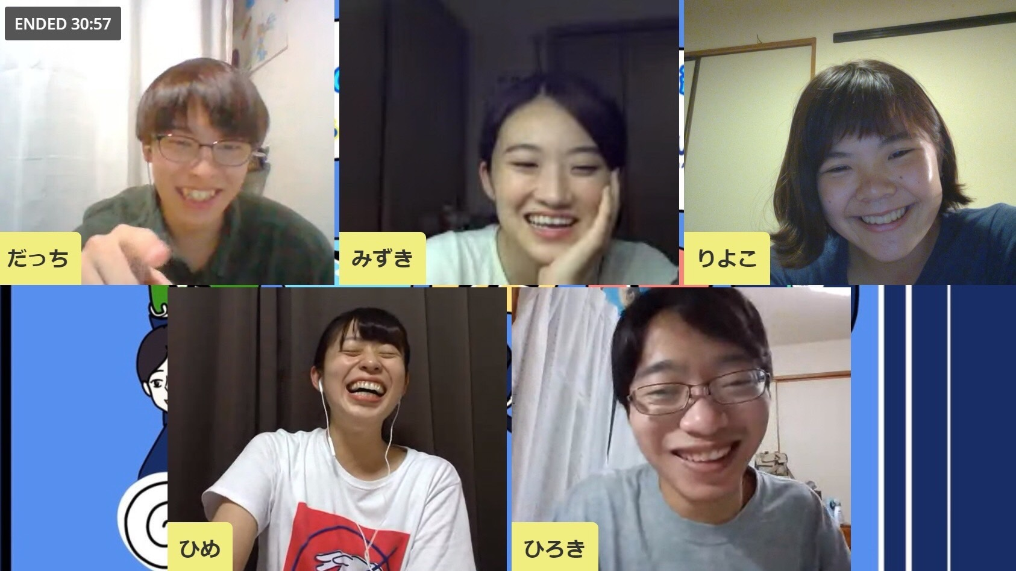  Yokokashi1.jpg |  | Yokokashi members |  | RCE横浜若者連盟
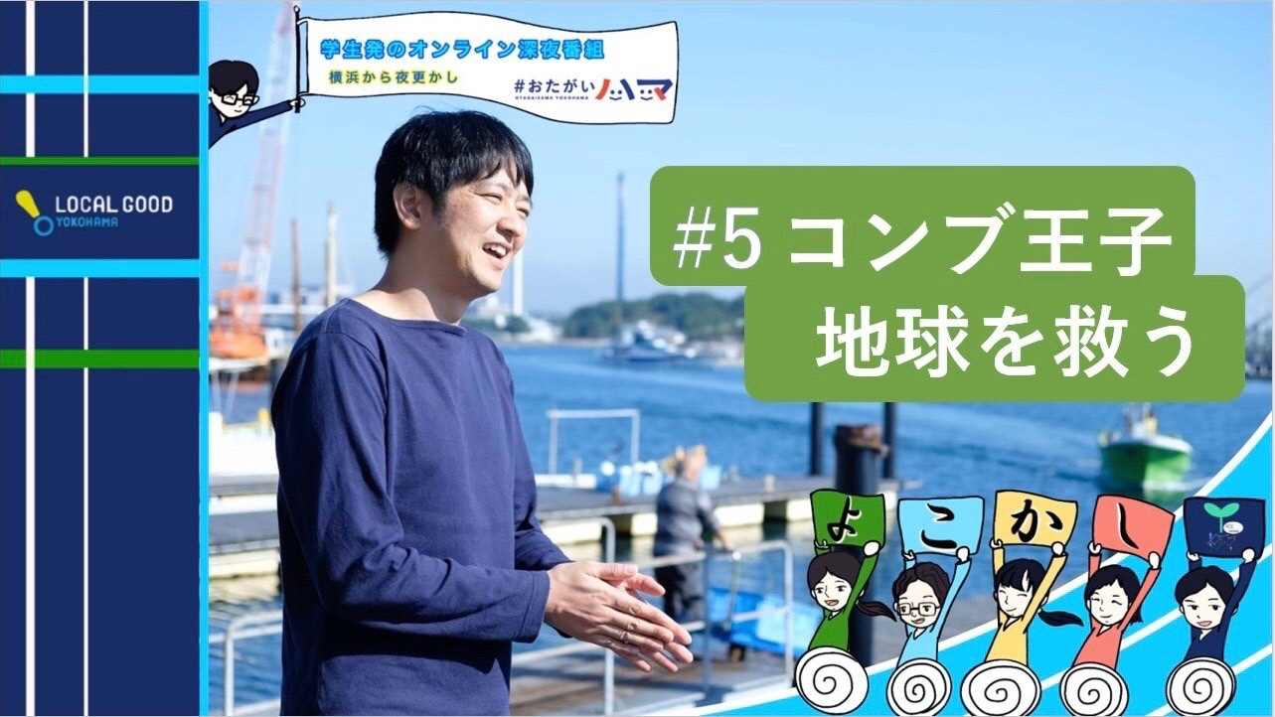  Yokohashi2.jpg |  | Yokokashi example |  | RCE横浜若者連盟

UN Sustainable Development Goals (SDGs) (https://sustainabledevelopment.un.org/sdgs) and other themes of Education for Sustainable Development (ESD)
国連持続可能な開発目標(SDGs)(https://sustainabledevelopment.un.org/sdgs)および持続可能な開発のための教育（ESD）の他テーマ
Please place an “x” in the “direct” or “indirect” boxes next to any of the UN Sustainable Development Goals and/or other themes of Education for Sustainable Development (ESD) to which the work described in this project contributes as appropriate. Note: please mark only those that the ESD project actually has made or is making a contribution, not those to which it could make a potential contribution in the future.
本プロジェクトが貢献する国連の持続可能な開発目標（SDGs）や持続可能な開発のための教育（ESD）のテーマについて、「直接的」または「間接的」のいずれかに「x」を付けてください。注：ESDプロジェクトが実際に貢献した、あるいは貢献しつつあるものにのみ印をつけ、将来的に貢献する可能性のあるものには印をつけないでください。
SDG | Description 概要 | Direct直接的 | Indirect間接的
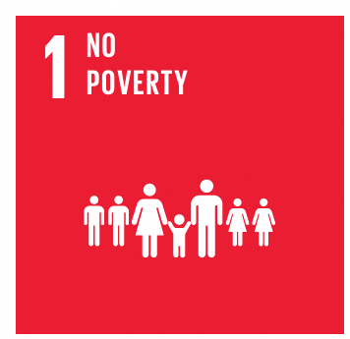 | End poverty in all its forms everywhere あらゆる場所のあらゆる形態の貧困を終わらせる
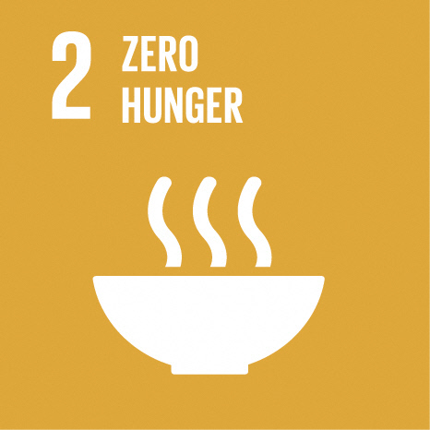 | End hunger, achieve food security and improved nutrition, and promote sustainable agriculture 飢餓を終わらせ、食糧安全保障および栄養改善を実現し、持続可能な農業を促進する
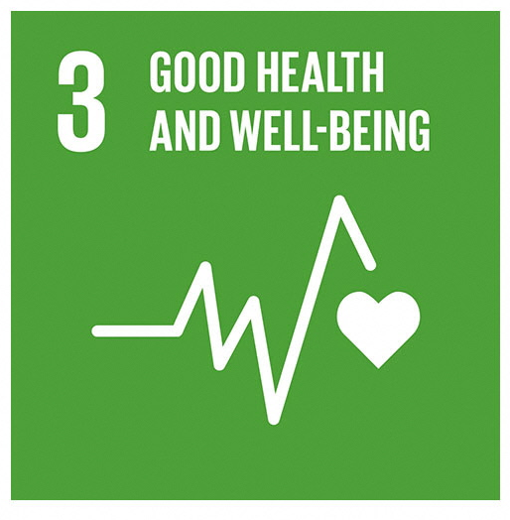 | Ensure healthy lives and promote wellbeing for all at all ages あらゆる年齢のすべての人々の健康的な生活を確保し、福祉を促進する
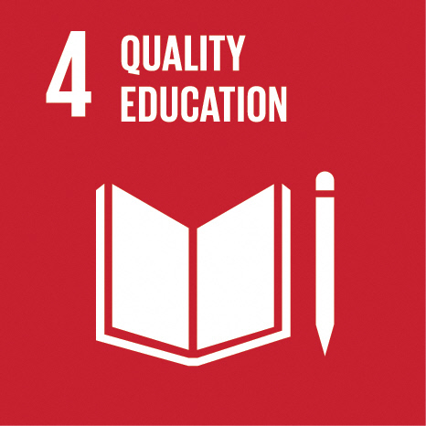 | Ensure inclusive and equitable quality education and promote lifelong learning opportunities for all すべての人に包摂的かつ公正な質の高い教育を確保し生涯学習の機会を促進する |  | x
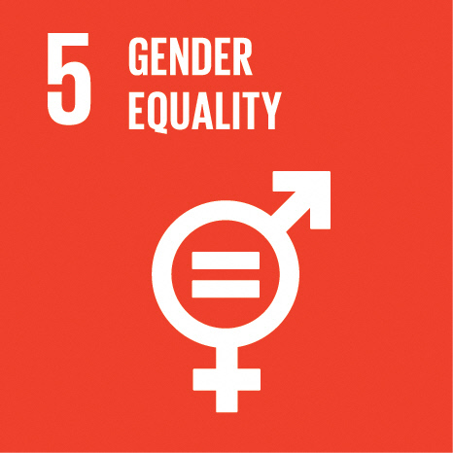 | Achieve gender equality and empower all women and girls ジェンダー平等を達成し、すべての女性および女児の能力強化を行う
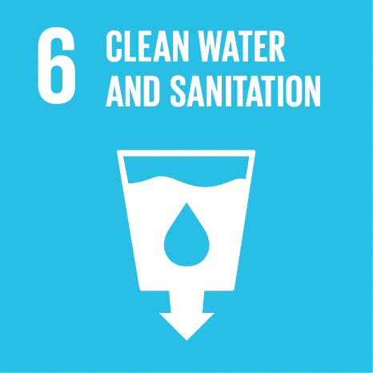 | Ensure availability and sustainable management of water and sanitation for all すべての人々の水と衛生の利用可能性と持続可能な管理を確保する
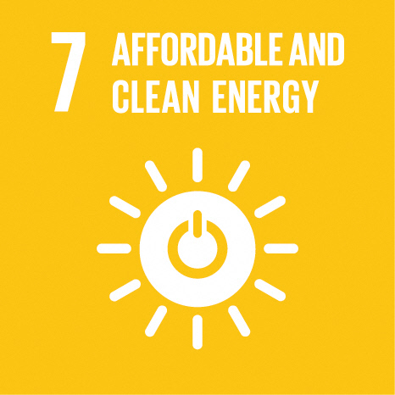 | Ensure access to affordable, reliable, sustainable and modern energy for all すべての人々の、安価かつ信頼できる持続可能な近代的エネルギーへのアクセスを確保する
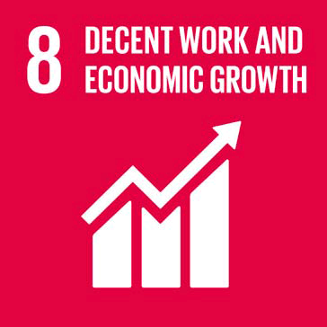 | Promote sustained, inclusive and sustainable economic growth, full and productive employment, and decent work for all 包摂的かつ持続可能な経済成長及びすべての人々の完全かつ生産的雇用と働きがいのある人間らしい雇用（ディーセント・ワーク）を促進する |  | x
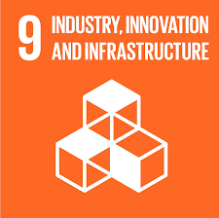 | Build resilient infrastructure, promote inclusive and sustainable industrialisation, and foster innovation 強靭（レジリエント）なインフラ構築、包摂的かつ持続可能な産業化の促進及びイノベーションの推進を図る |  | x
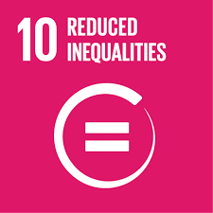 | Reduce inequality within and among countries 各国内および各国間の不平等を是正する
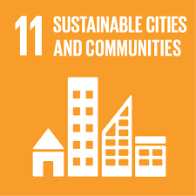 | Make cities and human settlements inclusive, safe, resilient and sustainable 包摂的で安全かつ強靭（レジリエント）で持続可能な都市および人間居住を実現する |  | x
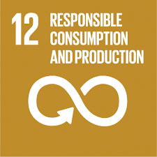 | Ensure sustainable consumption and production patterns 持続可能な生産消費形態を確保する |  | x
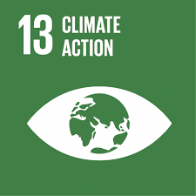 | Take urgent action to combat climate change and its impacts 気候変動及びその影響を軽減するための緊急対策を講じる |  | x
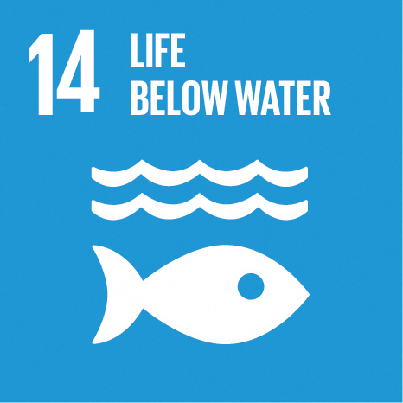 | Conserve and sustainably use the oceans, seas and marine resources for sustainable development 持続可能な開発のために海洋・海洋資源を保全し、持続可能な形で利用する |  | x
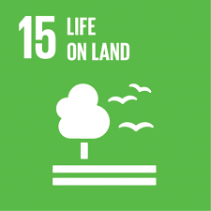 | Protect, restore and promote sustainable use of terrestrial ecosystems, sustainably manage forests, combat desertification and halt and reverse land degradation, and halt biodiversity loss 陸域生態系の保護、回復、持続可能な利用の推進、持続可能な森林の経営、砂漠化への対処、並びに土地の劣化の阻止・回復及び生物多様性の損失を阻止する |  | x
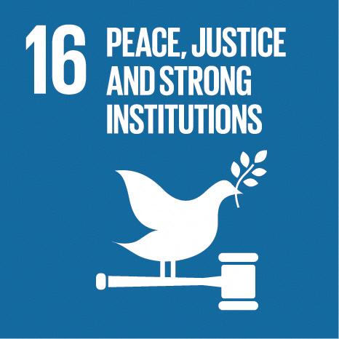 | Promote peaceful and inclusive societies for sustainable development, provide access to justice for all and build effective, accountable and inclusive institutions at all levels 持続可能な開発のための平和で包摂的な社会を促進し、すべての人々に司法へのアクセスを提供し、あらゆるレベルにおいて効果的で説明責任のある包摂的な制度を構築する | x
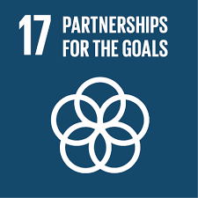 | Strengthen the means of implementation and revitalise the global partnership for sustainable development 持続可能な開発のための実施手段を強化し、グローバル・パートナーシップを活性化する | x
Icon | Theme テーマ | Direct直接的 | Indirect間接的
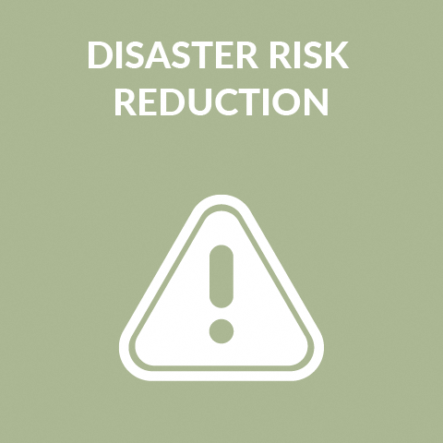 | Disaster Risk Reduction 防災・減災 |  | x
 | Traditional Knowledge 伝統的知識 |  | x
 | Agriculture 農業 |  | x
 | Arts 芸術 |  | x
 | Curriculum Development カリキュラム開発
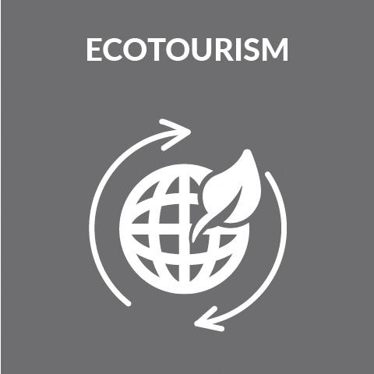 | Ecotourism  エコツーリズム |  | x
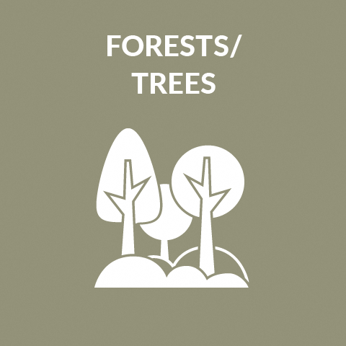 | Forests/Trees  森林/樹木 |  | x
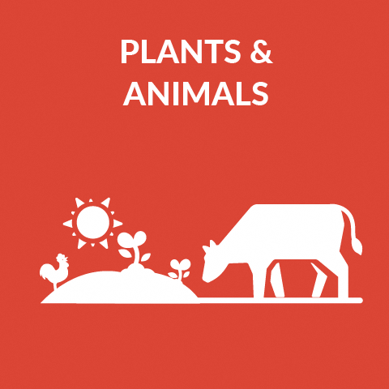 | Plants & Animals  植物/動物 |  | x
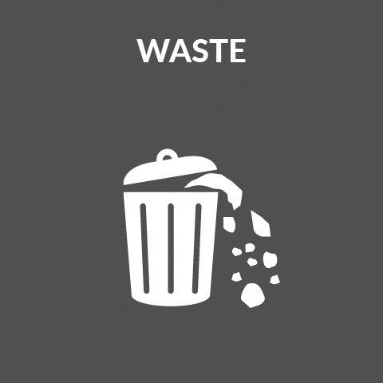 | Waste  廃棄物

ESD for 2030 – Priority Action Areas (https://en.unesco.org/esdfor2030)
ESD for 2030 - 重点活動分野(https://en.unesco.org/esdfor2030)
Please place an “x” in the “direct” or “indirect” boxes next to any of the ESD for 2030 Priority Action Areas to which the work described in this project contributes as appropriate. Note: please mark only those that the ESD project actually has made or is making a contribution, not those to which it could make a potential contribution in the future.
本プロジェクトが貢献する「ESD for 2030」枠組みにおける重点活動分野について、「直接的」または「間接的」の枠に「x」を付けてください。注：本プロジェクトが現時点で実際に貢献した、あるいは貢献しつつあるものにのみ印をつけ、将来貢献する可能性があるものには印をつけないでください。

Priority Action Area重点的活動分野 | Description 概要 | Direct直接的 | Indirect間接的
1 | Advancing policy 政策の推進
2 | Transforming learning and training environments 学習と研修における環境の変革（期間包括型アプローチ） |  | x
3 | Developing capacities of educators and trainers 教育者とトレーナーの能力構築
4 | Mobilizing youth 若者のエンパワーメントと参画促進 | x
5 | Accelerating sustainable solutions at local level 地域レベルにおける持続可能な解決策の加速 | x

日本語の文字数は、英語の単語数の2倍で設定しています。

