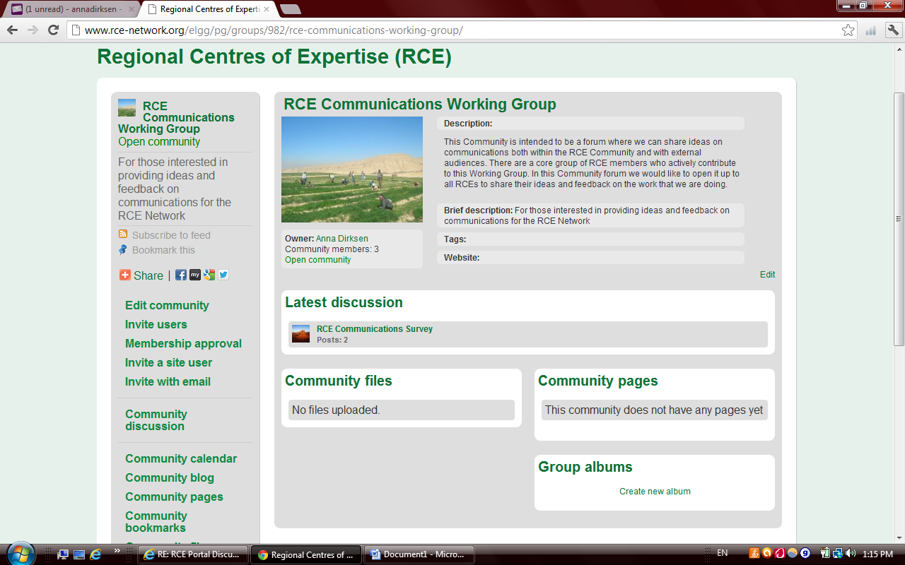 | Click on the EDIT COMMUNITY link on the left hand side.
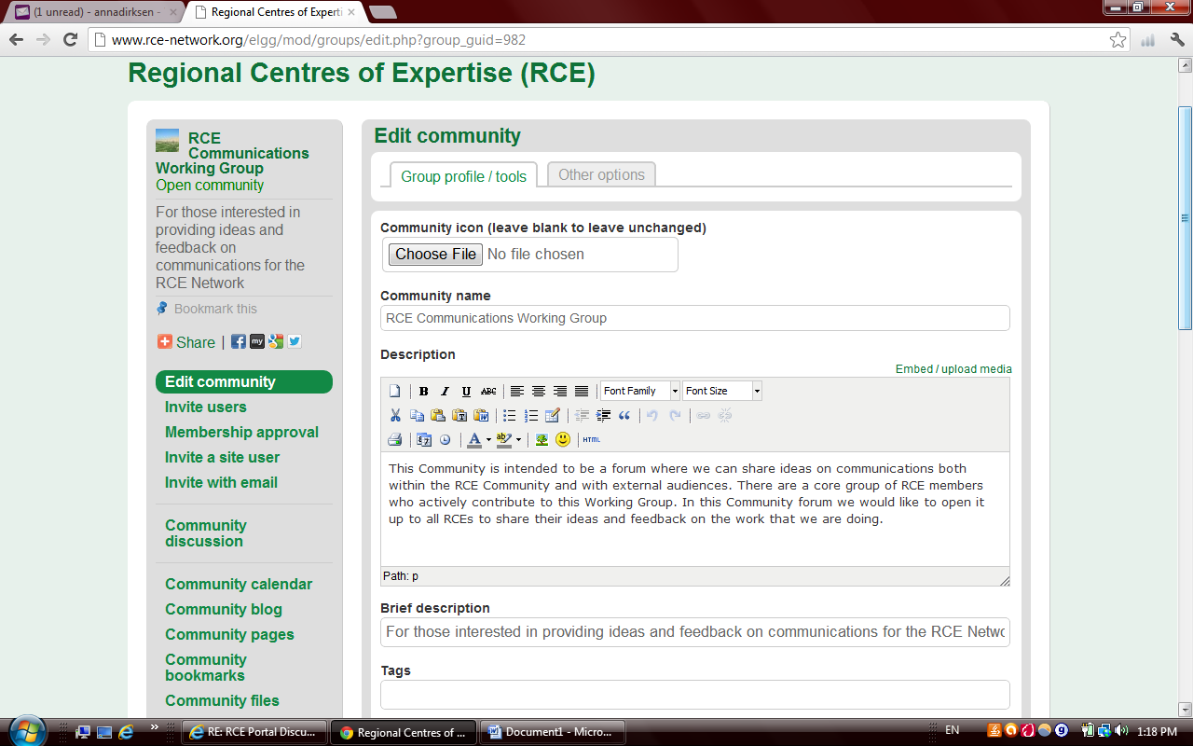 | In the Description area, include a short text description of the group.
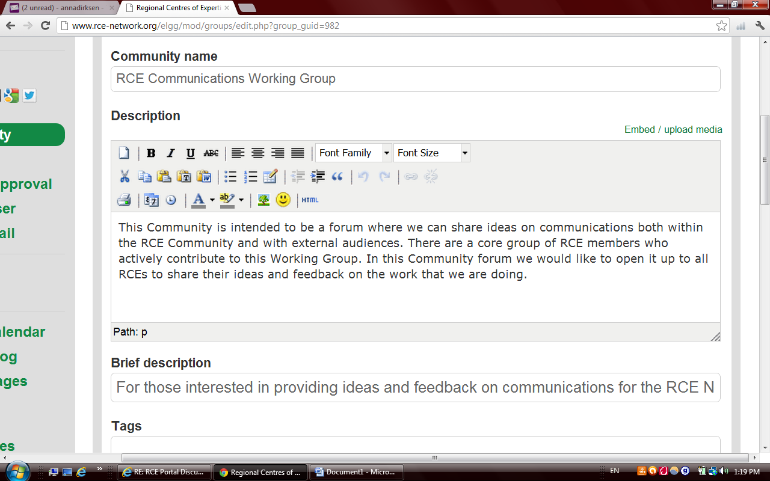 | If you would like to embed your template document in the text description of the group, click the EMBED/UPLOAD MEDIA link
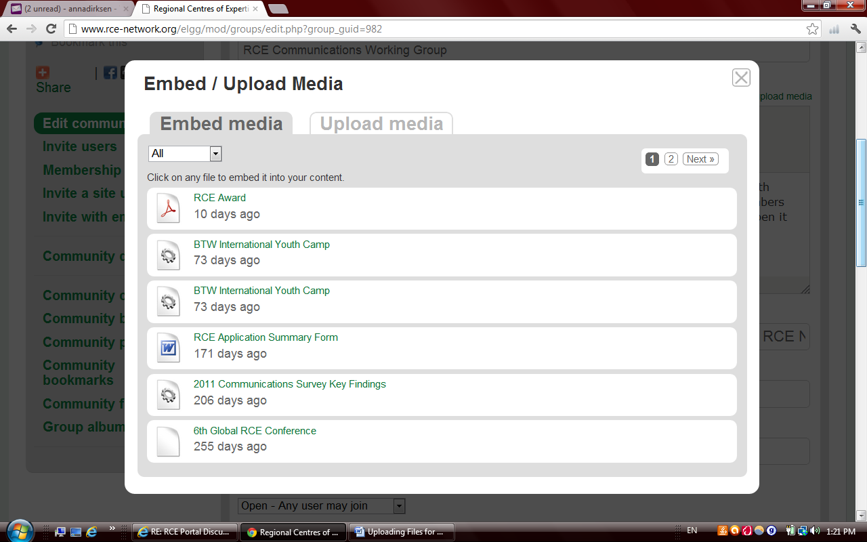 | Click the UPLOAD MEDIA link, choose your file and upload it.

