PEMA EDUCATION CENTRE

Your trusted counterpart agency for "Innovative & Viable Social Investments" in Eastern Africa
Senior Youth (Building New Futures - BNF)

PEMA Education Centre is on Ol'Musalala Rd, Off Ol'Pogoni Rd, Off Mumias South Road
Buruburu Phase 1, Petunia Court, Block 73/368
PO Box 00668-00515 Buruburu, NAIROBI, Kenya; email pema@pema.ac.ke or pema.ac.ke@gmail.com
Kenya

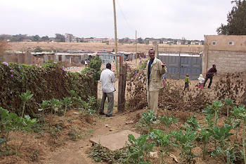 |  | 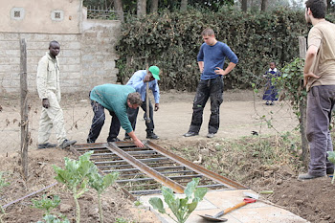

Building New Futures (BNF) was a programme supported by the Dutch Government through Xplore. It involved international exchange of experiences between Dutch and African youths.

Above left: Two senior Kenya youths who participated in Building New Futures (BNF II 2009) Exchange Programme assess the work that needs to be done at PEMA. Having traveled to The Netherlands for three weeks, they would be joined by their counterparts in carrying out renovations at PEMA School. Above right: Heinz, a Dutch BNF supervisor oversees works on a footbridge to PEMA.Below right: The bridge is complete.
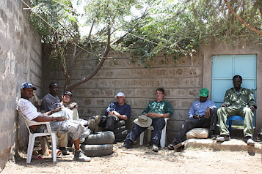 |  | 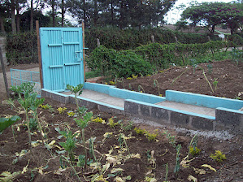

Above left: Combined Dutch and Kenya BNF teams rest at midday after working in the hot sun. Here, they are expecting a delicious hot lunch. Above right: The final result of their work is the current footbridge to PEMA. We usually take up a project for completion once volunteers are done with it.
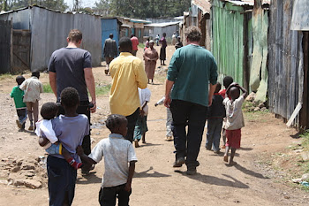 |  | 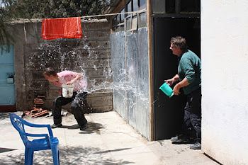

Above Left: BNF team visits City Carton Village from where some of best pupils at PEMA come from. Above right: The supervisor of BNF III enjoys 'water fight' to cool off midday sun heat.
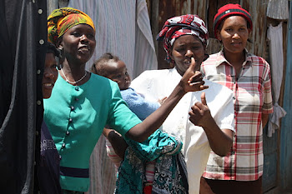

Above left: Yurick, a member of BNF III Dutch team enjoys the company of school children. Above right: Young mothers within their social environment at City Carton. Such mothers know the value of PEMA Pre-School where some of them drop off children in the morning before they go searching for casual work. This photograph was taken by a Dutch volunteer in BNF III.

