RCE Assessment and Evaluation background paper
Draft 23 April 2013

Background
During the RCE International Conference in Tongyeong, the RCE community proposed to further develop a monitoring and evaluation strategy for assessment of effective change practices within the developing RCE community. To address this goal, a working group consisting of UNU-IAS representatives and RCE members came together to frame goals and principles for assessment and evaluation in RCEs as developing initiatives in social learning and change.
The document is subject to further development and elaboration through contributions from RCEs and wider stakeholders, including members of the Ubuntu Alliance of Peers. Development of the strategy to produce stories and data that capture collective learning will take place prior, during and after the RCE initiatives to strengthen and disseminate assessment and evaluation case evidence.
It is the intention of the working group to assist in framing an open-ended and developmental assessment process, initially with a group of the RCEs (up to 20) in 2013. This period will also be used for developing a system of support for enhancing such processes in the future. Initial plans and ideas to frame and mobilize an expansive assessment process of monitoring and evaluation are presented further in this paper.
Members of the RCE Working Group
UNU-IAS: Zinaida Fadeeva, Abel Atiti
RCE KwaZulu Natal: Jim Tailor, Tich Pesanayi
RCE Western Sydney: Geoff Scott
RCE Graz: Clemens Mader
RCE European Advisor: Jos Hermans

Goal and justification of the RCE assessment process
The assessment process has three overarching goals:
- To collectively learn about the work of RCEs and thereby improve its quality;
- To improve the quality of RCE contributions into transformative learning and sustainability change; and
- To facilitate collective work of RCEs as a networked community engaged in diverse social learning and change initiatives.
The first goal reflects the potential for RCE assessment as an opportunity for its members to generate monitoring and evaluation assessments that are helpful for reporting and improve their RCE as a social learning to change initiative. Such learning could be focused not only on the sustainability goals that the RCE members collectively pursue in context but also on the ways the RCE members and stakeholders work and learn together (i.e. governance and coordination).
The second goal relates to generating appreciative contextual evidence on change-oriented activities of the RCEs as regional stakeholders working in the context of social learning to foster change that reduces risk. Such work has a potential to stimulate not only change-orientated work in local RCE contexts but also coordinated work across the RCE community and with its global stakeholders. If the RCEs, as a networked community, are to be positioned as a regional and global player, especially after the end of the Decade on ESD in 2014, evidence of social learning and change within and across RCEs would have to be available.
The third goal relates to the opportunities for coordinated dialogue and collective action across RCEs on issues of monitoring and evaluation assessment.

Principles of RCE assessment
The assessment is developed around:
- The production of contextual data in relation to the constituting document goals and activities. It will be treated as a start-up baseline for monitoring and assessment activities that will build into evaluation work, as described in point 2.
- Appreciative enquiry into the social learning to change activities within RCE initiatives so as to generate data on the programmes, how the activities are implemented and how desired outcomes are achieved.
- Some critical and strategic analysis across contextual data (point 1) and appreciative responses (point 2) within RCEs so as to strengthen situated initiatives in social learning as well as enable engagement across RCEs and with RCE stakeholders.
Here generating detailed baseline information (point 1), appreciative enquiry into RCE initiatives (point 2) and deepening analysis to strengthen RCEs (point 3) is seen as a strategic process that can be started internally and which could ideally bring together key stakeholders to assist in monitoring and evaluative assessments of RCE practices so as to strengthen them.
It recognizes that effective monitoring and evaluation develops from baseline contextual data and diverse forms of appreciative review of RCE programmes and activities.
It notes that there are diverse ways of undertaking review processes such as these, and that their primary function is to develop a capacity to deepen understanding and promote culture of learning to change in the spheres of personal and professional life.
Evaluations would need to focus on an RCE case context (point 1) alongside appreciative data on developing change practices, their outcomes (point 2) and the emerging impact of change amongst those intended to benefit from the work of RCEs (point 3).
Elements of the evaluation processes
After the development of a baseline perspective on the RCE, an appreciative evaluation of developing activities can involve a strategic progression, as outlined below:
- Listen: Self-enquiry; documenting what is going on at the RCE; deliberating what is missing that could otherwise optimise the potential.
- Link or Network: Enable professional linkages to be strengthened and new links to be developed.
- Live & Learn: Working in context to situate learning in the daily reality of living and working at the RCE.
- Leverage: What could be done to widen the learning by forming partnerships and strengthen resource relationships that support wider RCE developments?
Baseline, appreciative and more strategic evaluation processes can take several forms. All evaluation would, however, require participation of major stakeholders in some form of appreciative discussion with data generation and analysis to clarify the valued beings and doings associated with RCE change initiatives.
While dependent on the aspirations of the RCEs partners and available resources, analysis of documents might be complemented by the additional data collection through questionnaires, sight visits, etc.
A constitutive and appreciative evaluation can involve contextual data being summarized on templates with appreciative enquiry commentaries focused on RCE projects and processes, including the generation of information on the scope of valued change.
In addition to the assessment processes in individual RCEs, it is important to envision a process, regional or global, for support of the evaluation processes and people taking leadership roles in evaluation. Such processes (further identified in the next section) could take the form of peer assessments, research or capacity development processes (e.g. courses on monitoring and evaluation assessments).
Engagement of peers from other RCEs in evaluations might help to identify common challenges, creative solutions to address these challenges, and creative ESD solutions. Working with stakeholders outside of the RCE community could assist in better positioning RCEs to serve regional needs.

Strategies for RCE evaluation (“menu of evaluations”)
Figure 1 presents various elements of starting from a constitutive evaluation stage (built around key elements of RCEs – baselines), followed by appreciative inquiry and expanding to more strategic evaluation and even meta analysis undertaken at the supra-RCE level (i.e. at the (sub)continental or international levels in and across a networked learning community). The three elements – constitutive evaluation, appreciative evaluation, strategic evaluation – could either be used as a sequential flow as illustrated by Figure 1 or taken separately, dependent on the needs of the RCEs. The meta-analysis is used to identify trends in development of the RCEs in the community.
Figure 1
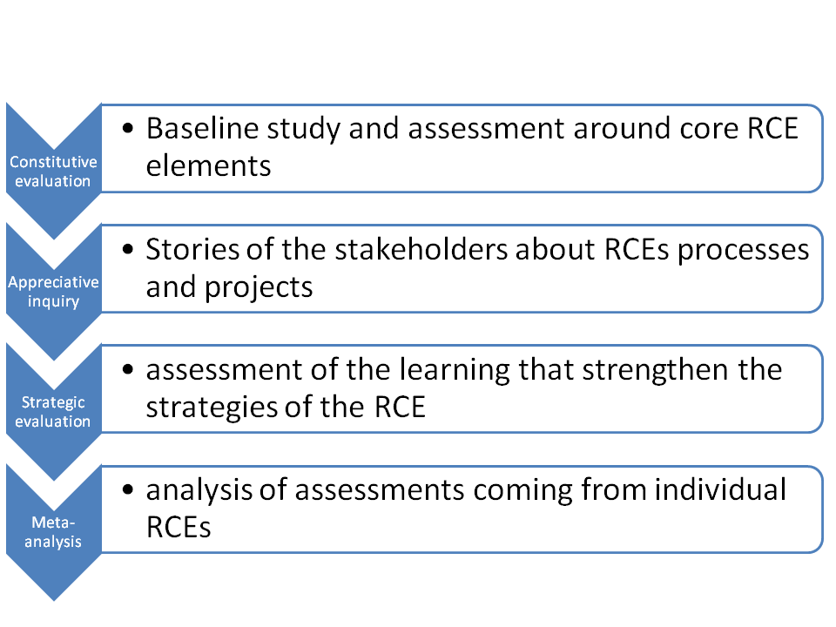
- Constitutive evaluation
Constitutive evaluation is focused on the core elements of the RCEs and its functions as stated in its inception document and as peer reviewed and vetted by the Ubuntu Committee. The questions guiding evaluation should be designed against the backdrop of these core RCE elements – Governance, Scope of Collaboration, Research & Development, and Transformative Education. While recording and analyzing this data could take different forms, the foundational – constitutive – framework could be derived from the RCE principles and treated as a baseline.
A sustainable RCE is one that is strong in all four elements. The evaluation will be taking stock of the initial situation of where RCEs stood at the time of formation in terms of their understanding of regional challenges, goals, strategies and planned collective actions as well as actions that have been recorded through various project reports, scientific and popular articles and other reporting documentation. It is expected that a sustainable RCE will maintain the values on which it was evaluated at the time of acknowledgement, contributing to the constitutive/core elements.
The assessment should also be anchored on the three main RCE functions, namely:
- As a platform for dialogue among stakeholders,
- As a local resource base on ESD, and
- As an active participant in the alignment of ESD in formal and non-formal education.

In all the areas, above, simple sets of leading questions should be designed to assess whether or not the RCE has indeed carried out these three main functions. Box 1 presents examples of potential evaluation questions. The RCE could also be assessed on its engagement with wider RCE communities – national, continental, and global – to ascertain if it functions as a node in the so-called Global Learning Space.
Data feeding from the application for the regional stakeholders for the RCE status as well as reports on the RCE projects, publications, articles and other recorded accounts. Data, recorded through agreed descriptors, would need to be put into data templates. Templates could take inspiration from summaries of RCE candidate applications

Box 1. Examples of the questions that RCEs could be asking in a course of constitutive evaluation
How does the coordination structure of the RCE support its activities? How did this structure evolve and to what effect?
How has the number and composition of RCE partners changed?
How did the portfolio of research/educational projects of the RCE evolve?

- Evaluation based on appreciative inquiry
Evaluation based on appreciative inquiry (AI) focuses on positive experiences of RCE members in realizing ambitions stated in the RCE application and goals developed on the basis of the RCE, as stated in its vision statement made after acknowledgement. This approach, opposite to problem-based evaluations, is “based on the assumption that questions and dialogue about strengths, successes, values, hopes, and dreams are themselves transformational” (Whitney & Trosten-Bloom (2003, p. 1)). Consequently, the questions asked during AI focus not on problems but on positive aspects of RCE work. Examples of questions are given in Box 2.
Box 2. Examples of questions RCEs could be asking in a course of appreciative inquiry
What, in your view, are the best/most successful projects of the RCE?
How can we do more of such/similar actions?
What was an example of successful collaboration/decision-making?
What are your/our wishes for the work of the RCE/region?

It can include governance and resources, core activities, support and impact of activities. There is no perfect recipe here as to what the RCE elects to examine (point 1) or what must be seen in relation to the context and purpose of the RCE (point 2) as an initiative in expansive social learning to change in response to social-ecological risks. The results of evaluation will assist in helping define new goals or affirm existing goals.
Affirmation and appreciation are given to the work of individuals and organizations that are members of the RCEs, through consultations. Key areas for evaluative review would need to be made explicit by the RCEs, focusing on valued projects, valued collaborative practices, and valued benefits of collective work, among other issues. The key areas (with potential indicators and benchmarks associated with them) would enable an improvement of actions in the desired areas and also across the RCEs.
Data for appreciative enquiry comes from different sources; for example, from accounts (through bilateral interviews) or key players, group, group interviews, stories, written reflections of values, aspirations, and wishes of the stakeholders.

- Strategic evaluation/change evaluation
Strategic evaluation focuses on the RCE actions that help to further advance the work of the RCEs (RCE Greater Western Sydney case). To move beyond focus on “immediate cases in the here and now” and to develop an understanding of the social learning to change potential for various RCE actions, an evaluation could include an assessment of the RCE context of risk and the emerging scope and impact of the activities being undertaken within the RCE.
Box 3. Example of the questions the RCEs could be asking in a course of strategic evaluation
Questions could be related to:
- Transformation in the areas of strategic importance for RCEs: what are the transformations that have taken place and in what area(s)? Over a period of 12, 24, 36 months etc. what has changed? This should be evidence-based.
- Linkages and SD knowledge transfer in the areas important for the region/RCE: how much has this taken place - vertically, horizontally, and diagionally over similar time period? Evidence should support the observations.
- What are the flagship projects that can be used to illustrate the success of the RCEs post Rio+20?
- What is the amount of budget spent for human resources involved as well as governance structure?
- What are the main barriers to overcome for (c) to prevail post Rio+20
The difference between constitutive evaluation and strategic evaluation might not be always evident in RCEs. If an RCE created its own strategies as contributing to the core/constitutive elements of the RCEs (i.e. governance, transformative education, research and development, etc.) assessment of the effectiveness of these strategies would naturally be related to these constitutive elements.
Strategic evaluation is similar to change evaluation (CE) where stakeholders aim at advancing their collective capacity for analysis and collaborative actions. They systematically reflect on cultural, economic, political changes and their work in the context of these changes. Their evaluation is, therefore, focused on assessing the environment, assumptions, stakeholder needs and preferences, and possible choices leading to adjusting ways of individual and collective practices.
CE is built around the assumption that with a constantly changing environment (due to changes in funding, policies, interests, etc.) interests and strategies of different organizations and consortia are changing too. As a result, there is a need to critically assess the adequacy of already adopted strategies and develop new approaches, while keeping in mind lessons learned in the past and opportunities of the future.
In a course of the CE, RCE stakeholders assess what processes contribute to the intended RCE objectives and why. The partners might select to focus on the assessment and adjustment of he process (formative evaluation) and/or on the outcomes.

- Meta-analysis across RCEs
Across-RCE analysis of evaluation reporting (i.e. results) could be undertaken at different levels: regional (e.g. SADC countries), continental (e.g. Europe, Africa, Latin America) or global. It would require a significant dedication of analytical time. To assist the process, the analysis could be associated with across-RCE capacity development practices (e.g. courses, seminars, couching), policy advocacy actions and research projects. Depending on the process, the meta-analysis could engage analysts from outside of the RCE community.
Meta-analysis identifies diversity of RCE development, their contribution to change processes in the society and towards goals of sustainable development. It should be undertaken across RCEs (e.g. by the groups of analysts from the RCE community) with possible engagement of external analysts. Among the outcomes of the analysis will be policy documents positioning the RCE community by focusing on the questions “What do we have to offer in the field of ESD and SD?” and “To whom do we offer it?”

Outputs of evaluations (outcomes are already mentioned under the section on Goals)
Regionally appropriate handbooks addressing principles of evaluation, elements of evaluation processes, expected outcomes, ideas on up-scaling and leveraging actions within and beyond the region and its immediate resources.
Tested and collectively designed courses intended to strengthen capacity for evaluation.
Identified opportunities for across-RCE engagement.
Documented case evidence of RCE capacity to deliver change.
Meta-picture of the RCE community in its richness and diversity.

Processes for supporting RCE assessments
Europe
There are several opportunities for initiating discussion of RCE evaluation, including on the fringes of the GUNI conference, the RCE meeting in Kerkrade and the meeting of German RCEs. In the course of these meetings, the Evaluation Working Group members will collect feedback on the general idea and identify the RCEs willing to initiate the evaluation process.
Japan
The opportunities for discussion on evaluation will present themselves in connection with the regularly scheduled meetings of Japanese RCEs. If agreed, the meetings will open space for refining approaches, addressing challenges and analyzing the results of the ongoing evaluations.
Africa
A project for deepening evaluation processes in the RCEs located in SADC countries has been suggested (see Appendix).

