Appendix D - Media

The majority of related media coverage (informal education) is included here:
1. Global TV morning show
>>> Natalie Tomczak 4/10/2015 3:16 PM >>>
Hi Tanya,

I spoke with Andrea from Global and you're set for 8 a.m. on April 22 for the morning show on Earth Day. As of now, it sounds like doing the interview at Miller High School or very close to the school shouldn't be a problem. As we near the 22nd, Andrea will confirm the location!

Thanks again and have a great weekend!

Natalie

2. CTV News - http://regina.ctvnews.ca/video?clipId=597986&binId=1.1165847&playlistPageNum=1

3. CKRM - U of R and Miller High School to continue joint research project
Published: 22 April 2015
14 Miller High School students and students at the University of Regina are working together on an environmental research project. The two schools are combining to look at the effects of pesticides on the environment by using the Plant Health Care Model (PHCM) as an alternative to chemical treatments. Doctor Tanya Dahms is the project lead at the U of R and she says it's important research. "There are many pollutants that we put into the environment. We have no idea of the impact of those combined components. This is what's inspired me to reorient my research to look at the impact of all these types of chemicals on non target organisms such as human cells, microbes and so on." The project started last spring. http://www.620ckrm.com/ckrm-on-air/ckrm-local-news/9227-u-of-r-and-miller-high-school-to-continue-joint-research-project

4. Plant health research project celebrated on Earth Day
www.pressreader.com/canada/leader-post/20150423/.../TextView
Leader-Post - 2015-04-23 ... Earth Day often acts as a reminder for people to reduce their environmental impact. ... The project is led by biochemistry professor Tanya Dahms, along with microbiology professor Chris Yost and ecology professor ...
Earth Day often acts as a reminder for people to reduce their environmental impact. Several students at Miller Comprehensive Catholic High School do not need such a reminder.
Since last spring, students from Miller have partnered with the University of Regina on a research project that focuses on a plant health care model as an alternative to using pesticides.
The project is led by biochemistry professor Tanya Dahms, along with microbiology professor Chris Yost and ecology professor Scott Wilson.
"As a professor of biochemistry, I was interested in sustainable initiatives that would improve community health. So that was my interest in reducing pesticide use in the city," Dahms said.
But to conduct this type of research, Dahms required help. She turned to longtime friend Heather Haynes, a biology teacher at Miller.
"We realized we needed a number of student researchers, and it came to my mind that Heather Haynes would be an excellent contact. So I asked her if she would be willing to be involved, and she was actually the person responsible for amassing the Miller High School research team," said Dahms.
Haynes organized 14 students to take part in the project, ranging from grade 9 to grade 12. The students and university staff then analyzed and compared data from two plots of grass, one treated with pesticides and one treated naturally through the plant health care model.
"By using really simple methods and things like compost tea, which returns healthy microbes into the soil, what we can do is we can empower the plants so they can be their own defence against infestations," said Dahms.
Chantelle La Rocque, a Grade 11 student, has been involved with the project since its beginning. She says she has a passion for environmental sciences, and realizes the need for this type of the research.
"These pesticides are not only affecting our grass, our soil, organisms, (and) micro-organisms. They are affecting humans as well. And when we were doing our research, we saw little children playing on these fields, and that affects them," said Le Rocque.
"These pesticides and herbicides, they are going to affect us in the long run as well."
In addition to the research on environmentally friendly alternatives to pesticides, Haynes says the project has been a great learning opportunity for the students.
"It's absolutely remarkable, their ability to learn the different type of science techniques, analytical skills, (and) data collection. It's far and above what we could ever do just here in our own school, because the professors bring so much knowledge to these practices. They are becoming so confident when we head out to the university, working in these professional laboratories," Haynes said.
In the future, Haynes hopes her students will be able to run the project autonomously.
"Then, as our students graduate from university, we (can bring in) new students into the program in Grade 9, 10, 11, and 12. And, of course, we'd also like different projects as well on campus in the different areas of chemistry, physics, and biology," Haynes said.

5. UofR Website: U of R connects with Regina high school for Earth Day

Posted: April 22, 2015 10:30 a.m.
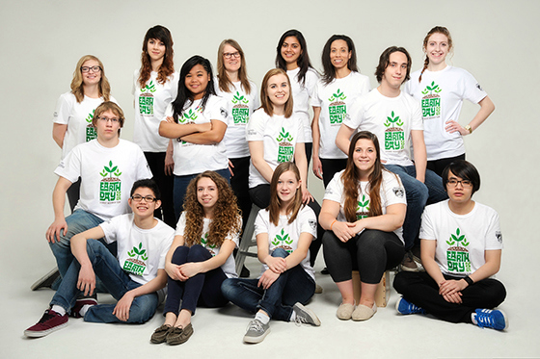
Students from Miller Comprehensive Catholic High School celebrating Earth Day and their collaborative science project with the University of Regina. Photo: U of R Photography.
Earth Day was celebrated April 22 with the launch of a collaborative science project between researchers at the University of Regina and students and teachers at Miller Comprehensive Catholic High School.
Drs. Tanya Dahms, Chris Yost and Scott Wilson from the Faculty of Science, have collaborated with the Regina high school on a project that uses the Plant Health Care Model.
“We have found promising preliminary results using the Plant Health Care Model on campus, a safe and environmentally-friendly alternative to toxic pesticides,” says Dr. Dahms.
There are 14 students from Miller involved in the project led by their biology teachers Heather Haynes and Nicole Anderson. The students are examining the ecology of test plots.
The preliminary qualitative results indicate that the Plant Health Care Model plot had richer turf than the one that used pesticides - even without aeration, over seeding, and organic fertilizers.
“Anything that allows our students to participate in scientific investigations and to see how they unfold over the course of time, while using inquiry approaches, is of interest to Ms. Anderson and myself. This project provided our students the opportunity to collaborate with university professors in an effort to create ‘greener’ green spaces,” says Ms. Haynes.
Ms. Haynes and Ms. Anderson say this project is an excellent opportunity for their students to engage in purposeful scientific field work. Two of those students, Chantelle La Rocque and Adrian Muscat, realized the importance of a safe environment with the collaboration of science.
"Our research will have a remarkable impact on our environment and ensure a safe and better future for generations to come,” says La Roque.
Muscat agrees. “The research project has given us the opportunity to expand our knowledge and gain experience working in a research lab alongside professional researchers.”
Over the course of the project, students will have gained valuable insight about environmental challenges and the potential of scientific research as a career option.
Dr. Dahms’ application to the University of Regina’s Sustainability and Community Engagement Fund made this project a reality, while realizing the University’s Strategic Plan of its commitment to our communities and research impact.

6. UofR Media Release - University of Regina researchers and Miller Comprehensive Catholic High School students collaborate on pesticide project
News Release Release Date: April 22, 2015 10:15 a.m.
University of Regina researchers continue to lead the way in supporting healthy community living. Dr. Tanya Dahms, project lead, along with Drs. Chris Yost and Scott Wilson from the Faculty of Science, are collaborating with students from Miller Comprehensive Catholic High School (MCCHS) on a project that uses the Plant Health Care Model (PHCM) to avoid the use of pesticides.
“The Plant Health Care Model is a safe and environmentally-friendly alternative to toxic pesticides for which we have demonstrated proof-of-principle on campus,” said Dr. Dahms. “This project supports our University’s commitment to sustainability and community engagement by linking the next generation of leaders in our city to research that has the potential to make our shared green spaces safer for everyone.”
PHCM uses a combination of hand weeding, other standard methods, and compost tea sprays to replace healthy soil bacteria that are required to release nutrients into the soil from decomposing dead plants.
In partnership with University of Regina researchers, Biology teachers Heather Haynes and Nicole Anderson lead the group of 14 students at MCCHS examining the ecology of the test plots. The preliminary qualitative results indicate that the PHCM plot had richer turf than the plot that used pesticides - even without aeration, over seeding, and organic fertilizers.
“It is great to have a partnership between our students and the University of Regina to explore a green approach to lawn care” said Jamie Bresciani, MCCHS principal. “Especially on Earth Day it is important to realize that it is our students today who will create a better world for tomorrow.”
The collaboration enables the student research team to learn the scientific method and laboratory tools in a professional research setting, while gaining valuable insight into common environmental challenges in our own community. It also helps students become aware of possible career options as researchers, particularly in the environmental sciences.
The PHCM project was made possible with support from the University of Regina Sustainability and Community Engagement Fund and supports the University’s Strategic Plan, which identifies sustainability and community engagement as key priorities for the University.

7. Miller High School Earth Day School Assembly Address – T. Dahms
About 15 years ago, a small group of students, faculty and staff at the UofR gathered informally to discuss sustainability on campus and come up with a sustainability policy. That group eventually led the initiative to establish the Saskatchewan RCE in 2007 – regional center of expertise on education for sustainable development, part of a United Nations University initiative. Some folks at UNU realized that governments could sign all the accords in the world, but those changes may never be realized, so they proposed the RCEs to harness grass roots sustainable initiatives. As a founding member of RCE SK, its Health and Healthy Lifestyles coordinator and as a Professor of Biochemistry, I have pursued sustainable initiatives intended to improve community health, hence my interest in reducing pesticide use. The use of pesticides had been questioned by doctors, nurses, the Canadian Cancer society, to name just a few. In 2002 a proposal came forward to ban pesticides for cosmetic use in the City of Regina, but was not supported. However subsequently the Regina Catholic School Board banned pesticide use on school property and in 2012 the city proposed to use the plant health care model to vastly reduce pesticide use in the city, based on the premise that healthy plants are
their own best defense against weed and insect infestations. The method uses over watering, high mowing, aeration, dethatching, top-dressing and overseeding, organic fertilizer and the application of compost tea. Last year, with teachers Heather Haynes and Nicole Anderson, we embarked on a project to evaluate the effectiveness of the plant health care model on the UofR campus using the scientific method. The project was met enthusiastically by the Miller student research team who learned scientific techniques so that they collect data on the UofR test plots, are learning to analyze the data, make hypotheses and design their own experiments to test their hypotheses. It is appropriate that this year, when the University of Regina has unveiled its strategic plan in which sustainability is a major emphasis, that UofR Sustainability and Community Engagement Fund has supported this project to move forward and expand into the center green. This is the center piece of the University, and also an area of high traffic, where in the summer employees eat lunch, students lounge and play on the grass and kids attend summer camps. As we fully implement the PCHM this year on the center green, the Miller research team is perfectly poised to help us evaluate its success.
The moral of this story is that long, arduous journeys are the most rewarding – it has led me into the community and here to Miller high school where I get to work with talented young researchers and teachers. You are our future and I am excited to be able to work with you. Thank you.

8. Talk to the Regina Horticultural Society
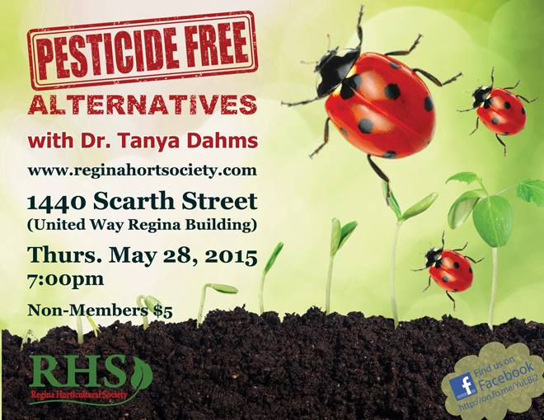

9. UofR Website - Campus community gets ‘green’ in support of sustainability
By Dale Johnson Posted: October 9, 2015 11:00 a.m.
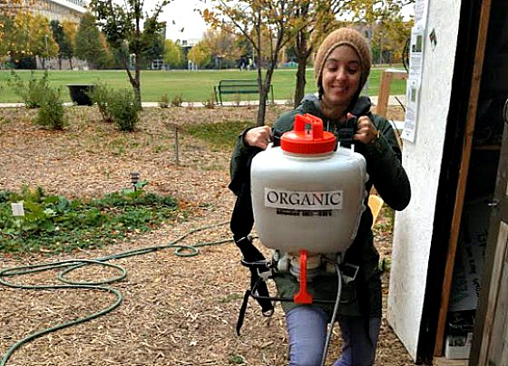
Taneal Brucks gets ready to apply compost tea to the Dr. Lloyd Barber Academic Green – part of the Plant Health Care Model trialed this summer and supported by the Sustainability and Community Engagement Fund. Photo courtesy of Andres Palma.
October is Sustainability Action and Awareness Month (SAAM). As part of the month-long activities on campus, the University is offering students, faculty and staff a chance to earn some ‘green’ to support sustainability initiatives.
Back for the second year is the Sustainability and Community Engagement Fund, which helps build a culture of sustainability among the University of Regina campus community while fostering positive impacts in the surrounding community.
The Fund supports students, faculty and staff in becoming more active citizens by funding projects that foster a stronger engagement for sustainable and socially responsible practices and actions on campus.
The deadline to submit ideas is Nov. 2, 2015. In all, $28,000 will be available to help develop new iniatives.
Last year, funding was provided for such programs as a bike repair station, a portable digital smart board, and a greywater treatment system.
Another project trialed the plant health care model – a method of plant stewardship that builds up healthy soil bacteria that are required to release nutrients into the soil from decomposing dead plants, generating healthy plants without the need for pesticides or chemical fertilizer.
The plant health care model was piloted on the Dr. Lloyd Barber Academic Green this summer, thanks largely to the hard work of students Taneal Brucks and Andres Palma.
“These highly talented summer students did an amazing job using compost tea, overseeding, organic fertilizer and hand weeding. The oval lawn is in much better shape than it normally would be at this time of year,” says biochemistry professor Dr. Tanya Dahms, who was the project lead.
“The Plant Health Care Model is a safe and environmentally-friendly alternative to toxic pesticides,” she says. “This project supports our University’s Strategic Plan, which identifies sustainability and community engagement as key priorities for the University.”
In addition to launching the second round of the Sustainability and Community Engagement Fund, a number of events will take place on campus in October in support of SAAM. Whether it’s coming up with ideas to engage in sustainable and socially responsible practices and actions on campus, trying fair trade coffee, learning about the car share program, taking the stairs or recycling, there are lots of activities throughout the month.

10. UofR Leader Post Ad – Research that has Impact

11. Degrees Alumni Magazine – Our commitment to Research that has impact

12. Innovating Life – UofR Research Quarterly Update

