Biochemichal Testing
An indication of germination capacity can also be obtained by a biochemical test, using the reagent tetrazolium. Chemically, this is a 2,3,5-triphenyltetrazolium chloride or bromide-either salt may be used. It is colourless and soluble, and diffuses readily into and through tissue. There, in the presence of the enzyme dehydrogenase, it is reduced to triphenyl-formazan, which is red and non diffusible, remaining inside the cells where it is formed. Chemically this is a test for the presence of dehydrogenase, but this enzyme is active in living tissue unstained. This reaction may also be brought about by light or, if the solution is alkaline, by other substances such as ascorbic acid. The solution of tetrazolium is therefore adjusted to a pH between 6.5 and 7 and kept in the darkness both before and during the test.
In the test, the seeds are immersed in a 1percent solution long enough for the tetrazolium to penetrate, and the staining of the embryo is noted. The intensity of staining is not significant. Embryos that are completely stained or completely unstained present no problem, but an embryo may be found to be stained in part only, indicating, for example, that the plumule is viable but the root is dead. In a germination test, the embryo is evaluated on the emergence of essential structures in the seedling; similarly, in the tetrazolium test, the embryo is evaluated on the staining of essential parts. The minimum staining required has been determined experimentally and is not the same for all the species. For example, all the root tissue needs to be stained in sorghum, but only a small part in barley and rice, and an intermediate proportion in wheat. For each species there is a minimum staining pattern which has to be learned by the analyst.
To facilitate the entry of the tetrazolium into the embryo and to make the staining part visible, preparation of the seed is necessary before immersion in the solution. This may consist of presoaking in water, removing the outer layers, or cutting each seed into halves.
If the germination capacity is high, the agreement between conventional and tetrazolium test is good, but at lower germinations the tetrazolium test is less reliable. There are several reasons for this. Dormant seeds are not differentiated from non-dormant seeds. Abnormal growths may not be detected; embryos which develop into deformed seedlings may nevertheless stain normally. Living micro-orgsanisms present in decayed embryos may cause staining. There is a risk, too, that in seeds killed by overheating in the drying process, or in seeds that have sprouted, dehydrogenase may persist for a short time and reduce the tetrazolium.
The great advantage of the test is its speed, and it is of particular value in processing establishments where incoming seed has to be assessed quickly, even at the risk of occasional error. Normally the test is completed within 24 hrs, but this time can be reduced by having the seeds taken up the reagent under a vacuum, by maintaining a higher temperature during immersion, or by using the iodide salt of tetrazolium.
The test can also be used to decide whether seeds still un-germinated at the end of a conventional germination test are dead or dormant. The use of tetrazolium is not restricted to actual testing. It is a versatile tool and can be used to investigate the causes of poor germination or low vigour.
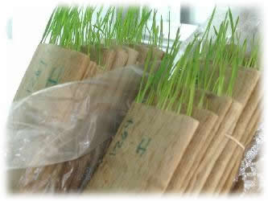
Picture 6: Germination Test Using Moist Paper Towels

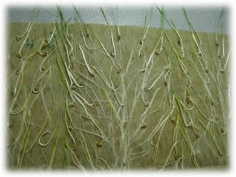
Picture 6: Germination Test Evaluations

Ungerminated seeds at the end of the germination test are examined for dormancy with TZ testing.
When a quick estimate of the total viability is needed, a tetrazolium test
should be requested. The test usually takes 24 hours to complete, but with native species this may take 48 hours or longer.
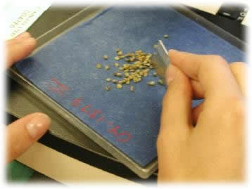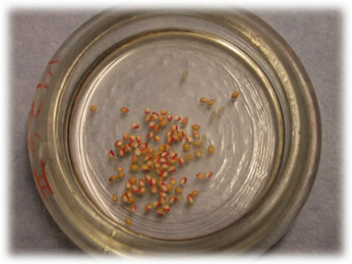
Picture 7: Tetrazolium (TZ) Testing

