Mapping Equity in Portland

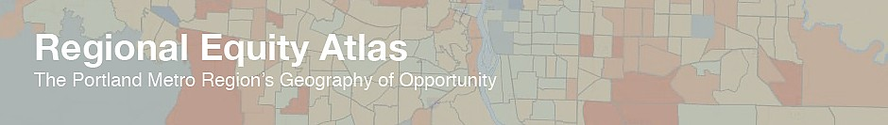

Friday, December 6
10:30 am to 12:00 pm
PCC Sylvania SS 122

Join PCC Sylvania’s Social Sciences Division for a presentation by the Coalition for a Livable Future on their newly released Regional Equity Atlas 2.0. Based on current, regional data, the Regional Equity Atlas project uses maps, policy analysis, community based research, and other tools to assess how well different populations across the four-county Portland-Vancouver metro region can access resources necessary for meeting their basic needs and advancing their health and well-being. This presentation will provide an overview of the Equity Atlas project, a summary of key maps and findings, and an advanced demonstration of how to use the online mapping tool. All PCC staff and students and community members are welcome.

For more information on the Equity Atlas project,
please visit www.equityatlas.org.

