The 11th Global RCE Conference
D
“Education for the Sustainable Development Goals”
7th – 9th December, 2018; Cebu, the Philippines
Form D: ESD Workshop Proposal

Please fill out this form and send to the Global RCE Service Centre (rceconference@unu.edu). We request you to keep your responses as concise as possible. This information will be the basis for evaluating the suitability of your proposed workshop for the meeting. It is mandatory for those applying for funding support to either present a case study during Parallel Sessions I or II (Form C) or to conduct a workshop (Form D) and submit one of these along with Form B. Please note, an up-to-date RCE Profile Form is required for any participant seeking funded travel to the conference (if not submitted since June 2018).

Deadline: by 23:59, Sunday, 7 October 2018 (JST)
Kindly note that workshops will take place during the Global RCE Conference and each facilitator will be allocated 90 minutes during the afternoon sessions on December 8th. Please make sure all materials (PowerPoint presentations, handouts, etc.) are prepared well in advance of the day of the workshop. Please note all materials will be made public on the RCE portal after the conference – please let us know if there are any materials you do not wish to share on the portal by contacting (rceconference@unu.edu)

Theme: Education for the Sustainable Development Goals
It is encouraged to connect workshops to this year’s theme, education as an approach to implementing one of the respective Sustainable Development Goals (SDGs) for a given audience of learners – primary education, secondary education, higher education, technical and vocational education and training, or community education.
Please refer to the UN’s website for details on the SDGs: (http://www.un.org/sustainabledevelopment/sustainable-development-goals/#)
Criteria:
- Provide proposed title and organizers (names, RCE, affiliations, email, identify one primary contact person)
- Address one of the SDGs explicitly, connections to other SDGs also encouraged
- Be targeted to educators working with one of the following audiences: primary education; secondary education; higher education; technical and vocational education and training; or, community education
- Description of workshop: Objectives (at least 3) and expected outcomes
- Statement regarding how the workshop will benefit the RCE community and other attendees interested in ESD
- Proposed workshop format, activities, and schedule
- Any special A/V needs
- Short biographical sketch for each presenter, describing relevant experiences and qualifications (not included in word limit)
Please submit this form along with any relevant materials for your workshop, whether that be a training manual, curriculum document, or some other material. We request you to keep your responses within the below template as concise as possible. This information will be posted on the website of the Global RCE Network unless otherwise requested. Please inform the Global RCE Service Centre (rceconference@unu.edu) if there are any responses you would not like published publicly.

Basic Information
Title of workshop (should be concise and within approximately 15 words)
Submitting RCE
Contributing organization(s) (Individual RCE member organizations – minimum of 2 contributing organizations)
Primary contact person(s) (Name, organizational affiliation, e-mail)

Geographical & Education Information
Region RCE is located (Africa, Americas, Asia-Pacific, Europe)
Country (where site(s) or activities described in the case study are located – if multiple, please list all participating countries)
Location(s) (subnational units and/or cities within the country or countries – leave blank if specific location(s) cannot be identified)
Which level of education will your proposed workshop target? (please place an “x” in all appropriate boxes)
Primary |  | Higher |  | Community
Secondary |  | TVET |  | Other (Please specify)
Description of sustainable development challenge(s) in relation to one of the SDGs, and how workshop addresses these through education approaches (Within 50-100 words)

Contents of Workshop
Objectives (List at least three objectives of the proposed workshop, which you will cover during the course of the workshop. For example: Participants will gain an understanding of different approaches to education on inequalities in social systems. Please keep within 50-100 words)
Outcomes (Provide a brief description of at least three outcomes what participants should be able to do at the conclusion of the workshop. For example: when addressing climate change in community education, participants will know to take stock of the local economic sectors and tailor curriculum to fit emissions reduction education to these sectors. Please keep within 50-150 words)
Benefit to RCE community/ESD practitioners (Provide a brief description of how the proposed workshop will benefit the RCE community in particular and ESD in general. Consider if the workshop addresses a perceived gap in ESD, provides a new way to engage with an audience, etc. Please keep within 100-200 words)
Format and Schedule (Provide a brief description of what format the workshop will take, such as Live Training, World Café, Questions & Answers, etc. Then provide a schedule of how you will structure the 90 minutes with activities and lectures. Please keep within 100-200 words)
A/V Needs (Provide a brief description of any audio-visual needs you may have for the proposed workshop, such as speakers, projector, computer with internet access, etc. Please keep within 50 words)
Short biographical paragraph (Please provide a short biographical paragraph for each presenter, describing relevant experiences and qualifications. Please keep within 100-200 words)

Please select which one SDG below that the workshop will have a direct focus on. Please feel free to indicate any other SDGs that the workshop will have an indirect focus on.
UN Sustainable Development Goals (SDGs) (https://sustainabledevelopment.un.org/sdgs)

SDG | Description | Direct | Indirect
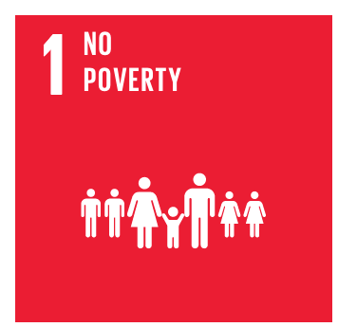 | End poverty in all its forms everywhere
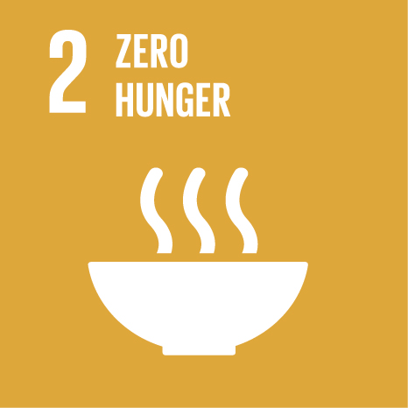 | End hunger, achieve food security and improved nutrition, and promote sustainable agriculture
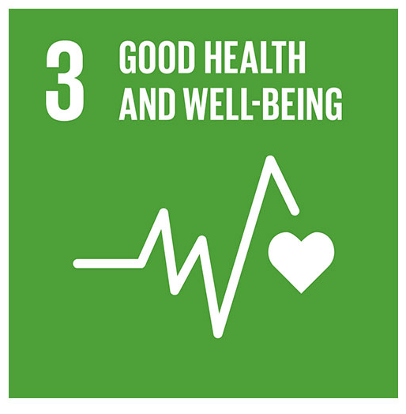 | Ensure healthy lives and promote wellbeing for all at all ages
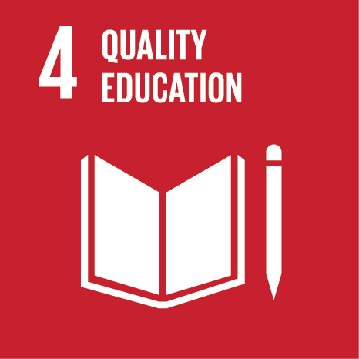 | Ensure inclusive and equitable quality education and promote lifelong learning opportunities for all
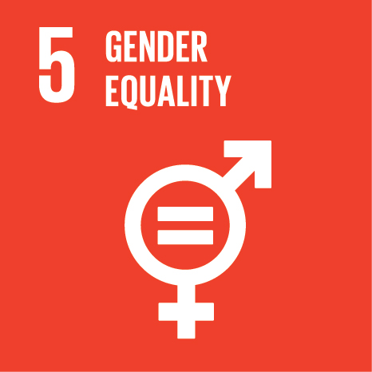 | Achieve gender equality and empower all women and girls
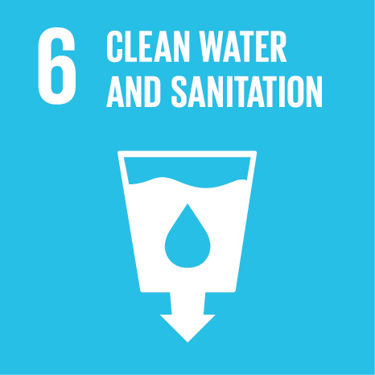 | Ensure availability and sustainable management of water and sanitation for all
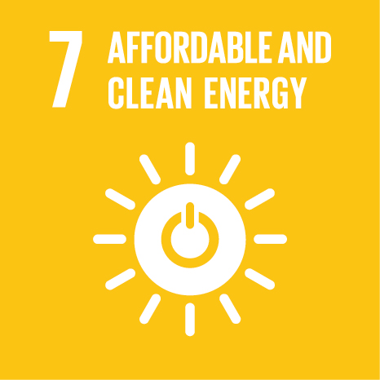 | Ensure access to affordable, reliable, sustainable and modern energy for all
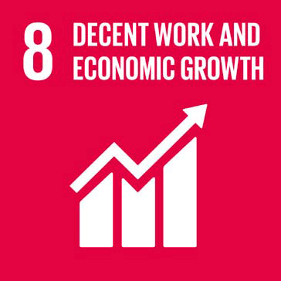 | Promote sustained, inclusive and sustainable economic growth, full and productive employment, and decent work for all
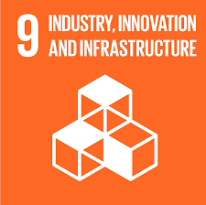 | Build resilient infrastructure, promote inclusive and sustainable industrialisation, and foster innovation
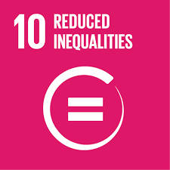 | Reduce inequality within and among countries
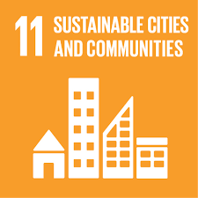 | Make cities and human settlements inclusive, safe, resilient and sustainable
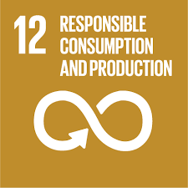 | Ensure sustainable consumption and production patterns
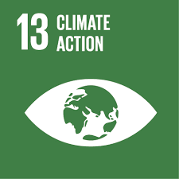 | Take urgent action to combat climate change and its impacts
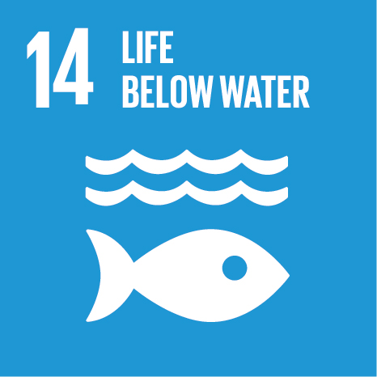 | Conserve and sustainably use the oceans, seas and marine resources for sustainable development
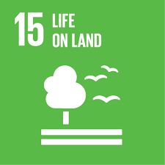 | Protect, restore and promote sustainable use of terrestrial ecosystems, sustainably manage forests, combat desertification and halt and reverse land degradation, and halt biodiversity loss
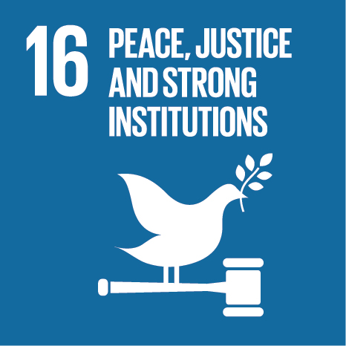 | Promote peaceful and inclusive societies for sustainable development, provide access to justice for all and build effective, accountable and inclusive institutions at all levels
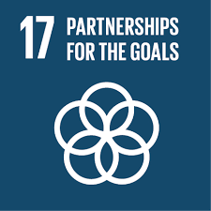 | Strengthen the means of implementation and revitalise the global partnership for sustainable development

