Equity Stories Project

Opening Reception

Thursday, January 30, 2014
3:00 pm – 4:30 pm
Portland Community College Sylvania
Performing Arts Center Lobby
12000 SW 49th Ave
Portland, OR 97219

Stories are powerful. They connect us to other people and help us understand their experiences.
That’s why the Coalition for a Livable Future (CLF) launched the Equity Stories Project. People from a dozen diverse community organizations throughout the region participated in the project. The stories are powerful reminders of the disparities people experience every day. But they also remind us of the richness, diversity, and resilience of the communities across our region.

PCC Sylvania’s Multicultural Center, Library, and Social Science Division are proud to host this powerful photo exhibit. We invite you to join us for the opening reception, to enjoy speakers, a short film, refreshments, and a tour of the exhibit.
The Equity Stories Project photo exhibit will be on display at the PCC Sylvania Library from January 30 to February 28.

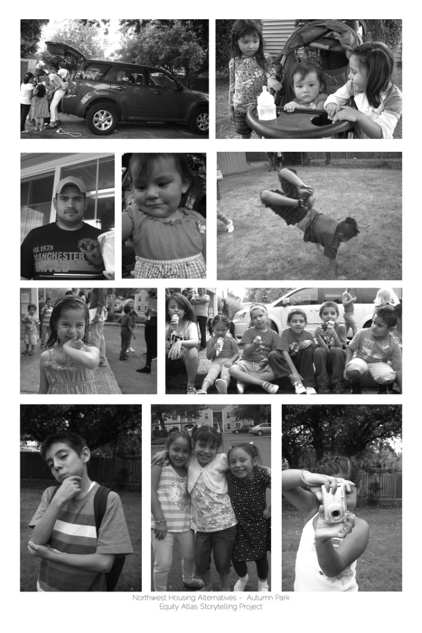

For more storytelling photos, videos, interviews, and personal narratives, go to https://clfequitystories.squarespace.com/

