COMMUNITY EDUCATION PROGRAMME IMPLEMENTATION IN GBARAIN/EKPETIAMA GMOU CLUSTER DEVELOPMENT COMMUNITIES
1.0 BACKGROUND
Regional Centres of Expertise on Education for Sustainable Development (RCE) are local networks affiliated to the Global RCE Service Centre situated in the United Nations University’s Institute for the Advanced Study of Sustainability which is located in Japan. RCE Greater Yenagoa is one of such networks having about 12 affiliate organizations within the Yenagoa and neighbouring local government areas of Bayelsa state. The affiliates include University, College of Education, Non-Governmental Organizations (NGOs), Private Companies and Community based organizations (CBOs). All the community based organizations for now are organizations formed by the Shell Petroleum Development Company of Nigeria Limited (SPDC) and the Bayelsa State Government as vehicles for sustainable community development of the host and impacted communities and for effective peaceful coexistence of all stakeholders in the area through the instrument of the Global Memorandum of Understanding (GMoU) model. Currently, the 4 such CBOs which are GMoU Cluster Development Boards (CDB) that are affiliated to the RCE Greater Yenagoa are Gbarain/Ekpetiama Cluster Development Board (CDB), Kolo Creek CDB, Okordia/Zarama CDB and Kolokuma/Opokuma CDB.
SPDC engaged the Community Inter-Relations and Conciliation Initiative (CIRCI) to facilitate the GMoU activities in the Gbarain/Ekpetiama, Kolo Creek and Okordia/Zarama Cluster Development Boards as the mentoring Non-Governmental Organization (NGO).
This presentation is on the community education/sensitization programme developed and carried out by the Gbarain/Ekpetiama CDB in 2020.
The cluster is made up of 12 communities; Agbia, Ayama, Koroama, Nedugo, Obunagha, Tunuama, Ogboloma, Okotiama, Okolobiri, Kumbuama and Polaku of Gbarain clan and Gbarantoru of Ekpetiama clan, all of which are in the Yenagoa Local Government Area of Bayelsa State. Each community has its ten-man Community Trust (CT) and it is the three selected representatives of every CT that form the CDB.
Yenagoa Local Government Area and its headquarters (Yenagoa) is also the State capital at 4°55′29″N 6°15′51″E.
2.0 NATURE AND RATIONAL FOR EDUCATION PROGRAMME
A team put in place by CIRCI (the mentoring NGO) jointly facilitated with the relevant Community Trust and representatives of the CDB, an assessment (by the communities for themselves) to understand their critical development problems and to brainstorm on possible choices of interventions to address these challenges, bearing in mind the funds available to the CDB/CTs from the GMoU they have with SPDC and others. At the end of the annual revalidation exercise for 2019/2020 session, a number of interventions were identified and some of which were infrastructural while others were human capital development in nature.
Apart from these identified development needs, we also observed a number of relational flash points that if not well managed, can grow into major issues. It was clear to the team the need to advocate for community education/sensitization as one of the interventions to be handled. CIRCI discussed this with the Cluster Development Board which eventually approved a programme of community education/sensitization for 2020.
The CDB identified the following communication packages or community education/sensitization items:
  - COMMUNICATION PACKAGES
There was a major need by the youths to be engaged actively including sport development and skill acquisition training. The Cluster Development Board decided to take on these two interventions and before the commencement of each intervention to make further stakeholders engagements with the view of getting beneficiary inputs on the operational modalities of the interventions. The Cluster Development Board also agreed to sensitize their communities on soft citizen improvement issues like managing conflicts, preventing diseases and drug addiction among others during such important community engagements as community education/sensitization activities. It was for that reason the following modules were presented in the cluster stakeholders’ engagements on the 21st of March and 4th of September 2020:
- HSE Talks
- Motivational talks
- The importance of peaceful coexistence
- Modalities for the Cluster-wide sports competitions (Football and Traditional wrestling)
- Presentation of the GMoU fund sharing formula among the communities and the annual project implementation performance report to the community stakeholders.
The objectives to be achieved for carrying out this programme are as follows:
- Opportunity for CDB to interact with the community stakeholders
- Open up a communication channels between CDB and their communities
- Build the capacities of the communities (especially youths) to understand how to reduce violent conflicts, social vices and drug addiction
- Motivate the youths to develop towards becoming outstanding adults that are good citizens
- Sensitise the community stakeholders on preventing the spread of COVID-19 through the NCDC protocols
- Involve the community stakeholders in project planning and buy-in
- Give a transparent programme implementation status report to the community stakeholders
3.0 PROGRAMME OF ACTIVITIES
3.1 DAY 1 (21ST OF MARCH 2020)
3.1.1 HSE BRIEFING WITH SHORT TALK ON COVID19 PANDEMIC
This was handled by CIRCI and it included a brief sensitization on COVID-19 pandemic. Though at that time, COVID19 Pandemic has not become rampant in the Niger Delta region and none existent in Bayelsa state, it was mention and Nigeria Centre for Disease Control (NCDC) protocol to prevent the spread of the pandemic was discussed as part of the Health Safety and Environment tips.
3.1.2 MOTIVATIONAL TALKS
Two RCE affiliates also motivated the participants with issues on how they can make their lives count, importance of effective leadership, why they must avoid any illegal and counterproductive vices including cultism, drug addiction etc.
3.1.2.1 PRESENTATION ON “YES I CAN” BY BRIGHT IGBURUBIA
This talk was made by Bright Igbubia of the Foundation for Entrepreneurial and Development (FEEDA), he said that he was asked by the cluster chairman and the NGO to advise the youth to desist from cultism and drug abuse. He also informed the house that there are lots of opportunities available in their immediate environment and that they can make their lives meaningful. He mentioned that the environment had predisposed young girls to getting pregnant resulting in poor school enrolment for female youths.
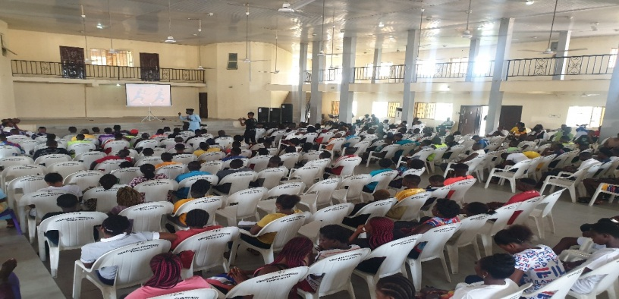
A cross section of participants in the event and Mr. Bright Igbubia
3.1.2.2 PRESENTATION ON “I CAN ACHIEVE GREATNESS’’ BY EARNEST SORGWE
He informed the youths in the Gbarain Ekpetiama cluster that they can still make it. He told the house his story, that he was no body before, following his educational background and accident, but right now everyone one reckons with him because he did not allow his physical condition to kill his ambitions/dreams. He went on the explain how good leadership has improved nations like Israel and Saudi Arabia and that our youths can resolve to make Nigeria great when they take up leadership.

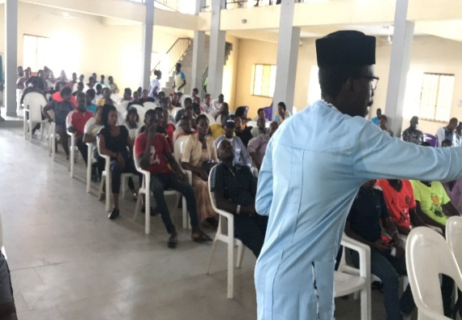
Mr. Earnest Sogwe making his presentation
3.1.3 PRESENTATION ON THE IMPROVEMENT OF PEACEFUL CO-EXISTENCE BY PAUL JOHN AGHARA
This was to make them appreciate the consequences of violent conflicts, promote peace, peaceful coexistence, security and how to empower the participants capacity-wise with some introductory skills to manage conflicts, be they among individuals, intra/inter communal disputes and community with other organizations.
Paul Aghara of SprintLife (RCE Greater Yenagoa affiliate) told the communities the dangers of violence, which he said is caused most times by greed and corruption, lack of accountability and bad governance. He noted that when there is violent conflicts and insecurity, government use the funds available to them to manage the insecurity than use the funds to implement developmental projects for the people. He concluded by saying peace is a necessary condition for development and wars/violent conflicts destroy and impede developmental advancements.

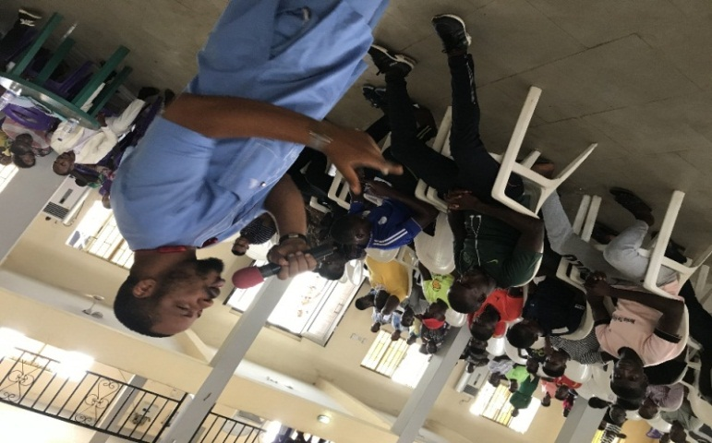
Mr. Paul Aghara making his presentation
3.1.4 PRESETATION ON HOW THE FOOTBALL AND WRESTLING COMPETITION WILL TAKE PLACE BY PROFIT BIBOBRA
The Chairman of the organizing community/PRO of the Gbarain Ekpetiama cluster development board, Mr. Izonbodei Sukuruowei gave an official time table of the events which he said has been arranged in categories. The Chairman with the Secretary of the CDB also discussed further the modalities for the Cluster-wide sports competitions using football game and Traditional wrestling competitions among the 12 communities and officially commissioned the jerseys and other football kits that will be used by the 12 communities of Gbarain Ekpetiama cluster for the sports competition,
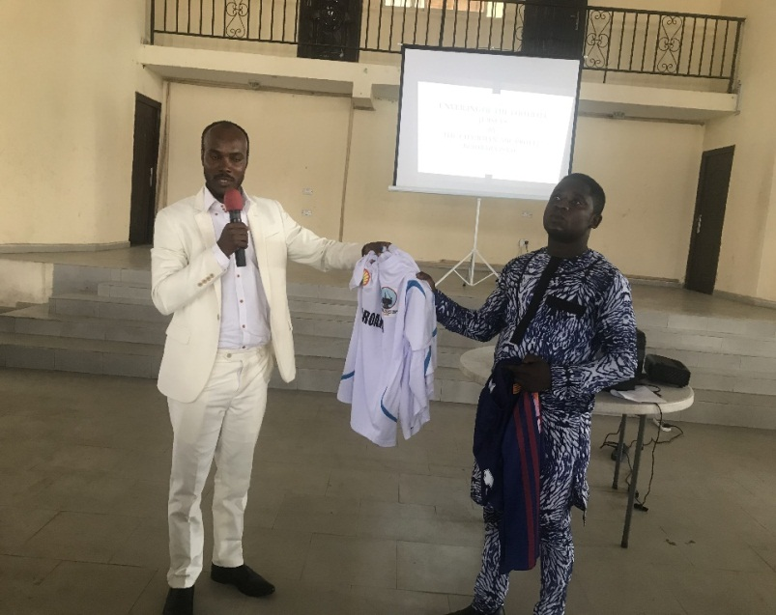
The Chairman and the Secretary (Mr. Bright Ogou) of GE/CDB unveiling some of the jerseys and the other football kits
3.1.5 QUESTION/ANSWER SESSION
Question: A lady asked why only men were considered in the football and wrestling competition?
Answer; the Ngo representative informed the house that this is the first phase of the sports competition, that subsequently women will be considered by the CDB for possible inclusion.
Question: Is the CDB planning more programmes for the youth?
Answers: the mentoring NGO informed the house that CDB is working on commencing a skills acquisition and training programme for the community youths as a cluster wide project.
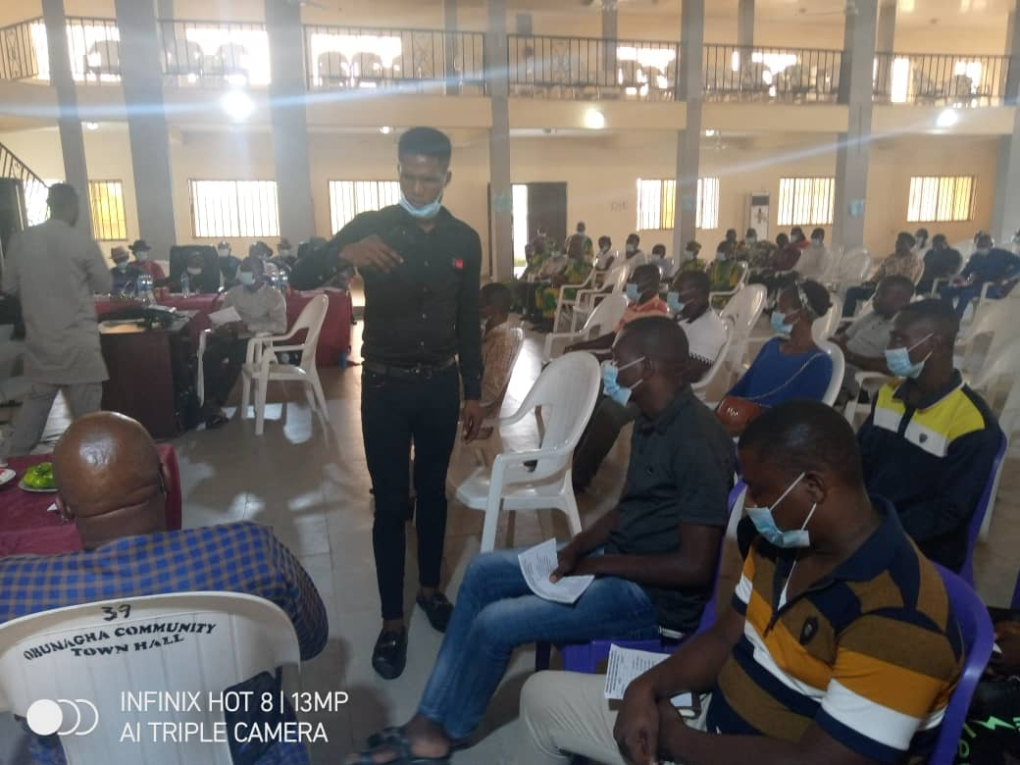

3.2 DAY 2: 4th OF SEPTEMBER 2020
COVID19 PREVENTION TALK AND GMOU IMPLEMTATION STATUS REPORT TO COMMUNITIES
3.2.1 Talk on COVID19 Prevention
With the onset of COVID19 Pandemic in the Niger Delta, the Cluster Development Board agreed to introduce a short talk on preventive measures to reduce or eliminate the spread of the virus among the communities. This was done on the 4th of September 2020 during the CDB project implementation performance reporting of how funds have been used by the CDB to implement projects.
It was pleasantly observed that this new community education exercise actively adhered to all NCDC protocols including safe distancing, use of sanitizers and use of face masks which were supplied by the organizers (CDB) to all participants.

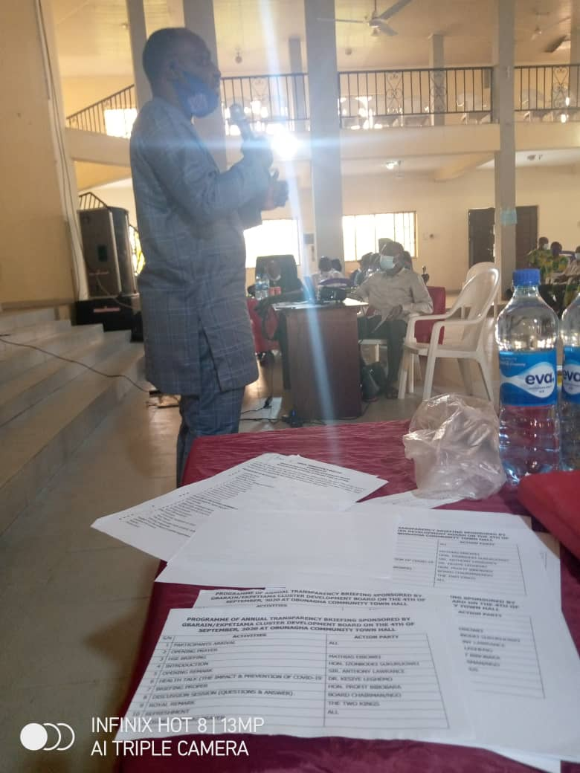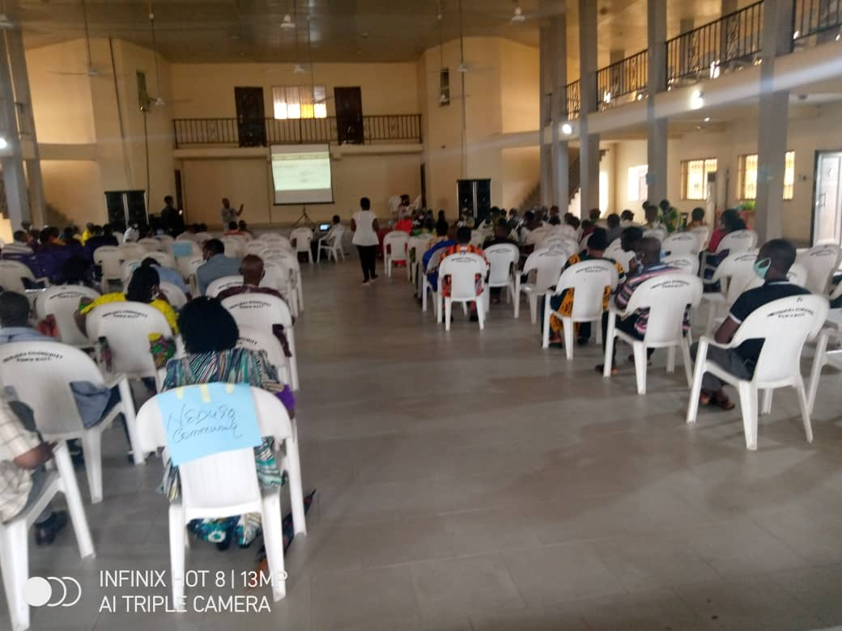
Dr. Kesiye Leghemo of the Bayesa State Government’s Ministry of Health making his presentation
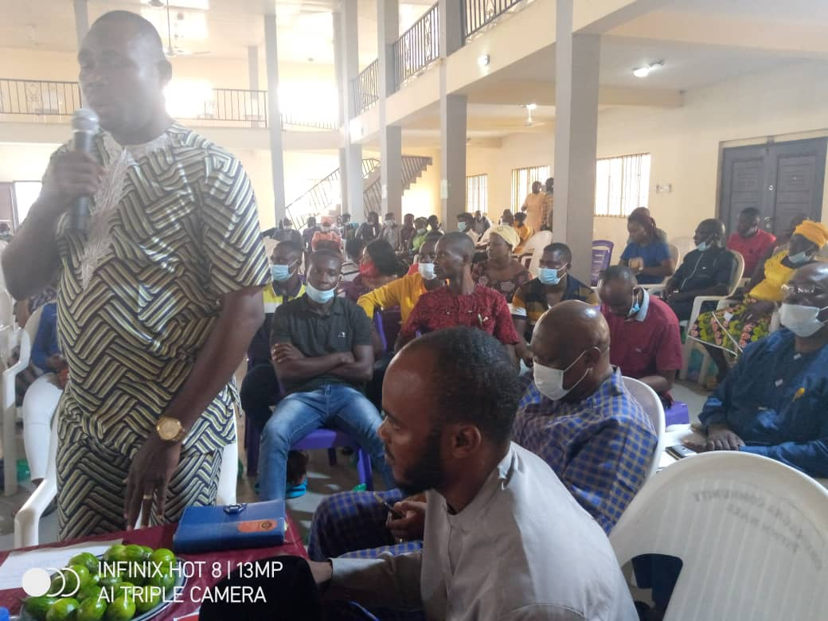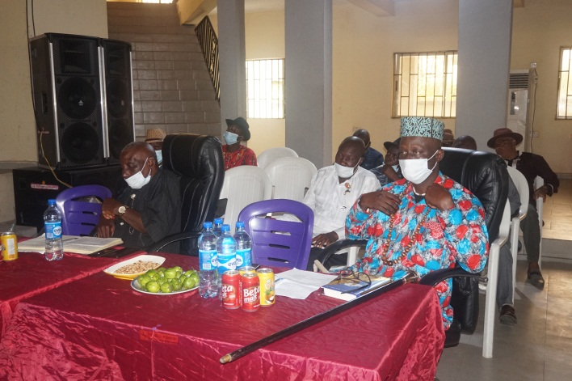
Address by the Government HRM King Bubaraye Dakolo of representative (Eng. Fambie Yakia) Ekpetiama clan with some
Paramount Chiefs of both clans.

3.2.2 Cluster Development Board’s Performance review presentation to the community stakeholders
The Chairman of the cluster gave a detailed implementation performance review of how funds collected from SPDC had been shared, disbursed and utilized to implement projects in the various communities.
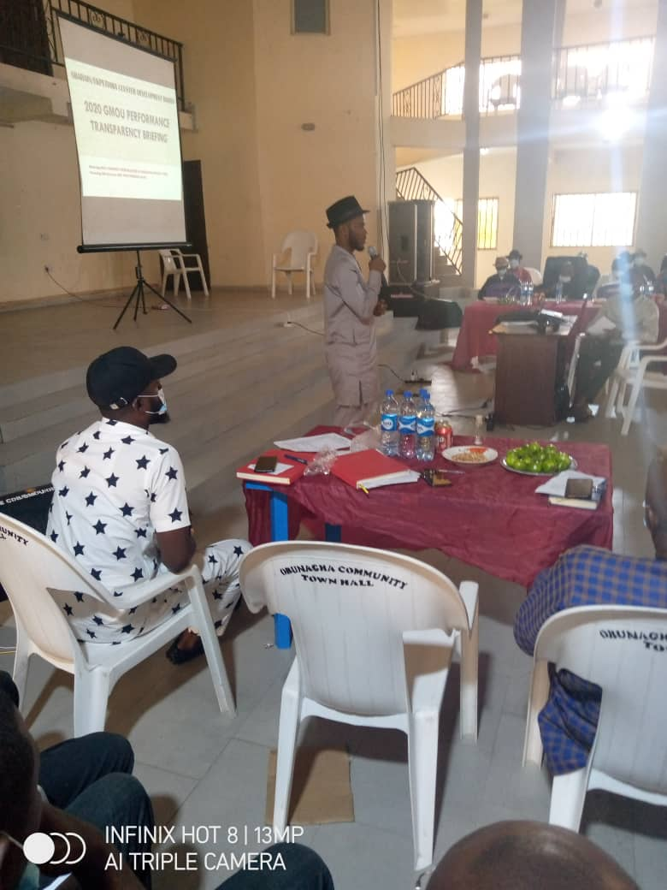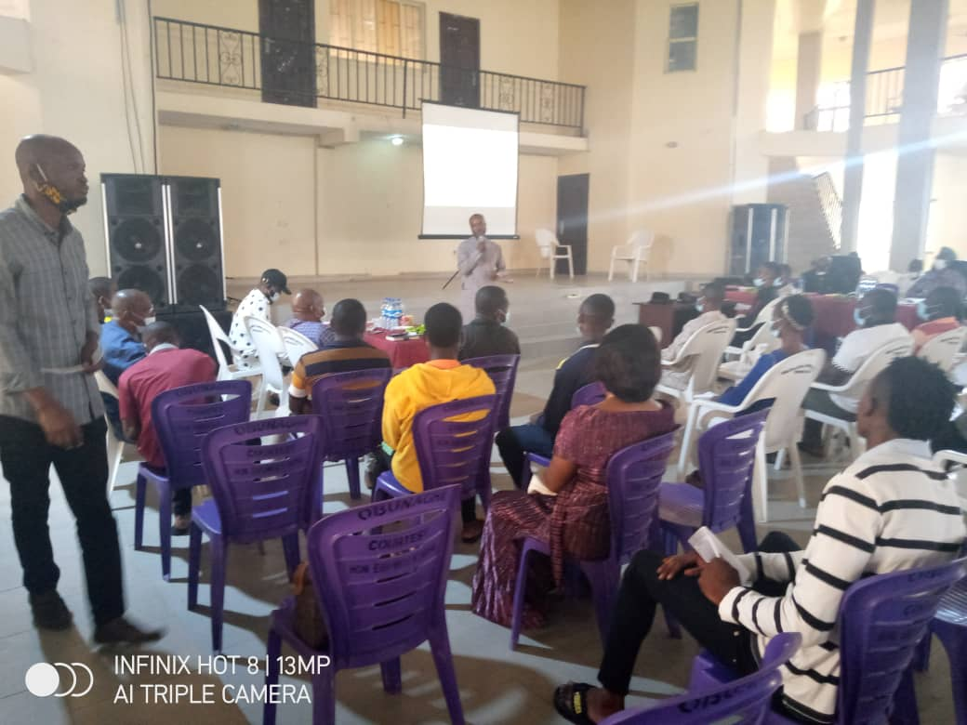

4.0 COMMUNITY FEEDBACK
The communities were elated on these interventions both the sports and the skill acquisition projects on one hand and the community sensitization talks on peaceful coexistence, motivational talks, COVID19 prevention talks and the project implementation status reporting to the community stakeholders.
The Paramount Ruler of Ekpetiama clan, His Royal Majesty King Bubaraye Dakolo who participated in the event from the beginning to the end described the report out of CDB implementation performance as very good strategy and should be continued so as to reduce miscommunication and dispel rumours.
It should be noted that a participant asked Dr. Kesiye Leghemo who made the presentation on reducing the spread of COVID-19 if the common use of the microphone by all may not be a source of spread of the virus. To this he answered that there are no full protection and it is for that reason, people are expected to combine the preventive measures. It is therefore advised that people should regularly wash the hands or use sanitizers to prevent infection from surfaces of materials in every environment.
The participants urged the organizers to continue with the events so that the people’s capacities will be built and the people will be aware of how their funds are being utilized.
5.0 CONCLUSION
The community education/sensitization programme achieved all the objectives set.
It is hoped that next year and with favourable security conditions, CDB will be able to carry out this programme not only in a centrally located place but equally in every community. Additional donor support from within Nigeria and beyond will enhance the quantity and quality of these events.
Four affiliates of RCE Greater Yenagoa participated in this programme. Apart from Gbarain/Ephetiama CDB and CIRCI which are affiliates of RCE Greater Yenagoa, the others were SprintLife and Foundation for Entrepreneurship Education and Development (FEEDA).
We thank SPDC and its Joint Venture partners who through the GMoU model provided all the funds for the projects being implemented, management of the GMoU and even for these events being reported here.

