COMPETITIVE EDUCATIONAL SUPPORT (BURSARY) SCHEME FOR SECONDARY AND UNIVERSITY STUDENTS IN TWO KOLO CREEK CLUSTER COMMUNITIES

A PRESENTATION BY

BARR. EBELEMA DANADANA
CHAIRMAN, KOLO CREEK CLUSTER DEVELOPMENT BOARD AND CHAIRMAN, ELEBELE COMMUNITY TRUST
The Cluster (CDB) and the Elebele Community Trust are affiliate Community-Based Organizations of RCE Greater Yenagoa

AND
BENSON OGBARA
CHAIRMAN, IMIRINGI COMMUNITY TRUST,
The Imiringi Community Trust is an affiliate Community-Based Organization of RCE Greater Yenagoa

AND

SIR ANTHONY WAKWE LAWRENCE
CHAIRMAN, COMMUNITY INTER-RELATIONS AND CONCILIATION INITIATIVE – CIRCI MENTORING NGO
Main Contact of RCE Greater Yenagoa and NGO is an affiliate of RCE Greater Yenagoa

AND

DANGO LAWRENCE
OPERATIONS COORDINATOR, COMMUNITY INTER-RELATIONS AND CONCILIATION INITIATIVE – CIRCI, MENTORING NGO

1.0 INTRODUCTION:
Educational development at any level is imperative for the development of youths in Society. Generally, the people of Imiringi and Elebele communities are aware of the importance of education in their developmental aspirations. The cost of education, the poor background of many families in the communities for some indigent fellows, the cost of paying the fees for the West African School Certificate Examinations (WASCE), the purchase of school uniforms, and the cost of university education stand as major problems due to endemic poverty of the community members. These factors including others seem to have combined to cause a setback in terms of the high occurrence of the number of out-of-school children in these communities. Aware that development in education determines the well-being and sustained overall socio-economic development of people, the communities decided to spend an amount of money from their development fund for projects to implement this scheme. Imiringi community had been spending for the last three years Twelve Million naira (N12,000,0000 – 30,000 US Dollars) from the One Hundred Million, One Hundred and Ninety-Two Thousand, Five Hundred naira (N100,192,500) annually: which is 12% of the mandate it gets from the Global Memorandum of Understanding (GMoU) the community entered with Shell Petroleum Development Company Nigeria Limited (SPDC) and her joint venture partners, who are operating within their community’s environment. Equally, Elebele spent Seven Million naira (N7,000,000 – 17,500 US Dollars) from its mandate from the same SPDC from its mandate of Sixty Eight Million Six Hundred Twenty-Five Thousand naira (N68.625,000) funding support. This amounts to about 10% of its mandated annual subvention from SPDC. While Imiringi had been implementing this project for several years at a lower scope, for the last three years the new members of the Kolo Creek Cluster Development Board and the Imringi Community Trust approved the new rate of N12,000,000 (30,000 US Dollars) for the project annually benefiting 100 secondary students and 100 university students as beneficiaries annually for the three years. Elebele on the other hand just started this scheme this year to benefit 80 secondary students and 84 university students as beneficiaries at a total cost of N68,625,500 as earlier stated.
Kolo Creek Cluster Development Board – KC-CDB is one of the Cluster Development Boards as a result of the Global Memorandum of Understanding (GMoU) between the Shell Petroleum Development Company of Nigeria Limited (SPDC) with her Joint Venture partners on one hand and their host communities, mediated in this case by the Bayelsa State government and facilitated by a Non-Governmental Organization (NGO). The purpose of the GMoU is to manage the relationships effectively to benefit all the parties including furthering the corporate social responsibility of the sponsors towards sustainable development of the host communities and at the same time the company to enjoy a peaceful and enabling operational environment. SPDC and her partners, therefore, fund the development interventions of the communities through the agreed annual funding support to the communities. The KC/CDB is made up of Four (4) communities from the Kolo Creek Kingdom of Ogbia ascent, representatives of SPDC and the Bayelsa State Government. The Board is empowered to facilitate the implementation of community-driven development projects across the 4 communities that make up the Cluster. The communities are Elebele, Imiringi, Otuasega and Yiba-Ama.
The educational support scheme is to support the education of intending and deserving indigenes of the community at secondary and tertiary educational institutions within Nigeria.
In line with the stipulated processes of implementing sustainable and participatory community development interventions, these projects started in both communities only after the sustainable livelihood and need assessment exercises were carried out where these interventions were identified and given a good ranking in their prioritized intervention lists.
Table 1: Below is a recent Needs Assessment ranking made by the Imiringi community stakeholders and facilitated by Community Inter-Relations and Conciliation Initiative (CIRCI):
SN | PROBLEM | PROJECT INTERVENTION | PROPOSED SPONSOR/ INTERVENER | RANKING
1 | Flooding / water logging in the community and accessibility to homes | - Construction of concrete roads within the community  - Reconstruction of the collapsed bridge  - Recanalization of Imiringi creek | - SPDC/CDB/CT  - Govt./Service providers  - Service providers | 1st
2 | Lack of social amenities | - Construction of Town hall with projected pavilion  - Construction of market  - Rehabilitate Imiringi football pitch | - SPDC/CDB/CT  - SPDC/CDB/CT  - SPDC/CDB/CT | 2nd
3 | Lack of employment | - Provision of micro-finance to traders, farmers etc.  - Provision of skill acquisition scheme  - Provision of improved farm inputs | - SPDC/CDB/CT  - SPDC/CDB/CT  - Govt. | 3rd
4 | Lack of adequate education support | - Provision of scholarship/bursary to both secondary and tertiary students  - Construction of Corpers’ lodge to attract NYSC Teachers  - Provision of school desks to the primary school  - Provision of ICT facilities at the Secondary schools  - Provision of Teachers’ quarters at the primary school | - SPDC/CDB/CT  - SPDC/CDB/CT  - SPDC/CT/CT  - Govt.  - Govt. | 4th
5 | Inadequate electricity coverage and supply | - Electricity extension in the community  - Improve electricity supply  - Repair broken down gas turbine | - Govt.  - DISCO  - Govt. | 5th
6 | Inadequate water supply | Water upgrade and extension | Govt. | 6th
7 | Poor health and sanitation conditions | Provide 5 number modern toilet facilities | CDB/Govt. | 7th

Table 2: Below is a recent Needs Assessment ranking made by the Elebele community stakeholders and facilitated by CIRCI:
SN | PROBLEM | PROJECT INTERVENTION | PROPOSED SPONSOR/ INTERVENER | RANKING
1 | Flooding / water logging in community and accessibility to homes | Provision of concrete road networks (5Nos)  - School Road (600m)  - Ogirinya Estate (500m)  - Betterland Road (300m)  - Redeemed Church Road (400m)  - Catholic Cathedral Road (400m) | SPDC/CDB/CT | 1st
2 | Educational challenges | - Provision of scholarship awards to secondary school and tertiary institution students  - Provision of’ lodge (women) | SPDC/CDB/CT | 2nd
3 | Inadequate water supply | - Extension of the existing reticulated water to Ebeimo Compound (1.5km)  - Provision of 5Nos solar-powered neighbourhood water | SPDC/CDB/CT | ^{3rd}
4 | Inadequate electricity coverage and supply | Extension of electricity to the newly developing areas Imonoti compound (2km) | SPDC/CDB/CT | 4th
5 | Poor health and sanitation conditions | - Provision of water borehole in the Health Centre  - Renovation of health Centre | SPDC/CDB/CT | ^{6th}
6 | Lack of employment | - Provision of micro-finance to traders, farmers etc.  - Provision of improved farm inputs | SPDC/CDB/CT/Govt.  . | 5th

Projects to be implemented by communities are those that are of the highest priorities but within the funds available to the communities. While Imirnigi community ranked educational challenges as the 4th out of 7 pressing challenges, Elebele community ranked it as the 2nd most pressing need out of 6 identified challenges and both communities identified competitive educational support (bursary) scheme as an intervention to ameliorate the situation they have identified. Both communities, therefore, spent between 12% (Imiringi) and 10% (Elebele) of the funding obtained from SPDC for this scheme.
Poverty or lack of finance by many individuals in Nigeria means that they cannot fund developmental activities including paying for their wards’ schooling needs. The third and fourth problems stem from this situation. This can be corroborated by the latest assessment that 33% of Nigerians (70 million out of about 200 million people) are living in extreme poverty (World Population Review 2022 - https://worldpopulationreview.com/country-rankings/poverty-rate-by-country).
The lack of adequate educational support for community members has always been considered one of the priorities by community stakeholders. Funding students’ education in terms of paying school fees and generally, financial needs of students are a major challenge for people that are not financially comfortable. As a result of this problem, many children in Nigeria are out of school. The World Bank has said that Nigeria has the highest number of out-of-school children in the world with 11 million pupils recorded in 2020. https://www.vanguardngr.com/2022/06/nigeria-has-11-million-of-out-of-school-children-highest-in-world-world-bank/
The United Nations International Children’s Emergency Fund (UNICEF) in collaboration with the Bayelsa State government (Imirnigi and Elebele are communities in this state) commenced a school enrolment campaign in Yenagoa aimed at reducing the increasing rate of out-of-school children in the state, which is put at 265,000 as at January 2019 https://independent.ng/unicef-bayelsa-move-to-reduce-rate-of-out-of-school-children/
While these communities cannot fund the schooling of every child in their communities on their own, they can contribute their quota to reducing the effects of the problem. They, therefore, chose to develop this competitive selection by merit intervention to ensure that every intelligent child in these communities, who if educated will mostly use the capacity building to better him or herself and in the long run these bright individuals are not denied education.
The scheme ensures the achievement of the following objectives:
- Provide funding as an incentive to motivate all bright and intelligent children to attend secondary school and also get a university education
- Provide motivation for all children to work hard, read effectively and compete to qualify for the awards
- Improve the general standard of education in the communities since every student will work hard to be selected
- Improve the availability of highly qualified professionals in every field, over the years through this intervention. That is, it will produce high-level manpower in different fields at the first degree level for employment in every sector of the economy and admission into postgraduate programmes.
- It will assist and reduce the financial burden experienced by poor students/parents.
2.0 IMPLEMENTATION:
2.1 AWARD AMOUNT/BENEFICIARIES:
Each student was given the following amounts annually:
Imiringi community
- Secondary school level N30,000.00 (75 US Dollars) per student
- Tertiary Institution N80,000.00 (200 US Dollars) per student
Elebele community
- Secondary school level N20,000.00 (50 US Dollars) per student
- Tertiary Institution N50,000.00 ( (125 US Dollars) per student

2.2 QUALIFICATION.

- Students of J.S.1 to S.S.2 FROM RECOGNISED Secondary Schools
- Candidates that have been offered verified admission to higher institutions from recognized Nigerian Universities, Polytechnics and colleges of Education.
- Candidates who are indigenes of Imiringi or Elebele Communities respectively.
2.3 PROJECT IMPLEMENTATION PROCESS:
Figure 1 shows the project implementation process. Community using participatory rural appraisal tools facilitated by a development agency prioritized their development areas requiring urgent interventions and then the communities also identified the suitable interventions that can be implemented within the budgetary constraints they have. After that, each community plans the implementation of the project and sets up a committee to execute the project. Following the steps, as shown in the figure below, the community implements the projects and carries out annual reviews/monitoring and project evaluations after every three years of implementation. Another approval is sought after such evaluation to commence a new round of the project.

Pre-project implementation participatory planning
Formation of Project Implementation Committee
Close-out project and seek approval for the next phase after evaluation
Conduct tests to select prospective beneficiaries
Selection of beneficiaries
Payment of bursary to the beneficiaries annually for 3 years
Evaluation of project to identify and improve weak aspects every 3 years

Figure 1: Project Implementation Process
2.4 PARTICIPATORY PLANNING
Pictures of recently conducted Needs Assessment Revalidation Exercises for Imirnigi and Elebele communities
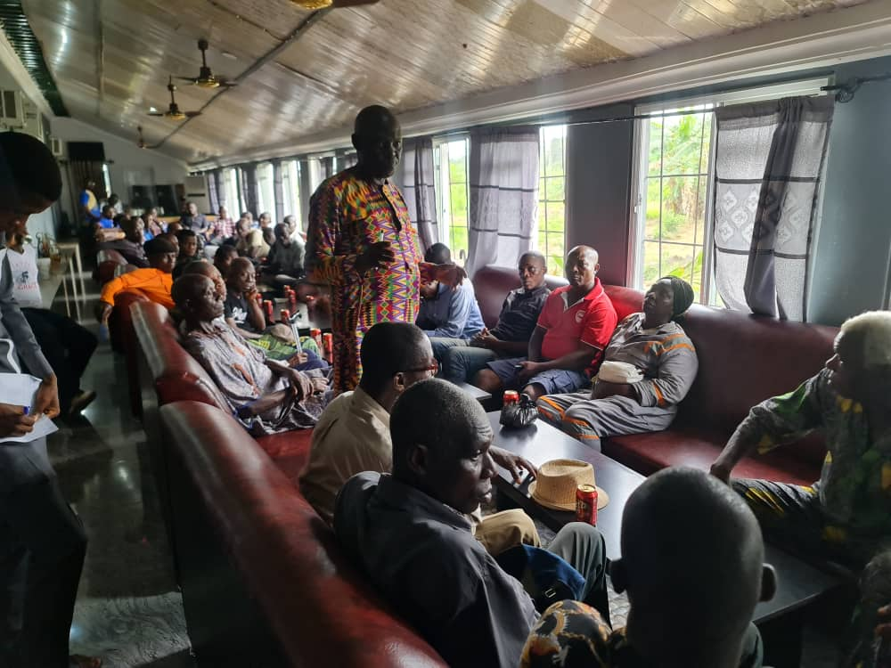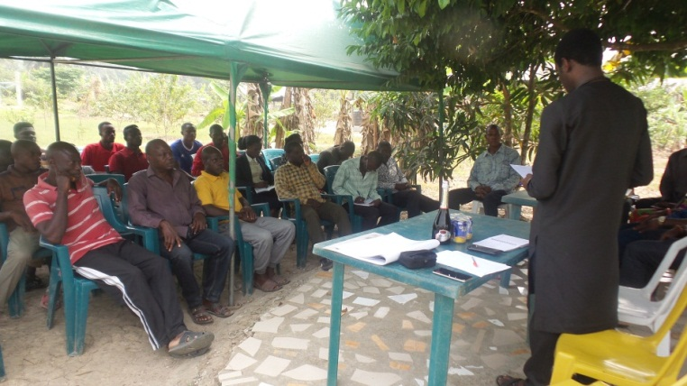
Fig. 2: Cross section of the Needs Assessment Fig 3: Cross section of the Needs Assessment Revalidation
Revalidation Exercise for Imiringi community Exercise for Elebele community

2.5 NUMBER OF BENEFICIARIES PER COMMUNITY PER YEAR
The Tables below show the number of students that have benefitted in Imiringi for the last 3 years. The same beneficiaries are paid annually for the 3 years.
Table 3: Imiringi Community Competitive Bursary Award Scheme
ITEM | CATEGORY | YEAR 2019/2020 | YEAR 2020/2021 |  |  | YEAR 2021/2022 |  | TOTAL
Secondary School Awards | Males | 51 | 51 |  |  | 51 |  | 153
 | Females | 49 | 49 |  |  | 49 |  | 147
 | Total | 100 | 100 |  |  | 100 |  | 300
University Awards | Males | 40 | 40 |  |  | 40 |  | 120
 | Females | 60 | 60 |  |  | 60 |  | 180
 | Total | 100 | 100 |  |  | 100 |  | 300
Table 4 shows the number that benefited from the scheme in 2022 from Elebele community.
Their scheme only started in 2022.
ITEM | CATEGORY | YEAR 2022/2023
Secondary School Awards | Males | 40
 | Females | 40
 | Total | 80
University Awards | Males | 46
 | Females | 38
 | Total | 84

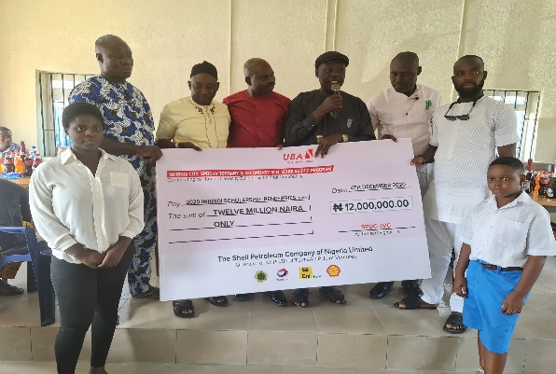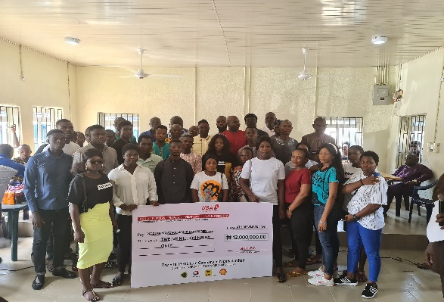
Some beneficiaries from Imiringi communities

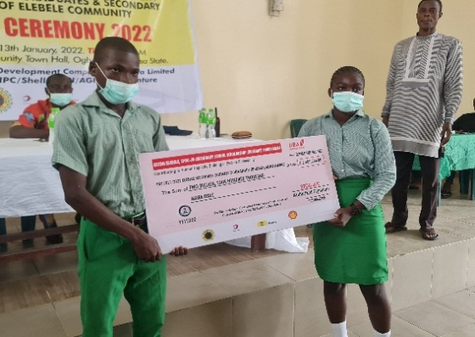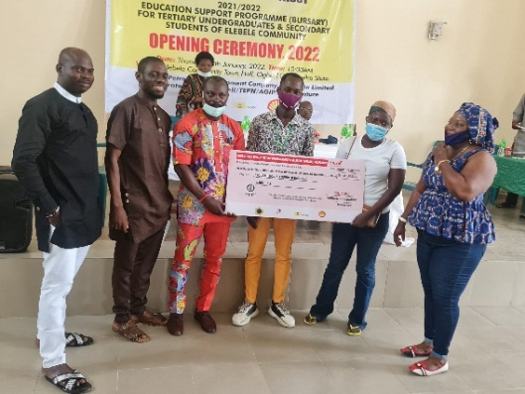
Some beneficiaries from Elebele communities

3.0 FEEDBACK/COMMENTS FROM KEY STAKEHOLDERS/BENEFICIARIES
Some key stakeholders were interviewed to get their feedback on the scheme. Below are the comments from some of them:
      - DAWARI OKPU-SOLOMON – CDC CHAIRMAN OF IMIRINGI COMMUNITY
The scheme is of immense benefit because many parents have no money; however, because of this project, we now have many graduates in our community. The amount given per person is small because of the money available to the community. If more money is given then more people will benefit and more graduates and postgraduate candidates can be included in the scheme.

      - AFEKAFE OYINIMIDO – JS3 STUDENT OF ARCHDEACON BROWN EDUCATIONAL CENTRE
The scheme has helped me in paying my school fees and paying for other school needs like textbooks. I wish that the amount given can be increased so that our parents will have less stress providing for us.

      - EBELEMA DANADANA ESQ. CT CHAIRMAN, KOLO CREEK CDB CHAIRMAN AND LEGAL ADVISER TO THE ELEBELE COMMUNITY
We thank SPDC for the GMoU they had put in place that has also enabled the communities to select projects to implement on their own. It is the communities that decided to use part of their money to implement this scheme. The community is benefiting from the scheme. Students who are in the final year of secondary education had paid for their West African School Certificate examinations (WASCE) and National Examination Council (NECO) from this support. We are hoping that funds for the communities can be increased so that we can also increase what we give out to the students.

      - HIS ROYAL HIGHNESS DAVID OSENE OSENE – PARAMOUNT CHIEF OF ELEBELE COMMUNITY
The scheme has been helpful in general and despite the quantum of money given being small, any support for a very poor person is appreciated and it goes a long way in making a difference. We hope to consolidate this scheme in subsequent years and also increase the amount given to each beneficiary. I am fully in support of this scheme and for me, it is a priority intervention.

      - JOSEPF JAMES ADUMEIN – PETROLEUM ENGINEERING UNDERGRADUATE STUDENT OF NIGER DELTA UNVERSITY AND PRESIDENT OF THE STUDENTS
This project has reduced my expenses. I am a self-sponsoring student. Nobody is helping me and it will help if the amount is increased and the benefit is extended to postgraduate students.

      - COMRADE OGBARA OBI NELSON – VICE PRESIDENT OF THE STUDENTS
The money given to me from the scheme is used to buy reading materials, pay house rents and also make part payment of my school fees. I hope that the programme will be expanded to postgraduate students too.

4.0 RELEVANCE TO THE SUSTAINABLE DEVELOPMENT GOALS:
This project is in support of several Sustainable Development Goals (SDGs), especially SDG 4 (Ensure inclusive and equitable quality education and promote lifelong learning opportunities for all). More specifically the following targets:
- It is boosting SDG4 Target 1: “By 2030, ensure that all girls and boys complete free, equitable and quality primary and secondary education leading to relevant and effective learning outcomes”. While education is not completely free at the secondary level in this community, the effort is to reduce the financial burden on the beneficiaries to enable them to attend school.
- SDG4 Target 3 states thus “By 2030, ensure equal access for all women and men to affordable and quality technical, vocational and tertiary education, including university”. The university’s competitive bursary scheme that benefits both males and females is aimed to contribute in this regard. The girl-child was not disadvantaged by the scheme. Instead, 60% of the beneficiaries of the university scheme for Imiringi were females.

- SDG4 Target 5 “By 2030, eliminate gender disparities in education and ensure equal access to all levels of education and vocational training for the vulnerable, including persons with disabilities, indigenous peoples and children in vulnerable situations”. The scheme addressed this SDG target in that female beneficiaries were given equal consideration. Same as Target 3.
- Target 4.b “By 2020, substantially expand globally the number of scholarships available to developing countries, in particular, least developed countries, small-island developing States and African countries, for enrolment in higher education, including vocational training and information and communications technology, technical, engineering and scientific programmes, in developed countries and other developing countries”. While this is a local effort, it is geared towards contributing to this target.
This project will in the long run equally contribute toward reducing poverty (SDG1) and hunger (SDG2), improving health conditions (SDG3) and gender equality (SDG5), reducing inequality (SDG10), etc.
5.0 CONCLUSION
The Imiringi community had been implementing this project for about 5 years; however, the current round of implementation started about three years ago. The amount paid to each beneficiary also increased from N20,000 naira for secondary school and N50,000 naira for university students to N30,000 and N80,000 respectively for secondary and university beneficiaries. This reduced the negative impacts of inflationary increases suffered by all. However, all the beneficiaries interviewed indicated that (if possible) they would prefer an increase in the amount per beneficiary because of the continuously increasing cost of things. That notwithstanding, the goals set and the derived objectives are met by the scheme in its present form while efforts will continuously be made towards improving the scheme.
The scheme has improved school attendance by beneficiaries since such beneficiaries will be removed from the scheme if they stopped going to school. The competitive selection process has also ensured general improvement in the standard of education as every student is serious about his/her academic work to enable them to qualify to benefit from the scheme at the secondary or university levels. The comments by the community leaders and the beneficiaries have corroborated this assertion.
We thank Shell Petroleum Development Company of Nigeria Limited (SPDC) and her joint venture partners for sponsoring both the projects of the GMoU and contracting the mentoring NGO (Development partner) to execute this scheme and all the other interventions implemented by the GMoU Cluster Development Board.
6.0 REFERENCE
Busari, B., 2022. Nigeria has 11 million of out-of-school children, highest in world – World Bank. [online] Vanguard. Available at: <https://www.vanguardngr.com/2022/06/nigeria-has-11-million-of-out-of-school-children-highest-in-world-world-bank/> [Accessed 28 August 2022].
Oduma, I., 2022. UNICEF, Bayelsa Move To Reduce Rate Of Out-Of-School Children. [online] Independent Newspaper Nigeria. Available at: <https://independent.ng/unicef-bayelsa-move-to-reduce-rate-of-out-of-school-children/> [Accessed 28 August 2022].
World Population Review, 2022. Worldpopulationreview.com. 2022. Poverty Rate by Country 2022. [online] Available at: <https://worldpopulationreview.com/country-rankings/poverty-rate-by-country> [Accessed 28 August 2022].

