KENYATTA UNIVERSITY ENVIRONMENTAL CLUB (KUNEC) REPORT 2014
KENYATTA UNIVERSITY ENVIRONMENTAL CLUB (KUNEC):
K
enyatta university environmental club is a club registered within Kenyatta University with the dean of students affairs. The club is among the oldest clubs within the university, formed in 1992 by environmental science students and has been operational since then with the main objective of nurturing environmentally sensitive issues, educate, manage, conserve, protect and sustain the entire environment within and outside the university; individuals and the entire community at large. The club registers members every semester and subscription for membership renewal involves students from different departments who become the members.
Since May 2014.when the semester began, the CLUB is involved in a series of activities in order to ensure that the club’s aim and objective is achieved.
Some of the activities are as follows:
- Tree Planting at The Ngong forest on World Environmental Day)
- Conducted lecture talk on Climate Change with MULTILINK COMPANY.
- Planted two hundred tree seedlings within Kenyatta University, through the partnership of Kenya International Conference Center (KICC) AND GREEN AFRICA FOUNDATION. (Marking Environmental day).
- Kenyatta University Community clean - up at Githurai Kimbo area.
- Training on Farming input in Africa.
- Leadership training on animal welfare workshops.
- On 14TH June 2014 held King and Queen Environment at Nairobi National Museum through the partnership of Zetech, Nairobi, Kenyatta universities and sponsored by National Museum, Trust for Indigenous Culture and Health (TCAH) and African Biodiversity Conservation and Innovation Center (AIBC). The event was captured in Standard newspaper on 20th June 2014 shown in the picture.

King and Queen Environment competition at Nairobi National Museum: June 2014
The Farm input program in Africa at KU has enabled one of the club members to get employment after his 4th year exams. The club has continued to achieve different categories of awards like Satima award, Kenyatta University Student Award (KUSA) and Mazingira (Enironment) Quiz Award in Kenya. Furthermore, the Club organizes a green weekday every month of April each year.
The club has come up with strategic plan on how to achieve its vision and the objective on the environmental issues for the September semester and also on how to involve the other stakeholders and organizations that are willing to partner with us thus attaining the vision 2030 on the environmental sustainability.
T
- (ii) (iii)
he club usually holds its weekly meetings every Tuesday from 7.00p.m to discuss emerging progress of its activities, emerging environmental issues, possible actions and partnership/collaboration.

CONCLUSION.
The Club is very proactive and already to work with stakeholders who are willing to enable the club to achieve its mandate without political and/or ethnic bias to enable it advance the goals of university education and contribute positively to ESD in higher levels..
KUNEC CURRENT ACTIVITIES
Educational Officer (center), KUNEC vice chair Lawrence KUNEC members during Clean-up Day

Launch of Green Eco schools in Mukuru Kwa Njenga in Nairobi County 2014

Environmental club members with the Patron Prof Kungu’ and the club members receiving the Mazingira cup award
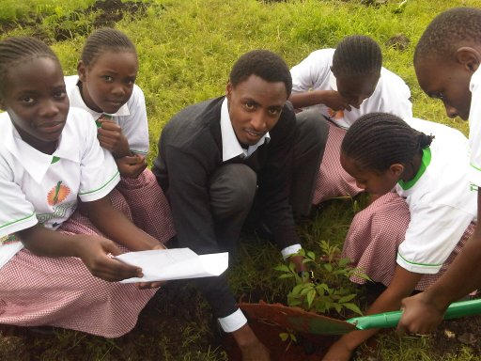
World Environmental Day at Ngong Forest by Primary school pupil and Tree planting Day, by KUNEC members, 2014

