GBARAIN/EKPETIAMA DEVELOPMENT CLUSTER-WIDE YOUTH DEVELOPMENT PROGRAMME

A PRESENTATION BY

MR. PROFIT BIBOBARA
(CHAIRMAN, GBARAIN/EKPETIAMA CLUSTER DEVELOPMENT BOARD)
The Cluster (CDB) is an affiliate CBO of RCE Greater Yenagoa

AND

SIR ANTHONY WAKWE LAWRENCE
(CHAIRMAN, COMMUNITY INTER-RELATIONS AND CONCILIATION INITIATIVE – CIRCI) MENTORING NGO
Main Contact of RCE Greater Yenagoa and NGO is an affiliate of RCE Greater Yenagoa

AND
PROF. TUEMI TUDOU ASUKA
(CHAIRMAN, GBARAIN/EKPETIAMA SCHOLARSHIP/SKILL ACQUISITION COMMITTEE)
Alternate Contact of RCE Greater Yenagoa / Professor of Education in the Niger Delta University –an affiliate of RCE Greater Yenagoa/Chairman Gbarain/Ekpetiama Scholarship and Skill Acquisition Committee

1.0 INTRODUCTION:
Gbarain/Ekpetiama Cluster Development Board – G/E-CDB is one of the Cluster Development Boards as a result of the Global Memorandum of Understanding (GMoU) between the Shell Petroleum Development Company of Nigeria Limited (SPDC) with her Joint Venture partners on one hand and their host communities, mediated in this case by the Bayelsa State government and facilitated by a Non-Governmental Organization (NGO). The purpose of the GMoU is to manage the relationships effectively to benefit all the parties including furthering the corporate social responsibility of the sponsors towards sustainable development of the people. Each development cluster comprises of community based organizations called Community Trusts (CTs), the Chairmen, Secretaries and Treasurers of these CTs form the Development Cluster. This Gbarain/Ekpetiama Cluster Development Board is made up of 12 communities namely: Agbia, Ayama, Koroama, Nedugo, Obunagha, Tunuama, Ogboloma, Okotiama, Okolobiri, Kumbuama and Polaku of Gbarain clan/kingdom and Gbarantoru of Ekpetiama clan/kingdom, all of which are in the Yenagoa Local Government Area of Bayelsa State in Nigeria.
During the Sustainable Livelihood Assessment conducted in 2019/2020 in the twelve communities, it was observed that the priority problems requiring urgent interventions in most of the communities were massive poverty, general youth unemployment and lack of adequate educational interventions.
It was also observed that the two segments of the community stakeholders that are most affected by these problems stated above are the youths and the women. To contribute towards alleviating the impacts of these problems on the women folk, the development cluster earlier had agreed that 15% of every income or revenue obtained for their development will specifically be used to implement projects that are aimed at addressing the problems of the women by the women themselves.
These stated problems of pervasive poverty, unemployment, inadequate educational support have far reaching impacts on the youths than the other segments of the community stakeholders. The idleness, increasing hunger in the land and the hopelessness being suffered by these youths are driving a number of them into taking hard drugs, joining cult groups, resorting to confrontational violence as means of resolving conflicts and committing crimes. The Gbarain/Ekpetiama Cluster Development Board (G/E-CDB) therefore chose to invest 22% of the funds obtained from the sponsors in 2021 in addressing these youth related problems.
After the sustainable livelihood assessment which was facilitated by the consulting organization - Community Inter-Relations and Conciliation Initiative –CIRCI (a non-governmental organization - NGO) in partnership with the cluster development board, CIRCI facilitated intervention planning in all the affected 12 communities.
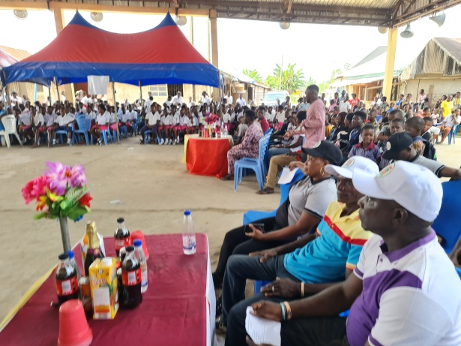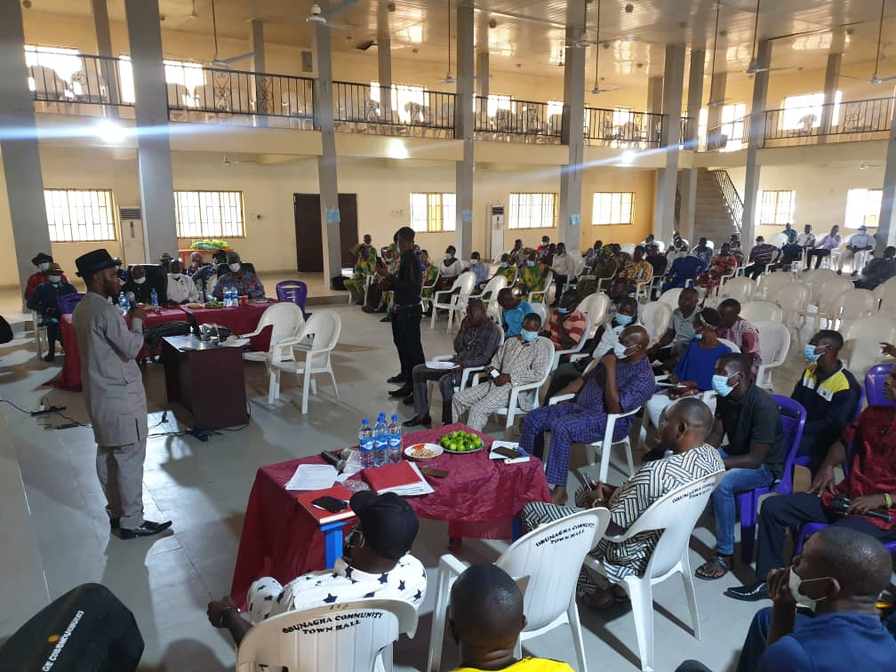
Community engagement exercises as part of community sensitization
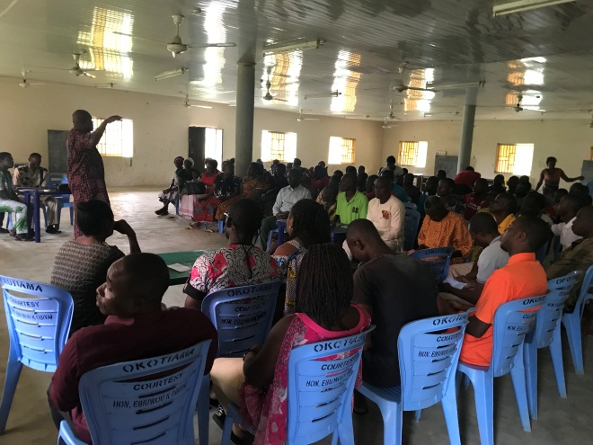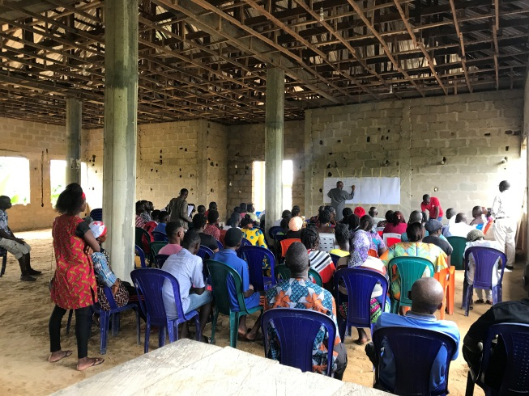
Sustainable development planning engagements in Obunagha and Tunuama communities
Two sets of interventions emerged from those engagement exercises: those to be implemented in all the 12 cluster communities as cluster-wide interventions and those to be implemented separately, as required by the individual communities as interventions that are peculiar to them. Based on the need to urgently address the threats particularly posed by the youth poverty and unemployment conditions, a decision was taken by the development cluster G/E-CDB to initiate a strategic interventional approach involving formulating the goals, agreeing the objectives and developing the interventions to address the issues holistically and in an integrated manner.
This approach was adopted to ensure the following:
- All the segments of the youths (unskilled, semi-skilled and skilled) are carried on board. The targets were to further build the capacities of each segment to make them more effective, productive and employable.
- Adopt an integrated approach and implement a programme that will synergistically and holistically better achieve the set goals and objectives.

Figures 1 and 2: Diagrams below give more elucidation to the concept:

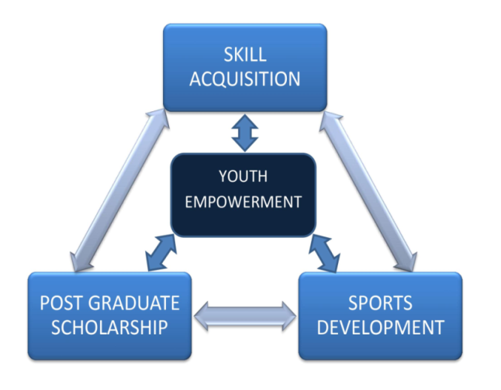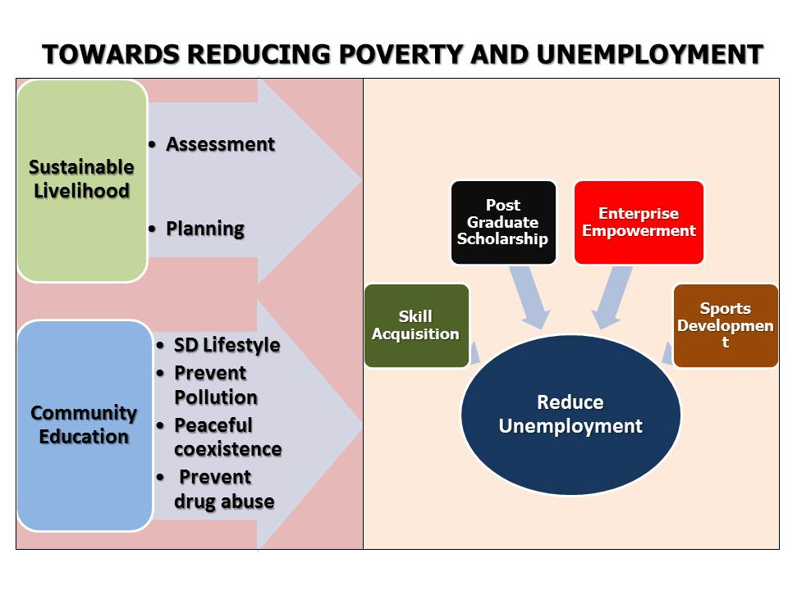
Figure 1 Figure 2
Figure 1: Integrated/holistic approach to addressing the youth poverty/unemployment problems using 4 inter-related interventions.
Figure 2: Integrated/holistic approach to address poverty/unemployment problems using 4 interventions in addition to three sustainable development enablers (sustainable livelihood assessment, participatory intervention planning and community education)
Figure 1 outlines the broad strategic concept of the youth development programme showing specific projects/schemes for skill development and skill improvement towards empowering the youths to be more effective, productive and employable.
The figure also explains that the four broad categories of interventions are directed at resolving the same problems of pervasive poverty, incompetence and massive unemployment. Since the approach is essentially empowerment of beneficiaries in nature, the interventions that are interrelated were considered.
In addition to the Figure 1 above, Figure 2 further elucidated the need to do sustainable livelihood assessments prior to participatory planning and subsequently after that programme implementation. The need to equally carry out community education whenever appropriate was highlighted.
2.0 COMPONENTS OF THIS YOUTH DEVELOPMENT PROGRAMME
This programme in 2021 had 4 major categories of interventions:
  - Skill acquisition:
Due to the increasing rate of unemployment and the attendant negative effects, it became necessary to engage the youth in vocational skill training programmes aimed at equipping them with appropriate skills and abilities to enable them become self-employed and/or seek employment to provide for themselves the basic necessities of life. 22 skill areas/vacations including the following: Ankara making, Computer Engineering, Hairdressing, Crane Operation, Rigging and Sling, Safety, Computer Training, Video Editing, Poultry and Fish Farming, Catering, Welding, Electrical Installation, Facial Make-up/Head-tie application (Gele), Driving, as well as Fashion and Design were selected as options for the beneficiaries to choose from.
80 youths were selected and trained by an affiliated organization to the RCE Greater Yenagoa (Niger Delta University - NDU). The NDU was engaged as the consultant to carry out the skill acquisition scheme with their partners. Two other aspects of the scheme were: giving stipends/allowances to the benefiting participants during the 4 months of the exercise and at the end of the training each graduant would be given One Hundred Thousand Naira (243 USD) as start-up grant. Total cost of the scheme is forty five million seven hundred and twenty thousand naira (N45,720,000) or about 111,133 USD.

The objectives of the schemes are as listed below:
- Enable youths to acquire skills/vocations for self-employment and/or job creation.
- Reduce poverty among the unemployed and idle youths in the development cluster area.
- Reduce the level of idleness among youths.
- Provide the hope for a better life among youths which could also discourage them from drug abuse.
- Engage youth in a manner that would enable them to have a better purpose and meaning of living, which could hinder them from violent acts that threatens the peace, orderliness and wellbeing of the Communities.
- It may on the long run, also reduce the levels of different crimes in the clan.

The Skill acquisition scheme was aimed at addressing the following Sustainable Development Goals (SDGs): 1 (No Poverty), 2 (No hunger), 3 (Good health and wellbeing), 4 (Quality education), 8 (Good jobs and economic growth) and 11 (Sustainable cities and communities)

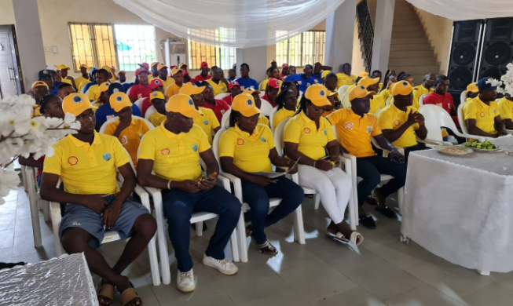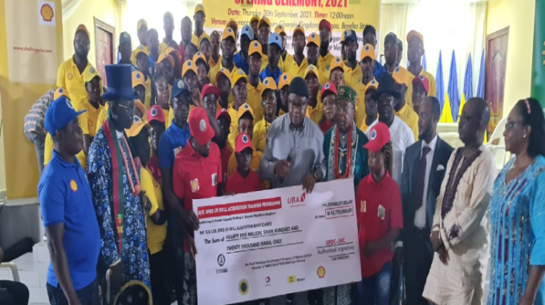
Cross section showing some beneficiries of the Skill Acquisition scheme

  - Post Graduate Scholarship:
While some of the 12 communities are individually providing some level of bursary support to their secondary school students, however, at the cluster level, it was agreed that the aimed would be to motivate intelligent members of the communities that can benefit from higher education to avail themselves and achieve their potentials for the good of their individual selves and the clans at large. This scheme selected 2 Master’s degree and 1 PhD degree candidates from each of the 11 participating communities totalling 22 Master’s and 11 PhD candidates in the first instance to benefit in the first batch and 24 Master’s degree and 12 PhD candidates in the second batch when all the 12 communities participated.
The second batch of this scheme which is part of this report is costing the G/E-CDB a total of fifty six million and six hundred thousand naira (N56,600,000) which is about 137,579 USD.
This scheme is expected amongst others to be very significant in the following ways:
- Produce high level manpower in different fields at the masters and Doctorate degree levels for employment and growth in different sectors of work organizations.
- Increase the employment opportunities of beneficiaries in different work organizations: locally, nationally and internationally.
- Graduates of the scheme to constitute the future knowledge elites, improving the knowledge economy of the clans and the state at large.
- The overall effect of this is an enlightened and highly critical human group that would positively contribute to the sustainable development of their clans and communities.

The project is consistent with some key Sustainable Development Goals (SDGs): 1 (No Poverty), 2 (No Hunger), 3 (Good health and well being), 4 (Quality Education), 8 (Good jobs and Economic Growth), 10 (Reduced inequality) and 16 (Peace and Justice)
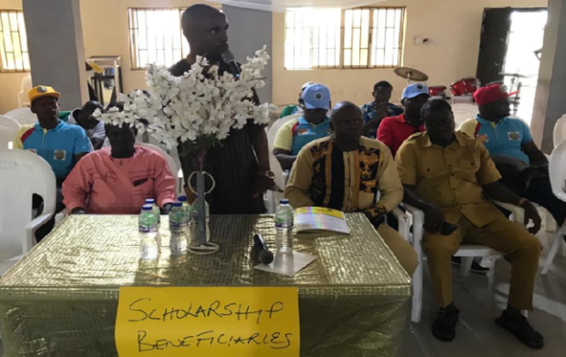 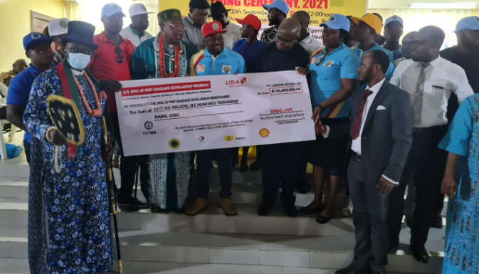Cross section showing some beneficiries of the Post Graduate Scholarship scheme (Batch 2)
  - Sports Development interventions:
Participating in sporting activities is one of the best ways to stay healthy and those who are very good at it equally get wealthy. Unhealthy people cannot be very productive in any endeavor which includes acquiring skills or undergoing other educational self-improving ventures. Since resources are limiting, the stakeholders of the development cluster G/E-CDB choose two sporting events namely inter-community football championship competitions and inter-community traditional wrestling championship competitions as pilots towards achieving the following objectives:

- Provide a platform for youths of the various communities in the cluster to interact together, know each other better and develop friendly relationships.
- Motivate the youths and point them towards the direction of self-worth, self-reliance, and working harmoniously in teams.
- Draw the minds of the youths away from possible criminality and youth restiveness.
- Give the youths the opportunity to prove their hidden talents including and specifically taking football and other sports as professions/careers.
- Create better foundation for peace, love and friendliness in the cluster.
- Use the competitions and the accompanied engagement processes as tools to instil the culture of discipline and discourage any youth from involving in antisocial activities.
- Create an opportunity to build positive relationships between SPDC, the community based Development Cluster G/E-CDB members and the community youth stakeholders.
- Fulfil a passionate need of the youths of the cluster to organize and manage quality sports development competitions as part of management capacity building activity.
- Enhance the reputation of all the parties especially the sponsors of the event.

In order to ensure that these competitions motivate and achieve excellence, handsome prizes were awarded to the winners/champions in each of the respective categories in the keenly contested inter-community competitions. Total of nine million and ten thousand naira (N9, 010,000) or 21,901 USD was utilized for the project.

The project was aimed at addressing the following Sustainable development goals: 1 (No poverty), 2 (Zero hunger), 3 (Good health and well-being), 4 (Quality education), 8 (Decent Work and Economic growth), 11 (Sustainable cities, Human settlements inclusive, safe and resilient).

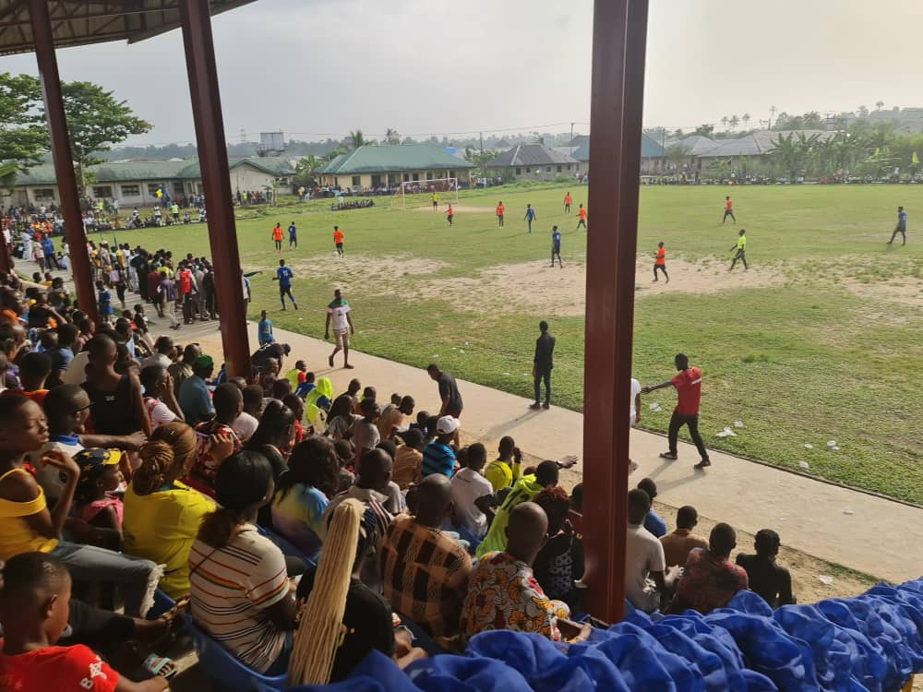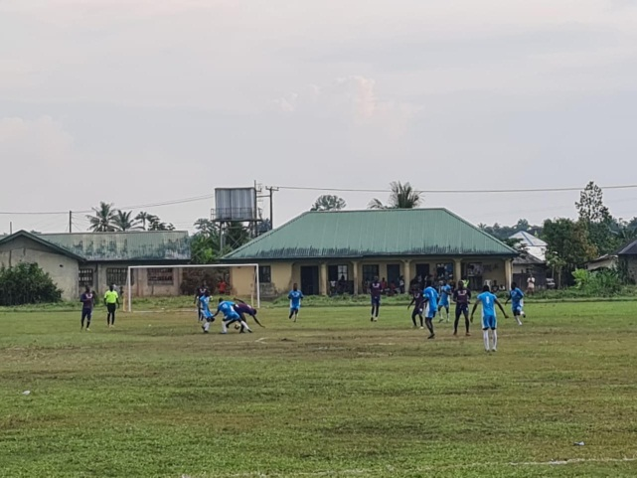
Cross-sections of two of the inter-community football competitions

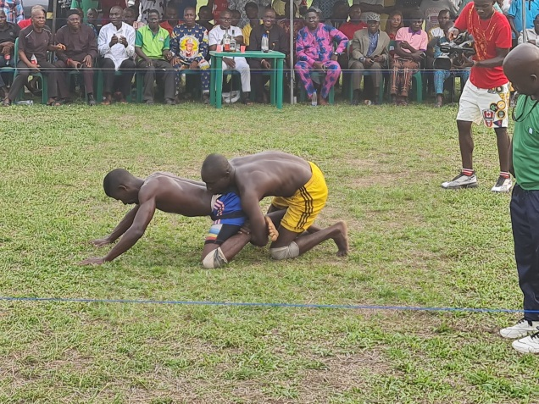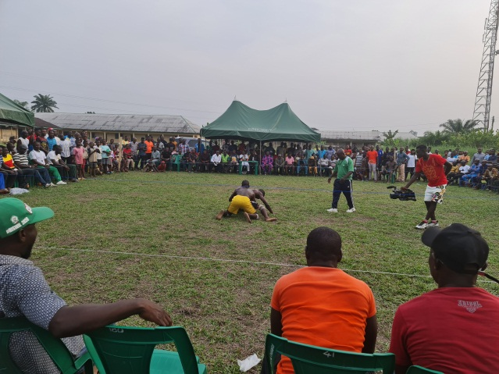
Cross-sections of two of the inter-community wrestling championship events

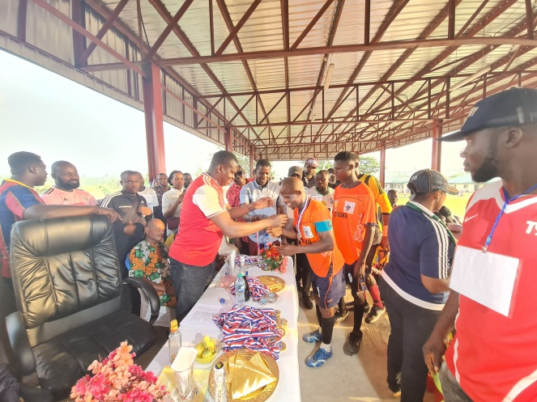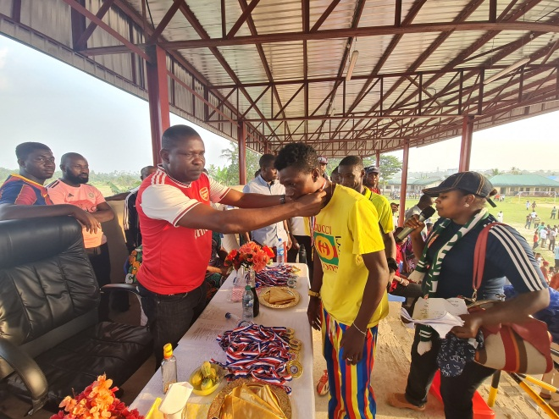
Cross-sections of two sets of prize awardees after the championship competitions

  - Enterprise Improvement Empowerment project:
While skill acquisition scheme as explained in 2.1 is aimed at building youths’ capacities, this intervention aims at supporting existing agricultural businesses to improve on their current levels. Inputs like fertilizers, pesticides, farming gadgets were given to 36 crop farmers (men and women) and dug-out canoes, fishing nets and other fishing gears were given to 24 fishing folks (men and women) to enable them become more productive and more effective in their chosen businesses as economic empowerment efforts. Total amount expended on this project was three million nine hundred and sixty thousand naira (N3, 960,000) or 9,626 USD.

The empowerment of the fishing and crop farming population will reduce poverty (SDG 1), reduce hunger (SDG 2), improve the health and well-being of the people (SDG 3), improve employment and economic activities (SDG 8), reduce inequality (SDG 10), improve sustainable cities and communities (SDG 11) etc.

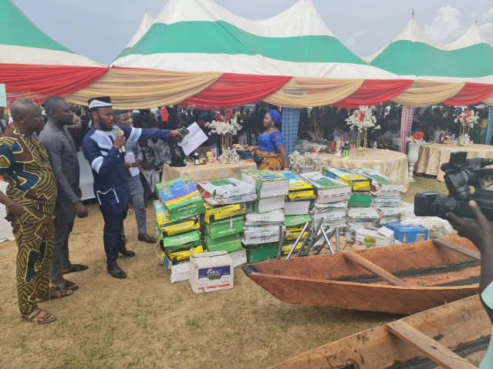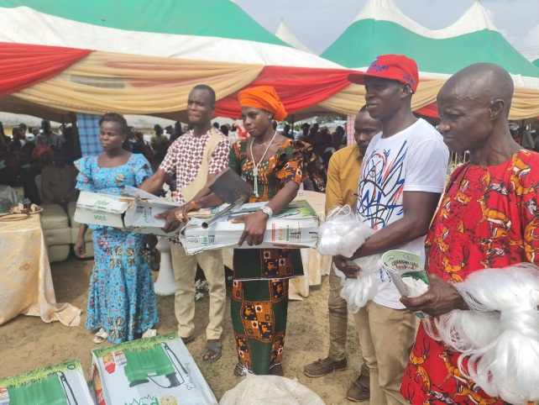
Cross-sections of beneficiaries of the Business Improvement Empowerment

3.0 WHAT ARE THE STRATEGIC RATIONAL FOR THIS APPROACH?
As earlier stated, the beneficiary communities made the choices of interventions after they had prioritized their most pressing developmental problems. CIRCI only facilitated the process which equally included sustainable development sensitizations on what are the basic sustainable development principles, how they can ensure project sustainability and the need to approach development problem solving from holistic and integrated way.
Figures 1 and 2 had shown that this programme with 4 component developmental interventions had met both the criteria of capturing as many segments of the target beneficiary stakeholders as possible and also addressed the problems identified in holistic and integrated manner.

  - SUSTAINABILITY PLAN IN PLACE
The programme will be evaluated at the end to see areas requiring improvement, areas to be strengthened and areas to discontinue if necessary. This evaluation will be beneficiary driven.
Sustainable development community education will continue in the communities when the sustainable livelihood assessments and community development plans will be revalidated.

- CONCLUSION
The Gbarain/Ekpetiama Cluster Development Board G/E-CDB has been very effective in the efforts towards imbibing best developmental practices. It has been very supportive to the efforts of RCE Greater Yenagoa network achieving its purposes. We will continue to encourage the other affiliates of the network to becoming more involved in the network operations.
The strengths of the programme approach included the following:
- It is beneficial driven and not a top down approach
- It is strategically developed where goals and objectives were agreed and the interventions were generated from the beneficiaries in line with budgetary constraints and bearing in mind the need to make the programme as holistic/integrated as possible.
- It is broad-based and aimed at addressing more of the stakeholders segments.
In summary we can say that in order to ensure more impactful synergistic outcomes, a multifaceted programmatic approach was adopted to implement this youth development programme.
The development cluster G/EC-DB looks forward to partnership with other local, national and international organizations to better achieve the set goals and objectives.
In this wise, we are ready to learn from all collaborators towards serving our people better.
- ACKNOWLEDGEMENTS
We thank Shell Petroleum Development Company of Nigeria Limited (SPDC) and her Joint Venture partners for all the funding support they have given to these communities and also for building the capacities of these communities to drive their own development, deciding their priorities, plan their projects and implementing them by themselves.
Funding of this programme was 100% by SPDC and her Joint Venture partners.

- REFERENCES
  - The SDG in action (UNDP) 2021
https://www.google.com/url?sa=t&rct=j&q=&esrc=s&source=web&cd=&cad=rja&uact=8&ved=2ahUKEwiPuIDUxfLyAhWwyoUKHXGSAfQQFnoECBQQAQ&url=https%3A%2F%2Fwww.undp.org%2Fsustainable-development-goals&usg=AOvVaw0Q6-i3ttVAVB0c0gBujdFM

  - Make the SDG a reality (United Nations) 2018
https://www.google.com/url?sa=t&rct=j&q=&esrc=s&source=web&cd=&cad=rja&uact=8&ved=2ahUKEwiAkr68xPLyAhVBhRoKHT2SBlwQtwJ6BAgaEAM&url=https%3A%2F%2Fsdgs.un.org%2Fgoals&usg=AOvVaw2OAoADkursLaeVqubOJGAq

7.3 Anthony Wakwe Lawrence, Noel Ihebuzor, & Damiete O. Lawrence (2020) “Some challenges militating against Nigeria achieving SDG4 on targets”. Modern Economy, 11, 1307-1328. doi: 10.4236/me.2020.117093. https://m.scirp.org/papers/abstract/101621

7.4 Anthony Wakwe Lawrence, & Damiete O. Lawrence (2019) -Level Considerations for Effective Implementation of Sustainable Development Interventions. International Journal of Development and Economic Sustainability, 7 (6) editor.ijdes@ea-journals.org

