THE 8TH TONGYEONG ESD INTERNATIONAL FORUM
Sejahtera Forest for All
21-22 October 2016
RCE Tongyeong Sejahtera Center, TONGYEONG, KOREA
Draft. Aug.20, 2016(Details To be confirmed)

DAY OF ARRIVAL 21 OCTOBER 2016

16:00-18:00 KOREAN RCE’s NETWORK MEETING
18:00-19:00 WELCOMING DINNER
At Sejahtera Center

DAY OF FORUM 22 OCTOBER 2016

09:30-10:00 REGISTRATION
10:00-10:30 OPENING CEREMONY
Opening performance, Welcoming remarks
10:30-11:30 PLENARY 1
Keynote Speech and panel discussion on the concept of Sejahtera Forest
11.30-13:00 WORKSHOP 1.
Designing the spaces
13:00-14:00 LUNCH BREAK
14:00-15:10 PLENARY 2
Good Case Presentations on Sejahtera Forest for All
15.10-15.30 TEA BREAK
15:30-16:30 WORKSHOP 2.
Sejahtera Forest for All
16:30-17:00 CLOSING

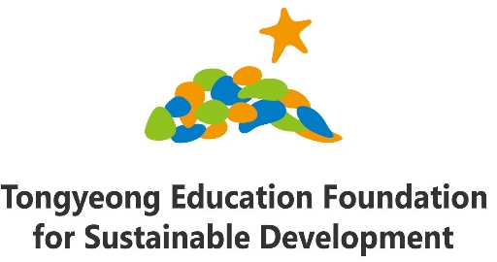
THE 8TH TONGYEONG ESD INTERNATIONAL FORUM
21-22 October 2016
Tongyeong, Republic of Korea

REGISTRATION FORM
Name (one written on your passport) | Fist Name Last Name Middle Name
Prefix | Ms. Mr. Dr. Prof.
Professional Title
Organization (RCE)
Mailing Address
Telephone No.
E-mail address
Attendance | Please put a check mark next to the events you will attend.  Welcoming Dinner 21 October, 18:00~19:30  8th ESD International Forum 22 October, 09:30~17:00
Need for personal invitation letter/ visa assistance? | - No - Yes
Food Restriction
Port of Departure  Date of Arrival  Date of Departure | City, Country:
Preferred  Accommodation | Sejahtera Centre Dormitory Sejahtera Centre Guesthouse  Geobukseon Hotel Anchovy Hotel  Napoli Motel Others _______________________________
Have you confirmed accommodation reservation? | - No - Yes
Need support for financial assistance for participation? | - No - Yes
If answered “Yes” on the question above, please fill folowing questions.  For what part of traveling do you seek for assistance? | Please put a check mark next to the events you will attend.  For traveling to Tongyeong,Korea (Air, Train, etc)  For local expenses including accomodation  For both traveling and local expenses
What contribution have you made or plan to make to the Asia Pacific RCEs Sejahtera Network?
Prefered traveling dates | Date of arrival  Date of departure
Other remarks, if any

We thank you in advance for having completed this registration form and ask you to send it back to us via email(rceorg@gmail.com) by 30 September 2016.

For further questions;

Ms SuYeon Park
Chief Programmer, Education Team.
Tongyeong Education Foundation for Sustainable Development
RCE Tongyeong Sejahtera Center, 116 Yongnam-Haean ro, Tongyeong, Gyeongnam, Republic of Korea(650-800)
Tel: +82-55-650-7400/ Fax: +82-55-650-7449/ http://www.rce.or.kr/english
E-mail: rceorg@gmail.com

