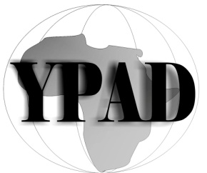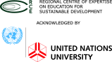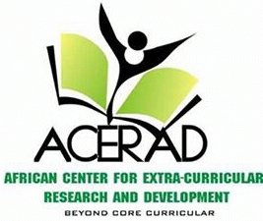
RCE MINNA YOUTH NETWORK COLLABORATE WITH YOUNG PEOPLE FOR AFRICA DEVELOPMENT (YPAD) AND AFRICAN CENTER FOR EXTRA-CURRICULAR RESEARCH AND DEVELOPMENT (ACERAD) TO HOST
THE MINNA 2015 INDEPENDENCE DAY DEBATE CHAMPIONSHIP
THEME: Youth, Education and Independence
VENUE: Abdulsalam Youth Center, Minna, Niger State, Nigeria
DATE: 1st October, 2015
TIME: 10:00am
CONCEPT NOTE
The idea of organising the 2015 Minna Debate Championship was first conceived at the last RCE Minna Youth Network Round Table Discussion, held on 16th August, 2015 at the RCE Minna Resource Centre. However, as part of RCE Minna Youth Network Initiatives of bringing other youth led organisations to direct their focus on Sustainable Development and volunteer towards achieving it. RCE Minna Youth Network decided to collaborate with some of the youth organisations that participated at the round table discussion to organise the Minna debate championship to commemorate Nigeria’s Independence. The two collaborating NGOs are YPAD and ACERAD.
YOUNG PEOPLE FOR AFRICA DEVELOPMENT (YPAD)
Young People for African development YPAD is a Non-profit Organization with the Mission: to Empower African youths for 21st century challenges. Founded on May1st 2014 with the
Vision: Making Every Young African Equipped to positively affect their immediate environment. The organization has since its inception created an avenue for Intellectual competition among schools within Africa. It has also been an avenue of succor, encouragement and reliable news channel for young Africans at home and in Diaspora (http://www.ypadafrica.org).

AFRICAN CENTER FOR EXTRA-CURRICULAR RESEARCH AND DEVELOPMENT (ACERAD)
The African Centre for Extracurricular Research and Development (ACERAD) is a development education social enterprise (DESE) and one of Africa’s emerging centers for extracurricular research and development. Established to bridge the divide between in-class and out-of-class avenues for attaining better learning experiences, focused on educational development, ACERAD was born out of the need to encourage out of class activities as a major aspect of learning.
AIM OF THE DEBATE
We aim to present a platform that creates thunderous voices for young Africans from inception.
Together, we would create a generation that speaks out and inquires and demands for its rights.
FRAMEWORK
Why 1st October, 2015: The programme was slated for 1st October to commemorate the Independence Day of Nigeria.
Who participate: About ten (10) Secondary Schools from Minna are to participate for the programme.
How: The ten schools in participation will be paired in twos to face off. Grading would be on individual performance first, then on school performance. Therein, the first two schools would battle it out on the second stage of the debate to select the overall winner.
Responsibilities of Collaborating NGOs:
RCE Minna Youth Network: Will provide expertise in framework, host meetings at its RCE Minna resource centre, and provide an expert as part of the judging team. Furthermore, RCE Minna will design and produce the programme banner and hire a Disc Jockey (DJ). Make follow up with schools invited.
YPAD: Produced the original concept, secured a venue with the Ministry of Youth Affairs, Niger state. To produce medals and placards for prizes, send and expert to be part of the judging team and produce who anchor the event. Provide the necessary publicity for the programme, distribute invitation letter to schools and invite an entertainer (comedian) for the event.
ACERAD: Produce certificate to all participants and participating schools. Design an online poster for the event, provide an expert to be part of the judging team and make follow up with invited schools.

APPENDIX: Online Poster for Publicity
