Rural Home Centered Aggregated Farming is a Social Farming Model for Food and Nutrient Security, Recycling, Biodiversity Conservation and Ecosystem-based Adaptation
Mohammed Ataur Rahman, Coordinator, RCE Greater Dhaka and Director, IUBAT Institute of SDG Studies (IISS), IUBAT, Uttara Model Town, Dhaka-1230, Bangladesh, Email: marahman@iubat.edu
Introduction
The densely populated the Brahmaputra, Ganges and Meghna basin or the Great Bengal Basin is an alluvial plain with fertile land. Traditionally its rural homes are the centres for all agricultural activities. Homes have raised-floor with houses, forest grove and a pond. Hundreds of plants, animals and birds are grown and nurtured in every home. This home ecosystem with huge biodiversity is rare and unique in the world. Rice dominated agriculture with many diversified crops is processed in the homes; biomass is recycled to the field. Moreover, the inhabitants of the Bengal basin are more conscious about hygiene, natural resources and agricultural practices and they used to practice simple methods in their homesteads which are really important and scientifically rich even during this advanced technological era.
However, with the technological advancement, loss of huge biodiversity, ecotypes and landraces and degradation of soil health have occurred resulting mainly from mono-cropping with HYVs, GMOs, plantations crops; irrigation, fertilizer and pesticide dependent hybrid culture. Moreover, in Bangladesh, a great transition is going on in the agricultural sector specially to feed a large population of about 180 million. On the other hand, huge labor crisis in the rural areas as a great portion of the workforce migrated to the cities for better opportunities mostly in the garments and textile industries, transport sector mainly rickshaw pullers, construction and other industries. Many workers also migrated to overseas countries. In this transition period mechanization has been started which needs skilled workers.
Realizing the situation, The Centre for Global Environmental Culture (CGEC) of the International University of Business Agriculture and Technology, the host institution of RCE Greater Dhaka started a project in January 2018 with the following objectives:
- To conserve the rural home-centered aggregated farming and to develop it a more sustainable model
- To train up youths and jobless men and women for capacity building and to develop a skilled workforce with knowledge on sustainability, healthy and functional ecosystem, and biodiversity conservation.
- To evaluate the existing rural homes where aggregated farming models are following to save biodiversity and ecosystem to ensure nutrient management through biomass recycling to improve the soil health in the Great Bengal Basin.
- To evaluate the environmental benefits with special attention to find out the reasons for the causes and effects of the gradual degradation of the unique culture.
- To investigate the science behind traditional practices and wisdoms
- The aggregated farming model will be reviewed and more productive and sustainable crops, animals, beneficial insects (honey bees), pearl (Oyster) and mushroom cultivation will be introduced according to the needs of the community
- The findings of the project can be utilized locally, nationally, regionally and globally under similar circumstances through facilitating collaboration between the global and South Asian countries scientists.
- Sharing of information among the countries.
Rural Home Centered Aggregated Farming (RHCAF) Model in COVID 19 Pandemic
During the Covid 19 pandemic locked down period, the situation aggravated; labor crisis for harvesting paddy, movement of workforce stopped although thousands of migrant workers from the cities and overseas as returned to the rural homes but they are unskilled and not fit for agricultural works. According to the Expatriate Welfare Desk, a total of 1,11,111 migrant overseas workers have returned to the country from April 1 to September 6 and about 1.7 million youths may lose jobs this year due to the Covid-19 pandemic if the virus containment measures continue to be in force for six months as reported by the Business Standard on September 30, 2020.
Therefore, RCE Greater Dhaka partners: International University of Business Agriculture and Technology (IUBAT), Centre for Global Environmental Culture (CGEC), the host organization of RCE Greater Dhaka, IUBAT Institute of SDG Studies (IISS), Worldwide Opportunities on Organic Farms (WWOOF) Bangladesh and its hosts INSAF Agro, Boalmari, Faridpur; Sonali Agro, Feni and Masum Agriculture Village of Pirojpur have taken an immediate plan to save the traditional home ecosystem of the Bengal Basin with the aim to develop the rural home-centered aggregated farming to a more sustainable model with valuable homestead crops viz. spices, coffee, taro and also bee and mushroom culture along with traditional multiple farming with cows, goats, sheep, chicken, pigeon and ducks etc. to ensure a healthy ecosystem with biodiversity and nutrient management.
Inspired by WWOOF Hungary through Federation of WWOOF Organizations (FoWO) (www.wwoof.net), WWOOF Bangladesh and its host organizations, started to implement Practical Skills Therapeutic Education (PSTE) of Social Farming model of European Union, the Revitalist, established three centres for training for the youths and jobless workers in the following aggregated farming organizations:
- INSAF Agro, Boalmari, Faridpur
- Masum Agriculture Village, Pirojpur
- Sonali Agro and Feed, Feni
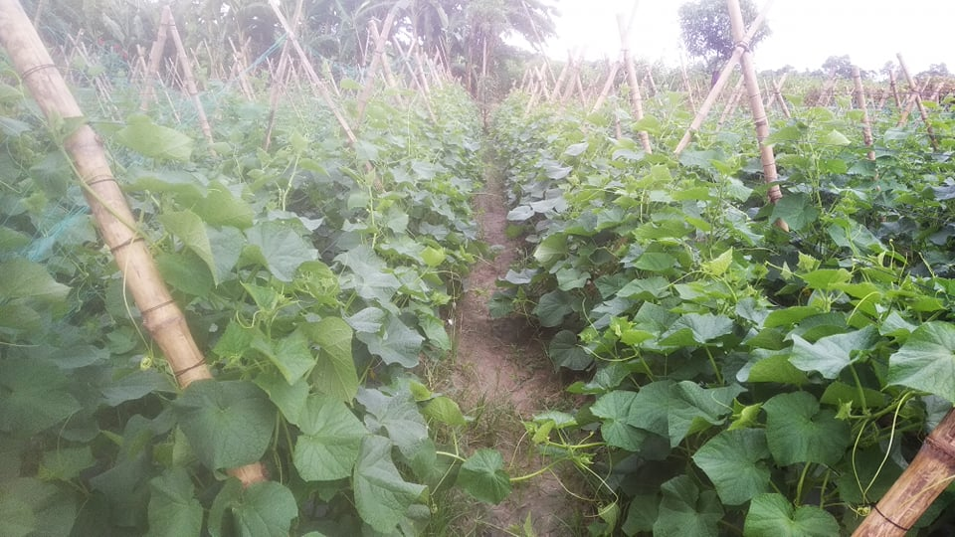
They are implementing the Revitalist: European Union Guide: Social Farm Mentor Training Model: https://www.revitalist.eu/uploads/1/1/4/3/114388427/trainers_guide.pdf
The main objective of social farming is the combination of sustainable agriculture production with a social function within the farming process, integrating factors such as: agricultural production, farming methods and protection of the environment against the negative impacts of agricultural activities, and also promote the quality of life in rural areas, improving the quality of social services, favouring the use of local resources, protecting and maintaining the traditional living, working heritage, social justice, landscape development and protection of biodiversity.
Through this project job opportunities are created for the youths and jobless workers.
Special Training on Sustainable Agriculture is provided to attain:
- Rural Home Centered Aggregated Farming (RHCAF) and Ecosystem-based Adaptation (EbA)
- ESD Skilled workers those can use of modern equipment in agriculture

EbA Model for Rural Home Centered Aggregated Farming (RHCAF)
- A Home with A Pond, Homestead Forest & Houses for Dwelling
- Ensures Water source, Biodiversity, Recycling, Reuse & Livelihoods

Fig. A schematic diagram of rural home with excavated large pond, homestead forest and houses for dwelling
Every home has a common feature: a pond, covered shed or houses for dwelling and a forest which is a unique feature in the world. Here aggregated farming with paddy and many other crops, domestic animals viz. cattle, goats, sheep, chicken, ducks, pigeon, dogs and cats; homestead forest include fruits and tree crops, bamboos and many plants species including wild plants and the pond is the water source for domestic uses, fishes, crabs and turtles etc. The forests also protect the houses from cyclonic storms and strong winds. This traditional model respecting the ecosystem, biodiversity and short cycle biomass recycling ensures ecosystem-based adaptation and a very effective model for environmental safety and protection.

Sustainable Agriculture by WWOOF Bangladesh
Training for the Youths and Jobless Workers Organized by WWOOF Farms
1 INSAF Agro, Boalmari, Faridpur
2 Masum Agriculture Village, Pirojpur
3 Sonali Agro and Feed, Feni

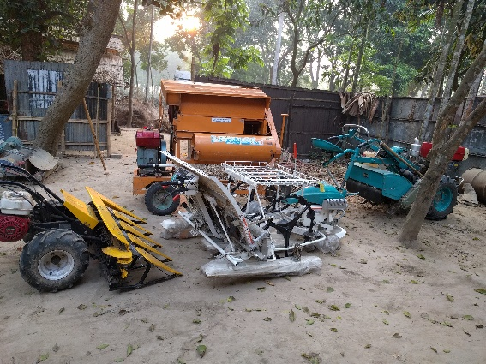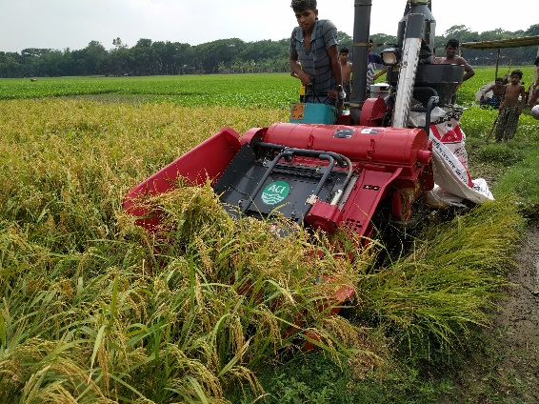

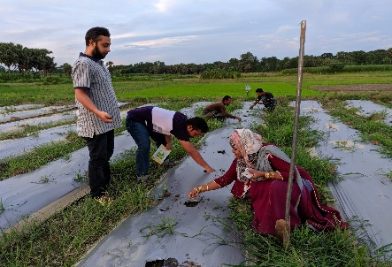
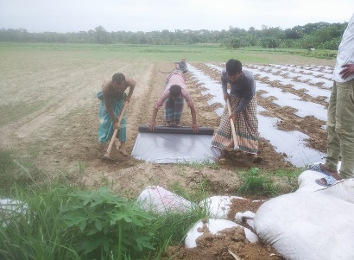

Pictures: INSAF Agro, Boalmari, Faridpur: 1. Modern agriculture equipment 2. Combined Rice harvester (above), 3. Bed preparation and mulching; 4. Demonstration on seed sowing (above)

Pictures: Masum Agriculture Village, Pirojpur: 1. Feeding fishes in pond; 2. Poultry farming (above); 3. Fruit tree management (below)
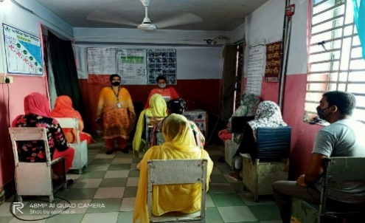
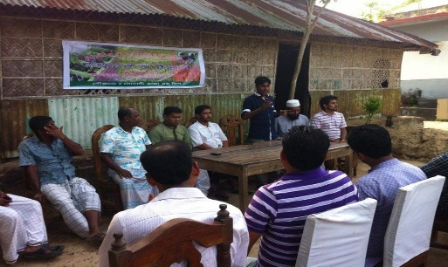

Pictures: 1. Training demonstration for male 2. Training demonstration for female
Status of the Project
It is an ongoing project. During the Covid 19 pandemic situation work has continued maintaining hygienic protection and social distance. The training is found very effective and more organizations showed their interest to participate in this program. But in the unprecedented flood-affected areas some works were hampered. However, the training program will be extended in other WWOOF host organizations throughout the country.
Environmental Impacts
With increased monoculture practices in the modern industrial era, the ecosystem-based adaptation is at the verge of extinction. But the people of Bangladesh are still maintaining ecosystem-based adaptation. No environmental degradation there. Nutrient recycling, reuse and regeneration are common practice. No segregation of lives and a unique coexistence there protecting and restoring the ecosystem. Conserving thousands of plant species under wild and domesticated as crops for sustainable management of natural resources. Ensures all members participation and thus create equal opportunities for all. It also ensures need-based production and consumption. Homestead forest usually established with the suitable plants that etc. provide food, fuel, medicine, recreations, habitat for birds and other wild animals, protect the structures from cyclones
Sustainable development impacts
Home centred farming ensures sustainable agriculture and organic farming covers SDG 2, Resource utilization for zero hunger and poverty alleviation SDG 1
Biodiversity conservation: Life on Land SDG 15
Biomass and nutrient recycling SDG 2 for Good health and wellbeing SDG 3 and Clean Water and Sanitation SDG 6
Ensures all members participation and equal opportunities for all SDG 5 and 10
Need-based production and consumption covers SDG 12
Forests provide shelter and prevent from climate extremes covers SDG 13 ie. Climate action
Scalability
The importance of ecosystem-based adaptation should carefully be understood as the people of Bangladesh have realized the benefits of forests and water bodies for rural homes. Still, this practice is following by the local people. The environmental and social benefits are huge. This practice is the more productive and hence sustainable, pollution-free healthy living condition for a better life is encouraging. It is simple but needs deep understanding and it is replicable and this model is in practice throughout the flood plain ecosystems of Bangladesh through building houses and raising greeneries after digging water bodies or man-made ponds. This model can be spread throughout the region
Replicability
As mentioned earlier this model is in practice throughout Bangladesh especially in the Brahmaputra basin. It is copied in the floodplain habitation by excavating ponds in every home.
Resilience, adaptability, and self-sufficiency
It is a great initiative CGEC of IUBAT, host of RCE Greater Dhaka to conserve the nature-based practices from the changed monoculture segregated farming. The communities are getting social, economic and environmental benefits maintaining age-old traditions although industry-oriented practices showing more short-term benefits. But people understand the long term social and environmental benefits for a healthy and peaceful community. RCE Greater Dhaka partners have introduced some practices like bee culture, homestead coffee plantations etc. to make the society economically and environmentally more resilient.
Reduced inequalities and social inclusion
RHCAF Model believes all members participation and, in this model, all are having an equal right. The social coherent is firmly bonded. Helping neighbour in need and crisis is a practice there. This system is usually called as "Jugali". Jugali system is very effective in a crisis situation like big calamities supporting the neighbour or in crop planting or harvesting time all neighbours work together for supporting a farmer without any money. As mentioned here all member's participation has enriched the project understanding the needs of the neighbourhood. The youth, elders, irrespective of caste and religion work together and live in peace maintaining social harmony. It is committed to include social farming model of European Union.
Gender equality
RHCAF Model believes all members participation and, in this model, women are specially empowered. Most of the activities mainly water and food management are done by the women. They are very efficient in seed and food processing and preservation techniques. Women-led families are happier and more successful.
Conclusion
To ensure ecosystem-based adaptation, to conserve biodiversity and to bring social coherence home-centered aggregating farming is utmost essential. This home ecosystem with hundreds of thousand flora and fauna where crops are processed; both domestic wild animals, birds, reptiles and insects etc. find their habitats live with social harmony through ecological interdependence. Reuse, recycling of biomass, water, nutrients and energy transfer are occurred in the home ecosystem. Quick urbanization and industrialization, these homes are losing their heritage and breaking the social bondage. Therefore, it is essential to study the components, structures and functions of the existing aggregated farming for introduction of upgraded technologies for more productive and sustainable crops, animals and social well beings.
RHCAF is more functional and safer in the pandemic situation. The training program that started by WWOOF organizations embedding the social farming model of the European Union will improve productivity and social bonding which will definitely change the urban migration mentality towards safe, quiet, and peaceful rural village life.
Literature Review
1. Model Rural Homestead Farming – a real example of Crop Diversification
M A Rahman 2004 In Some Environmental Problems and Their Solutions: Plantation Crops and Organic Farming Research Article Series: 1 ISBN984 32 1154 5, Touhid Publication Dhaka Bangladesh http://feppcar.org/16/model-rural-homestead-farming-a-real-example-of-crop-diversificaton/
2. Save the Rice Landraces and Ecotypes and Save the Ecosystems
M A Rahman; The New Age, Bangladesh on May 19, 2019, http://www.newagebd.net/article/72833/saving-rice-landraces-ecotypes-ecosystems
http://feppcar.org/474/save-the-rice-landraces-and-ecotypes-and-save-the-ecosystems/
3. Study On The Traditional Practices For Solid Waste Recycling In Rural Homes: M A Rahman Waste Safe-2009 Website: www.wastesafe.info
http://feppcar.org/wp-content/uploads/2019/07/STUDY_ON_THE_TRADITIONAL_PRACTICES_FOR_SOLID_WASTE.pdf
4. Importance of Landscape Management in Bangladesh
S Rahman, S Nargis and M A Rahman
http://feppcar.org/wp-content/uploads/2019/06/Importance-of-Landscape-Management-in-Bangladesh-1.pdf
5. Global Assessment Report on Biodiversity and Ecosystem Services
https://www.ipbes.net/global-assessment-report-biodiversity-ecosystem-services
6. Revitalist: European Union Guide: Social Farm Mentor Training Model: https://www.revitalist.eu/uploads/1/1/4/3/114388427/trainers_guide.pdf
7. http://feppcar.org/wp-content/uploads/2019/07/STUDY_ON_THE_TRADITIONAL_PRACTICES_FOR_SOLID_WASTE.pdf

