**Drought Mitigation of Bangladesh by Traditional Approach of Surface Water Utilization: A RCE Greater Dhaka initiative for Sustainable Development**

**Centre for Global Environmental Culture (CGEC) of IUBAT** the host of **RCE Greater Dhaka has been** contributing to sustainable national policy formulation and implementation of the government by actively working with Environmental Department of the country. RCE Greater Dhaka has participated in the national level Environmental Fair 2015 and could catch the attention of the audience, stakeholders and government policy makers. The project name was: Drought Mitigation of Northern Region of Bangladesh by Surface Water from the Deep Ponds.

**BACKGROUND**   
Bangladesh is an alluvial floodplain with hundreds of rivers, canals, ponds and water bodies. The importance of the wetlands has significance for ecosystem. But the modern landscape management does not consider this and has unsustainable agricultural and infrastructure development work. As a result, wet lands of the country are shrinking with the danger of depletion of water resources and increased vulnerability of flood, drought and climate extremes. The situation in the North Bengal with prolong drought and water scarcity is accelerating with the changing climate and threatening food security of this densely populated country. Wetland Landscape management is of prime importance now to fight with climate change induced drought, flood and many other natural disasters and to ensure food security.

**PROJECT PLAN**

**Survey of wetlands in North Bengal:** This survey includes filled and existing ponds, depth of rivers and canals, availability of land for digging ponds. Traditional excavation of deep ponds and wet bodies like lakes, Beels and Haors; dredging of canals and rivers are important which has to be implemented through community engagement;

**EXPECTED OUTCOME**

1. This project is aimed to reduce water crisis in the driest part of Bangladesh, North Bengal by a long term sustainable landscaping.
2. Ensure food security for the one-fourth of the country’s area and population.
3. Reduce drought impacts made by the upstream river diversion of the neighbor countries.
4. Enhance surface water irrigation and prohibit groundwater usage for flatland agriculture practice.
5. Proposing a traditional approach of harvesting monsoon rainfall in the deep ponds of individual home and regaining wetlands of the region.
6. A network of ponds and water bodies will create an ecoscene that harvest excess monsoon water, conserves water for dry season and protect flooding damages and also for multipurpose use for fish production and domestic uses etc.

**Partner Organization**

Department of Environment (DoE), Ministry of Environment and Forest & IUBAT- International University of Business Agriculture and Technology

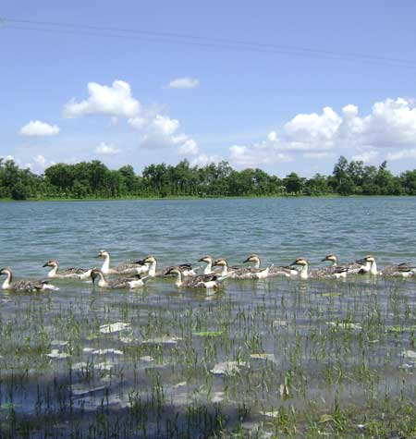

Fig: 1 Ramsagor, a deep pond in DInajpur area of the country



Fig. 2 Cross-sectional view of traditional landscape management

The project was evaluated by the Ministry of Environment and government officials and selected for national award third prize and handed over the prize on The International Ozone Day, on September 16, 2015.

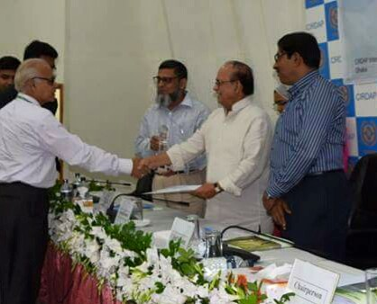

Fig. 3 Professor Dr Mohammed Ataur Rahman, Coordinator or RCE Greater Dhaka receiving National Environmental Award from the Minister of Environment and Forests Mr. Anwar Hossain Monju MP

The government of Bangladesh has already declared re-excavation of the wet bodies following our method “step down deep ponds” with ring-well connecting ground water-table.

Reference:

1. Rahman, MA and Rahman S. 2015: Proceedings of the Internationalconference on Climate Change in relation to Water and Environment (I3CWE-2015) DUET - Gazipur, Bangladesh 8-11 April, 2015 “Traditional Floodplain Managements of the Ganges, Brahmaputra and Meghna Basin are Unique Landscape Management Practices for Climate Change Adaptation”

2 The Department of Environment, Agargaon, Dhaka, Bangladesh