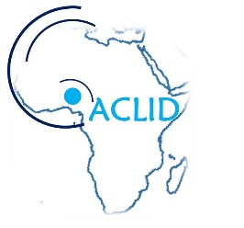
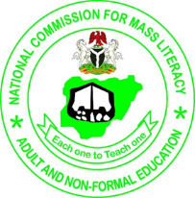
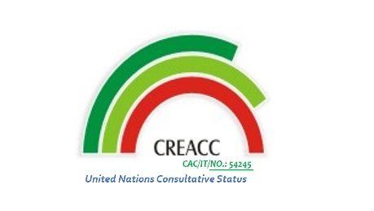
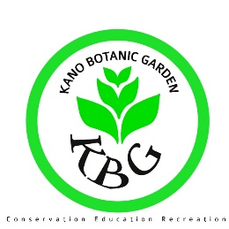

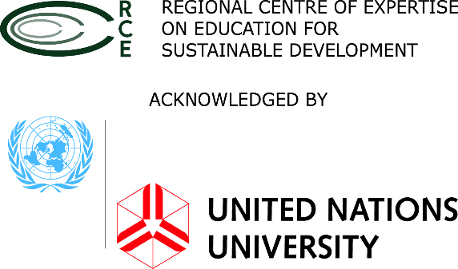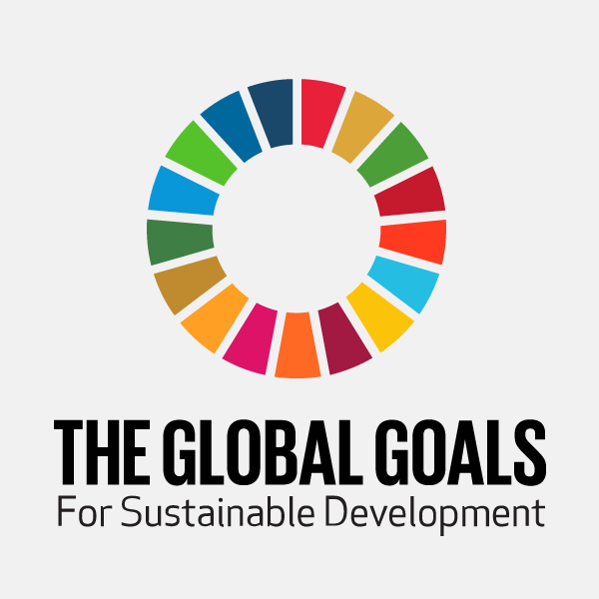
The Regional Centre of Expertise (RCE) Kano; Bayero University Kano (BUK); National Commission for Mass Literacy Adult, and Non-Formal Education; and Centre for Renewable Energy and Action on Climate Change (CREACC) are organising a one day National RCE Youth Conference on Education for Sustainable Development. The Conference will be held on 3rd October, 2017 at the Faculty of Law Theatre, Bayero University Kano. Kano
*Deadline 1st October, 2017
Name of RCE/Affiliation
Name of Participant (please use separate form for multiple participation)
Address
Email
Phone
Do you have any specific dietary requirements?
Motivation to Participate in the Youth Conference
Any other thing you wish to share with us?

