The Ecomuseum Concept: A Saskatchewan View

DRAFT – Nov 20, 2013

“An ecomuseum is an agreement by which a local community takes care of a place.”
(Maggi 2002, Ecomusei. Guida europea)

Context and Purpose of this Paper 2
A Brief History 2
What is an Ecomuseum? 3
Why do Ecomuseums matter, locally and provincially? 5
What does it mean to be an Ecomuseum? 6
Connections to Policy 6
The Ecomuseum ‘Brand’ 7
What Distinguishes an Ecomuseum? 8
How does an Ecomuseum compare to a Heritage District? 8
How does an Ecomuseum compare to a Main Street project? 9
How does an Ecomuseum compare to a Park? 9
How would an Ecomuseum be associated with Cultural Planning? 10
Ecomuseums as Community Museums 10
Suggested reading 11

Context and Purpose of this Paper

In October 2011, as part of a human ecology research program, the Royal Saskatchewan Museum (RSM) launched a project called the Saskatchewan Ecomuseums Initiative (SEI). There are currently no ecomuseums in this province, so the aim was to explore the potential for them through discussions and concept development at the provincial level and at self-identified demonstration sites.

Ecomuseums are locally-driven, place-based organizations that encourage sustainable community development, based on heritage conservation and interpretation. As a provincial coordinating body, the SEI is aimed at municipal leaders, community groups, government agencies, non-government organizations, and other stakeholders with an interest in this area. The SEI Steering Committee is chaired by the RSM, as part of its ongoing commitment to conservation work and sustainability education. Other organizations on the Steering Committee include the Museums Association of Saskatchewan (MAS), SaskCulture, Heritage Saskatchewan, and Heritage Canada. Still at the exploratory stage, the SEI is a core project of both the MAS Museums and Sustainability Committee and the Saskatchewan-UNESCO Regional Centre of Expertise (RCE) on Education for Sustainable Development.

In February 2013, the SEI organized a provincial workshop that attracted people from a dozen potential ecomuseum sites and produced an Ecomuseum Planning Framework that the Steering Committee and demonstration sites are using to guide their next steps. The workshop illustrated how the ecomuseum model can bring a range of stakeholders together for unique and stimulating discussions. It also highlighted the need to clarify what an ecomuseum is and how it would relate to current community-based activities. This paper examines the ecomuseum model from a Saskatchewan perspective by elaborating on a working definition developed by the SEI Steering Committee and by illustrating how an ecomuseum compares to a park, a heritage district, a traditional museum, and the provincial Main Street program.

A Brief History

The ecomuseum model was developed in France in the early 1970s to foster holistic interpretations of cultural heritage. The aim was to combine tangible objects, sites, and built structures with the traditions, practices, and customs associated with intangible or “living heritage.” As the idea caught on, the model was broadened to include natural heritage, including local flora and fauna, important wildlife habitats and geomorphology sites.

Today, hundreds of ecomuseums are in operation around the world, especially in Europe and Asia, in many different forms. Some cover large areas; others are small, isolated sites. Some provide a showcase for local arts and crafts; others reflect local industries and related skills. Some rely on tourism; others are mostly about encouraging community engagement. Some also encourage research through local governments and universities.

Despite this variation, ecomuseums tend to share a number of common features. They occupy a definable region delineated by local residents, where people work together to adapt to a changing world through mindful development processes that reflect their communities, their landscapes, and their ways of life. The stakeholders often include businesses, heritage and community groups, and local decision-makers, and their work usually entails site development or restoration, biological and environmental surveys, and activities designed to attract tourists. Together, their efforts create a ‘museum’ as they identify and interpret stories and features that reflect the cultural and natural heritage of the region, including past and current businesses, and potential opportunities.

The Saskatchewan museum community first talked about ecomuseums as a different sort of community museum shortly after the model took root and started to flourish in Europe. Through the SEI, there is now renewed interest in the concept at the provincial level, and a number of urban and rural communities are exploring its potential as demonstration sites.

What is an Ecomuseum?

“Combining the nature and heritage perspectives to foster a sustainable community.”
Saskatchewan Ecomuseum Planning Framework

To encourage discussion about the ecomuseum concept in Saskatchewan, the SEI Steering Committee has adopted the following definition:

An ecomuseum is a community museum that provides a unique mechanism for community engagement, in which community members work to preserve and learn from tangible and intangible heritage in its living form. Through community consultations, stakeholders agree on natural and cultural assets that they value and create plans to ensure they are preserved and used to foster a culture of sustainability. Unlike a traditional museum, ecomuseums do not necessarily gather objects in a museum facility. Instead, they enable communities to preserve valued objects, sites, and cultural practices where they exist, enhancing their visibility and the contributions they make to community development activities.
These words and ideas have a number of implications. First, as community museums, ecomuseums are products of their communities, so they need to be initiated, characterized, and managed by local residents. Their geographic scope, governance structure and other features are not determined or overseen by an outside agency, and whatever ends they decide to pursue, their activities and outcomes hinge on active community engagement.

Second, ecomuseums put equal emphasis on natural and cultural assets, including local industries. This separates them from recreational or wilderness parks, which focus mostly on nature, and from heritage districts, which focus mainly on the built environment.

Third, in keeping with their role as a museum, ecomuseums aim to preserve and interpret heritage assets, but they also work to apply this knowledge to address local development issues, with a focus on sustainability. To that end, ecomuseums provide a valuable conduit between the heritage community, the private sector, and elected officials.

Fourth, the focus of an ecomuseum goes beyond objects, buildings, wildlife, and other tangible assets to include music, ceremonies, traditions, and other aspects of intangible heritage. This means that ecomuseums can be defined and mapped based on their tangible features, but they can also encourage learning and cultural adaptation by drawing on intangible assets.

Finally, the fact that all of the assets associated with an ecomuseum continue to ‘live’ where they exist means that the organization itself is light-weight and flexible, with little need for capital investment. In effect, an ecomuseum emerges from, and adds to, the fabric of a community through what it does and who gets involved, using the unique features and qualities of a place as context.

Many of these points were echoed at the February workshop, where people talked about:
- A holistic approach to understanding, interpreting and celebrating an authentic cultural landscape that encompasses the natural and built environments as well as natural and human-made processes, heritage and cultures.
- Holistic approaches to community engagement based on cultures, traditions and assets that currently exist (lifestyle) so that people can adapt to change and growth and promote their unique region, heritage and sense of place.
- Ecomuseums being designed to share the experience of place, community, people, and their natural and cultural heritage. They provide the opportunity for communities to actively participate in developing dynamic and fluid relationships and to share and learn about their stories in their own ways.
Workshop participants also noted that ecomuseums need to be based on a flexible model that works in large urban and small rural areas, enabling communities to govern themselves while still following some general principles. To that end, the Ecomuseum Planning Framework lists seven guiding principles for Saskatchewan sites:

- Community-based ownership and involvement: to help people enhance their quality of life by telling their own stories and facilitating discussion and participation (knowledge exchange)
- Authenticity: true to the people involved
- Unique locations defined by community: interpreted by them and not for them - sharing folklore, traditional knowledge, scientific information, spirituality and personal discovery and expression
- Experiential, dynamic and community-led: a local place and vehicle for discussion and demonstration of culture, heritage, art, environment and economy
- Pride and identity: creates and focuses on pride of place via “place making” and celebrating the culture and heritage in that place
- Inclusive and collaborative engagement: of a wide range of community interests and stakeholders – creating a sense of belonging and being part of it
- Done by, not on behalf of, the community: in the spirit of learning and problem solving with shared leadership and stewardship. This involves a commitment to social and environmental responsibility and building in feedback loops to help guide decision-making.
These principles reflect the notion of an ecomuseum as a ‘museum without walls’ that depends on community engagement and local ownership. They also provide a framework for volunteer-based, community actions that bring a range of stakeholders together to make informed, fair, and democratic decisions about shared concerns and the tangible and intangible aspects of their cultural and natural heritage. As noted, the aim is to understand today, based on the past, and to apply this understanding in ways that help residents respond to local issues.

Why do Ecomuseums matter, locally and provincially?

“An Ecomuseum would unite into one package all of the diverse and dynamic initiatives that have been evolving here in our community. It would focus our thinking, and help direct future action in a thoughtful, coordinated, and strategic manner.”
Response from Maple Creek to a survey about needs and issues an ecomuseum might address.

Where people are working but somewhat isolated in their efforts to conserve and learn from the cultural and natural heritage of a region, an ecomuseum provides a forum for crafting shared visions, resolving conflicts, sharing information, and coordinating activities. Over time, it can help local people protect their land, their communities, and their ways of life, by giving them a strong voice and the chance to influence, promote, and engage in activities that affect their region.

Ecomuseums also matter because of their focus on sustainable forms of community development. Many factors enter into this work, as communities contribute and respond to globalized economies, changing and chaotic environments, and a host of societal changes. Heritage is an important consideration, since people need to appreciate the history of their communities and landscapes, if they are going to understand their potential for adaptation (Walker and Salt 2006).

Sustainability is about more than the past, though. It depends on people being aware of current trends, opportunities, and limitations, and responding to them in ways that ensure a reasonable quality of life in the future. This is especially important where economies are growing rapidly, like they are in Saskatchewan.

What does it mean to be an Ecomuseum?

A number of broad outcomes can be realized when an ecomuseum gets underway, including:

- Increased social cohesion, conflict resolution and awareness, e.g., via sense-of-place mapping, project planning, learning opportunities;
- The conservation and interpretation of local heritage, e.g., via restoration projects, interpretive trails and maps about past cultures, current industries, wildlife areas;
- Environmental monitoring , e.g., via school programs, citizen science, research projects; and
- Enhanced tourism, e.g., via cultural programs, extension activities, website.
- New business opportunities and new systems for democratic participation.

Other discussions about the concept suggest that an ecomuseum would also provide a community or region with:

- A lightweight, resilient and responsive organization, possibly supported by low-cost technology.
- A way to acquire the funding and stakeholder commitment needed to pursue a complex development process.
- The means to create unique identity, pride of place, and locations where people want to live, visit and invest; to accomplish things a community may be struggling to do.
- A stronger basis for community learning, where residents gain insights about connections between people and where and how they live.
- A way to influence and support decisions made by local councils and other authorities, leading to increased local stability.
- A way to ensure that tourism experiences are culturally and historically authentic, with minimal environmental or social impacts.
- Affiliation with provincial, national and international networks that provide inspiration and visibility.

Connections to Policy

Ecomuseum activities can protect and enhance a range of local heritage assets, including local traditions, stories, and other aspects of intangible heritage. To that end, the development of Saskatchewan ecomuseums would address a number of principles and capacity goals and outcomes in the provincial government’s 2010 Cultural Policy.

The principles in question include: community-based decision making, sustainable development, and communication, coordination, and collaboration. All of these principles are reflected in a successful ecomuseum, which needs to grow from the ground up based on decisions that are made and acted on by local residents, in response to issues that they see as important. At the same time, there needs to be an awareness of resource limitations, systemic imbalances, potential synergies, and other aspects of community sustainability, and a wide range of stakeholders need to work together as projects are planned, promoted, and carried out.

One of the most relevant capacity goals in the 2010 Policy is: strengthening communities and organizations by enhancing their capacity to support cultural activity and development. Ecomuseums are about bringing individuals and groups that are interested in culture and development together, increasing their visibility, and adding to their capacity. This means that their collective voice is stronger, their reach goes further, and they are able to pursue their shared interests more easily.

The main capacity outcomes include: knowledge, expertise and resources to manage cultural resources; and the ability to preserve, enhance and celebrate distinctive character and identity. Ecomuseums are part of a recent trend in the generation and application of knowledge. In March 2013, as part of a blog called How Knowledge is Changing – and How That is Changing Sustainability, Alan AtKisson points out that:

“…the nature of knowledge is changing. The amount of knowledge is growing so fast that no one can manage it. And the way that professional knowledge managers are thinking about it — especially driven by new technologies — is changing too.

… We should no longer think of [knowledge] as something that accumulates in our minds; it is rather a river in which we must navigate. … All of this is shifting the way sustainability must be done, rather dramatically. The focus shifts from individual experts to high-capacity groups, and from one-way knowledge production and broadcasting to the “boundary work” involved in exchanging knowledge among us.”

As a ‘high-capacity group,’ ecomuseums can help communities stay afloat and prosper, with a focus on sustainability and features that make a place distinctive and identifiable.

The Ecomuseum ‘Brand’

Hugues De Varine coined the term ‘ecomuseum’ in 1971 and later noted that “too many people have used that word for too many things” (quoted in Davis 2011, pg 78). It is also common for people to equate an ecomuseum with environmentalism, instead of the intended integration of culture and nature. Yet the ecomuseum ‘brand’ continues to draw attention and bear fruit.

Part of the appeal may have to do with the word itself. The prefix ‘eco’ is derived from the ancient Greek ‘oikos’ for house, household, or family. Words that start the same way, like ‘ecology’ and ‘economy,’ are associated with holism, relationships, interactions, inter-dependence, and the behaviour of complex systems. This gives an ecomuseum a broad foundation for addressing issues and bringing groups together to protect and raise the profile of local heritage assets and living cultures.

The word ‘museum’ is also rich with meaning. Museums are usually seen as places with collections, but the word itself refers to ‘places of the muses,’ the ancient Greek goddesses of inspiration and creativity (Worts 2006, pg 167). In early Greek mythology there were three muses – meditation, memory, and song. Later, the muses were the nine daughters of Zeus, responsible for history, song, dancing, astronomy, and different types of poetry. That may be lot to ask of a single place or institution, but it also gives the word ‘museum’ a fair bit of flexibility, and cache.

Whatever the reason, the word “ecomuseum” appears to be an effective brand, given the popularity and longevity of some sites. There seems to be something compelling about a home-based (eco) place of the muses (museum) that gives a community “a dynamic way in which to preserve, interpret, and manage their heritage for sustainable development” (Declaration of Intent of the Long Net Workshop, Trento (Italy), May 2004).

What Distinguishes an Ecomuseum?

Ecomuseums have unique and brand-able features, but they can also share goals, values, and operating principles with other community-driven initiatives or place-based organizations.

How does an Ecomuseum compare to a Heritage District?

There are clear overlaps between the ecomuseum model and Heritage Conservation Districts (HCDs) that have been set up in other parts of Canada and the U.S. In Ontario, HCDs are designed to help local authorities “manage and guide future change … through adoption of a district plan with policies and guidelines for conservation, protection and enhancement of the area’s special character,” and they can include “residential, commercial and industrial areas, rural landscapes or entire villages or hamlets with features or land patterns that contribute to a cohesive sense of time or place” (HCD Designation Guide, 2006).
Ha Long Bay, Viet Nam, was designated as a World Heritage Site in 1994 and again in 2000. An ecomuseum was established on the site in 2002, partly to address tourism impacts.

Ecomuseums differ from HCDs in that they are not constrained by the word heritage, which is often equated with the past, or by the word conservation, which tends to imply stasis or a ‘look-but-don’t-touch’ approach. Instead, ecomuseums are based on dynamic agreements that give rise to plans, and actions that can contribute and respond to local ecologies, including human ecologies. Ecomuseums are also not set up or overseen by an external authority. As noted, they are established and administered by local residents.

There are no HCDs in Saskatchewan, but several other initiatives are similar to the ecomuseum model, including Main Street projects, parks, cultural planning activities, and community museums.

How does an Ecomuseum compare to a Main Street project?

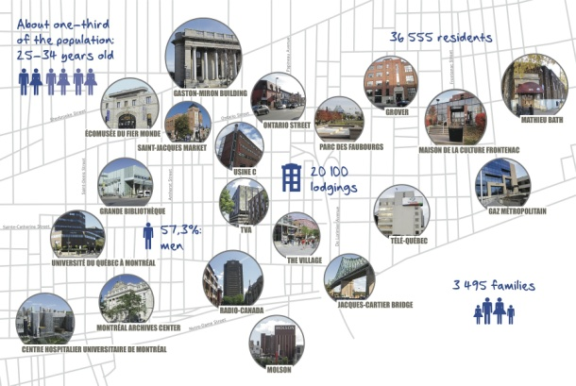
According to the Government of Saskatchewan website, Main Street is “a community-driven program that revitalizes historic downtown commercial districts based on the principles of community organization, economic development, marketing and heritage conservation.” This description implies that an ecomuseum and a Main Street project can be complementary activities, with a shared interest in heritage restoration and economic revitalization.
The Écomusée du Fier Monde in Montreal focuses on the manufacturing and cultural history of the Centre-Sud territory.

A key difference is that Main Street has a restricted geographic focus and is primarily about the built environment, while an ecomuseum provides a broad foundation for networking, planning, and projects aimed at a range of social, economic, and environmental issues. In theory, ecomuseum activities can foster relationships that make a community more resilient and adaptable, including communities that are part of the Main Street program.

How does an Ecomuseum compare to a Park?
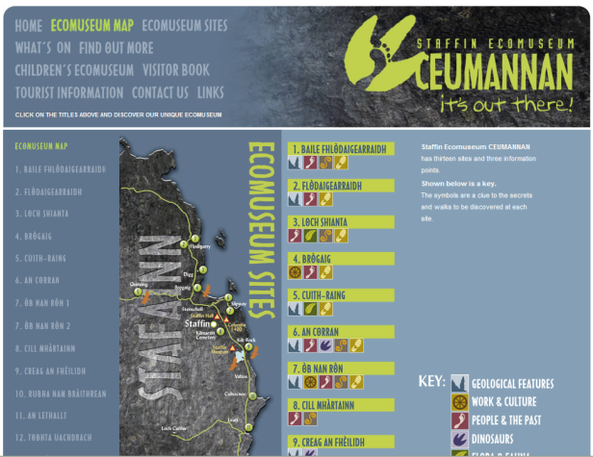
The Staffin Ecomuseum on Scotland’s Isle of Skye uses unique natural and cultural assets to attract tourists.
According to the provincial government, there are 196 lands in Saskatchewan that are designated as parks, comprising 1.4 million hectares. These areas were established and are managed for recreation, the propagation, protection and preservation of wild plants and animals, and the protection and preservation of interesting geological, ethnological, historical or other scientific objects. The current classification divides this land into: 4 wilderness parks, which are mostly free of development; 11 natural environment parks, which include small areas for intensive recreation; 10 recreation parks, which encourage recreational pursuits; 9 historic parks and 8 historic sites, which preserve and interpret provincially-significant events; 24 protected areas, which preserve exceptional natural and cultural features; and 130 recreation sites, ensure recreational access to water bodies and other natural features.

Ecomuseums are clearly not wilderness or natural environment parks. Nor are they necessarily concerned with recreation access or the protection of provincially-significant features. The biggest distinction is the degree to which cultural heritage is addressed, and how sites are established. There are cultural dimensions to the 41 historic parks, historic sites, and protected areas noted above, so these could be important building blocks for a local ecomuseum. But those ecomuseums would be instigated and nurtured by local residents to address local concerns, instead of being set up by an external body. Their work would also be tied to the local economy, since “most ecomuseums are created … to aid their communities, often having an economic dimension” (Davis 2011, p 15).

How would an Ecomuseum be associated with Cultural Planning?

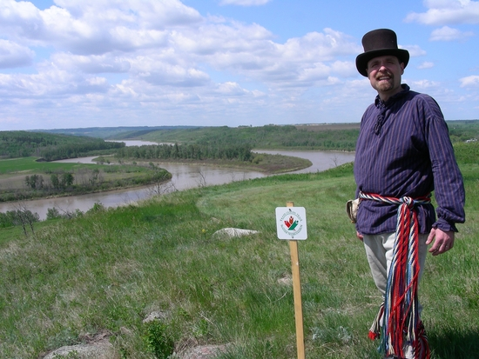
Supported by SaskCulture grants, a number of Saskatchewan communities have recently developed, or are currently crafting a cultural plan. These plans provide a foundation for municipal initiatives that bring a range of stakeholders together, including culture, business, social, and environmental groups, to enhance the creative and cultural potential of a community, with an emphasis on the arts and entertainment sector.
Kalyna Country is a large “living museum” east of Edmonton that focuses on local geography and natural history, as well as Metis, First Nations and Ukranian cultures.

Ecomuseum activities are aimed at culture in a broader sense – as the evolving set of artifacts, behaviours, values, and assumptions that affect the way people live – but they can be an effective way to facilitate the development of a cultural plan, or to bring an existing one to life. The vision, mission, and partnerships that make up an ecomuseum can provide valuable context and visibility as a culture plan is implemented.

Ecomuseums as Community Museums

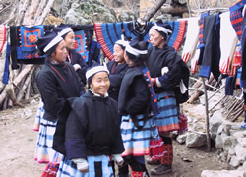
In the end, as suggested by the SEI definition, ecomuseums are best understood as a different type of a community museum. As noted above, they are established and operated by local residents, drawing on a range of local assets to address matters of local importance. What separates them from the typical community museum is their emphasis on intangible heritage and the distributed nature of their collections. They depend on active community engagement that brings the intangible heritage of a site to the fore, and instead of being moved into a central facility, the tangible assets are conserved, interpreted, and enjoyed in situ. This not only fosters adaptation and preserves context, it leaves room for visitor-driven interpretation and dramatically reduces the capital investment needed to get an ecomuseum up and running.
The Nandan Lihu White Trousers Yao Ecomuseum in China draws attention to actions and practices of Baiku Yao culture through school classes, fieldwork, and youth cultural programs.

Suggested reading
Corsane G, Davis P, Elliot S, Maggi M, Murtas D, Rogers S. (2007). Ecomuseum Evaluation: Experiences in Piemonte and Liguria, Italy. International Journal of Heritage Studies 13(2), 101-116.
Davis, P. (2011). Ecomuseums: a Sense of Place, 2nd Edition. Continuum, New York, NY.
Heritage Conservation Districts: A Guide to District Designation Under the Ontario Heritage Act ISBN 1-4249-0052-2, © Queen’s Printer for Ontario, 2006.
Murtas, D., and P. Davis (2009) The role of the ecomuseo dei terrazzamenti e della vite, (Cortemilia, Italy) in community development. museum and society 7(3): 150-186
Nitzky, W. (2012). Mediating Heritage Preservation and Rural Development: Ecomuseum Development in China. Urban Anthropology 41(2,3,4):367-417.
Walker, B.H. and D. Salt. (2006) Resilience Thinking: Sustaining Ecosystems and People in a Changing World.

Researchers have identified twenty-one characteristics that are shared by most ecomuseums. For the complete list, see p. 92-3 in Davis (2011).

