INTERNATIONAL MOUNTAIN DAY CELEBRATIONS
The world’s mountains are in danger and we are responsible for it. Increasing urbanisation, population growth, climate change issues and random development efforts are endangering the mountains and the very existence of flora, fauna and mankind. The Indian Himalayan Region (IHR) is amongst the most vulnerable mountain systems of the world. The issues of this region are varied: habitat loss, fragmentation of landscape, poaching, uncontrolled and unsustainable tourism, over-consumption of non-renewable resources, ecologically harmful developmental activities, food insecurity, loss of traditional land-use systems, changes in seasonal characteristics, livestock health and grazing patterns, danger of extinction of locale-specific flora and fauna, loss of livelihood, migration of labour, poverty, disintegration of local culture and lifestyle, natural disasters and so on. And unfortunately, it is those who contribute least to climate change issues that suffer the most for it.
Sensing the need to educate and sensitize the global population to the perils faced by the world’s mountains and mountain communities, the United Nations General Assembly, with the aim of raising awareness and triggering action on issues relating to sustainable mountain development, declared the year 2002 “The International Year of Mountains”. As the year drew to a close the UN designated December 11 as International Mountain Day and encouraged the international community to organize events to highlight the importance of sustainable mountain development on this date. International Mountain Day was first observed on December 11, 2003. Each year International Mountain Day has a particular theme. Previous themes have focused on freshwater, peace, biodiversity and climate change. The theme of this year’s IMD was Mountains and Forests. The aim of IMD 2011 was to “raise awareness about the relevance of mountain forests and the role they play within a Green Economy as well as in climate change adaptation measures” (http://www.fao.org/mnts/en/).
Mountains are a part of the lives of millions of children in India. The mountains are their shelter, teacher, protector and friend. Thus, it is important for children in the IHR to recognise the danger that their surroundings are in. It is also important for them to understand their role in preserving the mountains and ecology of the region. It is generally believed that educating a child leads to the education of a family. This means that educating a child in sustainable thoughts and actions will lead to valuable education of his/her family and friends. Recognising immense potential in the inculcation of ‘green’ ideas and habits in the nation’s younger generation, the Centre for Environment Education CEE launched the Paryavaran Mitra program, the largest school program in the world, in 2010.
Paryavaran Mitra or ‘friend of the environment’ is a sustainability and climate change education project aimed at sensitising children to issues of environmental degradation and involving them in the struggle to save our planet. Paryavaran Mitra is a nationwide initiative to directly transform 2 crore students (200,000 schools * 100 students per school) into Paryavran Mitra through participation in curricular and co-curricular activities and projects.These children will, in turn, influence their siblings (2), parents (2) and atleast 2 friends. Along with 200,000 teachers (one from each of the 200,000 schools), over 10 crore people will be impacted by this initiative.
To qualify for the Paryavaran Mitra status, a student must participate in one activity in each of the five areas: waste management, biodiversity & greening, energy, water, culture & heritage. All five areas are of great importance to the Indian Himalayan Region.
• Water is a critical issue as glaciers are retreating, thereby, increasing the likelihood of flashfloods, landslides and glacial lake outburst floods (GLOFs).
• Waste management, a consequence of unsustainable tourism activities in the Himalayas, is another area of great concern.
• Himalayan biodiversity is under threat due to climate change impacts: increased temperatures, dry spells, high intensity rainfall, pest attacks, soil erosion, lack of fodder, water and pastures for cattle, and habitat loss for wild animals and plant species.
• Forest wood and hydroelectricity are the main sources of energy in the Himalayas. As snow-melt from the glaciers become irregular and regeneration of forests slows down considerably, energy availability in the Himalayas will become increasingly unpredictable.
• The cutural heritage of the IHR is also at stake due to urban influence, migration of labor and loss of traditional livelihood options.
It is, therefore, expected that greater the awareness and intervention levels of children in each of the five areas, the more positive and sustainable will be the future of the region. A Paryavaran Mitra student demonstrates environmental leadership qualities through positive change in behaviour and action at individual, school, family and community levels. Thus every Paryavaran Mitra student becomes a change agent for sustainability (http://paryavaranmitra.in/).
The Paryavaran Mitra program is being implemented in the IHR by CEE Hiimalaya. CEE Himalaya is an initiative of the Centre for Environment Education (CEE), a national institution established in 1984. CEE Himalaya was launched in the year 2002 to strengthen environmental education and communication interventions towards sustainable development in the fragile mountain ecosystems of the Indian Himalayan region. The organisation promotes environmental awareness and support for sustainable development in the fragile mountain ecosystems of the Indian Himalayan region (http://www.ceehimalaya.org/).
IMD was observed by CEE Himalaya as part of their Paryavaran Mitra program at two schools in Kashmir. The two schools, Baby’s Land Public School, Wakura, Ganderbal District and Govt. Girls’ Middle School Botingoo Sopore, Baramulla District hosted IMD celebrations on 10th December, 2011 (11th December being a Sunday). Both programs were of four hours duration and were attended by boys, girls and several teachers.
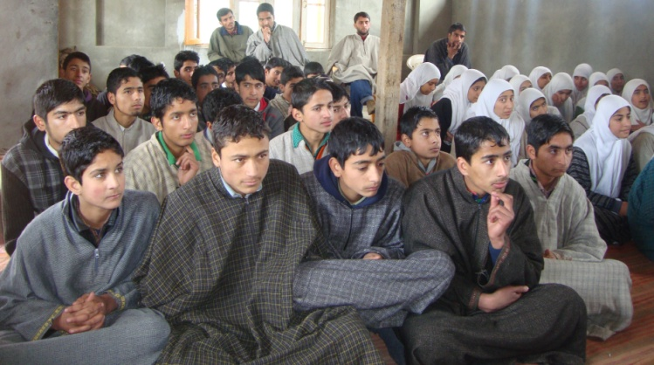
Figure 1 Students at Baby’s Land Public School IMD Celebrations
Sixty-five students in the age range of 12 to 15 years belonging to standards 7, 8, 9 and 10 attended the event at Baby’s Land Public School, along with seven teachers. The program commenced at 12:30pm with an introduction of CEE Himalaya and the Paryavaran Mitra program. This was followed by the screening of “Planet Earth - Mountains”, an internationally acclaimed documentary related to mountains and forests, narrated by David Attenborough and produced by British Broadcasting Corporation (BBC). The film, interpreted in Urdu for easy comprehension, educated the children about the origin of mountains, their importance to local livelihoods, wildlife, forests and environmental threats. It also depicted the lives of the Himlayan Bear, Snow Leopard and Black Eagle – the dominant fauna species of the Indian Himalayan Region (IHR). Enthusiastic discussions and debates ensued. The children were highly motivated by what they had seen in the film and raised several questions regarding habitat threats to Himalayan fauna, conservation strategies and the economic condition of the country.
An extempore session centred around issues of mountains, forests and their importance in the communities’ livelihoods was also organised. One student talked about how local grass species are in the danger of becoming extinct due to increased agricultural actitivies, pest attacks (especially daily Locust attacks on paddy fields from the western part of the state, the Pakistan-occupied-Kashmir region) and invasion by exotic tree species such as Black Locust. Another student talked about how Saussarea, a medicinal plant found in abundance in the past, was being destroyed due to lack of awareness amongst forest dwellers. They also stated that the Kashmir Stag was under severe threat due to habitat loss, overgrazing by livestock and poaching. Other students posed counter-questions to which answers were provided either by the students themselves or by the CEE Himalaya team. Some of the questions asked by them were: “Why should we in Kashmir celebrate International Mountain Day when it is decided by the General Assembly of UN – a foreign agency?”, “The importance of mountains apart from timber and non-timber products.” and “Cost-benefit analysis of programmes like International Mountain Day”.
The children also shared their views regarding climate change impacts in the Valley. They tried to compare the recent phenomenon of flashfloods and decreased snowfall with the Kashmir of the past. According to some, the onset of snowfall had been delayed in the recent years from early December to early January. They had also observed that the surrounding snow-covered mountains that they were used to for seven months in a year, now lasted barely four months.
A quiz contest comprising ten multiple-choice questions on the importance of local flora & fauna and global climate change issues was then conducted. Some questions were: “The most favored tree species by sheep (Bheru)…”, “Most of the human intervention in Kashmir is because of which animal?”, and “Chinar is a world renowed…?” Most students scored well, with a majority scoring over 70% marks. This shows high potential among students from rural schools.
The ratio of boys and girls being almost equal, prizes were awarded to three members of each group, on the basis of their performance in the extempore and quiz contests.
Prizes were handed over and certificates duly signed by CEE Himalaya and counter signed by Mr. Farooq Ahmed, Principal, Baby’s Land Public School. Refreshments were also provided to all participants. The principal was very happy to be part of the event and expressed his wish to be involved in similar programs in the future as well.
The IMD celebrations at Govt. Girls’ Middle School Botingoo Sopore, Baramulla District was attended by sixty students from standards 7, 8, 9 and 10 of the host school as well as from a neighboring private school, along with a few teachers. The program commenced at 10.30am with an introductory talk by Ms. Sibghat-un-nisa, CEE Himalaya team, about the beauty and value of the surrounding mountains, the concept of IMD and the need for the people of Kashmir to recognise this day.
A twenty-minute quiz competition based on this year’s IMD slogan Mountain And Forests was conducted and 40 students participated in it. They were provided with a question paper, pencil, sharpener and eraser each. Some questions of the quiz were: “Hangul is endemic to…”, “Which of these national parks is in Jammu and Kashmir?”, “Which is the largest freshwater lake in the Asia?”, “Which of these is a green house gas?”, “The state bird of Jammu and Kashmir?” etc. The quiz was followed by a talk by Mr. Riyaz Ahmad Mir, CEE Himalaya team, about issues of encroachment of forests, deforestation and road construction in the fragile ecosystems of the surrounding mountains of Sopore. He cited the example of Botingoo, a neighboring mountain village, which was previously known as “the heaven of flora and fauna”, but is now in a pathetic state. He also spoke about the medicinal values of trees.
An oath-taking ceremony was the highlight of the event where students repeated the following with the CEE Himalaya team: We will be more respectful towards our forests and wildlife and save these from destruction.
Another interactive session, this time by Mr. Abbas Ahmad, teacher of GMS Botingoo, followed. He emphasised that forests and wildlife habitat had been damamged extensively in the surrounding mountains and that this was resulting in increased man-animal conflicts. The children asked about the recent rise in causalities and loss of crops due to wild animals like the Himalayan Bear and Leopard. They opined that a decrease in forest area, shifting cultivation patterns, rising population and decrease in food sources for animals are the major factors leading to such conflicts. They also felt that since honey extraction from forests had increased manifold times, it was luring bears into areas inhabited by humans. Moreover, overgrazing and overexploitation of forest fodder had impacted the prey population of leopards as well.
The children also spoke about how they were being encouraged and inspired by the celebration IMD to save mountains and forests of the area. An extempore speech competition for students’ views on wildlife in forests, environment, global warming, conservation of biodiversity and importance of mountains was held and monitored by teachers. One of the students spoke about the importance of tourism to the economy of the state. She felt that in the recent years militancy had deterred tourists from venturing into the state. However, the loss of tourism activities, a major source of revenue for Jammu & Kashmir, had steered the state government towards increased focus on framing effective recreation and ecotourism policies. She also pointed out that mass tourism was generating pollution (as tourists drive SUVs) and non-biodegradable waste.
Both activies led to very informative discussions and saw the participation of most students. Prizes were distributed for the two contests separately.
Mr. Ghulam Nabi Malla, Principal, GMS Botingoo, gave away the prizes. Refreshments comprising fruits and sweets were served to all the participants. The program was a success with participants eager to share their learnings of the day with their families and friends, and also to put into practice all that had learnt.The program concluded with a group photograph and requests to the CEE Himalaya team to conduct more of such programs.
Celebrating IMD with school children in the Indian Himalayan Region is an important exercise as it reinforces the understanding that the mountains are a repository of life, nature, spiritualism and the lifeline of present and future generations. It is necassary for children of the region to understand that their communitites, livelihoods, homes, schools and local surroundings are under grave threat. It is also important that they realise that any adverse impact on the environment will have repercussions in the people’s social, cultural, economic and political lives. Moreover, the Himalayan ecosystem supports not just life on the mountains but also lowlands across the country. This inheritance is in danger today, and children being the future leaders of our nation, it is imperative that they address the perils of the Indian Himalayan Region and envision a ‘green’ future for our nation.

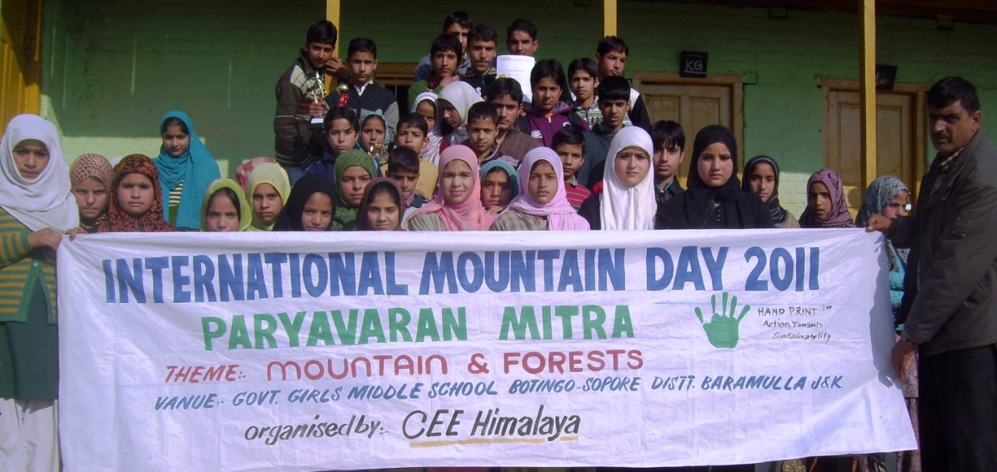
Figure 2 Students, Teachers and the CEE Himalaya Team at Govt. Girls’ Middle School

