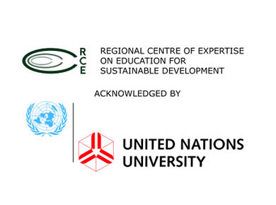
2nd AFRICAN YOUTH VIRTUAL CONFERENCE OF THE UNU RCEs
Organised by RCE Minna, Nigeria in Collaboration with RCE Grand Rapids, Michigan USA
13th September, 2017
REGISTRATION FORM
Response due by 6th September, 2017 via email to: isaibnmd@gmail.com and akijaff@gmail.com
Please provide us with the following information. This will assist us in the development of our program and help to make this an exciting and memorable experience. This conference will be conducted in English Language.
Name of RCE:
Address of RCE:
Contact Person(s):
Email:
Phone number:
Anticipated Number of Participants:
Anticipated Number of Audience:
Names of Team Members:

Name of Moderator:
Please List any additional question:

