GGF PROJECT KAYA AWARENESS MATERIAL FOR PRESENTATION TO SCHOOL CHILDREN IN SCHOOLS AROUND KAYAS KAUMA (JARIBUNI) AND TSOLOKERO (JUNJU).
Step | Sub topic | Activities | Facilitators notes
1 (2 min) | Introduction of presenter or facilitator, KICORNET and NMK CFCU | Facilitator Introduce self and organization (KICORNET) and explains the link between KICORNET and NMK CFCU- the Government custodian and duty bearer of Kaya forests conservation and management.  Students listen keenly, take notes | My name is --------------and am a member of Kilifi Natural Resources Network (KICORNET). We are implementing an awareness project for school children around kaya forests in partnership with National Museums of Kenya (NMK) Coastal forest conservation unit (CFCU) Kilifi. NMK is a state agency working for the protection of natural and cultural heritage in Kenya. I am happy and privileged to be the one to discuss this topic of conservation of kaya forests. I guess this topic is familiar with many of you and therefore we will all be learning and enriching our understanding. Welcome and feel free to contribute should I ask you to contribute to the discussion.
2 (10 mins) | Conservation of Mijikenda kaya forests | Introduce the topic and assure students you will be discussing it with them in a participatory manner for about an hour and will be free to ask questions at the end of the presentation. Advice them to take note of the questions as the lecture / lesson progresses so it does not escape their minds.  Find out how much knowledge the students know about the kaya  Ask the following questions and positively appreciate and acknowledge the responses. Take note of the participants contributions on the chalk board and enrich with facilitators material.  By a show of hand,  - How many of you have heard about a kaya  - Has any one of you been to or visited the kaya? When was that and what were you going to do?  - What is the name of the kaya closer to you and which you identify with  - What do you understand to be the meaning of kaya. What is the difference between kaya and kaya forest.  - Who are the custodians of the kaya. Has anyone ever met them? How do they look like/ what features distinguish them/ how would you identify them, among their peers. Any one related closely to one of them.  Appreciate that the students know a lot about the kaya and that you will not be discussing something new but building onto their understanding of a familiar object.  The responses provide essential statistics which need to be noted as the lecture progresses by gender.  Enrich their understanding with briefs of the following text on the meaning, location and custodians of the kaya.  Students listen attentively, respond to questions and take notes | The topic is Conservation of the Mijikenda kaya forests. It is my hope that we will all participate in discussing this topic. Anyone with a question should write it someplace and towards end of the topic will allow time to ask and will together answer them. Now I beg to start and hope we will have covered what we have planned for you after an hour.  Meaning of kaya, location and custodians of kaya include diagram of spatial arrangement of kaya  No of students who have heard about kaya Yes NO  No of students who have visited the kaya Yes No  How long was that and what was the mission Less than one year/ one year/ over a year mission  What is the name of the kaya your ethnic group identifies with and where is it located  How many of you understand the meaning of kaya and can differentiate between kaya and kaya forest  Who are the custodians of the kaya. Has anyone ever met them? How do they look like/ what features distinguish them/ how would you identify them, among their peers. Any one related closely to one of them.  Thank you so much students. You have a lot of prior knowledge about the kaya and this will make my discussion fairly simple.  Kaya means an ancestral home or homestead for the Mijikenda community. Mijikenda means 9 homesteads for the Digo, Duruma (Kwale County), Giriama, Rabai, Ribe, Kambe, Jibana, Chonyi and Kauma (Kilifi County). These homes were situated in deep forests- kaya forests and were accessed through narrow footpaths. The Mijikenda believe they came from Singwaya and settled in the kaya to hide away from war like Ormas and Gallas who were pursuing them to steal their cattle and also avenge killings of their people by the Mijikenda.  Lets now discuss the kaya in detail with specific reference to kaya Kauma. Draw diagram on the board and explain spatial arrangements.  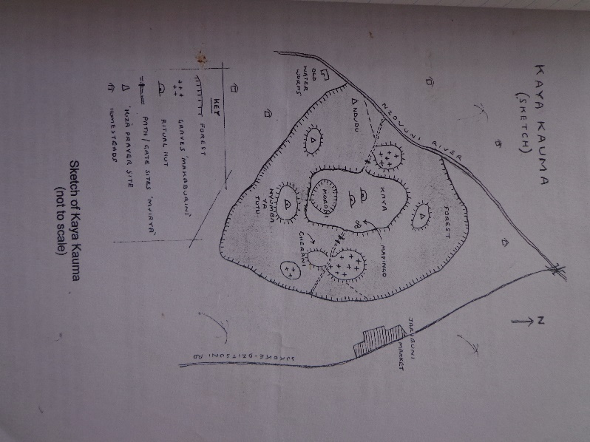  The main custodians of the kaya are the traditional council of elders ( kaya committee of elders). They oversee day to day activities of the kaya, make rules against excesses of resource use, administration of the people, lead in prayer and cultural activities and also settles conflicts within the community. Elders are very prominent and conspicuous personalities, highly respected and often dressed in traditional regalia and carry a long stick as symbol of authority.
Step 3 (8mins) | Importance of kaya forests | How many of you believe the kaya forests are important?  Let us list the importance of the kaya forests to the Kauma community  Facilitator appreciate every contribution and enrich it with the materials provided. Include importance nationally and globally.  Students listen keenly, answer questions and take notes | Local, national and global importance of kaya forests  - Places of Spiritual prayer, shrines, altar, cleansing rituals and traditional ceremonies  - Reference to the history and tradition of the people  - Burial sites and home of the ancestors  - Socio-political center and symbol of unity and identity of the community  - Support a high diversity of life (plants, animals, fungi and other creatures) on which community highly depends on and has potential undiscovered value to humanity. Some of these are found nowhere else in the world.  - Ecological benefits- climate, aesthetics, etc.  - National heritage  - World heritage
Step 4 ( 5mins) | Challenges facing the kayas or need for protection of the kaya forests | How many of you believe that the existence of kaya forests is under threat. Can we together list the threats facing the kaya forests that make it necessary for their protection. Ask one of the teachers to help capture their responses on the board. Applaud them for the great effort as you enrich with facilitators notes.  Students listen attentively, answer questions and take notes | Challenges facing the kaya  - Declining respect for traditional management systems  - Persisting low levels of awareness on the value of forests and linkage with our sustenance among youth, women and men.  - Inadequate Livelihood options for community.  - Weak community organization, the lack of legal recognition for traditional institutions  - High dependence on forest resources by communities.  - Elderly unfairly targeted for elimination over allegation of witchcraft  - Use of kaya forests as hideouts by illegal groups
Step 5 (5mins) | Kaya protection measures | Find out what measures the students recommend for safeguarding and conservation of their kaya forests. Ask another teacher to help with writing them on the board and you enrich and appreciate any response.  Students pay attention, answer questions and take notes | Kaya protection measures  - Boundary demarcation, survey and gazettement of kaya forest areas as National Monuments- 42 kayas gazetted as NMs and FRs and listing as world heritage sites under UNESCO in 2008 ( 8 listed as WHS including Kaya Kauma).  - Urgent safe guarding, documentation and dissemination of traditional cultural practices associated with the kayas  - Education and awareness to communities around kayas, students in schools around kaya localities  - Forest patrols and monitoring – using KFS rangers, Police, Community guards  - Livelihood programmes to diffuse pressure on forests such as bee keeping, woodlot establishment on farm, eco and cultural tourism, butterfly rearing,  - Strengthening community kaya institutions by respecting the elders and traditional cultural regulations, combining modern and traditional system of forest governance and management, strengthening laws to deter invaders  - Promote Research on natural and cultural heritage
Step 6 (10 Mins) | The role of school children in conservation of kaya and environment in General | Do you think as students we have a role to play in the conservation of kaya forests? How many say yes or No or have no answer. Get the two or three groups and let them debate it out among themselves/ present their case and the teachers to take note of the presentations. Enrich and applaud great contributions.  Students listen keenly, answer questions and take notes | Role of school children in kaya and environment conservation  - Documentation and dissemination of traditional cultural practices associated with the kayas among peers, community  - Education and awareness to communities, students in schools around kaya localities  - Advice and Reporting those destroying forests to authorities  - Support Livelihood programmes to diffuse pressure on forests such as bee keeping, woodlot establishment on farm, eco and cultural tourism, butterfly rearing,  - Showing respect to kaya elders and traditional cultural management system and supporting their efforts
Step 7 (5 Mins) | Application to conservation of environment in the school | Forests areas are getting smaller by the day and need to protect any vegetation you have around. What activities are we going to undertake in the school to help better the school environment . Take their responses.  Students listen attentively, answer to questions and take notes | How we can apply this knowledge in our local school settings  - Educating and creating awareness to our colleagues in school, parents and community to respect the environment and safeguard green vegetation in the compound.  - Participate in activities that enhance the quality of environment such as cleaning, proper disposal of waste, recycling, planting trees in the compound, taking good care of our trees  - Showing Respect for the elders- teachers, workers, parents and neighbours for peaceful coexistence  - Promote good environment practices such as energy saving, minimizing water loss, sanitation and good hygiene  - Showing appreciation and respect to the school culture and community culture
Step 7 (5 mins) | Conclusion | Thank the students for their time and wonderful contribution to the topic of discussion. Assure them you highly value their contributions and will be used with other lectures in future to make the presentations more appealing. Thank the school management and the teachers for helping you and assure them that you are available to help in giving talks about the environment in the future if needed. Respond to questions by students and teachers.  Students listen attentively
Step 8 ( 5 mins) | Evaluation. | Find out how many students found the lecture useful. What was interesting and what was not interesting. Encourage them to speak out without fear and assure them its for the purposes of improving future facilitations to the other students.  Students make appropriate responses

By
KICORNET Secretariat
January 2017

