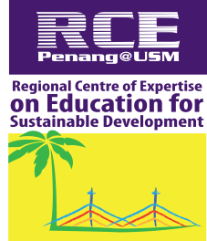
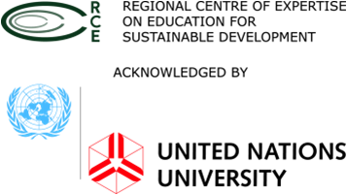

RCE SEJAHTERA YOUTH
UNIVERSITI SAINS MALAYSIA
ACADEMIC SESSION 2018 / 2019

PROJECT TITLE:
INTERNATIONAL BEACH CLEAN UP
ORGANIZER:
RCE SEJAHTERA YOUTH USM
WITH PARTNERSHIP:
REGIONAL CENTRE OF EXPERTISE ON EDUCATION FOR SUSTAINABLE DEVELOPMENT (RCE ESD) PENANG, USM
REEF CHECK MALAYSIA
VENUE :
PANTAI SUNGAI BATU, TELUK KUMBAR
DATE:
29th OF SEPTEMBER 2018 (SATURDAY)

1.0 OVERVIEW
The International Beach Clean Up programme is part of a global environmental movement and is important as an educational programme for all participants. A beach clean-up allows individuals and community to come together regardless of different background and interests, and address the issue of marine litter on our beaches and its impact. The overall aim is a local and global improvement of our beaches and coastlines. Through this programme, the community can participate and get exposure on waste management and environmental protection

- OBJECTIVES
  - To increase public awareness on the need to protect and preserve our natural environment
  - To encourage people to take part in the environmental activities
  - To build awareness of the problems that are caused by garbage left on the beaches

- TENTATIVE

Place :Pantai Sungai Batu, Teluk Kumbar, Pulau Pinang
Date : 29th of September 2018
Time : 7.00 am – 1.00 pm
Time | Activities
7.30 am | Depart from USM
8.00 am | Briefing to volunteers
8.30 am | Start clean-up
11.00 am | Volunteers bring all the trash collected to starting point  Separate waste according the catogeries  Record and submit the data to Clean Swell App Reef Check Malaysia
1.00 pm | End of clean-up

4.0 PARTICIPATION
This programme involve group from :

  - RCE Sejahtera Youth committee USM
  - Students from USM
  - RCE members

5.0 BUDGET

INCOME TOTAL  (RM/UNIT) | EXPENSES PRICE NUMBER TOTAL  (RM) (UNIT) (RM)
PARTICIPATION FEE  RM 5 x 80 Unit RM 400  TOTAL INCOME RM 400 .00 | TRANSPORTATION  Bus 280 2 560  MEALS  Breakfast 1 80 80  Lunch 4 80 220  GLOVES 2 40 80  PLASTIC 5 2 10  TOTAL EXPENSES RM 950.00

6.0 REFLECTION

This project helps in increasing public awareness on the need to protect and preserve our natural environment. It also encourages people to take part in the environmental activities and most importantly to build awareness of the problems that are caused by rubbish left on the beaches. Basically, this project is implemented not just to collect and segregate the recyclable and non-recyclable items but to join hands with volunteers and local community so that they can see by themselves about the amount of waste being produced hence can build awareness at a large scale for the future of mankind, flora and fauna especially animals that live in oceans that are deeply affected by the rubbish especially plastic bags and straws.

7.0 CONCLUSION

Beach clean up can be implemented more successfully if we receive full cooperation and support from all parties. This programme also aligns well with the Penang State Government’s campaign of “Greener & Cleaner Penang”. By doing more programme like this, it can help to educate students and Penang communities at large on importance of maintaining cleanliness of our healthy environment thus making Malaysia a greener nation. We also hope that our participants and people around the world can practice sustainable living and try to reduce amount of waste. We are looking forward for greener Universiti Sains Malaysia, a greener Penang, a greener Malaysia and thus a greener world

- ATTACHMENTS
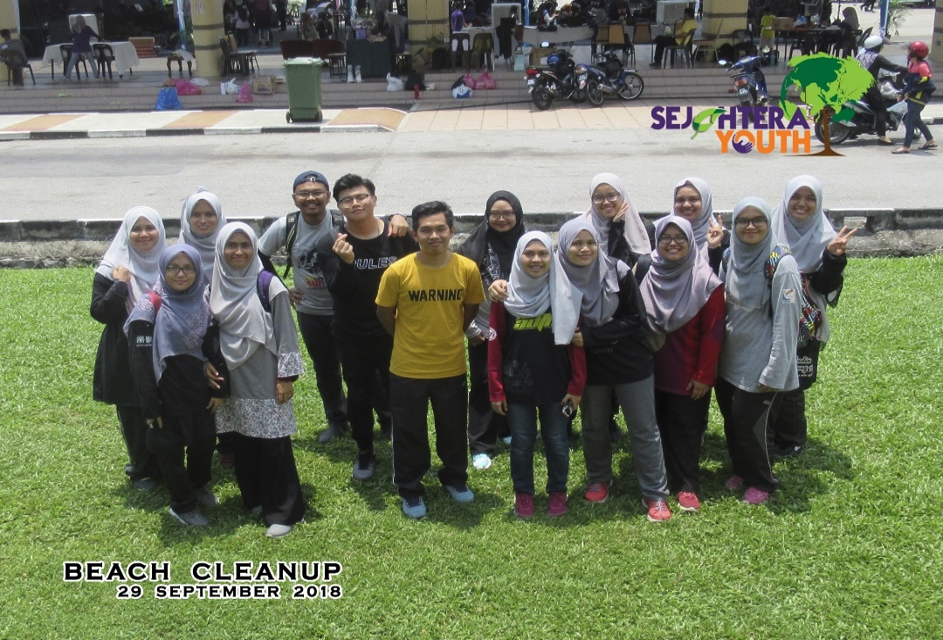

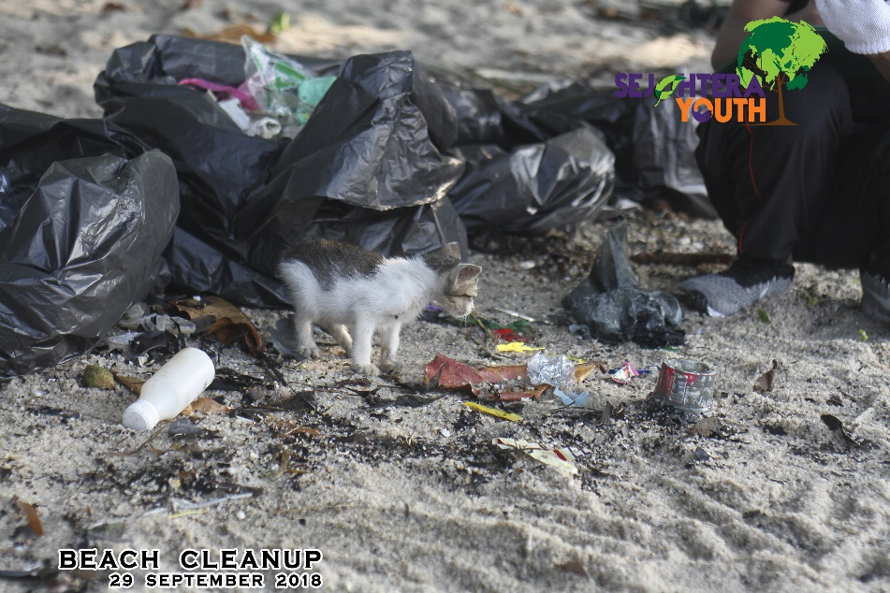

Photographed by Nur Hidayah Zainuddin, (Secretariats for International Beach Clean Up 2018)
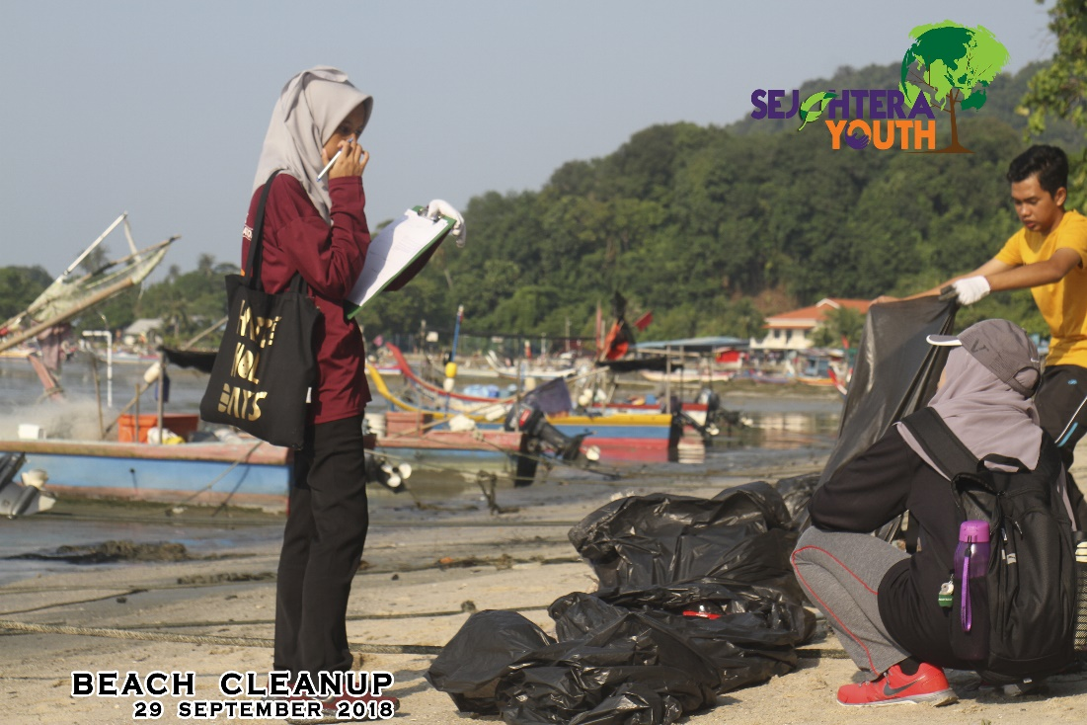

Photographed by Hazreen Eleida Binti Adnan,(Volunteers segregate the waste)

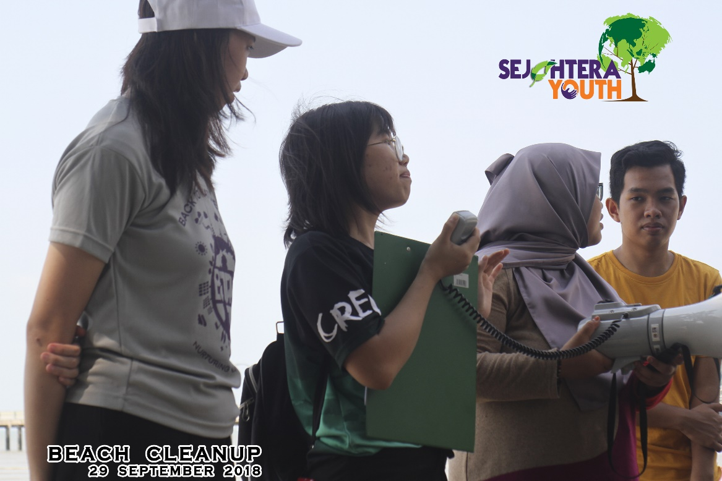

Photographed by Mohd Arief Alba, (Disscussion during International Beach Clean Up)

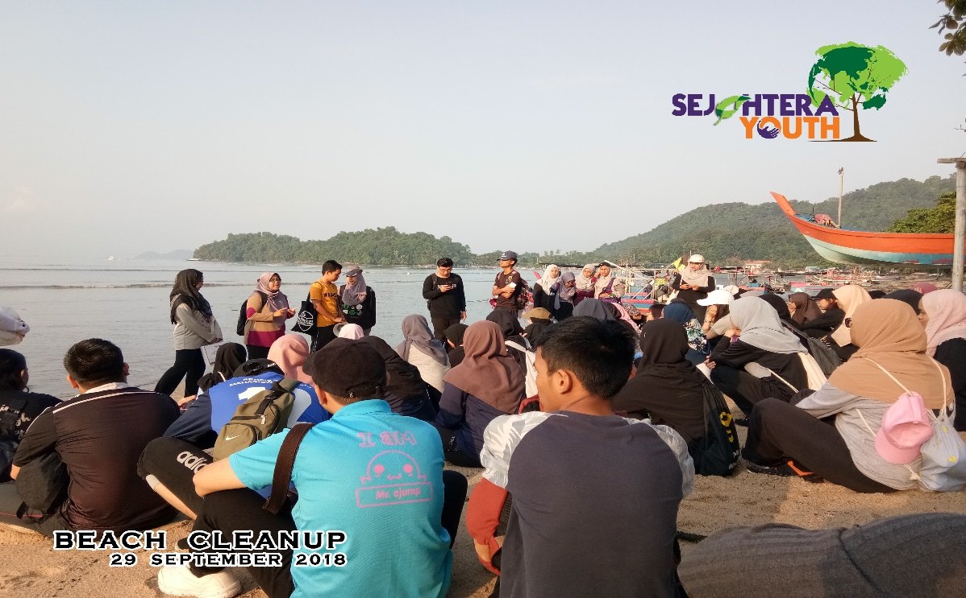

Photographed by Hazreen Eleida, (Briefing session)
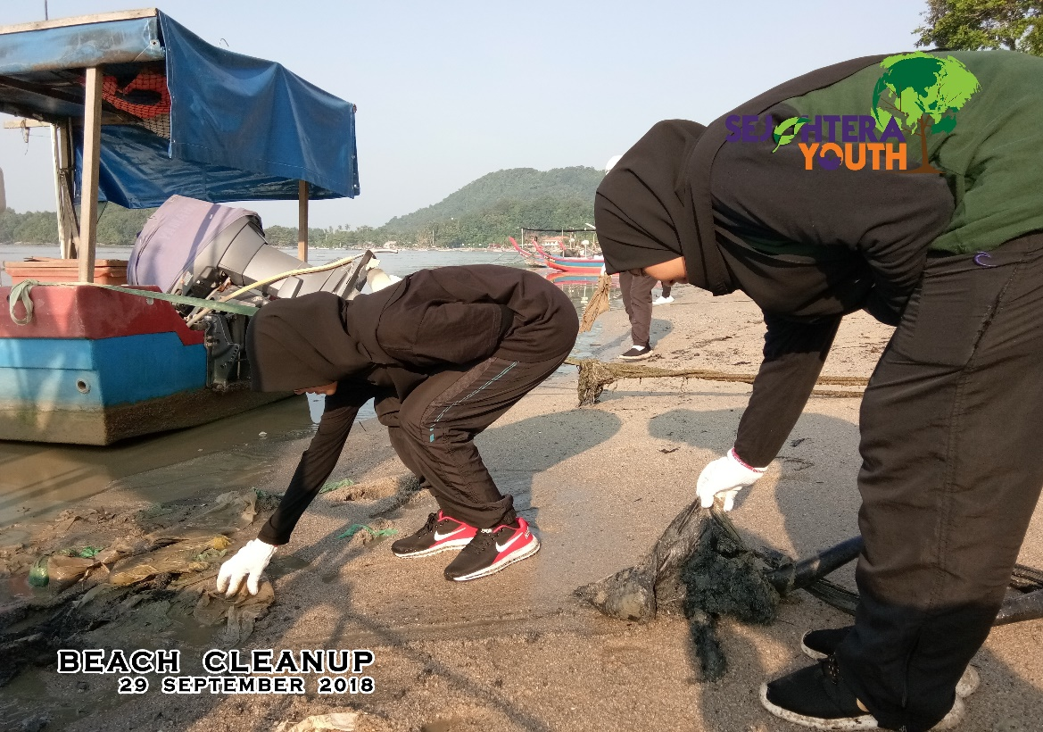

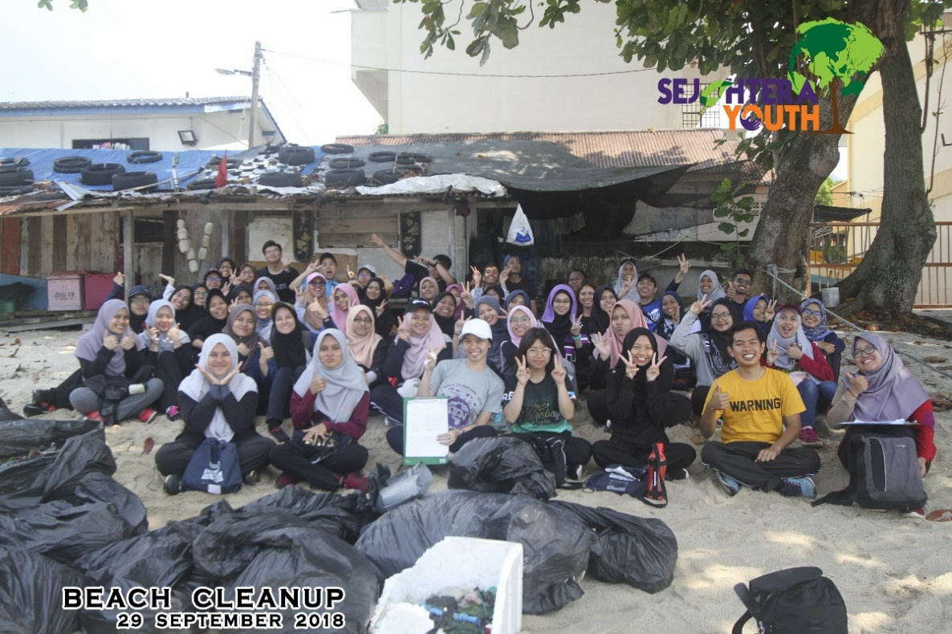
Photographed by Mohd Arief Alba, (Volunteers are collecting rubbish)

Photographed by Mohd Arief Alba, (Volunteers during International Beach Clean Up)

