**CONNECTIONS - THE PLAYERS**

**Penrith City Council** Andrew Hewson

Sustainability Education Officer

**Mamre House** Steven Fleischmann

Farm and Community Development Manager

Mamre, a project of the Sisters of Mercy Parramatta, commenced in 1986 with a vision to be ‘A place of promise where individuals are enabled to realise their potential and contribute to the community’.

**UWS** UWS Centre for Educational Research

UWS Office of Sustainability

UWS SELP Office of International

The Social Engagement and Leadership Program (SELP) is focused on developing students’ employable competencies. Small teams of domestic and international UWS students engage voluntarily on projects of social and community value.  It is anticipated that projects of between 16- 20 hours per project. The role of the community partner is vital for the success of this program.

**NSW Office of Environment and Heritage – OUR PLACE**

**Sustainable Communities**

‘Our Place Greater Western Sydney’: a funded research partnership between the Centre for Educational Research, University of Western Sydney (UWS), the Office of Environment and Heritage (OEH), NSW government, and the United Nations Regional Centre of Expertise on Education for Sustainable Development, Greater Western Sydney (RCE-GWS) to find out what places matter to these local communities and how they can be better supported to look after them. Part of this process will be to identify priority environmental issues, develop potential collaborative projects and link interested groups with resources and seed funding

**CONNECTIONS - THE STORY**

**THE STORY by:**

**ANDREW HEWSON**

**SUSTAINABILITY EDUCATION OFFICER**

I just talked to Steven Fleischmann who works at Mamre House, and thought I’d share this great little good news story. It’s a great reminder of how the work we all do is interconnected.

In 2013 the Centre for Educational Research and the RCE-GWS led ‘Our Place Western Sydney’ project which held a series of community forums. At one of these forums, Steve, on behalf of Mamre House, connected with a local lady called Zuzanna as part of developing a small collaborative project. Zuzanna is a great sustainability champion, and permaculture advocate. Together they were successful in getting seeding funding from the Our Place project, to actually establish the seed saving group and buy the equipment and so on to get started. Mamre house also participated in the UWS SELP program. They had a group of students develop a business case and do some business modelling around establishing a community seed saving program. The group still meets monthly, and Zuzanna started volunteering at Mamre because she was so interested in their work. She has since been employed at Mamre House as a Social Enterprise Officer. The back story to all of this was Zuzanna’s interest in sustainability and permaculture was peaked when she attended one of Council’s community workshops on permaculture, 3 or 4 years ago. Following this, her and her partner gave their whole home a permaculture makeover, and have been passionate about it ever since. Often we tend to do a project and then move onto the next one, so its great to be able to see how they link together and are creating real and positive change in our communities.

**CONNECTIONS - THE TIMELINE:**

1. **Penrith City Council – Permaculture Community Workshops**
2. **OUR PLACE Community Forum 13th June 2013**

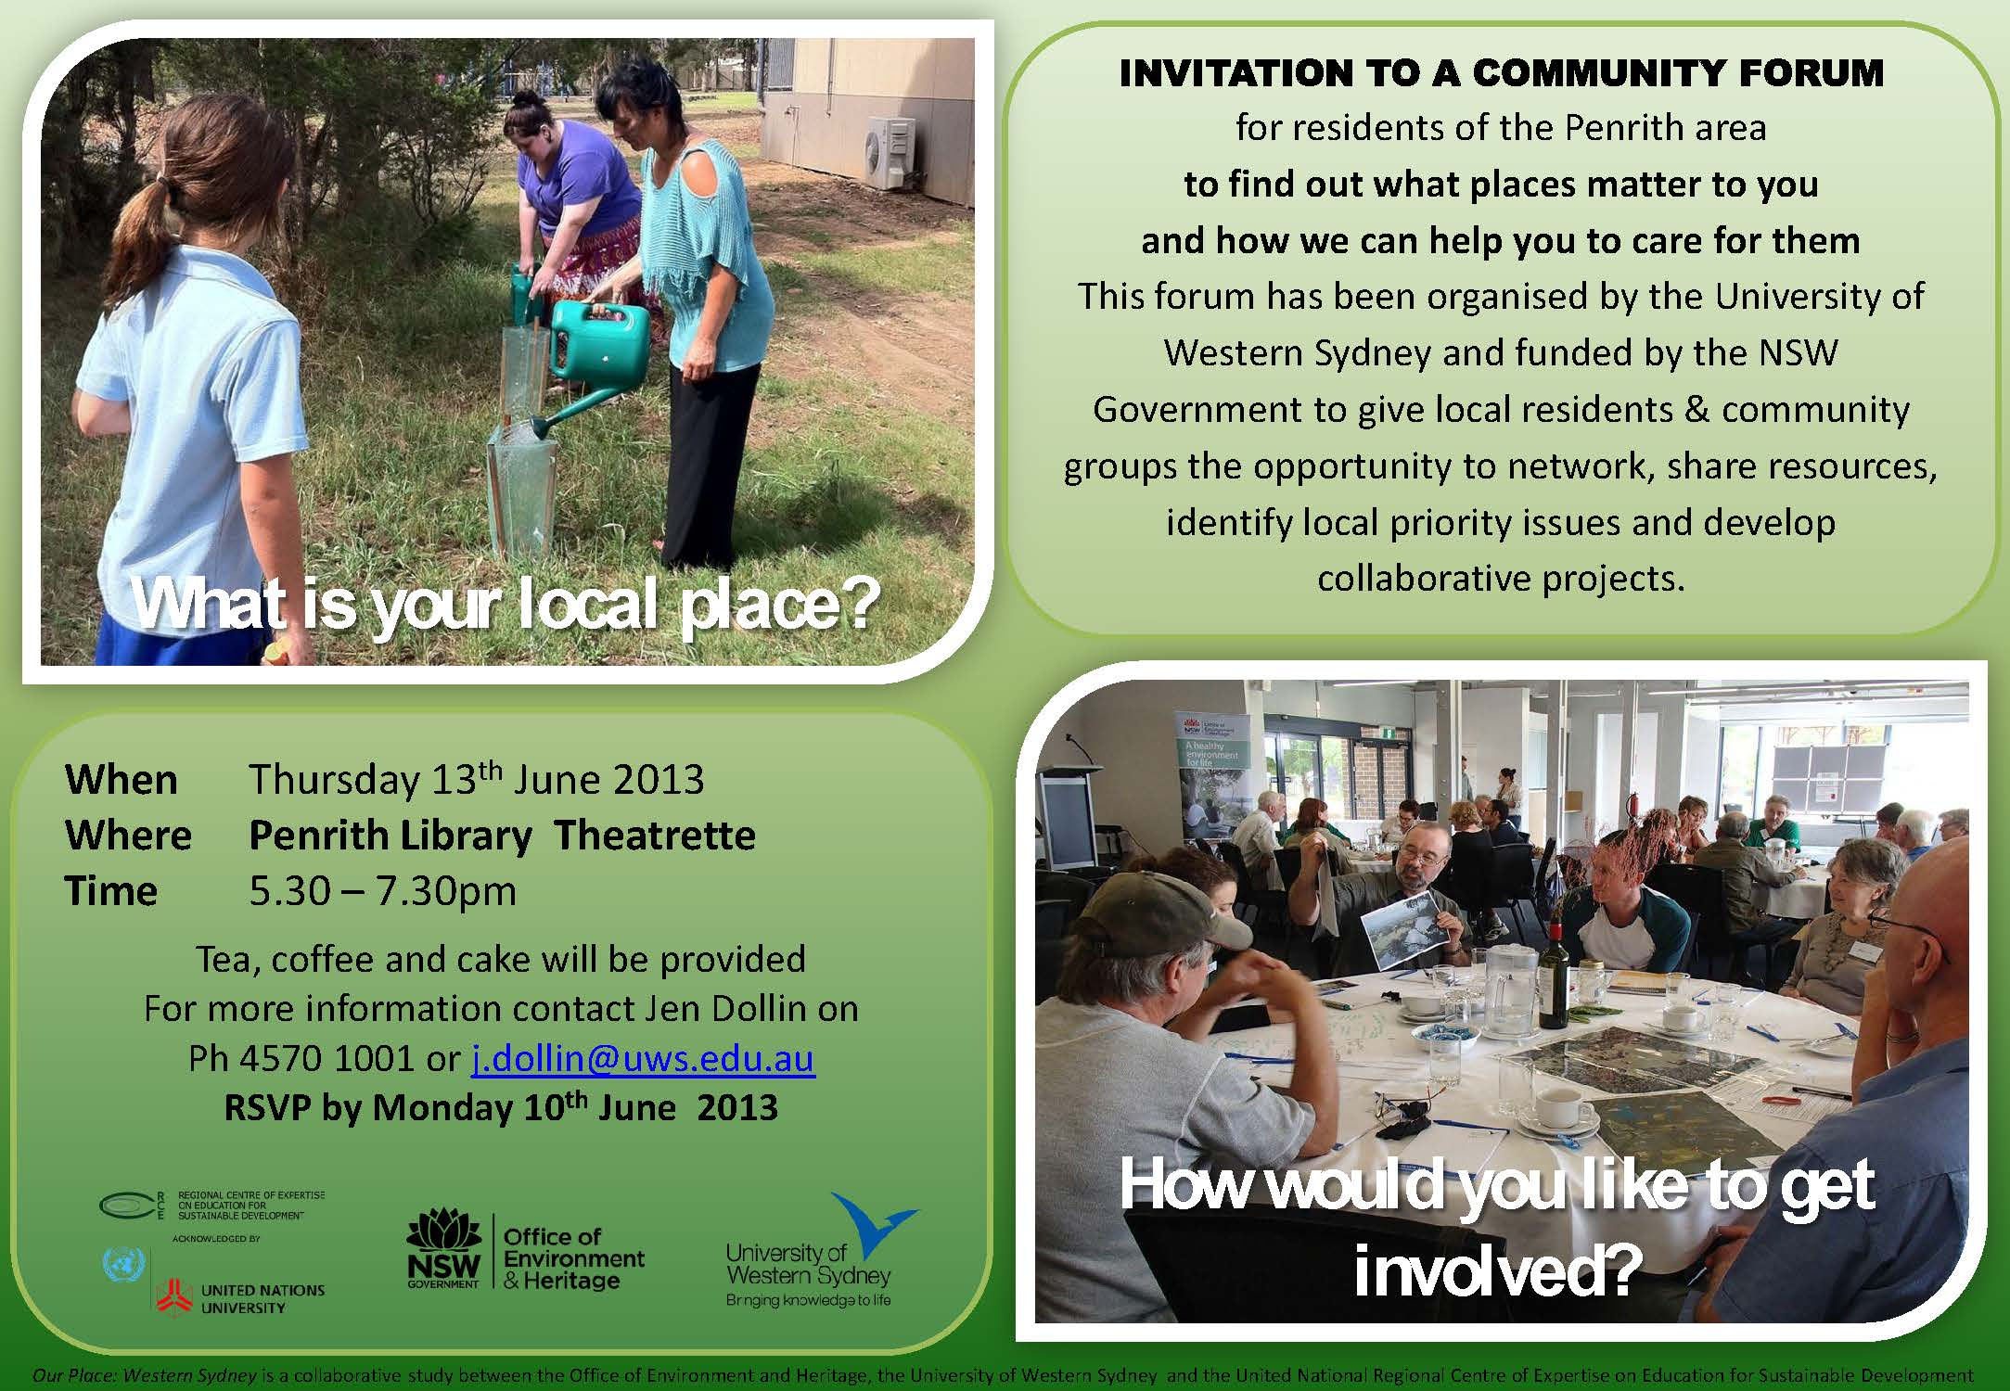

1. **SEEDS Development**
2. **UWS SELP**

**ATTACHMENT 1 - Background**

**Attendance:**

**From:** Steven Fleischmann [<mailto:steven.fleischmann@mamre.com.au>]   
**Sent:** Thursday, 6 June 2013 2:36 PM  
**To:** Jen Dollin; Rosemary Bishop  
**Subject:** Re: FW: Our Place Forum 13th June

Hi Jen,

Ill be there representing Mamre - Ill bring some produce form the farm and some other items that represent us if that is ok.

Steve

**From:** zuzana [<mailto:zuzanacernak@aol.com>]   
**Sent:** Wednesday, 15 May 2013 9:48 AM  
**To:** Jen Dollin  
**Subject:** Fwd: Great sustainability project, have your say on local sustainability matters

Hi Jen

My husband Robert Frketic and I (Zuzana Cernak-Frketic) would like to be part of this project. Please book us in.

All the best

Zuzana Cernak-Frketic

0415 310 068

-----Original Message-----

From: Hewson Andrew <[ahewson@penrithcity.nsw.gov.au](mailto:ahewson@penrithcity.nsw.gov.au)>  
Sent: Tue, May 14, 2013 5:21 pm  
Subject: Great sustainability project, have your say on local sustainability matters

Hello

The University of Western Sydney (UWS) are currently coordinating a project to look at how communities across Western Sydney relate to their local area and their local environment. One of the communities of interest to them is Penrith, and how people in our area relate to our environment. The other exciting part of the project is that UWS have a small amount of seed funding, which will be used to help kick start and assist sustainability projects in the Penrith area. In addition the process will help to identify larger funding sources. Council is a supporter of the project, and we’re really looking forward to the findings and the outcomes.

UWS have asked me to identify people we think would have valuable input. I was thinking that with your passion for sustainability and experience in working with others, you’d be a great person to be involved. It’s a great opportunity to share your views and ideas on what we as a collective whole should be focusing to improve the sustainability of the Penrith region. With the funding that they have and their connections, it’s also a great opportunity to share any projects or ideas you’ve had, but weren’t sure how to take them further.

A key part of the project is a forum which is being held on Thursday 13 June at the Penrith Library. I have attached the flyer for this forum for your information. I’d really like to encourage you to have your say and get involved in the project. As I said we believe it will be a valuable project with some great tangible outcomes. If you are interested in being involved, or even just getting updates as the project progresses, please let Jen Dollin at UWS know. I have pasted her details below. I am also happy to pass your details onto Jen at UWS if you would prefer.

***Jen Dollin***

[J.Dollin@uws.edu.au](mailto:J.Dollin@uws.edu.au)

Sustainability Coordinator | Office of Sustainability | University of Western Sydney

Locked Bag 1797 | Penrith | NSW 2751 | Ph 02 45 70 1001  | Mobile 0422 311 965

Thanks, and thanks for all of your work in helping to promote sustainability to our communities.

Regards,

**ANDREW HEWSON**

**SUSTAINABILITY EDUCATION OFFICER**

E [ahewson@penrithcity.nsw.gov.au](mailto:ahewson@penrithcity.nsw.gov.au)

T (02) 4732 7983 | F (02) 4732 7958 | M 0423 021 897  
PO Box 60, Penrith NSW 2751

**cid:image001.jpg@01CD2876.05C08F10**

[penrithcity.nsw.gov.au](http://www.penrithcity.nsw.gov.au/)

**From:** Jen Dollin   
**Sent:** Monday, 17 June 2013 12:23 PM  
**To:** steven.fleischmann@mamre.com.au; zuzana  
**Cc:** Sheila Mylvaganam; Alicia Kasbarian  
**Subject:** RE: Social Engagement and Leadership Program (SELP) - Mamre House

Dear Steve, Zuzana and Robert

Let me know if you need any help with this - SELP would be perfect for the information you need on SEED bank best practice. From a UWS perspective it would be just fantastic to have our students out to Mamre House and understand more about the fantastic work you are doing.

**Some further background:**

The Social Engagement and Leadership Program (SELP) is focused on developing students’ employable competencies. Small teams of domestic and international UWS students engage voluntarily on projects of social and community value.  It is anticipated that projects of between 16- 20 hours per project. The role of the community partner is vital for the success of this program.

PS I was such a wonderful night last Thursday at Our Place - we will need to look at how to support this network to stay in touch.

As ever

Jen

***Jen Dollin***

Sustainability Coordinator | Office of Sustainability | University of Western Sydney

Locked Bag 1797 | Penrith | NSW 2751 | Ph 02 45 70 1001  | Mobile 0422 311 965

**Please visit the UWS Bringing Sustainability to Life website:**

[**http://www.uws.edu.au/sustainability**](http://www.uws.edu.au/sustainability)