**International Webinar of the RCEs of Asia-Pacific Region**

**Celebrating ‘International Mountain Day’ 2020**

(Highlighting SDGs 1, 2, 13 & 15)

Theme: **Mountain Biodiversity**

Friday, **11th December 2020**; **10:30-12:30 hrs Indian Standard Time (IST)**

**Objectives**

* To create awareness about the importance of mountains and mountain people, and to inspire governments to launch urgent policies to alleviate the harsh living conditions of mountain people.
* To address aspects such as Institution building, and training and capacity building which will help strengthen the RCE Community.

**Background**

The roots of the ‘International Mountain Day’ date back to 1992. In that year, at the United Nations Conference on Environment and Development (UNCED), a document entitiled, [“Managing Fragile Ecosystems: Sustainable Mountain Development”](http://www.fao.org/fileadmin/user_upload/mountain_partnership/docs/Agenda21.pdf) was adopted as part of the action plan [Agenda 21](https://sustainabledevelopment.un.org/outcomedocuments/agenda21). It was agreed upon that fragile mountain ecosystems needed to be protected and developed sustainably.

On 11 December 2001, the United Nations declared the year 2002 as the ‘International Year of Mountains’ for the awareness and importance of mountains. On 20 December 2002, the UN declared 11 December as ‘International Mountain Day’ for the awareness of mountain development, and urged the international community to hold events relating to sustainable mountain development on this date. The [Food and Agriculture Organization](http://www.fao.org/nutrition/en/" \t "_blank) (FAO) was appointed as the coordinating organization of the UN regarding this mission. The first ‘International Mountain Day’ was observed on 11 December 2003.

Each year, the UN allocates a theme for this day. This year, ‘International Mountain Day’ falls on Friday 11, December 2020, and the theme is ‘Mountain Biodiversity’.

Climate change, unsustainable farming practices, commercial mining, logging, and poaching all exact a heavy toll on mountain biodiversity. In addition, land use, land cover change, and natural disasters, accelerate biodiversity loss and contribute to creating a fragile environment for mountain communities. Ecosystem degradation, loss of livelihoods and migration in mountains can lead to the abandonment of cultural practices and ancient traditions that have sustained biodiversity for generations.

The sustainable management of mountain biodiversity has been increasingly recognized as a global priority. Sustainable Development Goal 15, target four, is dedicated to the conservation of mountains’ biodiversity in consideration of its global relevance. Biodiversity in all ecosystems is in focus, as the United Nations has declared 2021 to 2030 the UN ‘Decade on Ecosystem Restoration’. Hence governments are now preparing to negotiate the post-2020 global biodiversity framework for adoption this year at the [15](https://www.cbd.int/cop/)[th](https://www.cbd.int/cop/) [meeting of the Conference of the Parties (COP 15) to the Convention on Biological Diversity (CBD)](https://www.cbd.int/cop/).

Key facts on mountains:

* Mountains host about half of the world’s biodiversity hotspots and 30% of all Key Biodiversity Areas.
* Of the 20 plant species that supply 80% of the world's food, six originated and have been diversified in mountains: maize, potatoes, barley, sorghum, tomatoes, and apples.
* More than half of humanity relies on mountain freshwater for everyday life.

**Speakers**

**Opening Remarks**

**Mountains: Upstream-Downstream, Sustainable Mountain Development**

Covering around 27 percent of the earth's land surface, mountains play a critical role in moving the world towards sustainable economic growth. Mountains not only provide sustenance and well-being to 1.1 billion mountain people around the world but also indirectly benefit billions more living downstream. Mountains provide freshwater, energy and food - resources that will be increasingly scarce in coming decades. Mountains are prone to natural disasters and the vulnerability of mountain people for disasters is very high. Making mountain communities sustainable, climate smart and disaster resilient warrants immediate and urgent attention.

Speaker:

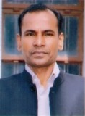

**Mr L. Venkateshwar Lu, IAS** Director General, Uttar Pradesh (UP) Academy of Administration & Management, and State Institute of Rural Development, UP, India.

Previously he served as Collector, Additional Registrar, Director, Managing Director, Divisional Commissioner, Relief Commissioner, Chief Election Officer, and Principal Secretary to Government of Uttar Pradesh serving various departments.

**Keynote Address:**

**'Mountains'**

Mountains are home to 15% of the world´s population and host about half of the world's biodiversity hotspots. They provide freshwater for everyday life to half of humanity. Their conservation is a key factor for sustainable development. Mountains are under threat from [climate change](https://www.un.org/en/climatechange/) and overexploitation. As the global climate continues to warm, mountain people, some of the world’s poorest, face even greater struggles to survive. The rising temperatures also mean that mountain glaciers are melting at unprecedented rates, affecting freshwater supplies downstream for millions of people.

Speaker:

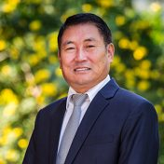

**Dr. Pema Gyamtsho**, Director-General, International Centre for Integrated Mountain Development’ (ICIMOD), Kathmandu, Nepal.

ICIMOD is a regional knowledge development and learning centre serving the eight regional member countries of the Hindu Kush Himalaya (HKH) – Afghanistan, Bangladesh, Bhutan, China, India, Myanmar, Nepal, and Pakistan – based in Kathmandu, Nepal. Globalization and climate change have an increasing influence on the stability of fragile mountain ecosystems and the livelihoods of mountain people. ICIMOD aims to assist mountain people to understand these changes, adapt to them, and make the most of new opportunities, while addressing upstream and downstream issues.

**‘Disaster Risk Reduction and Crisis Management’**

In the wake of increasing disasters, both in frequency and magnitude, and currently the COVID-19 pandemic, DRR Preparedness for all warrants urgent attention and becomes need of the hour, now and for ever. Crisis Management is equally important needed to be learnt by everyone. RCEs can help reduce the vulnerabilities and increase the capacities of their local communities in dealing with disasters.

Speaker:

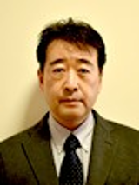

**Mr. IGARASHI Hitoshi**, Professor at the Faculty of Risk and Crisis Management at the Chiba Institute of Science

Mr. IGARASHI Hitoshi, is an experienced researcher and expert in Crisis and Emergency Management. Dr. Igarashi has helped in developing the Emergency Response System, provided expertise in the Emergency response and relief projects in Lusaka, Zambia, Phnom Penh, Cambodia, and Jakarta Indonesia.

**What’s in it for the Asia-Pacific RCEs?**

Two important aspects that will help strengthen the RCE community will be addressed in this webinar - Training and Capacity Building, and Institution Building.

Training and Capacity Building:Another important aspect for all the RCEs is Training and Capacity Building. We must learn how we can develop our people so that they can drive initiatives and produce long-lasting, life-changing results. Challenges faced by the local communities remain dynamic triggering dynamic role ESD has to play. For RCE community to keep pace with the dynamic roles ESD has to cater to ‘training and capacity building’ attains high importance.

Speaker:

**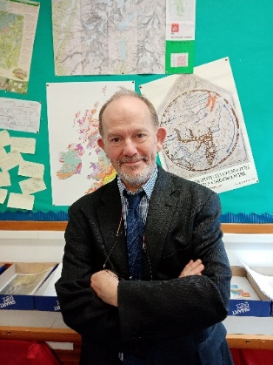**

**Dr. James Hindson**, Moreton Hall School, Shropshire, Formerly Director, International Programmes, Field Studies Council, United Kingdom.

He has delivered training programmes and environmental education projects in around 40 countries throughout the world ranging from Chile through to Russia, Central Asia and India. Currently he is teaching in Moreton Hall School and working on local environmental projects in the UK, Poland and Kenya.

Institution building: Most RCEs are hosted by some institutions and do not have their own assets. There are a handful of people, sometimes just one person, who handles RCE affairs. When the person leaves, the RCE work comes to a standstill. Human resource, next line of leadership, financial resources, resource efficiency, corpus building, sustainability, Standard Operating Procedures, creating a niche, branding, achieving excellence are some of the important considerations.

**Speakers:**

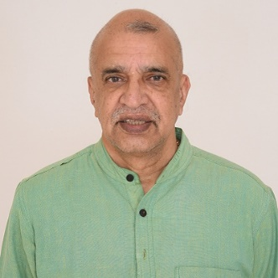

**Prof. Anant Darshan Shankar** is the Managing Trustee of the Foundation for Revitalization of Local Health Traditions (FRLHT) and Vice Chancellor of the Trans-Disciplinary University (TDU), Bangalore. Prof. Anant started an institution ‘Foundation for Revitalization of Local Health Traditions’ (FRLHT) and developed it into an innovation centred University named TDU. TDU is recognized by the University Grants Commission, India and a first of its kind University in India. All the programmes seeded during 24 years (1993-2014) of nation building achievements and pioneering work of the FRLHT have been adopted by TDU and are today being expanded. This is a brilliant success story.

**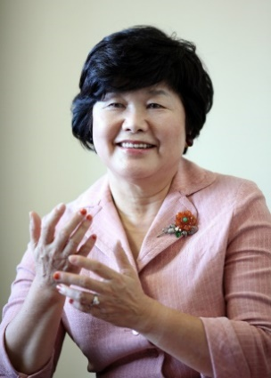Dr. (Ms.) Eun-kyung Park**, Founder and Chairperson, Sejahtera Forest Centre, Tongyeong ESD Council, RCE Tongyeong, Republic of Korea.

RCE Tongyeong has its own campus on a huge chunk of land, its own full-fledged building, staff, guest rooms, dormitories, cafeteria, library etc. It has an annual budget from the local Government. It gives fellowships, holds Youth programmes for the entire Asia-Pacific region, even other regions. They have mainstreamed ESD in schools. Through government orders schools must send their students to Sejahtera Forest Centre (part of RCE Tongyeong) for an orientation. So, they have all year engagement, income and sustainability. Dr. (Ms.) Eun-kyung Park is the architect and mastermind of this RCE. Sharing her experience of conceiving and getting RCE Tongyeong to this stage will be greatly motivating for all the RCEs.

**Concluding Remarks**

Speaker:

**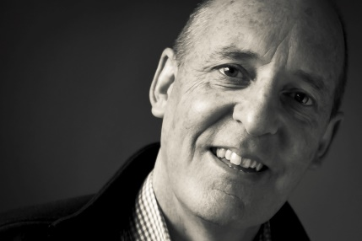**

**Dr. Barry Law**, Director, RCE Otago . Barry has 32 years’ experience in tertiary education at Canterbury University and Otago Polytechnic, specialising in experiential learning, education for sustainability, behaviour change and learner capability. He has been responsible for the development of frameworks to shift business and organisational thinking and practice in these four areas.

|  |  |  |
| --- | --- | --- |
| C:\Users\19806\Desktop\MS Pic.jpg  **Opening Remarks** :  **Ms. Mukvinder Kaur Sandhu**  Chairperson, RCE Kuching,  Chief Operating Officer,  UCSI University Sarawak Campus | **Vote of thanks:**  **Dr. Chinara Sadykova**  Chairperson,  RCE Kyrgyzstan | **Moderator:**  **Dr. Abdhesh Kumar Gangwar**  Coordinator & Focal Point,  RCE Srinagar,  India |

**Date**

Friday 11 December 2020 at 10:30 – 12:30 hrs Indian Standard Time (IST)

05:00 hrs United Kingdom | 10:00 hrs Pakistan | 10:30 hrs India | 10:45 hrs Nepal | 11:00 hrs Bangladesh and Kyrgyzstan |12:00 hrs Cambodia, Jakarta and Thailand | 13:00 hrs Balikpapan, China, Malaysia and Philippines | 14:00 hrs Japan & Korea |16:00 hrs Sydney | 18:00 hrs New Zealand

**Participants**

Asia Pacific RCE Community, ESD stakeholders in the region, government officials, Youth, the general public, and Indigenous communities

**Language**

English

**Virtual Platform and Communications**

Registration Link on: <https://bit.ly/RCENKCH>

Zoom ID: 878 4067 4436 (Link: <https://us02web.zoom.us/j/87840674436> )

Facebook Livestreaming for general public – RCE Kuching

There is no password. Prior registration not required.

**Contact Info**

Abdhesh Kumar Gangwar, Ph.D.

Coordinator and Focal Point, RCE Srinagar

[rcesrinagar@gmail.com](mailto:rcesrinagar@gmail.com)

Mukvinder Sandhu

Vice-Chairperson, RCE Kuching

[mukvinders@ucsiuniversity.edu.my](mailto:mukvinders@ucsiuniversity.edu.my)

[rcekuching@gmail.com](mailto:rcekuching@gmail.com)

**Agenda**

|  |  |  |
| --- | --- | --- |
| **Schedule**  **(IST)** | **Topic** | **Keynote Speakers** |
| 10:30 – 10:33 | Welcome address | Ms. Mukvinder Kaur Sandhu, Chairperson, RCE Kuching, and Chief Operating Officer, UCSI University, Sarawak Campus, Malaysia |
| 10:33 – 10:38 | About the Webinar | Dr. Abdhesh Kumar Gangwar, Coordinator & Focal Point, RCE Srinagar, India |
| 10:38 – 10:46 | Opening remarks | Mr. L. Venkateshwar Lu, Indian Administrative Service, Director General, Uttar Pradesh (UP) Academy of Administration & Management, and State Institute of Rural Development, UP, India |
| 10:46 – 11:00 | Key note address on IMD 2020 | Dr. Pema Gyamtsho, Director General, International Centre for Integrated Mountain Development (ICIMOD), Kathmandu, Nepal |
| 11:00 – 11:15 | Disaster Risk Reduction and Crisis Management | Mr. Hitoshi Igarashi, Faculty of Risk and Crisis Management, Chiba Institute of Science, Japan |
| 11:15 – 11:20 | BREAK | |
| 11:20 – 11:40 | Training and Capacity Building | Dr. James Hindson, Moreton Hall School, Shropshire, Formerly Director, International Programmes, Field Studies Council, United Kingdom |
| 11:40 – 12:00 | Institutional Building Challenges (FRLHT to The University of Trans-Disciplinary Health Sciences and Technology (TDU) a case Study) | Prof. Ananat Darshan Shankar, Vice-Chancellor, TDU, Member, Board of Governors, Founder Trustee, Foundation for Revitalization of Local Health Traditions (FRLHT), Bengaluru, India |
| 12:00 – 12:20 | Institutional Building Challenges (RCE Tongyeong a case study) | Dr. (Ms.) Eun-kyung Park, Founder and Chairperson, Sejahtera Forest Centre, RCE Tongyeong, Tongyeong ESD Council, Republic of Korea |
| 12:20 – 12:27 | Concluding Remarks | Dr. Barry Law, Director, RCE Otago, New Zealand |
| 12:27 – 12:30 | Vote of Thanks | Dr. Chinara Sadykova, Chairperson, RCE Kyrgyzstan |

**END**