IMPROVING ACCESS TO POST GRADUATE EDUCATION FOR THE PEOPLE OF GBARAIN CLAN AND GBARANTORU COMMUNITY IN THE GBARAIN/EKPETIAMA GMoU CLUSTER DEVELOPMENT AREA THROUGH SCHOLARSHIP AWARDS

A PRESENTATION BY

PROF. TUEMI TUDOU ASUKA
(CHAIRMAN, GBARAIN/EKPETIAMA SCHOLARSHIP COMMITTEE)
Alternate Contact of RCE Greater Yenagoa

AND

CHIEF KWEN KEME-IDERIKUMO
(CHAIRMAN, GBARAIN/EKPETIAMA CLUSTER DEVELOPMENT BOARD)
CDB is an affiliate CBO of RCE Greater Yenagoa

AND

SIR ANTHONY WAKWE LAWRENCE
(CHAIRMAN, COMMUNITY INTER-RELATIONS AND CONCILIATION INITIATIVE – CIRCI) MENTORING NGO
Main Contact of RCE Greater Yenagoa and NGO is an affiliate of RCE.

- INTRODUCTION
Educational development at any level of schooling is an imperative for the improvement of man and society. The people of Gbarain and Ekpetiama Clans knew the importance of education in their developmental aspirations and had made individual and group efforts and sacrifices to ensure they became educated societies. Prior to the finding of oil in commercial quantities in the clans, many people saw education as a critical need for individual and communal development.
However, with the finding and production of crude oil and hydrocarbon gas in the Gbarain-Ubie Oil and Gas operational area where these communities are situated, there was availability of jobs that did not require too much skilled manpower and mainly people with Senior School Certificate and First Degree holders or technical qualifications were needed. Many youths had to defer their university and higher degree educational plans to enable them to work in the oil and gas plants and many youths no longer had the drive to educate themselves especially at the post graduate levels.
This situation was further compounded by the erroneous perception that politics was a much easier way to get money, prestige and honour than acquiring post graduate education. Meanwhile, the truth is that often, it is people with high professional qualifications and post graduate degrees that are given higher political appointments both at the state and national levels and are employed at managerial levels in the public and private sectors of the economy.
Another reason why people are no longer interested in undergoing post graduate education is the cost of schooling at that level had increased tremendously. For some indigent fellows, a first degree was enough because of lack of money to proceed to higher degree studies.

The above factors seem to have combined to cause a dearth of higher degree manpower in the two clans. Aware that the educational development determines their wellbeing and sustained overall socio-economic development both at individual and at the community levels, it became necessary for the leadership of the clans and the Cluster Development Board to engage the beneficiary communities, for acceptance to spend a portion of the funds accruing to the communities from the Shell Petroleum Development Company of Nigeria Limited (SPDC) and her Joint Venture Partners (JV Partners), as committed to in the Global Memorandum of Understanding by the parties, to implement a post graduate scholarship scheme at the Masters and Doctor of Philosophy levels. This is aimed at motivating intelligent members of the communities that can benefit from this scheme to avail themselves and achieve their potentials for the good of their individual selves and the clans at large

This scheme is expected to amongst others be very significant in the following ways:
- It will produce high level manpower in different fields at the masters and Doctorate degree levels for employment and growth in different sectors of work organizations, including the armed forces.
- It will increase the employment opportunities of beneficiaries in different work organizations: locally, nationally and internationally.
- Graduates of the scheme will constitute the future knowledge elites improving the knowledge economy of the clans and the state at large.
- The overall effect of this is an enlightened and highly critical human group that would positively contribute to the sustainable development of their clans and communities.
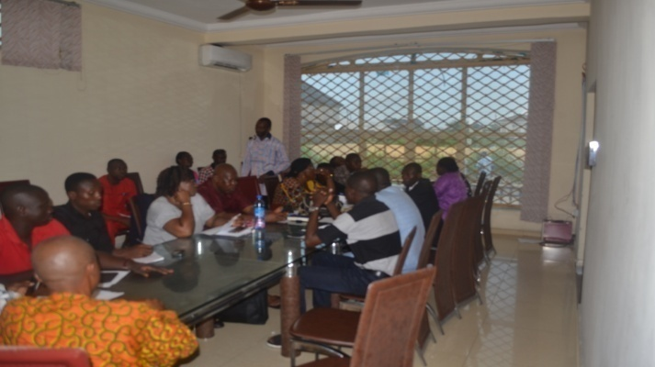
Gbarain/Ekpetiama CDB Meeting deliberating on the scheme

1.1 Prioritization of Needs
The facilitating NGO for the Cluster (Community Inter-Relations and Conciliation Initiative) along with the CDB carried out a number of livelihood assessment and developmental problems/needs assessments in all the communities and lack of finance was a major problem and people go through a lot of difficulty in educating their wards in all the communities. Equally lack of highly qualified community persons has recently been a major problem in all the cluster communities and those willing to go for further education lack the finance to undertake such.
This fact has been captured in all Community Development plans in all the communities involved.
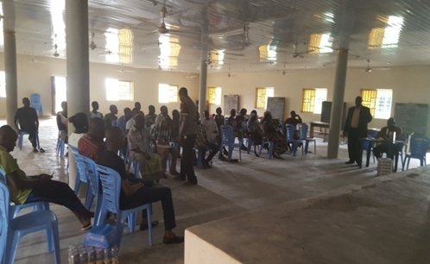
Community engagement in Okotiama by CIRCI for needs assessment. All 11 communities were assessed.

1.2 Project Goal:

Improve the number of highly educated and well qualified persons in Gbarain/Ekpetiama clans for high level employment/appointments anywhere in the world.

1.3 Project Objectives:
The specific objectives of the scholarship scheme are:
- To enable qualified and intending first degree and masters degree certificate holders from Ekpetiama and Gbarain clans to run masters and doctor of philosophy degree programmes in the sciences, allied sciences, behavioural sciences, arts, management sciences, medicine, law and Engineering in Nigerian Universities.
- To produce educated manpower from the above areas of study and to make them become self-reliant and contribute to community and national development.

- METHODOLOGY
  - COMMUNITIES/NUMBERS OF CANTIDATES TO BE AWARDED PER LEVEL OF HIGHER DEGREE
There are eleven (11) communities in total, ten (10) of them from Gbarain clan namely: Agbia, Nedugo, Ogboloma, Ayama, Okotiama, Obunagha, Okolobiri, Kumboama, Koroama and Polaku while Gbarantoru is the only community benefiting from the Ekpetiama clan.
Each community was given 2 spaces for Masters Degree and one space for Ph.D.

Allocation given to each community is as shown below:

S/N | COMMUNITY | MASTER’S DEGREE | PHD
 | Agbia | 2 | 1
 | Nedugo | 2 | 1
 | Ogboloma | 2 | 1
 | Ayama | 2 | 1
 | Okotiama | 2 | 1
 | Obunagha | 2 | 1
 | Okolobiri | 2 | 1
 | Kumboama | 2 | 1
 | Koroama | 2 | 1
10 | Polaku | 2 | 1
11 | Gbarantoru | 2 | 1
Total |  | 22 | 11

2.2 FORMATION OF A SCHOLARSHIP COMMITTEE BY THE CLAN
The King and leadership of the clans nominated and inaugurated seven man committee of trusted and reputable people to manage the process with Gbarain/Ekpetiama CDB, SPDC, Bayelsa State Government and NGO. The head of the Committee is Prof. Tuemi Tudou Asuka of the Niger Delta University (NDU) while the Secretary is Barr. Ibeni Iwolo.

SCHOLARSHIP COMMITTEE
- Prof. Tuemi Tudou Asuka
- Barr. IbeniI wolo
- Chief Tarila Coalter
- Chief Nicodemus Yasuo
- Dr. Tonye Samson
- Mr. Tonye Akpuruku
- Mr. Fewaripamogha G. Tolumoye
- Gbarain/Ikpetiama Cluster Development Board Chairman
- GbarainIkpetiama Cluster Development Board Secretary
- Community Inter-Relations and Conciliation Initiative (NGO) Representative
- Shell Petroleum Development Company of Nigeria Representative
- Bayelsa State Government Representative from Ministry of Mineral Resources
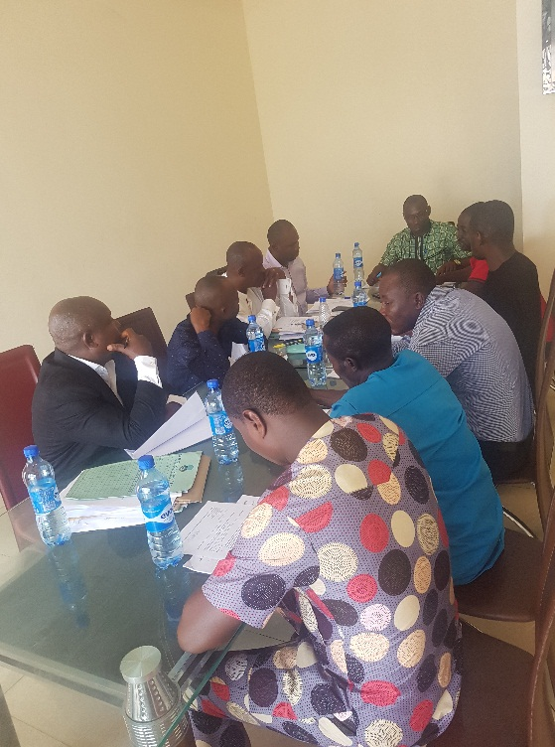
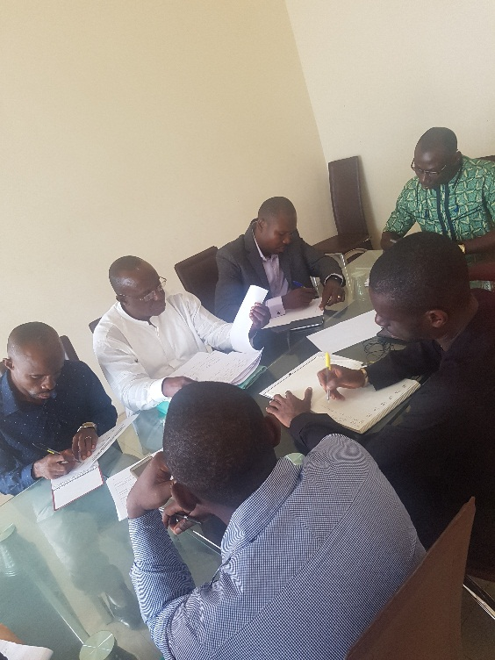
Deliberations at the Scholarship Committee level. This is regularly done to ensure smooth and successful operations.

2.3 ADVERTISEMENT/NOTIFICATION
Notice for interested candidates to apply for consideration was made in all the affected communities by the Community Trust and the Paramount Ruler. The process included the use of town Cryer and the Cluster Development Board made radio announcements to disseminate information widely.

2.4 APPLICATION PROCESS
Candidates for the scholarship scheme collected application form from the Community Scholarship Committee and submitted back the completed forms along with the following documents:

- Birth certificate or age declaration
- Local government identification letter
- Identification letter from community head
- Photocopies of educational qualifications
- Photocopy of post graduate admission letter from a recognized university
- One passport photograph
- Where there are only two (2) Master’s and one (1) Ph. D degree applicant from a community both groups were awarded if they satisfied the conditions outlined.
- Where there are more than the stipulated number of candidates for any community for any level of the scheme, the award was given to the candidate with the highest Cumulative Grade Point Average (CGPA) in the First or Masters Degree, having satisfied the conditions outlined. Applicants are therefore advised to write to their graduating institutions to send their academic transcripts to the Secretary of the Scholarship Committee. Candidate's applying for masters degree must submit their first degree transcript while those applying for Ph.D scholarship must submit their masters degree transcript.
- Every admission for post graduate was verified for authenticity.

2.5 SELECTION PROCESS
The Scholarship Committee including the representatives of Shell, Government and NGO met to consider the candidates in line with the preset criteria. Merit, accountability and transparency were the watchwords throughout the exercise.

2.6 DURATION OF AWARD
- Master’s Degree: A maximum of four semesters (two sessions). However, after the second year, only tuition will be paid for one extra year if the programme is prolonged.

- Doctor of philosophy Degree: A maximum of six semesters (Three sessions). However, after the third year, only tuition fee will be paid for one extra year if it is prolonged.

2.7 SCHOLARSHIP AWARD AMOUNT
2.7.1 MASTER’S DEGREE

Masters - 545,000.00 Naira annually
In US Dollars that is about $1,514 annually
This amount will be paid annually for 2 years. However an extra tuition fee of 135,000 Naira ($375) will be paid if programme spills into the third year.

2.7.2 DOCTOR OF PHILOSOPHY DEGREE
PhD –710,000 Naira annually
In US Dollars that is about $1,972 annually
This amount will be paid annually for 3 years. However an extra tuition fee of 240,000 Naira ($667) will be paid if programme spills into the fourth year.

- SUCCESS SO FAR RECORDED

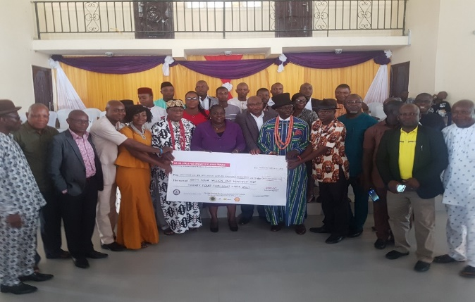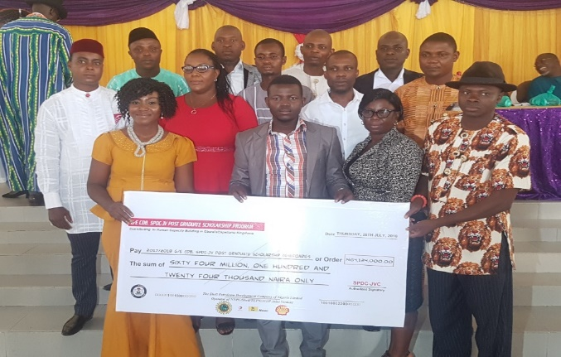
First disbursement ceremony of handing over cheques to beneficiaries

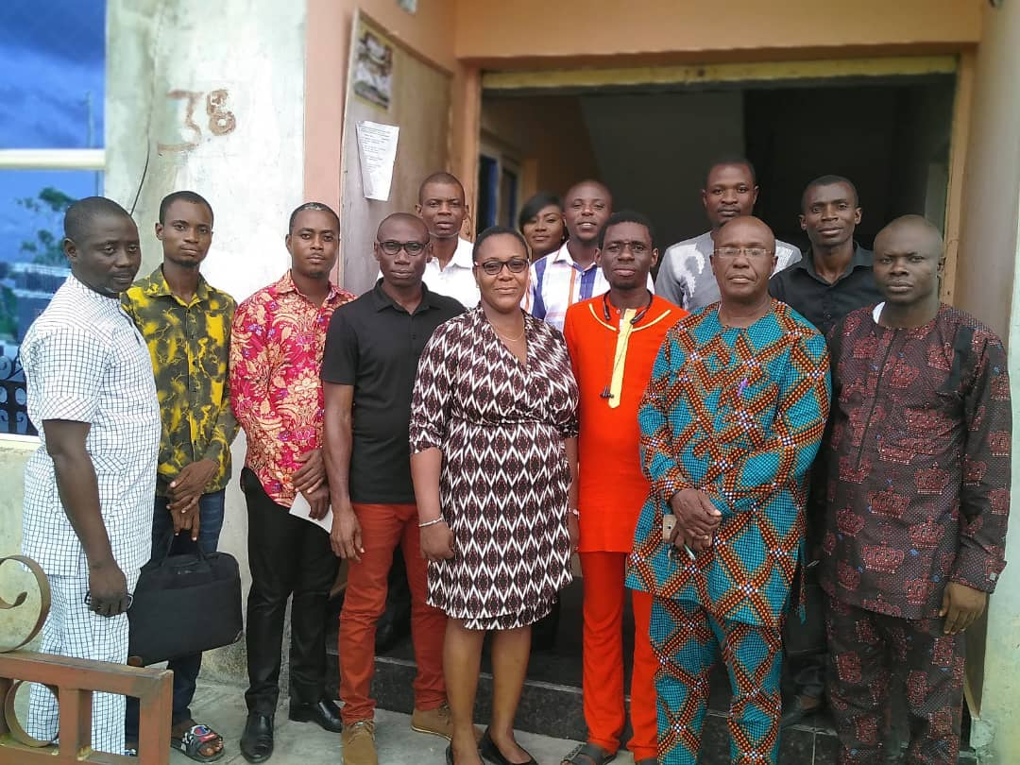
Picture of some beneficiaries with reps of Scholarship Committee and GE/CDB

3,1.1 FIRST BATCH Ph.D BENEFICIARIES FROM THE COMMUNITIES
AWARDED IN AUGUST 2018 (FIVE IN NUMBER)

SN | BENEFICIARY | AREA OF SPECIALIZATION | UNIVERSITY | GENDER | COMMUNITY
1 | FRED, EBIERE | GUIDANCE/COUNSELING | NIGER DELTA, UNIVERSITY, WILBERFORCE ISLAND,NIGERIA | FEMALE | AGBIA
2 | WEKE, IBARAFAKUMO MICHAEL | CROP SCIENCE | IMO STATE UNIVERSITY, NIGERIA | MALE | GBARANTORU
3 | KPUN FAITHFUL DENGIYEFA | CONFLICT, PEACE AND STRATEGIC STUDIES (POLITICAL SCIENCE) | UNIVERSITY OF NIGERIA, NSUKKA, NIGERIA | MALE | OGBOLOMA
4 | OTUOGHA AUSTINE MATHIAS | LINGUISTICS AND COMMUNICATION STUDIES | UNIVERSITY OF PORT HARCOURT, NIGERIA | MALE | NEDUGO
5 | TARIMOTIMI OKOKO | EDUCATIONAL MANAGEMENT | UNIVERSITY OF PORT HARCOURT, NIGERIA | FEMALE | OBUNAGHA

3,1.2 FIRST BATCH MASTERS DEGREE BENEFICIARIES FROM THE COMMUNITIES AWARDED IN AUGUST 2018 (EIGHTEEN IN NUMBER)
SN | BENEFICIARY | DEGREE SOUGHT | UNIVERSITY | GENDER | COMMUNITY
1 | GIBSON TIMIDUBA WILSON | SOCIOLOGY OF RELIGION | IGNATIUS AJURU UNIVERSITY OF EDUCATION, PORT HARCOURT, NIGERIA | Male | GBARANTORU
2 | INDALI, KEMELA STEVE | ENGLISH LANGUAGE/DISCOURSE ANALYSIS | UNIVERSITY OF PORT HARCOURT, NIGERIA | Male | GBARANTORU
3 | KUKU, EBIKISE | MARKETING | RIVERS STATE UNIVERSITY, PORT HARCOURT,NIGERIA | Male | KOROAMA
4 | AZI, EBIKILA TOMDICK | HISTORY AND POLICY OF EDUCATION | NIGER DELTA UNIVERSITY, WILBERFORCE ISLAND, NIGERIA | Male | KUMBOAMA
5 | ABRAHAM, TONBARA JUSTINA | LAW | UNIVERSITY OF BENIN, NIGERIA | Female | KUMBOAMA
6 | OTUOGHA, PHILOMENA GESIERE | EDUCATIONAL ADMINISTRATION AND PLANNING | NATIONAL OPEN UNIVERSITY, NIGERIA | Female | NEDUGO
7 | AYAFA, TARILA ISAAC | LAW | NASARAWA STATE UNIVERSITY, KEFFI, NIGERIA | Male | OBUNAGHA
8 | DADIOWEI, OPRITARI MAXWELL | BUSINESS INFORMATION SYSTEM | NOVENA UNIVERSITY, NIGERIA | Male | OBUNAGHA
9 | DICKSON, PREYE | EDUCATIONAL PSYCHOLOGY, GUIDANCE AND COUNSELING | IGNATIUS AJURU UNIVERSITY, NIGERIA | Male | OGBOLOMA
10 | OPURUPELEBO, AYAKIRI | BANKING/FINANCE | UNIVERSITY OF UYO, NIGERIA | Male | OGBOLOMA
11 | BARAFIAI, DOUBARA | HUMAN RESOURCES MANAGEMENT | UNIVERSITY OF BENIN, NIGERIA | Male | OKOLOBIRI
12 | KOKO, EDWIN PREYE | MECHANICAL ENGINEERING | NIGER DELTA UNIVERSITY WILBERFORCE ISLAND, NIGERIA | Male | OKOLOBIRI
13 | ANGALAPU, DENGIYEFA | POLITICAL SCIENCE | NIGER DELTA UNIVERSITY WILBERFORCE ISLAND, NIGERIA | Male | OKOTIAMA
14 | KOKO, MARY DODE | EDUCATIONAL MANAGEMENT | NIGER DELTA UNIVERSITY WILBERFORCE ISLAND, NIGERIA | Female | OKOTIAMA
15 | BARNABAS, GOOD-LUCK TARILA | GUIDANCE/COUNSELING | NIGER DELTA UNIVERSITY WILBERFORCE ISLAND, NIGERIA | Male | POLAKU
16 | AKPAINGOLO INARERE AKANGA | ACCOUNTANCY | NIGER DELTA UNIVERSITY WILBERFORCE ISLAND, NIGERIA | Female | POLAKU
17 | KOLOGA THANKGOD FREEDOM | SOCIAL SCIENCE EDUCATION | UNIVERSITY OF CALABAR, NIGERIA | Male | AGBIA
18 | BRIAN PRINCESS PERE-ERE | INFORMATION TECHNOLOGY | NATIONAL OPEN UNIVERSITY, NIGERIA | Female | AYAMA

3.2.1 SECOND BATCH Ph.D BENEFICIARIES FROM THE COMMUNITIES
AWARDED IN FEBUARY 2019 (FOUR IN NUMBER)

SN | BENEFICIARY | DEGREE SOUGHT | UNIVERSITY | GENDER | COMMUNITY
SN | BENEFICIARY | AREA OF SPECIALIZATION | UNIVERSITY | GENDER | COMMUNITY
1 | EBIYE ASUKA | GEOGRAPHY AND ENVIRONMENTAL MANAGEMENT | IGNATIUS AJURU UNIVERSITY OF EDUCATION, PORT HARCOURT, NIGERIA | MALE | KOROAMA
2 | KOLUBOWEI WOYENGIKURO | EDUCATIONAL PLANNING | IGNATIUS AJURU UNIVERSITY OF EDUCATION, PORT HARCOURT, NIGERIA | MALE | OKOLOBIRI
3 | TOMMY K. ANNY | CURRICULUM STUDIES AND INSTRUCTIONAL TECHNOLOGY | IGNATIUS AJURU UNIVERSITY OF EDUCATION, PORT HARCOURT, NIGERIA | FEMALE | KUMBOAMA
4 | TABOWEI C. ONUOSA | PLANT PHYSIOLOGY AND BIOTECHNOLOGY | RIVERS STATE UNIVERSITY OF PORT HARCOURT, NIGERIA | MALE | OKOTIAMA

3.2.2 SECOND BATCH MASTERS DEGREE BENEFICIARIES FROM THE COMMUNITIES AWARDED IN FEBRUARY 2019(FOUR IN NUMBER)

SN | BENEFICIARY | AREA OF SPECIALIZATION | UNIVERSITY | GENDER | COMMUNITY
1 | LOLIA T. FRANKLIN | MANAGEMENT | IGNATIUS AJURU UNIVERSITY OF EDUCATION, PORT HARCOURT, NIGERIA | FEMALE | KOROAMA
2 | MILLICIENT Z. BRIAN | EDUCATIONAL ADMINISTRATION AND PLANNING | NATIONAL OPEN UNIVERSITY, NIGERIA | FEMALE | AYAMA
3 | ODIGIRI A. JEREMIAH | MANAGEMENT | UNIVERSITY OF PORT HARCOURT, NIGERIA | MALE | NEDUGO
4 | APIA WOYENGIPREYE | ECONOMICS | UNIVERSITY OF PORT HARCOURT, NIGERIA | MALE | AGBIA

  - FUND DISBURSEMENT SO FAR

3.3.1 Funds have been disbursed to 9 PhD degree beneficiaries out of the 11 opportunities and all 22 Masters degree beneficiaries for the first year.
    - Second disbursement for Year 2 has been made to 4 PhD beneficiaries and 15 Masters degree beneficiaries, whose progress has been verified in line with the criteria set by the Scholarship committee.

  - BENEFICIARIES FEEDBACK SO FAR

3.4.1 NAME: Kpun Faithful Dengiyefa

COMMUNITY: Ogboloma

Male PhD Student in Political Science (Conflict, Peace and Strategic studies)

- The Scholarship Scheme is highly beneficial to me. It enables me to take care of my PhD programme expenses, especially school fees, books and accommodation.
- My new career as an expert in Peace and Conflict Management will come handy in fostering peace and sustainable development in my community and region.
- Special thanks to GE/CDB, the Scholarship Committee and the other partner organizations that made this scheme a reality.

3.4.2 NAME: Fred Ebiere Geoffrey

COMMUNITY: Agbia

Female PhD Student in Guidance and Counselling (Education)

- I am saying a big thank you, to GE/DCB and Shell Petroleum Development Company Nigeria Limited for the great opportunity given to me.
- I shall organize programmes for the youths after completing my education.

3.4.3 NAME; Koko Edwin Preye

COMMUNITY: Okolobiri

Male M.Eng Student in Mechanical Engineering

The benefits cannot be over-emphasized:
- With the scheme I am able to run my M. Eng degree programme without financial stress.
- I am motivated to put in my best, hoping to get another opportunity for my PhD programme since finance is the major challenge to further my studies.
- The scheme has helped me position myself for future academic work and employment.
- I will like to thank the Gbarain Ekpetiama Cluster Development Board for the privilege given to me through this scholarship award.

3.4.4 NAME: Philomena Gesiere Otugha

COMMUNITY:Nedugo

Femal M.Ed Student in Administration and Planning

- The scholarship award has enabled me pursue my M.Ed qualification that has broadened my knowledge, It has improved my management and inter-personal relationships skills and my planning skills to achieve set goals without difficulty.
- After graduation, I will create talk-shows in my community on the importance of education and why everyone needs to go to school. I will help them to plan for their future.
- I thank everyone that contributed to make the scholarship available especially Gbarain Ekpetiama CDB. I am grateful.

3.4.5 NAME: Angalapu Deingiyefa

COMMUNITY: Okotiama

Male M.Sc Student in Developmental studies

- The scholarship has afforded me the opportunity to attend notable academic conferences and I have published articles in good journals.
- The scholarship award has provided a great relief to me in my pursuit of academic excellence.
- I am indebted to my community for this award.
- I will contribute to community progress by making myself available for community consultancy when the need arises.
- I shall also establish a scholarship scheme of my own when I can afford it.
- I thank the CDB, Okotiama community and the Gbarain clan for this opportunity.

3.4.6 NAME: Barnabas Goodluck Tarila

COMMUNITY: Polaku

Male M.Ed Student in Education

- The Scholarship award has made my financial burden in the university lighter and my mind is better focused on academic issues.
- I have acquired new research, communicating and reasoning skills.
- I thank His Royal Majesty King Funpere Akah, His Council of Chiefs, the Scholarship Committee, CDB and SPDC for making this programme a reality.

3.4.7 NAME: Azi Ebikila Tomdick

COMMUNITY: Kumboama

Male M.Ed Student in History and policy in education

- The scholarship award is serving as financial support to my academic pursuit.
- It is human empowerment and the community has invested in me through it.
- It will improve my standard of living and will serve as avenue of exposure.

4.0 SUSTAINABILITY/SUCCESS PLAN

Only the best in each community are selected using the agreed selection criteria.
The Technical Committee of the GECDB (Gbarain/Ekpetiama Cluster Development Board), GECDB, Government, SPDC and the Scholarship Committee are monitoring the project from inception to completion with the assistance of the mentoring NGO.
After the first year payment, evidence of progress are required before additional payments are made to beneficiaries.
In order to ensure project continuity, all funds required for the scholarship scheme’s successful completion without any hitch have been secured and ring-fenced in a bank account for disbursement after each beneficiary meets up with the criteria set for each disbursement.
The day-to-day management of the project is in the hands of the Scholarship Committee.
The committee is responsible to institute a culture that would make beneficiaries be up and doing so that they successfully complete their studies.
At the end of this scholarship scheme, the project will be evaluated to ensure improvement in follow-up programmes.

5.0 Relationship to National/Internationally Accepted Development Goals
The project is consistent with some key Sustainable Development Goals (SDGs)
- No Poverty
- No Hunger
- Good health
- Quality Education
- Good jobs and Economic Growth
- Reduced inequality
- Peace and Justice

6.0 CONCLUSION
At the conclusion of this project, the Gbarain/Ekpetiama Cluster Development Board would have spent Sixty Four Million One Hundred and Twenty Four Thousand Naira (N64,124,000) or One Hundred and Seventy Eight Thousand US Dollars ($178,000) (including administrative costs) of the funds contributed by Shell Petroleum Development Company Nigeria Limited and her Joint Venture Partners for the development of the cluster through the Global Memorandum of Understanding and it is spent well for human capacity development.
While both human development and infrastructure development are equally important, concentrating on only infrastructure without human development means that the people will not have the capacity to sustain what is implemented on their own and will always depend on others. However, if the capacities of the people are enhanced, they will be able to contribute personal funds to collectively develop themselves. They will also be able to invest in activities that will develop the place and provide employment for others. Again, such educationally empowered people will be able to pay more taxes to government for the development of their place and building of more social amenities, which are currently not adequately provided.
This cluster has chosen to invest on human capacity building and that is as sustainable as it can get. Enlightened people will appreciate why they must protect their environment, become advocates of sustainable livelihoods for their communities and be less involved in violent conflicts.
This project has raised awareness on the importance of education and many people are showing the zeal to read further and with time, more people will seek personal educational development.
We thank the Chiefs, Community leaders, the community representatives in the Cluster Development Board and all the people of the communities, for embracing and supporting the development of knowledge economy that will sustain them even after crude oil and gas are no longer central in revenue generation.
We thank SPDC and her Joint Venture partners for all the funding support they have given to these communities and also for building the capacities of these communities to drive their own development, deciding their priorities, plan their projects and implementing by themselves.
Funding of this project was 100% by SPDC and her partners.

