Global Goals Fair Press Release
In celebration of World Environment Day 2017

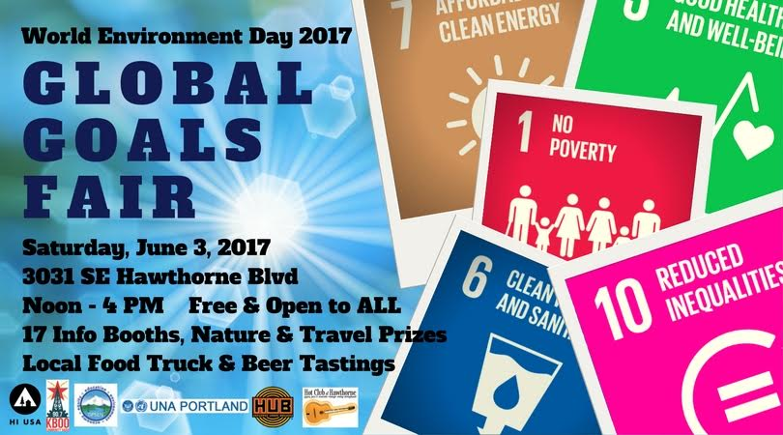

Portland, OR, June 3, 2017: The Global Goals Fair is Portland’s only community event organized in honor of World Environment Day 2017 and is offered in partnership with Hostellng International USA (HI USA), HI Portland Hawthorne Hostel, Greater Portland Sustainability Education Network (GPSEN), and the United Nations Association of Portland.

The event features 17 booths, one for each of the UN's Agenda 2030 Sustainable Development Goals. It will raise public awareness of the global goals, while connecting community members to local efforts. It will also highlight how organizations in the greater Portland region are doing amazing work to address important social, economic, and environmental issues.

From 12 - 4 PM at 3031 SE Hawthorne Blvd on Saturday June 3rd; the following organizations, institutions and businesses will be sharing their message and work with the community and more are being added every day.

- 350PDX
- Architects without Borders
- Clean Water Services; Portland State University
- GlobalPDX
- Conscious Capitalism
- Create Plenty
- Greater Portland Sustainability Education Network
- Green Empowerment
- Growing Gardens
- JOIN Portland
- Northwest Earth Institute
- OPAL Environmental Justice Oregon
- Oregon CEDAW Coalition
- Portland Community College
- Trash for Peace
- UNA Portland
- Urban Gleaners

Be inspired into personal action and take ownership of our collective future while enjoying live vintage jazz by Hot Club of Hawthorne, food truck bites and free Urban Hopworks Beer samples in a beautiful urban oasis. Join us and you'll also have opportunities to network and/or win one of several nature and travel prizes.

FREE Event and Open to All.

Be sure to check out our Global Goals Fair Facebook event page and help spread the word.

For more information, please contact: Michele Machado, HI Community Engagement Liaison, at michele.machado@hiusa.org.

Hostelling International USA (HI USA) is a nonprofit, member organization founded on an enduring belief in the power of travel to foster a deeper understanding of people, places, and the world around. HI USA promotes a dynamic community of global citizens who have the wisdom and humanity to actively make the world a better place. As the nation’s leading hostel brand, HI USA hosts more than 1 million overnights annually, with guests from more than 100 countries. For over 80 years, HI USA has provided a network of affordable hostels in converted mansions, reinvented lighthouses, and historic urban buildings all across the country. HI Portland Hawthorne Hostel is owned and sustainability operated by HI USA. Visit www.hiusa.org for more information.

The Greater Portland Sustainability Education Network (GPSEN) is a nonprofit multi-sector network of educators, students, non-profits, political and industry leaders, organizations, and community members collaborating to promote sustainability education in the Portland Metro region. Acknowledged as a Regional Center of Expertise (RCE) on education for sustainable development (ESD), by the United Nations University, in 2013, it is part of a coalition of 154 RCEs around the world, with only 5 in the U.S. Visit www.gpsen.org for more information.

United Nations Association of Portland (UNA Portland) is a nonprofit, member organization which advocates for strong U.S. leadership at the UN to help resolve the world’s most pressing challenges. Visit www.unapdx.org for more information.

