IGBP/APN “Write a Paper” Workshop: Global Environmental Change and Sustainable Development in the Asia-Pacific and SIDS Least Developed Countries
10 SEPTEMBER 2013POSTED IN: APN NEWS, FEATURED STORY
26-30 August 2013, Bangkok, Thailand — There are currently 49 countries that fall under the category of Least Developed Countries (LDCs). Citizens of LDCs suffer from multiple stresses emanating from the complex inter-linkages between local and global environmental and socioeconomic challenges. However, these challenges aren’t understood well resulting in less effective interventions. With this recognition, the International Geosphere-Biosphere Programme (IGBP) in its second major synthesis includes a theme on Global Environmental Change (GEC) and Sustainable Development: Needs of Least Developed Countries. The synthesis extends over LCDs in Asia, Africa and the Small Island Developing States (SIDS).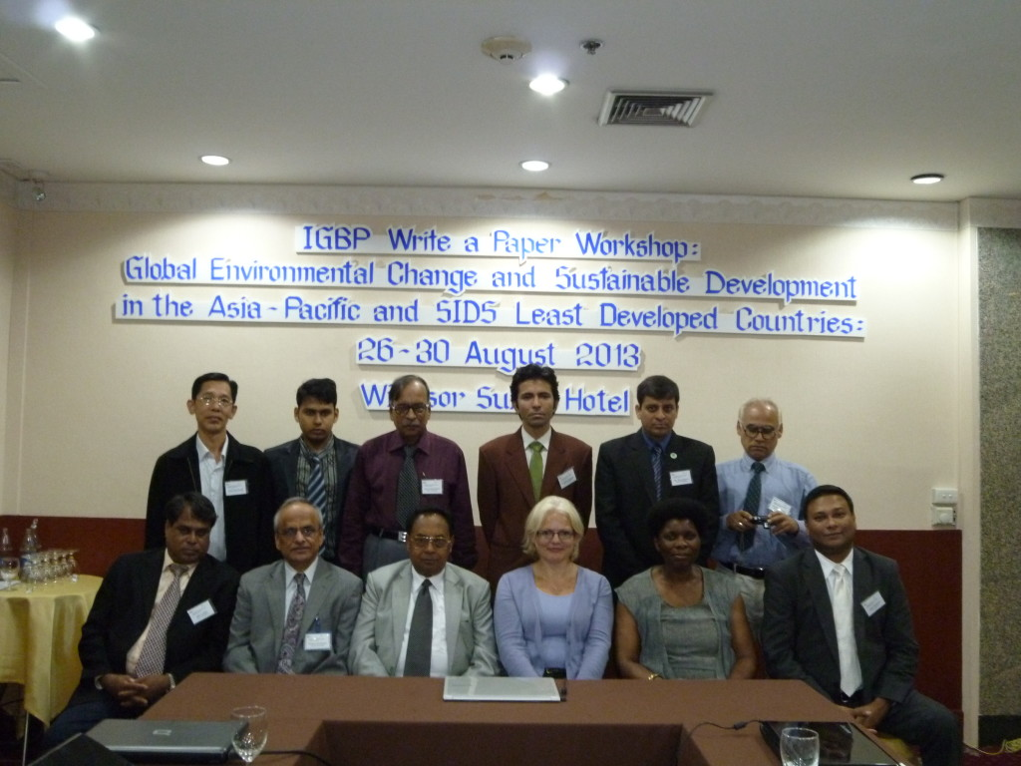
The aim of the synthesis is to build capacity in LDCs and facilitate integration of local information with relevant GEC science outputs generated by various international organisations to produce updated and consolidated outputs that can better address the challenges faced by LDCs. The synthesis contributes cross fertilisation of biophysical and socioeconomic information produced at different scales, i.e. local to global level, to help address pertinent policy needs of LDCs and stimulate further research under the following sub-themes: (1) hydro-meteorological hazards and disasters; (2) human health and environment with particular reference to food security and water resources and; (3) the role of indigenous knowledge systems in addressing GEC issues in LDCs.
The “Write a Paper” Workshop focused on Global Environmental Change and Sustainable Development in the Asia-Pacific and SIDS. LDCs in Asia-Pacific and SIDS face complex environmental challenges due to a combination of natural climate variability and climate change as well as development processes. Up to date information on the nature of these challenges and potential solutions are required by policy makers and society at large.

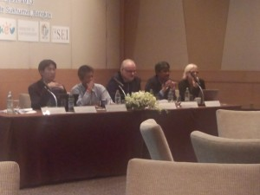

Objectives of the workshop
The purpose of the “Write a Paper” Workshop was to enhance capacity among LDC scientists to develop peer-reviewed publications relating to synthesis topics through a process of interaction with technical experts and international counterparts. The aim is to produce a detailed outline of papers for a special issue on Global Environmental Change and Sustainable Development in the Asia-Pacific and SIDS LDCs that will be published in the Weather and Climate Extremes Journal. The workshop will also deliberate on science-policy interface and identify potential key policy relevant information from proposed papers that can be used to produce policy briefs for local needs.
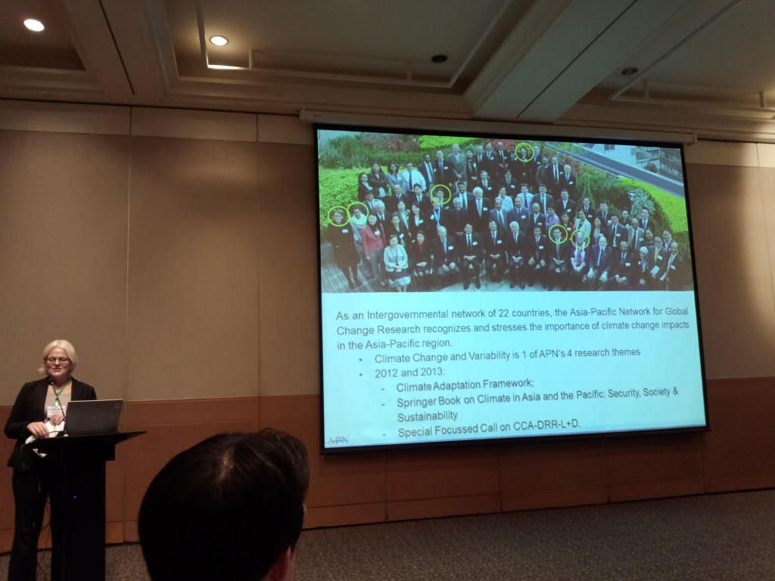Following four days of capacity development in the workshop – attended on the first day by APN’s SPG member for Thailand, Dr. Jariya Boonjawat – Dr. Linda Anne Stevenson, APN’s Division Head for Communication and Scientific Affairs, was invited to give a few words on her thoughts about the workshop. She noted first that, as an inter-governmental network of 22 countries, the APN recognises and stresses the importance of climate change impacts in the Asia-Pacific region. Climate change and variability is one of APN’s four research themes and recently launched the Climate Adaptation Framework and a book entitled Climate in Asia and the Pacific: Security, Society & Sustainability. Both the framework and the book stress the importance of RCMs, including CORDEX domains in the region. APN aims to share research, capacity development and partnership opportunities with the international climate community. In this context, she highlighted the synergy between the present workshop and the APN’s Climate Adaptation Framework, where opportunities will become available for funding under APN in September 2013.
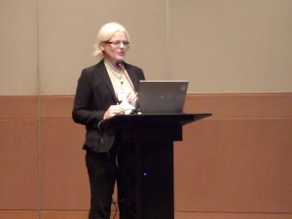Dr. Stevenson appreciated the work that had taken place over the past four days and highlighted that developing the capacity of LDC communities to be able to write and convey key messages in peer-reviewed journals is crucial. Engaging LDCs at this level of knowledge production, enhancing capacity and ensuring an inclusive process of addressing climate vulnerabilities to weather events and the societal impacts of these increasing events is needed.
Very often, the academia-ignored “grey” literature is the key to understanding the impacts of climate-related events, particularly at vulnerable small and remote community levels. Finally, Dr. Stevenson appreciated the review not being limited to peer-reviewed literature, particularly for this region. Addressing key materials from LDCs various documented sources will help capture the importance of traditional knowledge that cannot be ignored in Asia and the Pacific.
Prevalence of adverse impacts and events in LDCs will be the focus of a key special edition journal to be published by Elsevier in “Weather and Climate Extremes” led by Dr. Mannava Sivakumar. The special edition expects to highlight the global and regional development climate-related extreme events, including droughts, floods, heat waves, etc. and how they impact the most vulnerable communities in LDCs.
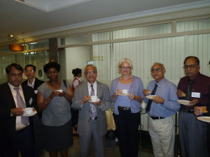An example of one paper will illustrate drought events in Bangladesh, Nepal, Bhutan and Afghanistan. The characteristics of drought in South Asia and Southeast Asia were highlighted in the workshop and will be key for the anticipated publication. Some of the impacts of droughts in LDCs were highlighted such as: adverse effects, economic consequences, environmental effects, societal effects, limited social capacity, complexities of measuring impacts, shifts on crop, etc. How do societies cope with droughts? There is a need to address the impacts first; which can be less than desirable food consumption and a lack of community support and relief. Some of the factors requiring more focus include; the creation of employment opportunities, preservation of food items, water storage and drought resistance crop varieties. An example, at the experimental stage, in Bangladesh is the production of underground water tanks; rainfall is pumped in and desalinisation, currently at the experimental stage, takes place, ensuring water for consumption is available during periods of drought.
The way forward to reduce vulnerability is to realise that vulnerability varies at different social levels. There are impacts on farmers, fishermen, women and children, illiterate and poorly educated, unemployed youth etc. Some of the probable solutions are:
- Demystify science and communicate science at levels appropriate to the audience.
- Identify, document and popularise indigenous knowledge using modern methods.
- Reduce what is now “over-dependence” on farming and fishing.
- Develop capacity among youth through education, skill development and employment (Monga areas in Bangladesh, for example).
- Conduct field-level research with adequate funding to unearth the real impacts of climate change “at the ground level” which is very often invisible and difficult to communicate.
Papers produced from the write-workshop for LDCs will be revised to capture limitations: complexity of impact measurement; difficulty in preparedness; limited focus for research and; more attention required for mitigation. Some of the impacts on the following sectors will also be incorporated:
- Plant nutrition and drought tolerance; plant nutrients and crop productivity (Relative sensitivity of crops to nutrients deficiency); Physical effect of nutrient deficiency, etc.
- Strategies to alleviate drought stress in cereal production, approaches to alleviate drought and the low nutrition problem.
- The key question is, how do we sustain food production? 4R (right) approach: right product, right time, right rate and right place – this can maximise yields and profitability, as well as minimise the impact on the environment.
What was learned from the workshop included many issues that are too often taken for granted, such as: writing a good manuscript and attracting positive reviews; drawing on virtual libraries via websites such aswww.scirus.com as a source for related citations and; grappling with the English language, especially when to use the right language (present or past tenses and making sense) — even confusing for native English speakers.
By: Linda Anne Stevenson, Head, Division of Communication and Scientific Affairs, APN Secretariat

