RCE GREATER NAIROBI
Hydraulic water pumps project for sustainable ecosystem
Project pictorial

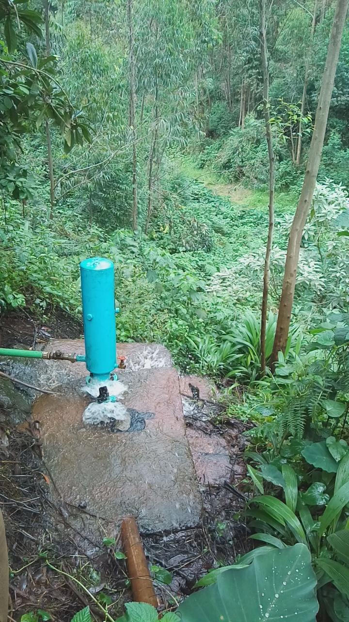
Hydraulic water pump (made from scrape metals) at a rehabilitated riparian land

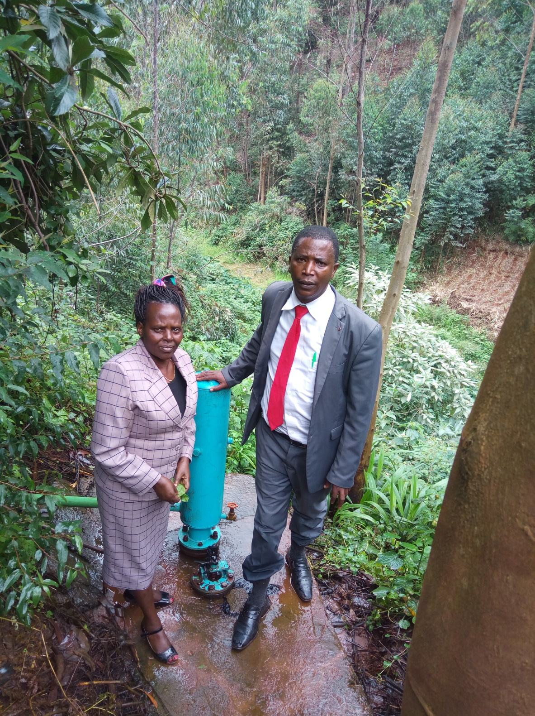
Dr. Esther Kitur and Mr. David Kariuki at one of the Hydraulic Water pumps site

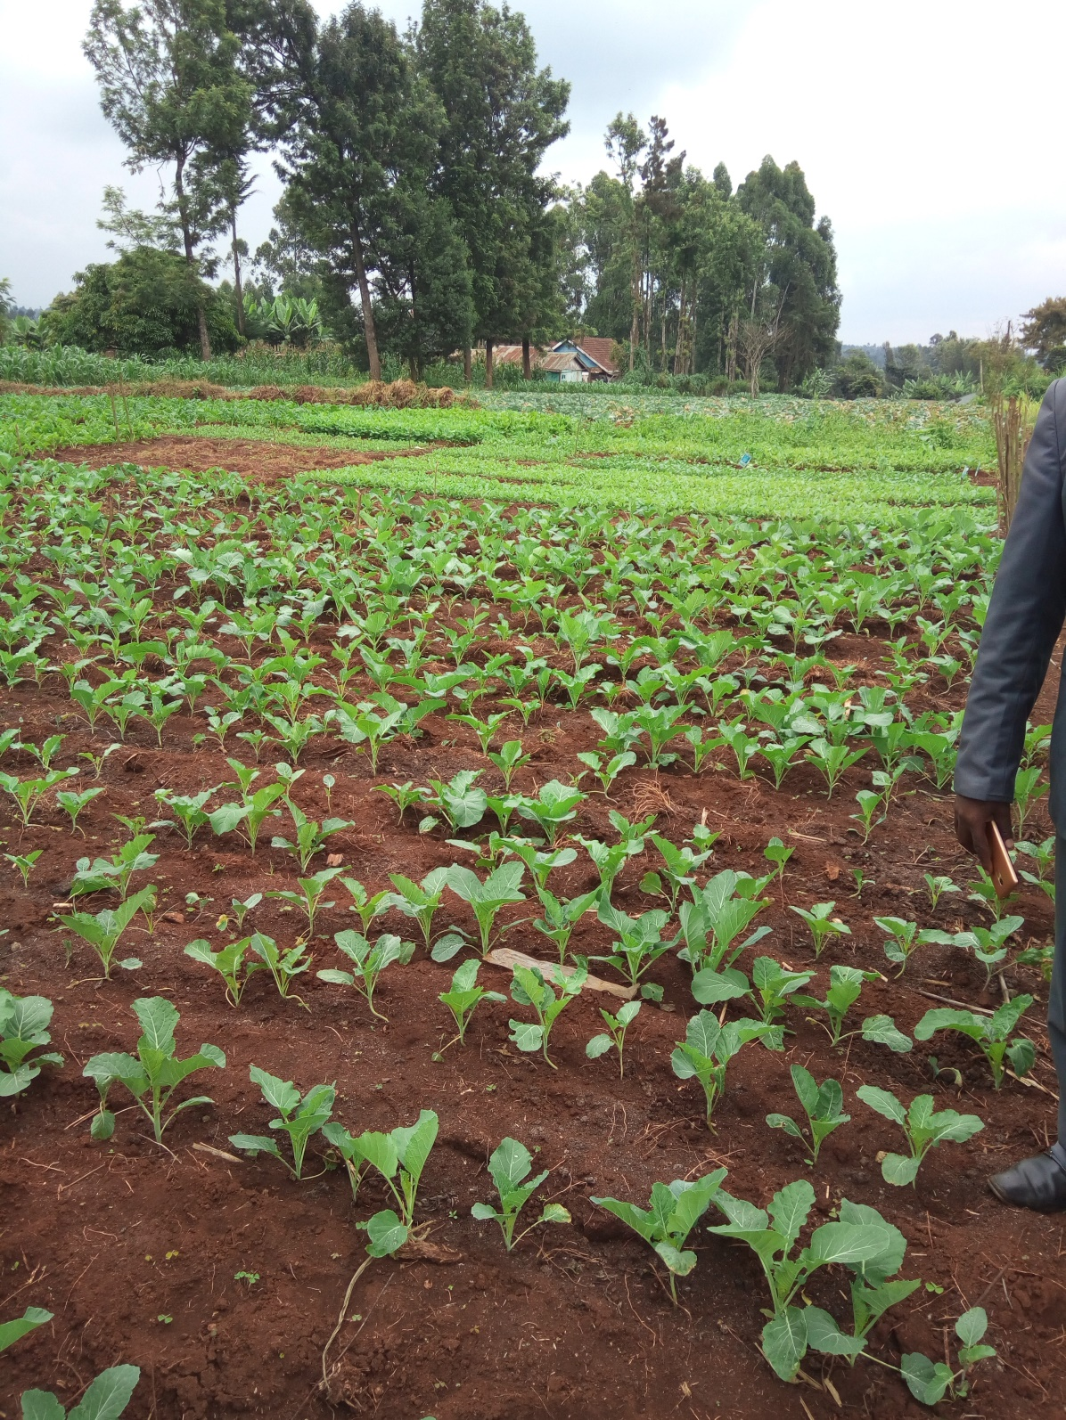
Vegetables farming on uplands through hydraulic water pumping for sustainable agriculture

