RCE NORTH RIFT - 2022
THE ROLE OF THE COMMUNITY ON ADAPTING CLIMATE CHANGE THROUGH APPROPRIATE CHARCOAL BRIQUETTING TECHNOLOGY FOR INCREASED DOMESTIC ENERGY PROVISION
HideBasic Information
Title of project :

The role of the community on adapting climate change through appropriate charcoal briquetting technology for increased domestic energy provision.

Submitting RCE:
RCE North Rift
Contributing organization(s) :
Art Youth Research Centre (AYRC)
Eldoret Uasin Gishu Cleaners Limited
University of Eldoret (U.o.E)
North Rift RCE
Format of project:
Powerpoint
Language of project:
ENGLISH
Date of submission:
Sunday, October 15, 2022

Web link:

Does this project link to any education and/or sustainable development policy or policies?:
yes
HideGeographical & Education Information
Region:
Africa and Middle East
Country:
Kenya
Location(s):
Eldoret

Address of focal point institution for project:
Art Youth Research Centre
West Market
P.O BOX 7346 -30100
ELDORET
Ecosystem(s)

Urban/Peri-urban
Target Audience:

Community
Socioeconomic and environmental characteristics of the area :

The County is located in the North Rift region of Kenya. The main Socio-economic activity is agriculture both crop and livestock farming. Others include wholesale and retail trading and manufacturing. The County is also a commercial hub in the region providing transport, financial and educational services. It is divided into three zones namely: the upper highlands, upper midlands and Lower highlands. The County has a total of 29,802.57Ha of gazetted forest found in Nabkoi, Timboroa, Kipkurere, Lurenge, Singalo and Kapsaret. The County face illegal logging and charcoal burning activities. Hence the need to save the forests by providing alternative source of energy for cooking as many households rely on wood fuel.

Description of sustainable development challenge(s) in the area the project addresses:

Wood fuel (Firewood and charcoal) is the main source of domestic energy in Kenya. In the year 2012, the total firewood and charcoal demand stood at 18,702,748 m³ and 16,3225,810m³ against sustainable potential supply of 13,654,002m³ and 7,358,717m³ respectively (Ministry of Environment, water and Natural resources 2013). This translated to a sustainable deficit for firewood and charcoal supply of 5,048,726m³ and 8,967,093m³ respectively. The projected firewood and charcoal supply percentage deficit in 2032 are 18.3% and 19.1% respectively. Based on this trend, the current use of firewood and charcoal to provide domestic energy is leading to negative environmental effects. The solution lies in widening the biomass resource bracket utilizable for domestic energy provision. One such approach is the use of alternative renewable briquetting technology to convert biomass residues to solid fuels (briquettes). However, the current briquettes in the market do not meet the standards for domestic usage additionally non availability of simple cheap and effective briquetting machines for wide spread adoption.

Status:
Ongoing
Rationale:

There is enough quantity of sawdust and charcoal dust in the country to support economic exploitation of briquette technology. Kenyan sawmills industry produces large quantity of sawdust which are underutilized and hence left to rot in timber yards. It is important to convert these wastes into economic use to reduce the energy deficit. With time, wood fuel is diminishing as wood become valuable for fuel I.e. more preferred for other products such as timber and therefore, wood waste is the best material to ensure wood fuels are available for usage.
Objectives:
1) To design, produce and test briquetting machine prototype
2) To determine physical properties of the produced charcoal briquettes from the designed machine
3)Determine the calorific value, combustion rate and emissions of the briquettes produced.
Activities and/or practices employed:

a) Design the appropriate design mechanism for hand operated briquetting machine.
b) Asses the physical properties of the produced briquette that meet the standards for energy provision.
c) Ensure that calorific value, combustion rate and emission level meet the standards for domestic energy provision.
d) Designed briquetting machine and briquettes are acceptable to the market for domestic energy production and provision.

Size of academic audience:

Since we started more than 1,000

Results:

Patentable designed and fabricated piston and screw force application briquetting machine is made available (See figures 1a, 1b and 1c). Main raw material (binder) made available for different levels of production processes. Scientific data on fragmentation, ash, volatile matter and moisture adsorption and desorption content properties of the produced charcoal briquettes obtained, further combustion quality and rate properties through scientific data on combustion quality and rate properties of the produced charcoal briquettes obtained.

Lessons learned:

- Under estimation of number of preliminary design repetitions to come up with the final economically viable briquetting machine/Technlogy.
- The budgetary allocation for the briquetting machine design, fabrication and further redesign to completion was underestimated and requires further funding.
- Coming up with final formulation and raw material ratios for good quality charcoal briquette takes time and requires further funding.
Key messages:
The following are the Key Messages they include:
- Under estimation of number of preliminary design repetitions to come up with the final economically viable briquetting machine
- The budgetary allocation for the briquetting machine design, fabrication and further redesign to completion was underestimated and requires further funding
- Coming up with final formulation and raw material ratios for good quality charcoal briquette is taking time and requires further funding.
Relationship to other RCE activities:
Other activities are like training students from RCE INSTITUTES as per below link

Funding:
Yes
The University of Eldoret (U.O.E), through the Directorate of Research and innovation provided annual research grants (A.R.G) for the project with funding of approximately Kshs. 500,000/= for financial year 2020/2021, However additional funding is required of Approximately Kshs 2.500,000/= to complete the research project.

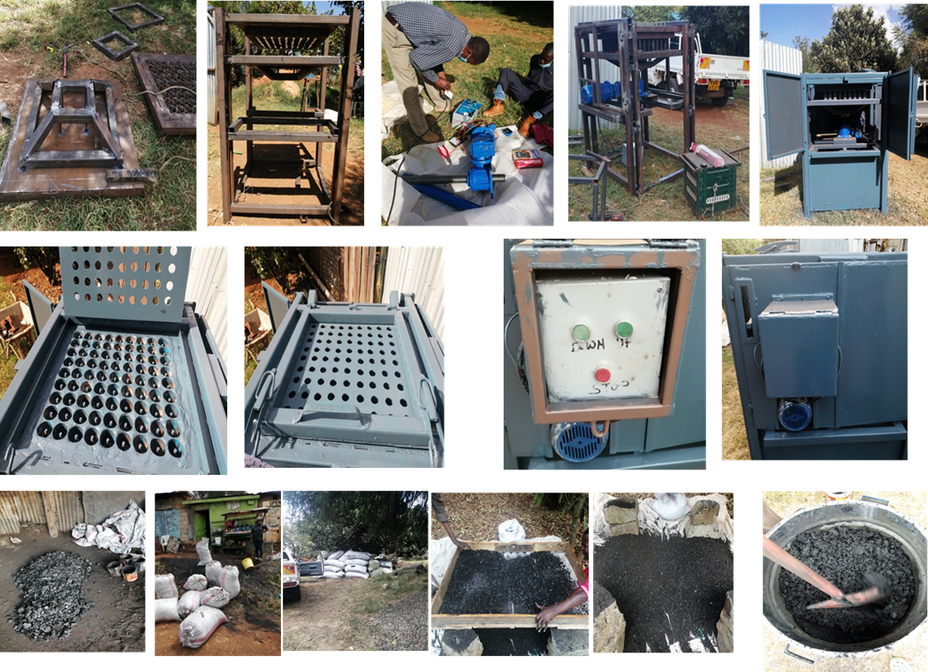
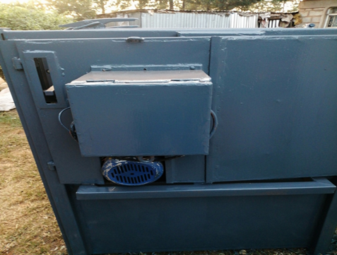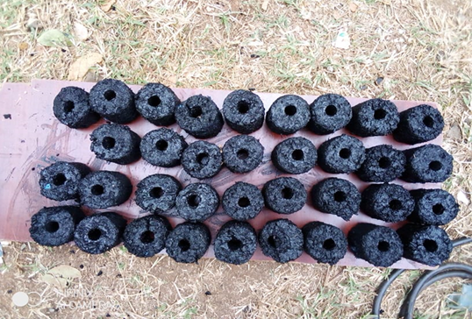

JPEG | Fabrication of machine & Renewable Briquette production. | Mr. Jacob Mbegoo and  Mr. Edwin Owino
“ | Preparation of Briquette Machine and Materials | Mr. Jacob Mbegoo and  Mr. Edwin Owino

UN Sustainable Development Goals (SDGs) (https://sustainabledevelopment.un.org/sdgs) and other themes of Education for Sustainable Development (ESD)
SDG 3 Ensure healthy lives and promote wellbeing for all at all ages: Direct

SDG 6: Ensure availability and sustainable management of water and sanitation for all Direct

SDG7 : Ensure access to affordable, reliable, sustainable and modern energy for all Direct

SDG9: Build resilient infrastructure, promote inclusive and sustainable industrialization, and foster innovation
Indirect
SDG12: Ensure sustainable consumption and production patterns Direct

SDG13: Take urgent action to combat climate change and its impacts Indirect

Waste Direct

ESD for 2030 – Priority Action Areas (https://en.unesco.org/esdfor2030)
Accelerating sustainable solutions at local level Direct

NAVIGATION

COMMUNITY
- RCE PROJECTS
- EVENT CALENDAR
- BULLETIN
- CAPACITY DEVELOPMENT
- FACEBOOK(LINK IS EXTERNAL)
- NEWS FEED

