Saskatchewan Ecomuseums Initiative (SEI)
Sometimes called “museums without walls,” ecomuseums are locally-run community museums that foster sustainable forms of community development based on in situ conservation and interpretation of natural and cultural heritage. The ecomuseum model was developed in France in the early 1970s to foster holistic interpretations of cultural heritage. The aim was to combine tangible objects, sites, and built structures with the traditions, practices, and customs, offering a more complete perspective on a region’s “living heritage.” As the idea caught on, the model was broadened to include natural heritage, including local flora and fauna, important wildlife habitats and geomorphology sites.
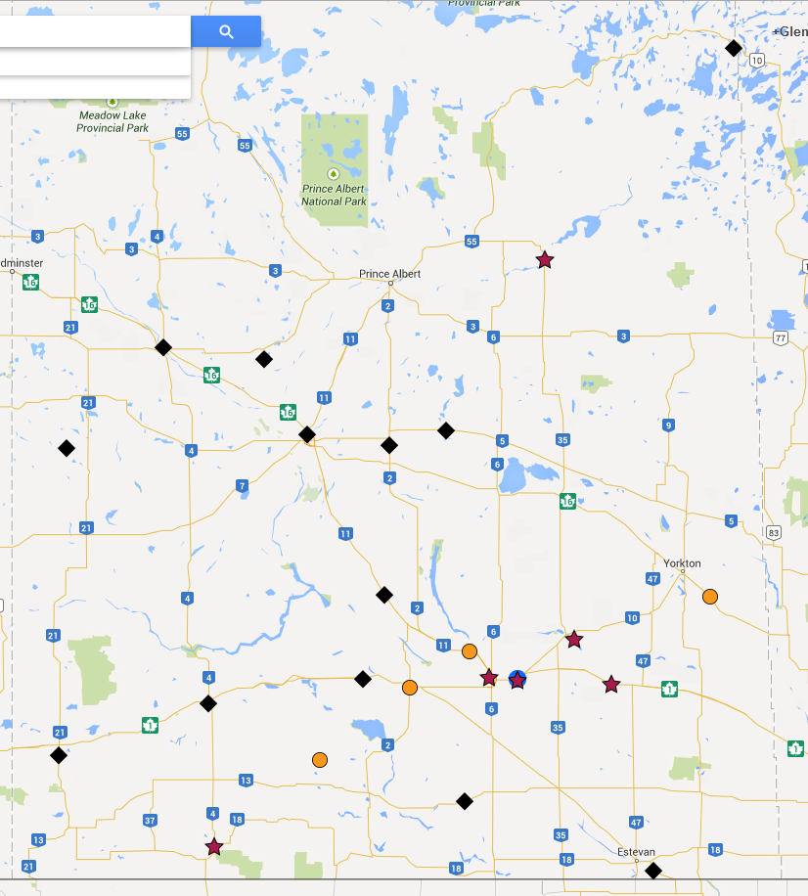
The Saskatchewan museum community first talked about ecomuseums shortly after the model started to flourish in Europe, but while some were developed in other parts of Canada, none took root here. In 2011, to assess the current potential for their development, the Royal Saskatchewan Museum (RSM) sent out a wide call for interest and received positive responses from over 15 locations across the province. Simultaneously, Heritage Saskatchewan (HS) initiated research regarding the broader scope of heritage, which resulted in a publication called Living Heritage by Sandra Massey, and the Museums Association of Saskatchewan (MAS) published a series of documents called Museums and Sustainability – Social Sustainability, examining links between the museum community (including 3 ecomuseum site case studies) and the social, economic, and environmental aspects of sustainability.
1. Map of Saskatchewan ecomuseums. Stars = active sites, Circles = emerging sites, Diamonds = Interested Communities
In 2012, the Saskatchewan Ecomuseums Initiative (SEI) was established and soon expanded to include other partners. The current SEI Steering Committee is chaired by the RSM and includes HS, MAS, SaskCulture, Nature Saskatchewan, the Saskatchewan Parks and Recreation Society, the National Trust for Canada, and Raven Consortium Inc. (an association of First Nations consultants). Participation in the SEI is a major focus of the MAS Museums & Sustainability Initiative that looks at how museums can, themselves, be more sustainable and how museums can contribute to the sustainability of their communities. The Saskatchewan-United Nations Regional Centre of Expertise (RCE) on Education for Sustainable Development, affiliated with both Saskatchewan universities and Saskatchewan Polytech, also recognizes the SEI as a core project.
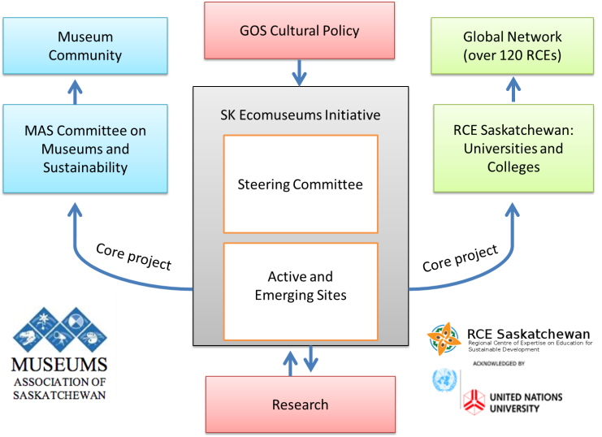
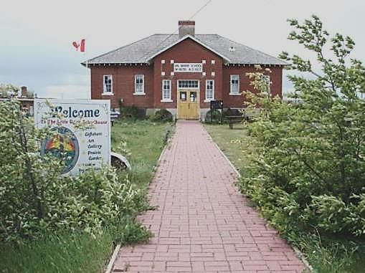
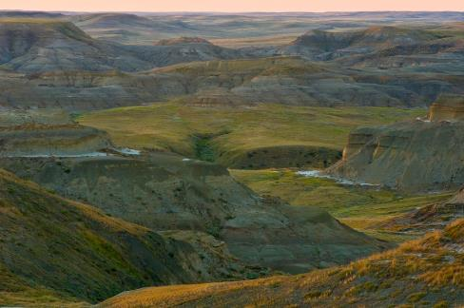
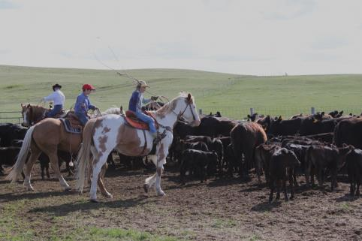
Through the SEI and the work of these partners, there is growing enthusiasm for the Ecomuseum Concept at the provincial level. On February 21, 2013, a workshop took place in Regina which included over a dozen potential stakeholders and community leaders from across the province interested in the ecomuseum model. This workshop gave rise to an Ecomuseum Planning Framework and a number of interested communities (Val Marie, Nipawin, North Central Regina, Wolseley, White City, and Katepwa) are now working with the model as demonstration sites. These sites range from rural prairie and boreal fringe communities, to an inner city neighbourhood, and they all include a focus on First Nations heritage.
Project updates:
http://heritagesask.ca/resources/saskatchewan-ecomuseum-project

Project lead:
Glenn Sutter, Ph.D.
Curator of Human Ecology
Royal Saskatchewan Museum

Themes ~ Residencies ~ Local Stories
Val Marie Ecomuseum

