Voluntary Sector Studies Network

VSSN Curriculum Survey Results and Priorities

Written by
Jennifer Billan, VSSN Coordinator
in collaboration with Dr. Mary Vetter and Dr. Gloria DeSantis
Luther College at the University of Regina

Submitted for consideration by the
Voluntary Sector Studies Network (VSSN)
DRAFT October 2015

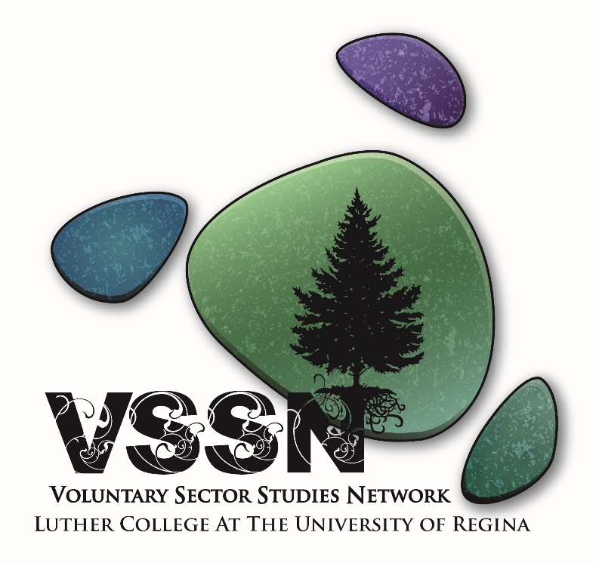
Table of Contents
1. Introduction ii
2. METHODS ii
3. DEMOGRAPHICS ii
3.1 Respondent demographics ii
3.2 Sector respondent works/volunteers most frequently in iii
3.3 City/town/community respondent nonprofit organization is located iv
3.4 Respondent organization’s approximate annual revenue iv
3.5 Length of time respondent worked/volunteered in the nonprofit sector v
4. Results vi
4.1 Course Ranking vi
4.2 Analysis of comments on courses vii
THEME 1 – Incorporating components of each course into 5 key courses vii
THEME 2 – Curriculum and levels of certificate vii
THEME 3 – Experiential learning and volunteer opportunities for students vii
THEME 4 – Importance of cultural competency vii
THEME 5 – The business of the nonprofit sector vii
4.3 Themes on Certificate name viii
THEME 1 – Names with “nonprofit” viii
THEME 2 – Names with “voluntary” ix
THEME 3 –Names without “nonprofit” or “voluntary” x
5. CONCLUSION xi
Appendices 12
Appendix A – Survey for VSSN network 12

1. Introduction

This report summarizes results from the October 2015 VSSN survey of the network of organizations and individuals that comprise our e-list to determine the priority of possible courses for the new Certificate. As well, the survey asked network participants to provide feedback on the preferred name for the Certificate. This survey was developed based on outcomes from public meetings, koffee klatches, focus groups, pan-Canadian research on courses offered at post-secondary education institutions, and a survey of university students, all undertaken this past year. This new Certificate will be informed by the VSSN network feedback. The Certificate will consist of 5 required courses and 1 elective. The target audiences for the Certificate program are undergraduate students who would like to be able to work in the voluntary/nonprofit sector and people working in the sector who want to advance their knowledge and receive the Certificate credential.

2. METHODS
An online survey was distributed to the VSSN network with a list of 14 possible courses for the new Certificate. Each respondent was to choose their top 5 courses, provide feedback on their respective top picks, and include a proposed name for the new Certificate. Data were entered and analyzed in Excel spreadsheet and a weighted sum was calculated to rank each question. For example: Q1 weighted sum = [(# of people who ranked course 1 x 5) + (# of people who ranked course 2 x 4) + (# of people who ranked course 3 x 3) + (# of people who ranked course 4 x 2) + (# of people who ranked course 5 x 1)]. Respondent comments were then thematically analyzed to determine overarching themes. Please find the questions to this network survey in Appendix A.

3. DEMOGRAPHICS
A total of 59 respondents completed the survey which is a 25% response rate.

3.1 Respondent demographics included:
- Paid staff of a nonprofit/voluntary organization 62.5%
- Volunteer with an organization 42.86%
- Student 10.71%
- Multiple roles in more than two organizations 8.93%
- Other (staff at a hospital, past director of a NPO, civil servant, program coordinator for CBO, government employee, university staff) 12.5%
Figure 1: Respondent demographics

3.2 Sector respondent works/volunteers most frequently in:

- Arts & culture 30.36%
- University & research 30.36%
- Health 25%
- Social Services 25%
- Sports & recreation 19.64%
- Religion 17.86%
- Business & professional associations/unions 7.14%
- Education & research 14.29%
- Grant-making, fundraising, volunteerism 14.29%
- Environment 12.5%
- Hospitals 7.14%
- Development & housing 5.36%
- Law, advocacy & politics 3.57%
- International development 1.79%

Figure 2: Sector respondent works/volunteers in

3.3 City/town/community respondent nonprofit organization is located:
Figure 3: Location of respondent’s nonprofit organization

3.4 Respondent organization’s approximate annual revenue

- $29,999 or less 9.09%
- $30,000 - $99,999 12.73%
- $100,000 - $249,999 1.82%
- $250,000 - $499,999 5.45%
- $500,000 or more 40%
- Don’t know 30.91%

Figure 4: Respondent organization’s approximate annual revenue

3.5 Length of time respondent worked/volunteered in the nonprofit sector
- Less than 1 year 5.45%
- 1 to 3 years 9.09%
- 4 to 6 years 18.18%
- 7 to 9 years 14.55%
- 10 years or more 52.73%

Figure 5: Length of time respondent worked/volunteered in the nonprofit sector

4. Results

4.1 Course Ranking

Figure 6: Ranking of core courses

Rank | Course
1 | Q1 Foundations of Nonprofit Sector
2 | Q2 Leading and Managing Organizations
3 | Q3 Managing Human Resources
4 | Q4 Communications and Strategic Relationship Building
5 | Q6 Program Planning, Monitoring and Evaluation
6 | Q5 Community Development and Advocacy for Change
7 | Q7 Financial Management, Philantropy and Revenue Source Innovations
8 | Q14 Intro to Business
9 | Q8 Governance and Legal Issues in Third Sector Organizations
10 | Q13 Intro to Organizational Behaviour
11 | Q9 Contemporary Issues
12 | Q11The Sociology of Indg Peoples in Canada
13 | Q12 People, Power and Politics: An Introduction
14 | Q10 NGO's Crossing Borders

4.2 Analysis of comments on courses (NOTE: These are not ranked in any way)

THEME 1 – Incorporating components of each course into 5 key courses
- All of the proposed courses contain elements that are crucial to a successful career in the Voluntary Sector and could be combined and/or introduced in the main 5 courses.
- Courses that were not selected could be electives or part of a level 2 certificate.

THEME 2 – Curriculum and levels of certificate
- The certificate should focus on courses that are least likely to be obtained through other educational avenues.
- Discussions of two certificates offering introductory principles as well as an advanced certificate that is accessible for people already with experience in the nonprofit sector (ie training around managing volunteer resources, community placements, practicums, designing appropriate roles, risk mitigation, screening and support).
- Other courses could be learned at a two-day workshop or through ongoing professional training sessions, attending summer school, etc.
- Providing a strong foundation and standardized tools such as the National occupational standards for Managers of Volunteer Resources will be critical elements of this certification.

THEME 3 – Experiential learning and volunteer opportunities for students
- Putting knowledge into practice by creating opportunities of experiential learning for students through work practicums or placements in the sector. It is important for students to have hands-on experience and awareness of how nonprofits function as well as learning strategic relationship building, giving presentations to different audiences and networking with the community/other nonprofit organizations (learn how to identify them, determine which are most in alignment with your organization's mandate, and create win/win opportunities).

THEME 4 – Importance of cultural competency
- Training on cultural competency and working with vulnerable populations as well as a deep respect and understanding for all walks of life is fundamental to the certificate. To successfully serve the populations of Saskatchewan and Canada, a deep and abiding understanding of First Nations history, sociology, spirituality and treaty rights is necessary as well as understanding the importance of incorporating cultural diversity and the benefits of diverse perspectives into all courses.

THEME 5 – The business of the nonprofit sector
- Prioritize courses that focus on providing management skills needed to create stronger nonprofit organizations. The sector needs people with leadership, management, financial, and other business skills that would allow organizations to develop a higher degree of independence. Growing a new generation of passionate, political, community-focused workers who also have mad business and marketing skills!
- Discussions around the relevance and term of “business” as it can imply “for profit”
- “Intro to Business” should be distinct from the faculty of business and placed in a nonprofit context.

4.3 Themes on Certificate name

THEME 1 – Names with “nonprofit”

Note: Many respondents commented on using the term “nonprofit” and less of “voluntary”, however other respondents were concerned that if you do not have the word “voluntary” people might not understand the connection to the “nonprofit” sector.

- Certificate in nonprofit studies (CNPS) I'd avoid using "voluntary" as I think students would see that as only pertaining to volunteerism. The focus needs to be on the entire sector.

- Certificate in nonprofit studies (CNPS) I'd avoid using "voluntary" as I think students would see that as only pertaining to volunteerism. The focus needs to be on the entire sector.

- Nonprofit and voluntary sector certificate (NPVSC) - But it turns out that this one is already taken by Ryerson - which is not a bad thing, unless it's very different? Still, I think that the word nonprofit needs to be in there, as it signals that its way more than volunteering.

- Community Organization Management Certificate Charity and Nonprofit Organization Leadership (COMCCNPOL)

- Nonprofit Management & Leadership (NPML)

- Nonprofit Management Certificate (NPMC)

- Non Profit Management (NPM)

- Nonprofit Organization Management (NPOM)

- Nonprofit and Voluntary sector Management (NPVSM) The above title captures the essence of the course structure and the intent of this project.

- Nonprofit Sector Certificate (NPSC)

- Certificate of Nonprofit Management (CNPM) - This seems like it would stand out on a resume for someone seeking work in the field.

- Certificate in "Nonprofit/Voluntary Sector Business Relations" (NPVSBR)

- Community Building through the Nonprofit sector (CBNPS)

- Leadership in the Not-For-Profit Sector (LNFPS)
- Certificate of Nonprofit Sector Structure and Operations (CNPSSO) It's the two basic elements of a nonprofit and can lead to work as a front line employee (operational) or behind the scenes in management, administration etc. (structural).

- Non Profit Sector Certificate (NPSC)

- Sector Success in the Non Profit (SSNP)

- Preparing for work in the NonProfit (PWNP)

- Nonprofit Sector Leadership Development Certificate (NPSLDC)

- the introductory certificate: Introductory Leadership for Nonprofits (ILNP) next certificate: Advanced Leadership for Non Profits (ALNP)

THEME 2 – Names with “voluntary”

- VSSN (Voluntary Sector Studies Network) why: this group started the certificate, why shouldn't the name of the certificate be just that.

- Voluntary Sector Studies Certificate (VSSC)

- Voluntary Sector Certificate (VSC)

- Volunteer manager certificate (VMC)

- Volunteer Management Studies (VMS)

- Voluntary Sector Management (VSM)

- Volunteer Sector Management Certificate (VSMC)

- Voluntary Sector Management Certificate (VSMC)

- Community Advocacy through Volunteer Organizations (CAVO)

- Volunteer Administration Certificate (VAC)

- Certification in non profit and volunteer administration (CNPVA)

- Service sector studies (SSS) Rational: Simple, flexible, adaptable to including other related subjects, the common element to all the existing labels.

- Voluntary Sector Business Essentials Certificate (VSBEC) or Voluntary Sector Business Competency Certificate (VSBCC) - In order to appeal to an undergraduate student, especially one that knows little of this field, the title has to indicate that it is offering something worthwhile and/or important. On the other hand, individuals currently working in the nonprofit sector need to see how the certificate is directly related to the field. I believe both of these titles offer these points, while still remaining accurate to the skills the certificate will help develop in individuals who pursue it.

- Voluntary Field Certificate (VFC)

- Voluntary Sector Leadership Certificate (VSLC)

THEME 3 –Names without “nonprofit” or “voluntary”

- Strengthening Civil Society Certificate (SCSC)

- Certificate in Working for the Public Good (CWPG). I think something about the nature and motivation of the work is important.

- Sustainable Community Studies (SCS) - Communities will never be sustainable without dedicated volunteers and not-for-profit organizations. Communities can be neighborhoods, cities, towns, countries or even a small groups of people.

- Social Economy and Community Development Management Certificate (SECDMC) (Volunteering and nonprofit being very narrow subsections of the above)

- Community Development Certificate (CDC)

- Certificate in Community Leadership (CCL) I think something that identifies community as the central theme of the course might be appropriate, based on the courses being offered.

- Canada's Third Sector: The Basics (CTS)

5. CONCLUSION
To be completed

Appendices

Appendix A – Survey for VSSN network

Voluntary Sector Studies Network

September 2015
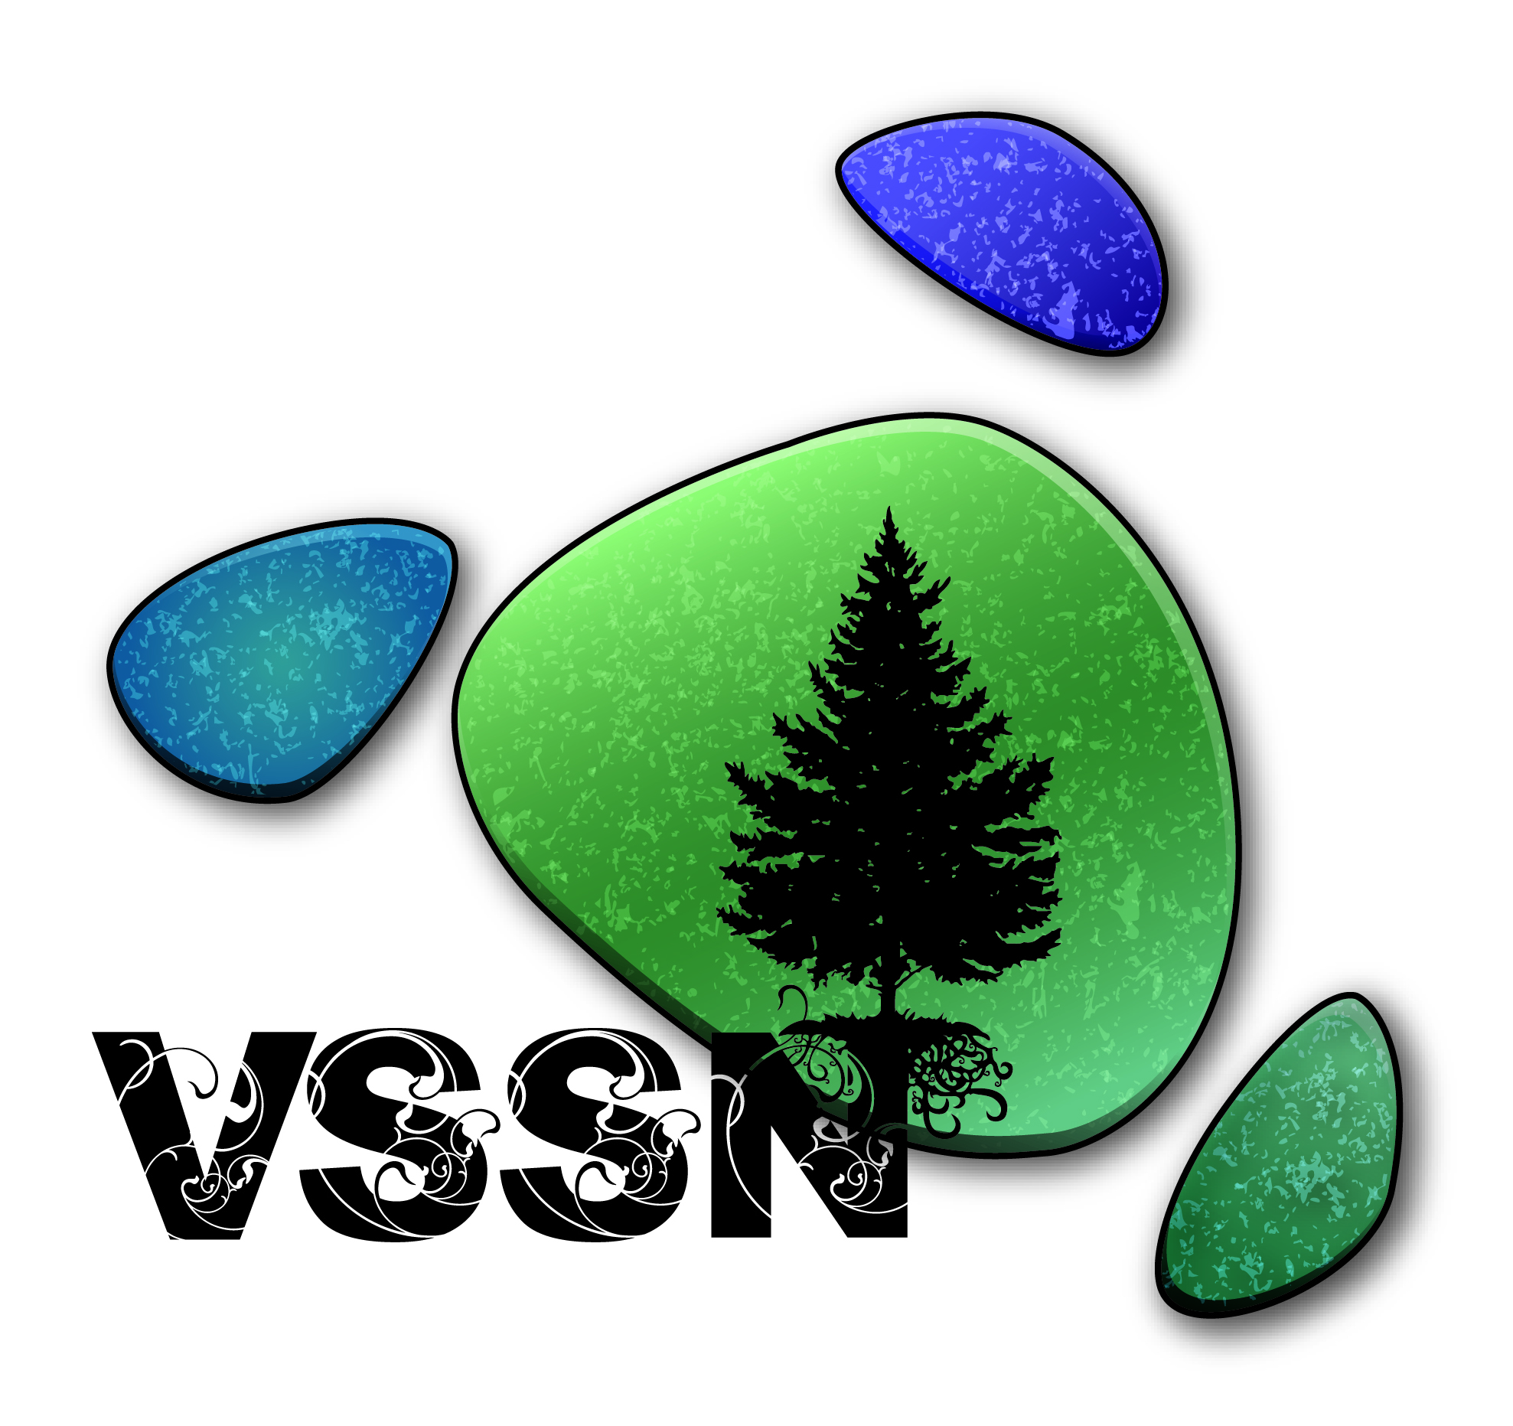
Dear Colleague,

The VSSN is an innovative, interdisciplinary, community-university collaborative comprising students, the voluntary sector and faculty/staff administered out of the VSSN office at Luther College at the University of Regina. It opened in September 2014 and appears to be the first of its kind in Saskatchewan (please see www.luthercollege.edu/vssn for more information).

You are invited to participate in shaping the new Certificate in voluntary sector studies at Luther College at the University of Regina because you work and/or volunteer in the nonprofit/voluntary sector; this survey is for people who have direct experience in the sector. This survey should not take any more than 20 minutes to complete – please complete this survey before Oct. 10. We value your input at this stage in our process.

This survey regarding a list of courses for the new Certificate was developed based on the public meetings, koffee klatches, focus groups, pan-Canadian research on courses offered at post-secondary education institutions, and a survey of university students undertaken this past year. You may have been involved in these meetings and recall that each successive step we have taken this past year has involved community engagement. It is important to us that this new Certificate be informed by people like you who work and/or volunteer in the nonprofit sector.

Please note that all your survey answers will be kept both confidential and anonymous; your answers will only be viewed by my research assistant and I. Your answers will be put together with answers from other respondents and only used in summary form for reporting purposes. If you are interested in receiving a copy of this summary report, please include your email address at the end of the survey.

If you have any questions or concerns, please do not hesitate to contact either the VSSN office (vssn@luthercollege.edu), myself, or Dr. Mary Vetter, the Acting Director of VSSN (mary.vetter@uregina.ca, 306-585-5036). Thank you in advance for taking the time to share your thoughts with us.

Sincerely,

Gloria DeSantis, PhD
Assistant Professor, Dept. of Justice Studies, University of Regina
Founder/Facilitator, Voluntary Sector Studies Network (VSSN), Luther College
3737 Wascana Pkwy, room CL 327, University of Regina
Regina, SK, Canada, S4S 0A2
306-585-5066 gloria.desantis@uregina.ca
Survey: Voluntary Sector Studies Network course priorities for new certificate
Please complete this survey before October 10, 2015

INTRODUCTION

After a very busy first year at the Voluntary Sector Studies Network (www.luthercollege.edu/vssn) and based on the participation of many of you at our community meetings, we have created a draft list of proposed courses for the new Certificate at Luther College at the University of Regina. Given your employment and/or volunteer work in the nonprofit/voluntary sector, we would appreciate you sharing your insights in two main areas:
- Rank ordering the draft list of courses
- Suggest a name for the new undergraduate Certificate
A third section is simply a series of questions about you as a respondent so that we get a sense of who participated in this survey.

1. RANK ORDER YOUR TOP 5 COURSE CHOICES

Below, you will find descriptions to 14 proposed courses that could be offered in this new Certificate. Please rank order the top 5 courses that you believe all students should take in order to graduate with this new Certificate. The 5 courses you choose should reflect the skills and knowledge base that you believe students who graduate with this Certificate should have.
To rank order the list of courses below, place a number from 1 (1 being most important) to 5 (5 being least important) in the boxes beside the 5 courses that you think all students should be required to take. Please note, a rank of 1 is considered the most important course. Please leave all other courses blank.

Please note that all of these courses will have real-world, experiential and problem-based learning components.

Foundations of the Nonprofit Sector – Proposed as the course that all students are required to take before other courses. It is an introduction to the nonprofit/voluntary sector including its unique characteristics and central philosophy/values, volunteerism and philanthropy, scope and size, history, types of organizations, roles in society, relationships with governments and the business sector, economic contributions, ethical challenges and current critical issues and debates. It focuses on Saskatchewan specifically and Canada generally. This sector is often invisible yet it contributes substantially to our quality of life, economy and democracy.
Rank #

Leading and Managing Organizations – This course introduces students to management and leadership principles and practices in an era of constant change. Of particular importance are different organizational types (e.g., registered charities, registered nonprofits, etc.), constitutions and by-laws governance models, decision-making models, strategic planning, ongoing organizational capacity building and learning, leadership styles, change and sustainability, and partnership/alliance types with other nonprofits, governments and the business sector (e.g., P3s), an exploration of the roles of boards of directors in nonprofits including fiduciary duty, liability and risk management as well as regulatory/legal requirements are presented and consideration of the role of technology and open source software in organizational development is presented.
Rank #

Managing Human Resources - Human resources fundamentals and management for both paid staff and Volunteers is the focus of this course. Key areas of recruitment, screening, orientation/training, evaluation, retention, supervision, coaching/mentoring, position duties and descriptions, policies and procedures, records management, communication and recognition are examined. Of major importance is confidentiality, deep understanding of cultural diversity, basics of healthy human relationships, self care and self management, and conflict resolution. Current standards are presented (e.g., Council for Certification in Volunteer Administration and Volunteer Canada standards, labour codes, occupational health and safety codes, Human Rights, etc.)
Rank #

Communications and Strategic Relationship Building – This course focuses on communications with the general public, governments, other nonprofit organizations, the business community, media, funders and donors in order to build intentional relationships with the variety of stakeholders in a nonprofit organization's environment. Both theory and practice are integrated into the examination of the different types of relationships and accountabilities required of nonprofit organizations. Students will learn about the newer role of social media and the importance of a virtual/public presence, branding, key messages and time-sensitive response mechanisms.
Rank #

Community Development and Advocacy for Change – Both theoretical and practical knowledge and skills are the focus of this course. The focus is on community development and community organizing including how to network and work across organizations as well as engage community residents in order to achieve changes in public policies and programs as well as educate the public about societal problems. An examination of power structures, systems, government structures and processes, as well as change theories is undertaken. Students will learn to critically assess the context (e.g., political, social, economic, historical) within which all advocacy work unfolds and make informed choices about appropriate strategies and tactics for their nonprofit organization. Legal restrictions for charities/nonprofits are also explored.
Rank #

Program Planning, Monitoring and Evaluation – The main focus of this course it on how nonprofit organization staff and Volunteers must understand both the shifting external environment in which they operate as well as their internal environment. Thus, central course elements are mixed methods research approaches, external environment trend analysis and projections, internal organization database management technologies and analytic strategies, evaluation and decision-making models for program renewal, outcome and impact measurement and special projects management.
Rank #

Financial Management, Philanthropy and Revenue Source Innovations - This course offers a broad overview of organizational economics and philanthropy that focuses on diverse funding sources and formulas: governments, donors, corporate sponsorships, fundraising, social enterprises, etc. Nonprofits are different from for-profit businesses in that they do not have shareholder equity, thus their financial management is different. Students will be introduced to financial monitoring systems, the roles of different people in the nonprofit organization (e.g., treasurer, bookkeeper, or accountant), creating and monitoring annual budgets, internal and external reports and procedures, cost accounting methods, long range financial planning and building capacity for innovation.
Rank #

Governance and Legal Issues in Third Sector Organizations - This course is designed to investigate the legal issues and management of risk in nonprofit delivery systems. This course will provide a basic understanding of the governmental systems and governing bodies that influence the delivery of recreation services and legal issues students will likely encounter in their future professions.
Rank #

Contemporary Issues - This course examines topics of critical interest in the 21st Century: religious diversity, marginalization and extinction of cultures, social constructions of identity, consumer choices, sustainable livelihoods, and climate change. We will explore ideas about locating ourselves and developing agency in a changing and challenging world. Developing communication and research skills is a focus. Coordinated by one faculty member, this course draws on the expertise of instructional faculty from different disciplines.
Rank #

Non-Governmental Organizations Crossing Borders
Do non-governmental organizations make a difference? How do they interact with and alter the international state system? This course examines the activities and influence of transnational non-governmental organizations such as global struggles against colonialism and slavery; and campaigns for human rights, women's rights, indigenous rights and banning land mines.
Rank #

The Sociology of Indigenous People in Canada
This course introduces students to the experience of Indigenous peoples in Canada from a sociological perspective. Employing historical and contemporary examples, students are introduced to policies and legislation shaping relationships between Indigenous peoples and other Canadians. Specific topics might include the neglect of Indigenous issues in Canadian sociological studies, applying social theory to the study of Indigenous issues, identity, Aboriginal and treaty rights, self-government, assimilation, land claims, health, education and justice.
Rank #

People, Power and Politics: An Introduction
An introduction to the issues, concepts and institutions of contemporary politics in both Canadian and international contexts, inviting critical thinking on subjects such as power, citizenship, democracy, diversity, feminism and colonialism. It links these topics to current world political events and issues. The objectives of the course are to introduce concepts and approaches in political studies and to cultivate civic education.
Rank #

Introduction to Organizational Behaviour - This course introduces various concepts and tools that will assist you to understand individual and group behaviour, the structure and design of organizations, and how to improve organizational effectiveness. Topics include: roles of the manager, goals, environment, structure/design, motivation, leadership, individual and group decision making, team dynamics, and conflict.
Rank #

Introduction to Business - This course provides a broad introduction to business and management concepts. Functional areas – marketing, finance, accounting, entrepreneurship, operations management, human resources, strategy, and organizational behavior – are also introduced. Further, the course covers key processes and topics such as the Canadian business environment, environmental scanning, ethics and risk, and decision-making. The course introduces material seen in higher-level business courses.
Rank #

2. COMMENTS ABOUT THIS LIST OF COURSES

Do you have any comments to share with us about this list of courses, your ranking of them or anything else we should know about the skills and knowledge bases that you believe should be required of students?

3. NAME THE NEW CERTIFICATE

Now that you've had a chance to think about and rank order the proposed courses, please tell us what you think we should name this new Certificate. Your suggested title(s) should not be more than 4 or 5 words long and should appeal to undergraduate students as well as resonate with those who already work/volunteer in the sector. Please add your suggestions here and tell us why:

4. SHARE YOUR INFORMATION WITH US SO WE KNOW WHO PARTICIPATED IN THE SURVEY

Please complete the following section in order for us to get a better understand of who you are.

- Which sector do you work/volunteer most frequently in? Please check all that apply to you.

___ Arts & culture (e.g., heritage groups; visual & performing art centres)
___ Sports & recreation (e.g., community recreation centres; youth sport programs)
___ Education & research (e.g., research institutes)
___ Universities and colleges (e.g., educational institutions)
___ Health (e.g., health and wellbeing programs; mental health organizations)
___ Hospitals (e.g., health care services; clinics)
___ Social services (e.g., support agencies; emergency shelters)
___ Environment (e.g., wildlife protection centres; conservation associations)
___ Development & housing (e.g., housing associations; community development programs)
___ Law, advocacy & politics (e.g., advocacy organizations; legal services)
___ Grant-making, fundraising, voluntarism (e.g., foundations; volunteer bureaus)
___ International development (e.g., overseas relief agencies; human rights organizations)
___ Religion (e.g., faith communities)
___ Business & professional assoc/unions (e.g., health associations; labor unions)

- Are you a (please check all that apply to you)
___ paid staff of a nonprofit/voluntary organization
___ volunteer with an organization
___ multiple roles in more than 2 organizations
___ student
___ other, please specify _______________________________________

- In what city/town/community is your nonprofit organization located? ___________

- What is your organization's approximate annual revenue? Please choose one.
___ $29,999 or less
___ $30,000 - $99,999
___ $100,000 - $249,999
___ $250,000 – $ 499,999
___ $500,000 or more

- How long have you worked/volunteered in the nonprofit/voluntary sector? Please choose one.
___ less than 1 year
___ 1 to 3 years
___ 4 to 6 years
___ 7 to 9 years
___ 10 years or more

- Please include your email address if you are comfortable with us contacting you for more information (if necessary) and for sharing the results of this survey with you.

Thank you very much for taking the time out of your busy schedule
to share your thoughts/advice with us!

