KENYATTA UNIVERSITY WASTE MANAGEMENT PROJECT IN NGONG, NAIROBI COUNTY

Introduction

Solid waste management is a major problem in most towns in Kenya. County Governments, who are charged with the responsibility of waste management, are usually faced with a huge challenge. Most towns do not have designated or licensed dumpsites and are characterized by small dumpsites at every corner or street which eventually grow into big piles that are unmanageable. It is also common to find animals such as cows, goats, chicken, and pigs feeding at these dumpsites. This poses health risk as disease causing organisms can easily be transferred from animals to humans through the food chain. Such sites, which are normally littered all over, are breeding grounds for disease causing organisms such as rodents and cockroaches. The dumpsites are also an eye sore apart from blocking drainage systems thus causing flooding in urban areas and breeding grounds for mosquitoes. All these are exacerbated by the rapid population increase as people migrate from the rural areas to towns to look for employment and also seek better social amenities. Increase in population gives rise to high waste generation turnover from domestic, agricultural and industrial sectors.

During the World Cleanup Day 2012 held in Ngong town, Kajiado County, Kenyatta University and NEMA partnered with Nuru Group based at the Ngong dumpsite to promote pilot waste segregation project.

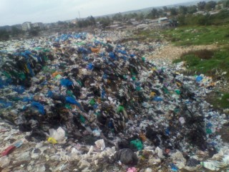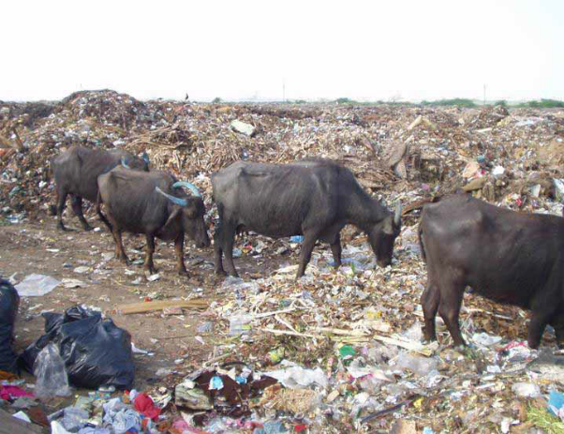

Disposed mixed waste and animals scavenging at the Ngong dumpsite are common
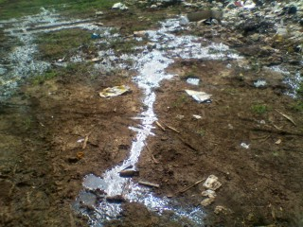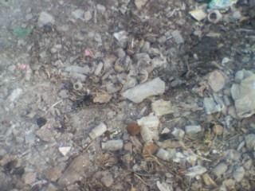

Leachates from Solid Wastes and medical waste as part of the pollution at the Dumpsite

Situational Analysis

Ngong and its environs, including Ongata Rongai, Kiserian and Karen do not have a licensed solid waste treatment facility. All the waste generated in these areas should be taken to the main Dandora Dumpsite located in Nairobi City County. However, due to the distance, all the waste is dumped in Ngong dumpsite. Over time, this dumpsite has been an eyesore. It used to be a small heap of waste but with time the site expanded and became a threat to the neighbouring church compound and school. On a windy day, plastic papers from the dumpsite would strew all over the area. Animals-goats, dogs, donkeys were scavenging freely in the dumpsite.

Scavengers or recyclers retrieve valuable waste products from the waste delivered to the dumpsite. These people carry out this activity in unhygienic conditions without personal protective gear and under the scorching sun. They rubble through the dirt sorting for materials with their bare hands and feet. They also eat their snacks or food in this dirty environment.

The valuable products include plastics, glass, metals clothes and organic waste for feeding the pigs. The plastics and glass collected are sold to brokers who sell to other recyclers companies. The dumpsite is managed by the County Government of Kajiado, who collect a fee from all the transporters as they dump their waste.

NEMA and Kenyatta University partnered with Nuru Youth Group and RCE Greater Nairobi to transform the dump site to an excellent centre for solid waste management, where students can also use as a learning center for waste management including research and innovation

Strengths of the Dumpsite.
- It receives a lot of waste from Karen, Ongata Rongai, Kiserian and Ngong towns.
- There is already a group practicing sorting and waste recovery.
- The group has a market for the recovered items
- The group is highly organized- its registered with the District Social Services Department, has elected group officials and a bank account.
- The land belongs to the County Government of Kajiado
- The site is fenced with a sorting shade build
- The group is trained on safe handling of waste
- A good working relation between Nuru group and stakeholders in the project.
Challenges at the dumpsite
In spite of the above strengths there are very many challenges that hinder proper waste management at this dumpsite,
- The waste delivered to the dumpsite is not sorted-the waste is normally mixed and dirty.
- The sorting is done in alternating manner since the shade cannot accommodate both males and females
- There is no storage for the sorted products
- The road to the dumpsite is impassable during the rains, so the waste is dumped on the road away from the dumpsite,
- Uncertainty about the ownership of the land where the dumpsite lies.
- The complexity of waste segregation at source. May not reach the segregator at the site.
- Brokers who buy recovered materials at a low price.
What has been done.
1. NEMA has engaged the key stakeholder, the County Government of Kajiado who manage the dumpsite.
2. Capacity Building of segregators and transporters has been done. They were trained on legislations, managing waste in the county, safe and health waste handling and entrepreneurship as well as financial planning.
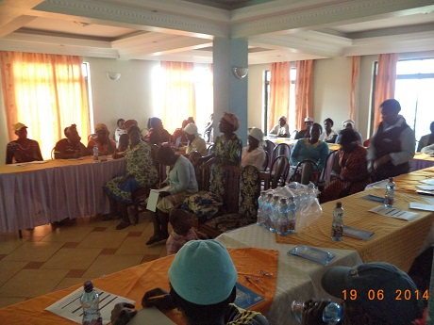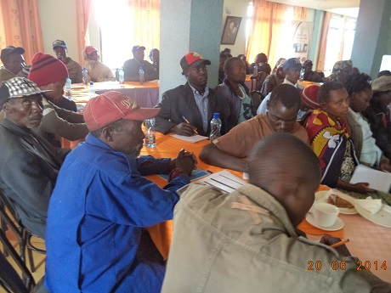
Training of segregators and Transporters from the dumpsite
3. Fencing of the Dumpsite has been done by the County Government of Kajiado to secure the place
4. A sorting shade has already been constructed and in the process of putting up a store, an office and install a water tank. A sanitation facility will also be constructed. There is also a consideration to put up a second sorting shade for women.
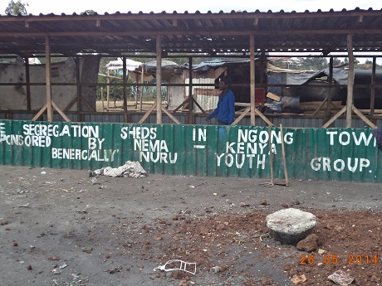
The sorting shade constructed by NEMA at the Ngong dumpsite
5. A waste compactor has been put in place at the site.
6. The weather road has been improved and is now passable much of the times.
7. Provision of Personal Protective Equipment (PPEs) to Nuru Youth group done by NEMA.
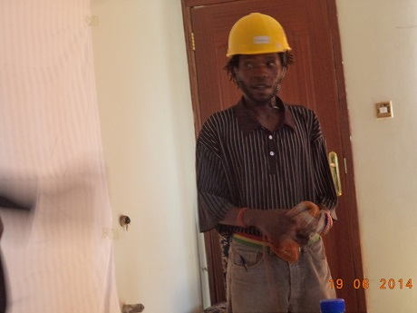
A member of Nuru group demonstrate the use of Personal Protective Equipment.

Impact of the project
- Reduced scattering of waste at the dumpsite
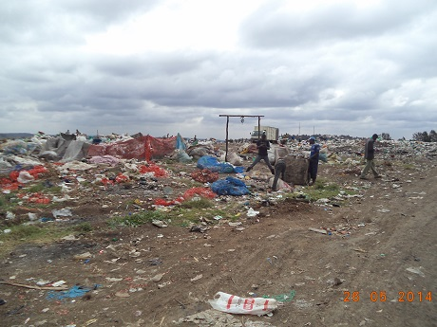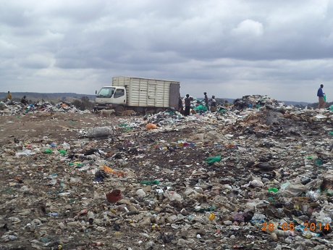
Improved road system and reduced waste at the dumpsite through material recovery
- Controlled access to the dumpsite by use of the fence
- Increased recovery of materials which is about 70% of all the waste delivered at the site
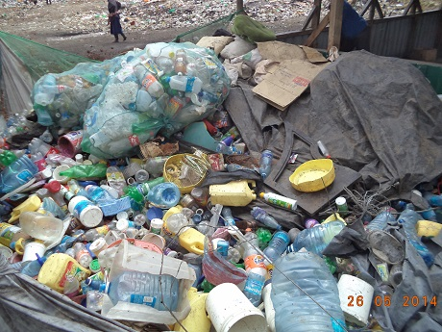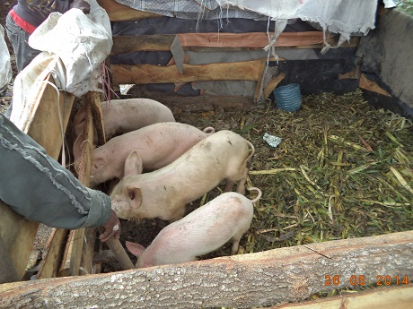
Recovered materials for recycling and an integrated big project by the group that utilizes organic waste

- Improved livelihoods of the segregators through better income
- Reduced cases of injuries and diseases
- Raised compliance levels to environmental laws/regulations

Conclusion
The site is proposed to be a transfer station as the County Government plans to put up a sanitary landfill. In this way the locals will benefit from an integrated waste management project involving all stakeholders in the waste management chain right from generation to final disposal.
There is need for the relevant stakeholders to support those working at the dumpsite adopt the 3R concept of waste management. This therefore will be a big business that can employ many people. Such sanitary landfill will create many jobs for people who can eke a living by trading in solid waste.

