SCHOOLS’ ENVIRONMENTAL PROJECTS FOR SUSTAINABLE DEVELOPMENT
By: Mr. George Njagi – Senior Education Officer, AFEW Kenya Ltd.

The African Fund for Endangered Wildlife - Kenya (AFEW-(K), popularly known as the Giraffe Centre is a charitable not for profit organization whose main objective is to educate the youth on the importance of conserving wildlife and the environment. The centre was founded by the late Betty and Jock Leslie Melville in 1979 with the aims of breeding a rare type of giraffe known as Rothschild’s as well as to educate on sustainable environmental conservation.
Giraffe Centre sensitizes Kenyans, especially the youth and the community on the importance of conserving nature and the environment so that they can take the initiative of preserving their own biodiversity. Through her training of trainer’s (ToTs) workshops, the Giraffe Centre has been at the fore front to ensure provision of Education for Sustainable Development (ESD) for the Kenyan teachers. This started way back in 2001, where during this period the Centre engaged teachers in all levels of education, training them in Environmental Education (EE). In 2005, Giraffe Centre shifted the approach of her trainings from EE to ESD in line with the UN Decade of Education for Sustainable Development (2005-2014) that seeks to Integrate the values inherent in sustainable development into all aspects of learning to encourage changes in behavior that allow for a more sustainable and just society for all. This program has seen over 2000 teachers trained to date and over 100 school environmental projects implemented (AFEW (2010)).
During the trainings, Giraffe Centre has partnered with different stakeholders during workshop facilitation as well as funding. These stakeholders include; National Environmental authority, Kenya (NEMA), Wildlife Clubs of Kenya (WCK), National Museums of Kenya (NMK), relevant government ministries to include; Ministry of Education (M.o.E), Kenya Institute of education (K.I.E) and Kenya Institute for the Blind(K.I.B), Community Based Organizations (CBOs) to include youth groups, women groups particularly those dealing with products made from recycled materials.

These (ToTs) programme emphasizes more on sustainability issues and sustainable development to the participants who thereafter are always expected to go and implement what they learnt in their respective schools and the surrounding communities. Most of the teachers trained with the Giraffe Centre are also challenged to facilitate information exchange on ESD from the grassroots level through the integration of environmental action learning in schools through micro projects implementation both in curricular and co-curricular activities. Integrating sustainable issues into all subjects and other school activities has shown to have potential in addressing current environmental problems facing the world today (Njagi, 2012).
School micro projects give the learners and the public an opportunity to participate and promote changes required for sustainable future. This stimulates the school-community action learning where teachers use such projects to educate students and the local community members on resource utilization and management. In 2012, Giraffe Centre was able to host many fora in partnership with other conservation organizations and donors to include; Kerrigan Waves Trust from the UK, Wildlife Clubs of Kenya (WCK) and National Environment Management Authority (NEMA) and Laikipia Wildlife Forum (LWF). Giraffe Centre in partnership with Kerrigan Waves Trust from the UK has over the years funded school micro projects in order to achieve the key objectives of the ToT workshops. These projects have played a key role in providing a platform for project based learning, problem based learning and practical based learning at school level with great opportunity for community involvement as well.
Our monitoring and evaluation exercises through school visits have revealed that despite the various challenges the schools have been facing, these projects sponsored by have immensely contributed towards sustainable environmental conservation hence achieving major goals of Education for Sustainable Development through sharing of information. In 2008, 2010 and 2012, Giraffe Centre organized for follow up workshops that brought together teachers from different schools that had benefited from the micro projects funding and donor agencies to include the Kerrigan Waves Trust, UK and Nile Basin Initiative. The participants shared their experiences as well as their success stories through presentations and field excursions to some of the schools within Nairobi that have implemented and managed their projects exceptionally well. The teachers were as well able to highlight the linkages of the projects with the curriculum and also brought out the sustainability aspects of the same.
Outlined case studies below are projects initiated by teachers after undergoing training at the Giraffe Centre. For any project to qualify for funding, sustainability is key, for example; the fish farming project is actually used by the school as a teaching tool during agriculture lessons, fish that is harvested has also supplemented protein in the school’s diet hence cutting down on cost for food. The tree nursery project sustains itself through the sale of seedlings to the community members. One notable aspect of all the projects is that they have created a link between the schools and the community in the school becomes a resource centre for them.
- Subuku primary school – Nyandarua County (Kenya)– Project: Water Harvesting and Tree Nursery

This is a school found in Nyandarua County in the central part of Kenya. The school was funded in March 2011 to implement water harvesting and tree nursery project. The tank was delivered to the school and installed to harvest water from the rooftops catchment of the classrooms. When I visited the school, I found out that the students together with their teachers were using the water harvested for the tree nursery which had over 3000 tree seedlings, flowers and on one side spring onions and vegetable. When ready, the students are usually allowed to harvest the vegetables and the onions for their family consumption, this motivates the pupils to work and involve themselves more.

The school collaborates well with an organization by the name ‘Tree is Life’ based in Nyahururu, they have given out a good number of trees to the community, the major challenges were; shortage of indigenous seeds for planting as the problem of water had been solved through the provision of the tank. Below are some of the pictures:

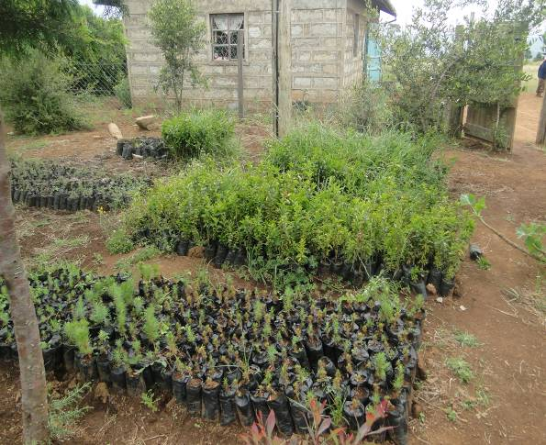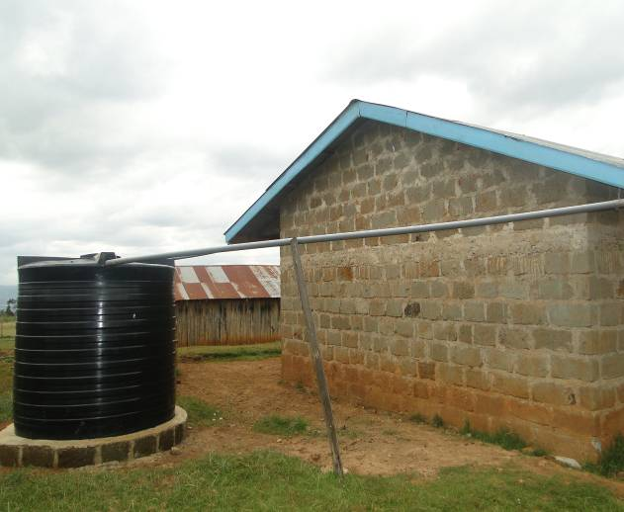

A Tree nursery Water harvesting in the School
- Kauti High School – Machakos County – Project: Water Harvesting and Tree Nursery

This school is located in Machakos County, in the Eastern region of Kenya. The school received the funding in February 2012 to implement a school greening project. The first step that AFEW carried out was to establish a source of water which was done through a water harvesting projects and there after the teachers and the students collaborated to get flowers and trees that were planted within the school compound. When I visited the school I found that the patron whom AFEW had trained and the one who had initiated the project was transferred to another school. However, this move did not kill the project as the head teacher together with her fellow teachers and the students went ahead and nurtured the project to what is today and as per AFEW’s expectations. The school has well tendered flower gardens in front of the administration block and all the classrooms. Due to this, community members have ended up using the school grounds for their wedding ceremonies, this has earned the school some revenue that has helped students to go out on field trips.

With the funding as well, the school started fish farming and from the head teacher, the fish was due for harvesting in September 2012. AFEW, s funded projects in the school have attracted other donors to include; the Constituency Development Fund (CDF) office and the local area member of parliament who came in and funded a green house project. The sustainability aspect of these projects is from the money earned through weddings, the sale of seedlings and the fish. For the community, it is a resource centre for them to learn about different projects that they can a well star at home.

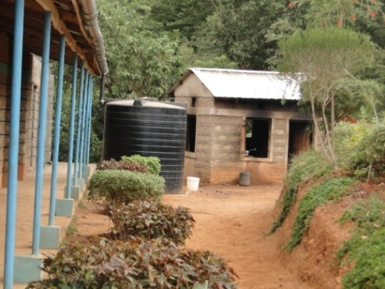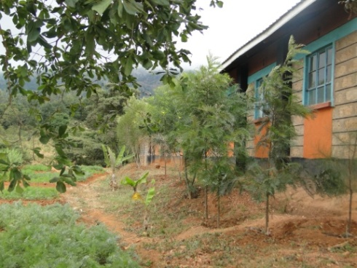

School beautification with flowers Trees planted behind the classrooms

- Katutu Girls Secondary School –Kitui County - Project: Fish Farming

This is a school that is located in Kitui County in the eastern region of Kenya. AFEW funded the project in February 2012. AFEW advised the school administration to consult with the local Fisheries Department under the Ministry of Agriculture for guidelines on how to put up the fish pond and once this was met, we released the funds. During my visit, I was marveled to find that the fish pond had over 1000 fishes and I got to understand that school wildlife club members had harvested the fish the previous day, enough fish to feed the whole school. The school also had a second fish pond that was funded by the Kenya Government through the Economic stimulus Programme (ESP) as a result of the good work they had done through AFEW funding.

The school also has established vegetable gardens, planted bananas and a tree nursery with about 100 tree seedlings surviving. The head teacher informed me that they have sold many seedlings to the community and for those who could not afford; they gave to them free of charge. Due to these projects, the school has become a learning focal point attracting the community members to learn on different sustainable agricultural methods. Visiting schools usually donate some money for the upkeep of the projects, the vegetables and the fish supplement the school diet hence saving money for the school.

Trees planted within the school compound have been labeled with their economic importance coming out strongly in order to give the students and anybody visiting the school a reason to conserve them, this has also changed the teachers and the students attitudes towards environment and they are also actively involved in feeding the fish, weeding the vegetable gardens, watering the trees as well as the flowers. Below are some of the pictures taken showing these projects:-

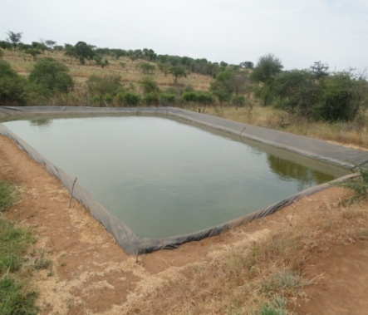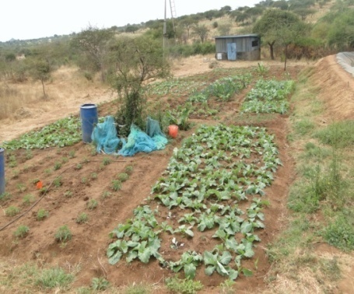
Fish Pond with about 1000 fishes A vegetable garden at the School
- Langata West Primary School – Nairobi County, Project:-Sustainable Waste Projects
Langata West Primary school located is located in Nairobi and was funded by AFEW for the first time in 2005 to implement a school greening project. After successful implementation of the project, AFEW once again funded a waste management project in the school with the aim of making the school into a model school where other school and the community at large would be visiting to learn on ESD. Initially buckets were strategically put outside the classrooms to be used as dust bins and in the course of the day pupils would carry the buckets and they would empty the trash in a pit which by now was no longer a pit but a pile of garbage. Actually, when I visited the school, I caught two pupils on camera disposing the waste.
The project entailed putting up of dust bins at strategic points where pupils could locate them easily; the dust bins also carried on themselves eco-codes e.g. “ Weka Taka Hapa” and “Taka ni Pato” translated respectively to mean “dump your litter in here” and “ Waste is money”, all these would constantly remind the pupils to make use of the dust bins. Secondly an incinerator was put up to incinerated non-biodegradable materials, e.g. the hard plastics instead of throwing them into the environment. With this project the schools has become one of the pupils’ friendly schools in the city and has attracted other schools and the community around to visit and about sustainable waste management. Below are pictures before and after the project implementation:-
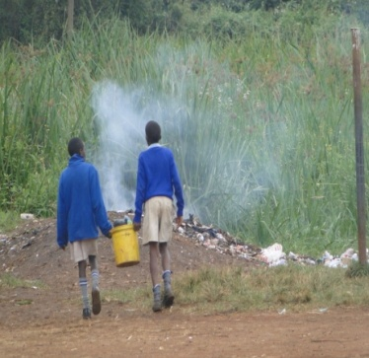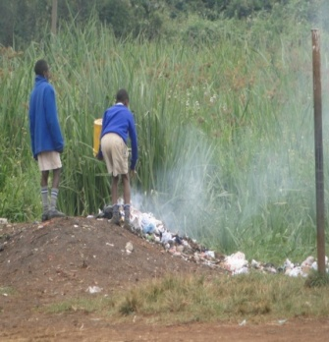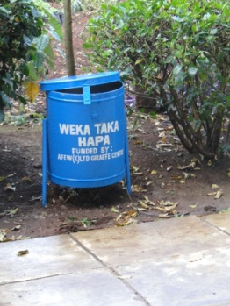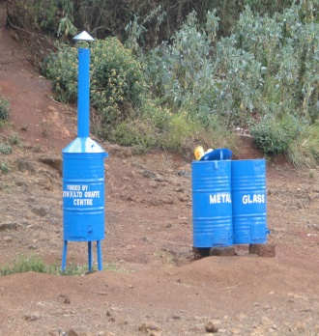
From this This
Training the teachers and implementation of these projects has not always been smooth sailing. One major challenge that we have faced is where the head teachers receives the money and denied to pass it to the patron to implement the project. We overcame this challenge by funding schools inform of the materials needed other than giving them money in cash. Other times may be the holds on to it.
These are just a few of the many success stories of what teachers have done after undergoing AFEW Training of Trainers programme. According to Njagi (2012), AFEW is one of the rare organization that have consistently upheld and respected the three pillars of ESD; society, Economy and Environment. In a nut shell, AFEW has effectively taken up the role of supporting the implementation of environmental education as a key policy instrument for bringing about transition to sustainable development.

References:
AFEW, (2006); AFEW Giraffe News; Issue no. 8
AFEW, (2008); AFEW Giraffe News; Issue no.10
Njagi G. (2012); Impact of Nature Education Centres in Promoting Sustainable Environmental Education and Awareness; A case Study of the Giraffe Centre: Unpublished Thesis

