TRADITIONAL DISPERSAL PRACTICE IN VERMICOMPOSTING: AN ADDED VALUE TO
SUSTAINABLE ORGANIC AGRICULTURE IN BOHOL

Description and Context of the Project

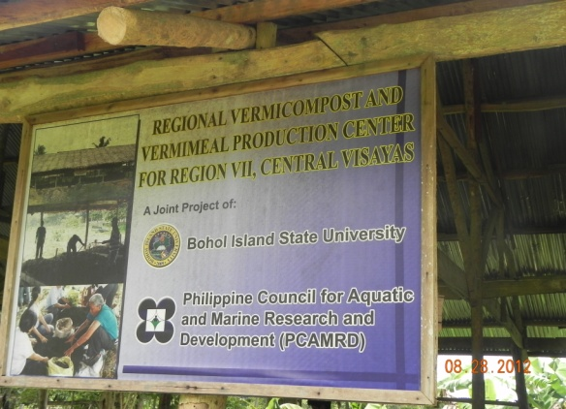
The use of alternative sources for chemical fertilizers is a felt need in the implementation of sustainable agriculture. One such potent source is vermicompost which is produced out of organic waste through the use of earthworms. It is largely made up of vermicast (worm cast) and organic matters that enrich the soil with nitrogen, phosphorous, potassium and humic acids. As such, vermicompost naturally nourishes the soil for continued years of optimum utilization ensuring the sustainability of farm production.

Bohol Island State University (BISU), an RCE-Bohol member institution, is the Vermicast and Vermi-Mill Center in the region. The center, established with 2.5 million-peso fund through a Memorandum of Understanding with the Philippine Council for Aquatic and Marine Research and Development (PCAMRD), does not only produce vermicast but also disperses worms and provides technical assistance to interested groups of farmers and Local Government Units LGUs).

The context by which this project springs is one that is engendered both by a national mandate and a local perspective of sustainable development. At one hand is the commitment of the Philippines to the Earth Summit in Rio de Janeiro calling for sustainable development in the areas of human activity so that a law has been passed mandating for the implementation of Sustainable Organic Agriculture. On the other hand is the local perspective of empowering the farmers who have become dependent upon commercially produced chemical fertilizers. This two- pronged framework begets the specific activities and guidelines of the vermicompost project in the region.

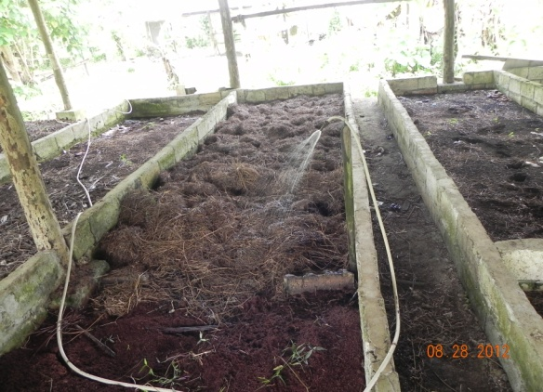
The project took off with a Trainers’ Training on the technology of vermicomposting. This was participated by Faculty from BISU, LGU members as well as Technicians from the province who, in turn conducted training to the farmers in their own locales. Since they are in the academe, trainers from BISU have been constantly requested as resource speakers in trainings throughout the region. It has thus become the assumed function of these BISU trainers and the whole Vermicompost Center in BISU to take charge of the transfer of technology to groups and individual farmer beneficiaries.

Training on vermicomposting is the necessary requisite for farmers to avail of the dispersal of worms. The Vermicompost Center in BISU sees to it that this requirement is met before requests for dispersal are granted. Center personnel conduct site visit to inspect readiness of substrate (worm food). At the end of the month is the harvesting of the worms so that it is also during this dates that dispersals are done.

Dispersals are granted to farmers’ groups and LGUs. Each group is allowed a maximum of ten kilos on condition that it shall be replaced after three or six months from the time the worms are dispersed.

To date, the extent of implementation of the project is already in the farmers’ level. This means that vermiworms and vermicompost have already been produced in the farmers’ own facility for their own use and for others to avail. The collaborative efforts of the Vermicompost Center in BISU, PCAMRD, the Government Organizations (GOs) and Non-Governmental Organizations (NGOs) of Bohol and the farmers themselves bring the project into full implementation.

Contribution of the Project

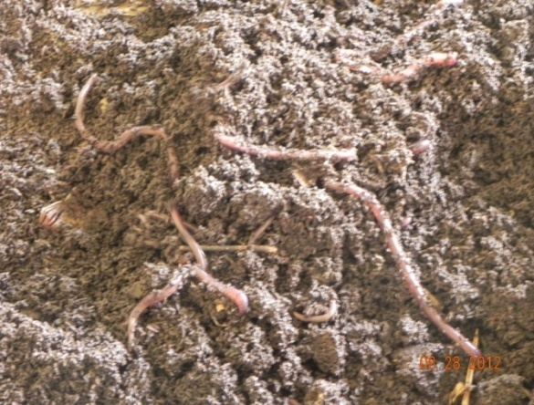
The region’s supply of vermicompost for organic farming has been sustained by the Regional Vermicompost and Vermi-Mill Production Center in BISU. Not only the farmers but also interested individuals have already availed of this organic fertilizer which is sold at an affordable prize. But since the objective of the project is to empower the farmers, the transfer of technology of vermicomposting and the dispersal of worms are musts for implementation. It is the latter that is considered as the most innovative aspect of the project.

After training on the technology of vermicompost is done, farmers, through their LGUs or associations are eligible to avail of worm dispersal. This dispersal is locally known as alima (translated in English as “care”) where worms are given for free to the farmers acting as their “caretakers.” After these worms shall have reproduced, the farmers are obliged to return to the center the number of kilos of the worms dispersed.

This scheme is one that addresses economic constraint to ESD project and showcases socio-cultural practice as solution. Originally, worms were for sale at 35 php per kilo. However, farmers couldn’t afford to pay the price so that there were no takers of worms. But the objective of the project was too noble to be jeopardized so that the alima system was adopted. Locals, especially the farmers, are not new to the scheme. Alima has been the practice of the local communities in Bohol. This is still the preferred option when a person or a household wants to own cattle, pig, or goat but is financially incapable to purchase one. He or she then goes to someone who has the animal and asks for a grant to be the “caretaker.” As the animal reproduces under the care of the farmer, he gets one of the offspring as his share and returns the others including the principal animal originally taken cared of to the owner. The sharing actually varies depending on the arrangement.

Indeed alima-of-worms-scheme addresses the economic constraints of the farmers to produce vermicompost. Moreover, it has also restored or sustained a socio-cultural value in the community that is instrumental for sustainable livelihood. Farming as a form of livelihood could be sustained through vermicompost by trusting one another even without the involvement of money.

The objective to empower the farmers is a local perspective that contextualizes vermicomposting in Bohol. It has been observed that for years, farmers have become dependent on multi-national companies to produce their farm inputs such as seeds, fertilizers and pesticides. This only effects a disadvantage to them since only the farm input producers reap the greater benefits. With vermicomposting, farmers now produce their own fertilizer in their own locality. This empowers them as they can now claim control in the production of a farm input. As this is replicated, eventually the whole community becomes empowered.

The long-term sustainability aspect of vermicomposting project rests on the fact that Bohol is a predominantly agricultural province. A major component of its workforce is in the agricultural production so that the long term goal of this workforce is farming. Side by side with the economy and the people is vermicomposting, thus there is a felt need of this kind of project.

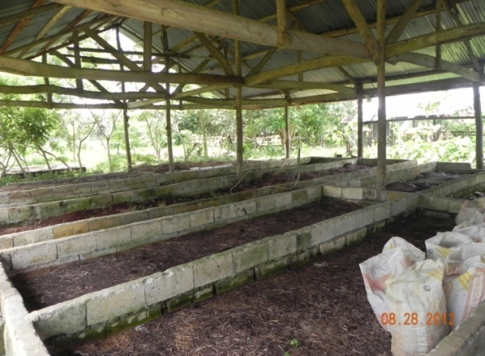
As pointed out, the project’s implementation is already at the farmers’ level. RCE-Bohol takes this as an initial success mainly brought about by two specific critical factors: (1) availability of materials to sustain production of vermicast and reproduction of worms, and (2) collaborative governance.

The substrate which the worms eat and convert into vermicompost is made up of materials that are readily available in the immediate surroundings. Animal manure, grasses and other farm residues mixed in varying proportions become the environment of the African Night Crawlers (worms) to reproduce and produce compost. Materials then will no longer be purchased as they are abundant in the locality so that one can easily replicate and sustain a vermicomposting facility in his own backyard. As this is done, the farmer puts into effect not only the Sustainable Organic Agriculture Law but also the Ecological Solid Waste Management Act of the Philippines. Moreover, collaboration among partners and stakeholders - BISU, PCAMRD, GO, NGO and the farmers, indeed contributed to the success of the project. These organizations and/or associations conducted trainings and seminars, provided funds, monitored and replicated vermicomposting that led to the full implementation of the project. The farmers’ mode of replication is worthy of highlight here. One of the conditions for dispersal is to return to the Vermicompost Center the worms based on the dispersed number of kilos. But most of the farmers opted not to replace and instead gave the worms to other qualified farmers thus strengthening networking among them.

The project also met certain barriers. This was mainly on the insufficient number of project workers at the initial stage of implementation. But this was immediately addressed when the Vermicompost Center appointed permanent and hands-on workers whose salaries were charged from the income of the project.

Upscaling of Project Results

The Vermicomposting Project of RCE-Bohol has been elevated to the farmers’ level. But there is still a need of further replication for the total community to adopt the technology. To do this, there should be a total social acceptance, that is, vermicomposting should be incorporated in the life of the farmer.

Next year’s project would be another upscale to vermicompost as an end product of the center. Initial activities are underway to realize the plan of upgrading the quality of vermicompost by mixing it with guano that is now extracted in Mabini, a municipality in the eastern part of the province.

