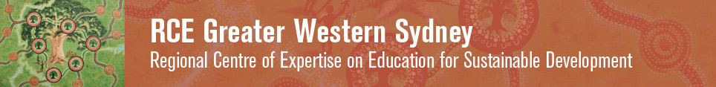

**UWS Hawkesbury Riverfarm**

**A living laboratory on education for sustainability in Greater Western Sydney supported by the UN Regional Centre of Expertise in ESD – GWS**

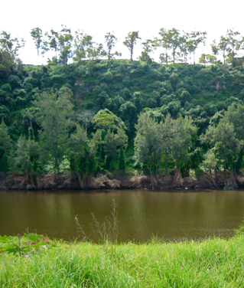 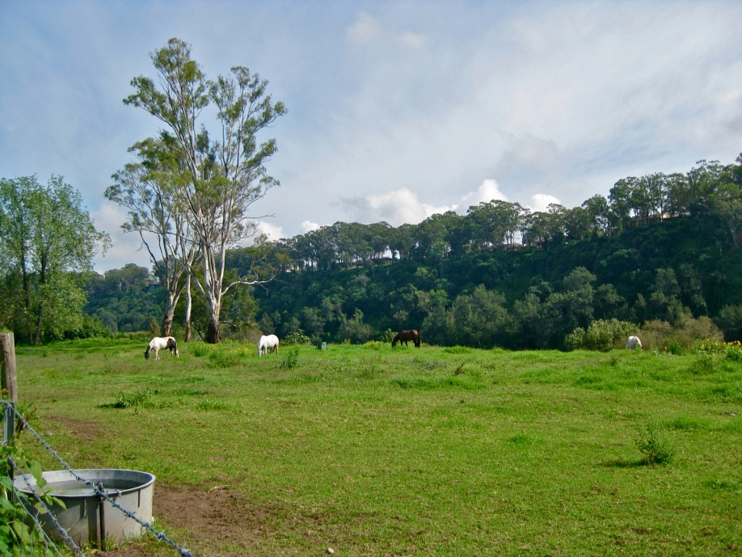 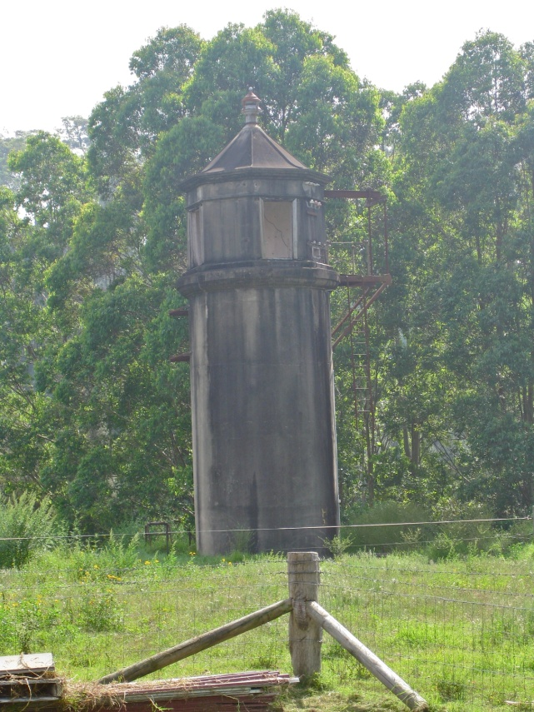

**Overview UNU RCE – Greater Western Sydney**

The newly endorsed Regional Centre of Expertise on Education for Sustainable Development – Greater Western Sydney (RCE-GWS) operates in the most rapidly developing area of Australia – a highly diverse region which has Australia’s third largest economy and faces the distinctive sustainability challenges associated with a rapidly developing, culturally diverse, dispersed peri-urban area. There is excellent work taking place in pockets around this area that needs to be identified, illuminated, linked and leveraged and the RCE-GWS aims to meet this need. The University of Western Sydney (UWS) will facilitate its collaborative design, development, implementation and quality assurance.

Four major sustainability challenges have been identified for GWS. Integrating themes that relate directly to these challenges include: public health, developing more active lifestyles, living and working productively with diversity, and economic vitality.

1. Transitioning to a Low Carbon Economy

2. Developing Sustainable Communities: Transport and Housing

3. Ensuring Agricultural Sustainability and Food Security

4. Conserving Biodiversity and River Health

**Major Lessons learnt from this initiative**

The following lessons on how to ensure an RCE partnership project is productive have been drawn from our experience in implementing the Hawkesbury Riverfarm partnership.

1. Undertake a stocktake of the particular capabilities and key projects underway in each RCE partner early on in the development of the RCE. In the current case this identified a strong shared interest in developing the UWS Riverfarm as a living laboratory for sustainability for the communities and students of Greater Western Sydney.
2. Jointly build an agreed plan of action and a clear picture of what will be in place when the project is operating successfully.
3. Ensure that it is clear what the roles and contributions of each partner are to be and set up clear milestones and indicators of successful implementation against which to monitor progress.
4. Ensure that what is to be delivered is feasible and relevant.
5. Allocate a single project coordinator to monitor implementation and ensure inevitable glitches are addressed promptly and wisely
6. Make sure that the achievements of those involved in implementation and identified and publically acknowledged.

**Outcomes to date**

These include:

* In a partnership between the University of Western Sydney and the Western Sydney Institute Technical and Further Education (WSI TAFE) work is well underway to renovate and reform the site supported by a Sustainability Memorandum of Understanding and the RCE GWS banner.
* WSI TAFE students are specifically developing the key capabilities and green skills identified in their respective national vocational education and training packages.
* UWS Wildlife studies students have successfully completed a fauna and flora survey of this site and the results are being used as part of a living laboratory program with GWS schools.
* A funded project in partnership with the Hawkesbury Nepean Catchment Management Authority is underway to address river bank restoration with in-kind contributions from the WSI TAFE bush regenerator.
* A Heritage Survey of the site has been successfully delivered and engagement with UWS engineering and heritage students has commenced with the results being used to inform living laboratory program with GWS schools and WSI TAFE students.
* The Indigenous partners of RCE-GWS have undertaken a preliminary survey of the site, identified indigenous plants and are developing a strategy for engagement with the students.
* The RCE-GWS partners forum on the 27th March 2012 formally acknowledged and endorsed the initiative.
* The RCE GWS Education for Sustainability working group is monitoring and supporting implementation of the initiative, supported by the senior leaders of school and vocational education in NSW.
* The Riverfarm has been identified as a case study of good practice of community engagement in the 2012 UWS Engagement Review.
* Discussions have commenced with providers to install Blue Economy demonstration sites on the Riverfarm include PVs that use both sides of the cell and demonstrations of how micro turbines can be used to generate energy from water flow in ordinary plumbing.

**Background & opportunity**

UWS occupies an historic 40 hectare holding of prime agricultural land on the Hawkesbury River – including a 1 kilometre of river frontage gazetted in 1799. The farm complex is comprised of an early 20th century cottage, a series of timber framed farm buildings, silos and an historically significant water pumping tower. The river banks are revegetated with species commonly found in River Flat Eucalypt Forest, a listed Endangered Ecological Community.  The Darug people are the traditional custodians of the land and yams and other Indigenous foods are still growing on the riverbanks. The Riverfarm is significant in NSW’s cultural history as evidence of agriculture and grazing on the fertile but flood prone Richmond Lowlands that has been in continuous operation since the late 18th century.

The Riverfarm is being developed as a living laboratory for learning and action-research on the key challenges of social, cultural, economic and environmental sustainability in the rapidly developing peri-urban region of Greater Western Sydney, Australia. The establishment of the UWS Hawkesbury Riverfarm Education Centre led by the UWS Office of Sustainability in partnership with the key educational, community and government groups that comprise the [United Nations University Regional Centre of Centre of Expertise on Education for Sustainable Development – Greater Western Sydney](http://www.ias.unu.edu/sub_page.aspx?catID=1849&ddlID=1998) will transform the site into a unique real-world learning and research resource which links land, food, culture and water for a range of educational purposes.  The project is to be virtually linked for a knowledge exchange with the RCE Youth Network led by the [RCE Rhine-Meuse](http://www.rcerm.eu/RCE_Rhine-Meuse_E.html).

The RCE-GWS partners which are collectively developing the Riverfarm Education Centre include The Western Sydney Institute of Technical and Further Education, The NSW Department of Education and Communities, The Brewongle Environmental  Education Centre, The Hawkesbury Nepean Catchment Management Authority, The Darug Custodian Aboriginal Corporation and The Hawkesbury Alumni Charter. The Centre will deliver a high quality engaged learning-for-sustainability experience for the school students of Greater Western Sydney. It will also facilitate increased community engagement and education around sustaining the health and heritage of the Hawkesbury-Nepean River and its surrounds. The project is a distinctive example of how institutions of primary and secondary, post-secondary and higher education can work in a coordinated way to support the implementation of the new national curriculum for the area and foster learning pathways. It is also a base for the [International Waterkeepers](http://www.waterkeeper.org/)-endorsed Hawkesbury-Nepean Riverkeepers project, coordinated by another RCE-GWS partner – the Hawkesbury-Nepean Environment Network.

**Construction and restoration of the site – a collaborative project**

Western Sydney Institute of Technical & Further education’s (TAFE WSI) pre-apprentice carpentry, electrical and plumbing students, under the supervision of their teachers, are assisting with the rejuvenation and renovation of the site free of charge. In undertaking this community-based learning they are gaining key development skills as part of their training, including the green skills now incorporated in each of their national training packages. TAFE WSI was named Australia’s leading educational institute for sustainability at the **Australian Training Awards** presentation on November 25 2010. [The Skills for Sustainability - Educational Institution Award r](http://wsi.tafensw.edu.au/about-wsi/news-and-media-centre/news-stories/840/)ecognised the exemplary efforts of TAFE WSI in not only demonstrating sound sustainability practices but also in its leadership in embedding these principles into its training and in the everyday business of teaching and learning.

The biological science students of UWS are currently undertaking a full mapping of the native and introduced plant and biological species across the site.

**Diagram 1 Diagram 2**

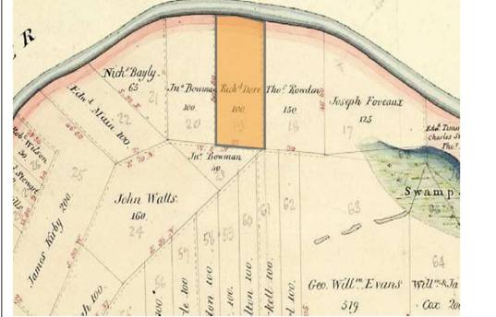 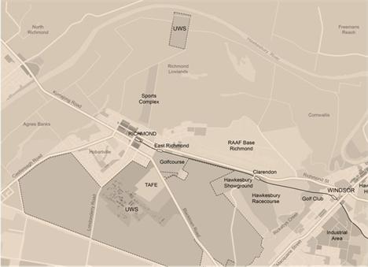

Diagram 1: Map of Ham Common showing Richard Dore’s 100 acres, later designated as Portion 190 and now known as Riverfarm (LP pMapMN03 Id 14068201),nd

Diagram 2: Map of UWS Hawkesbury holdings at Richmond including the Riverfarm, 2011.

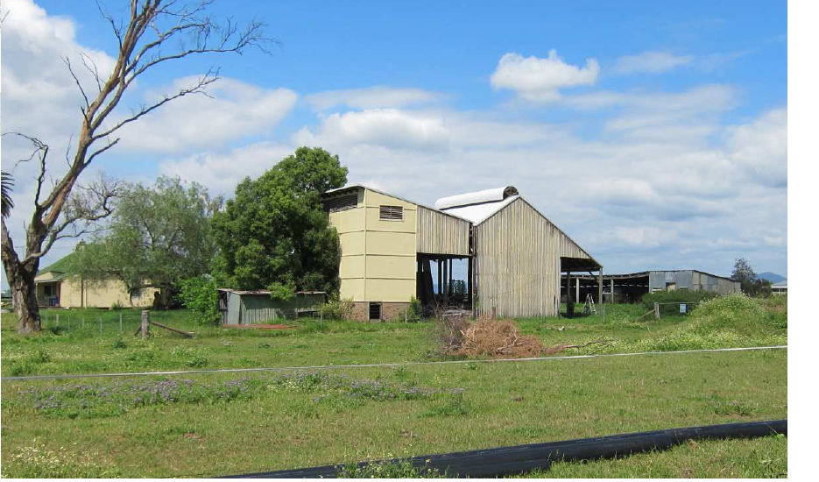 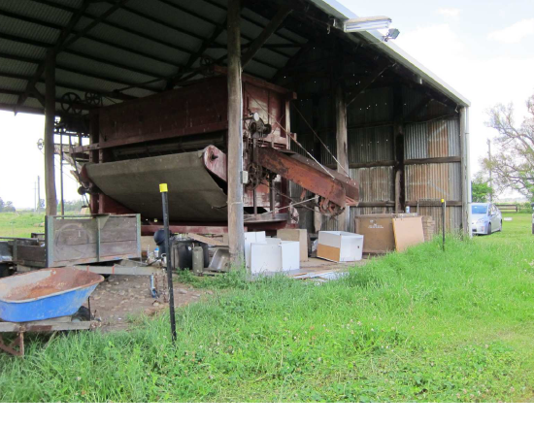 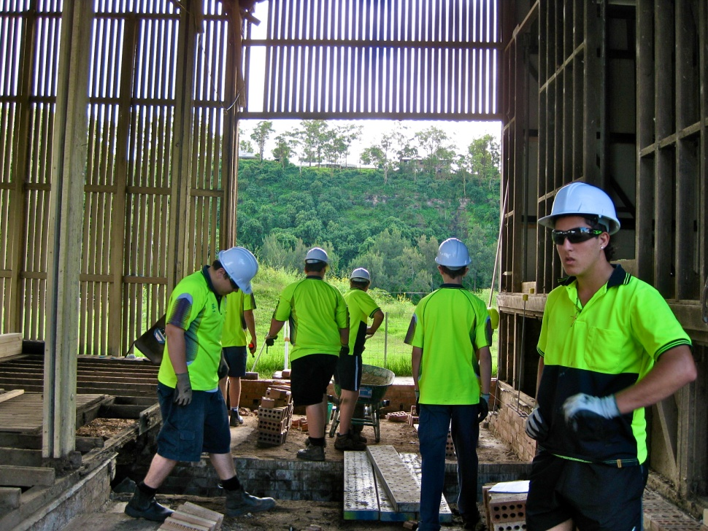

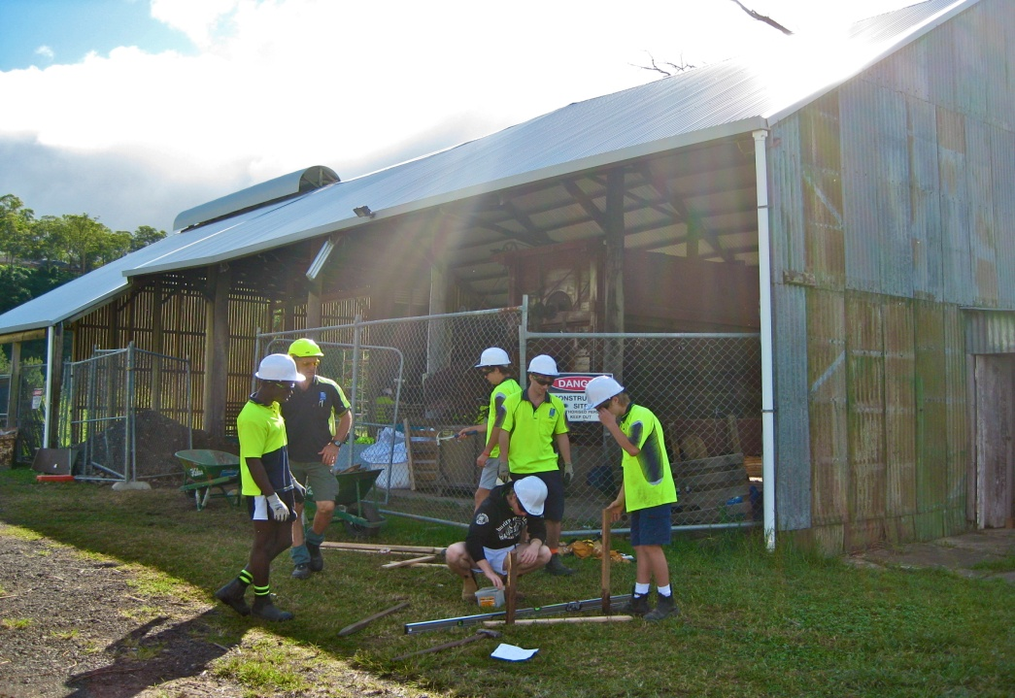 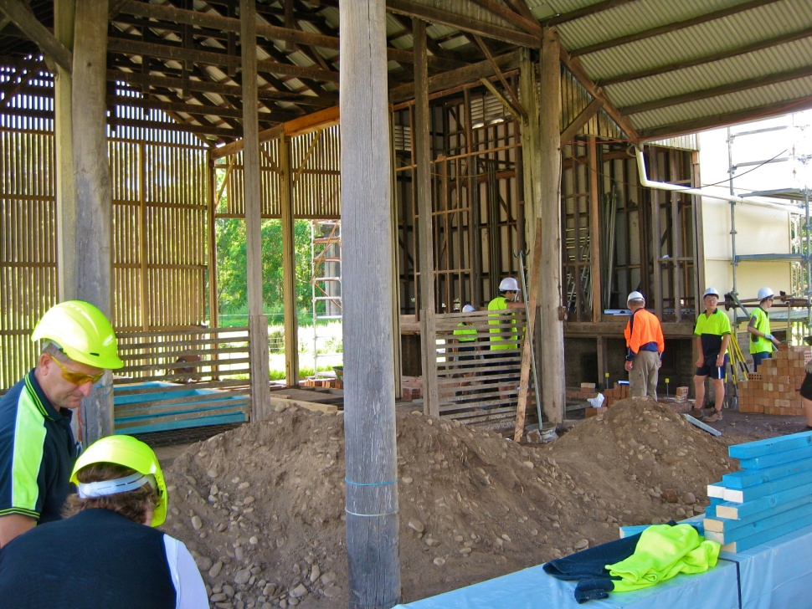 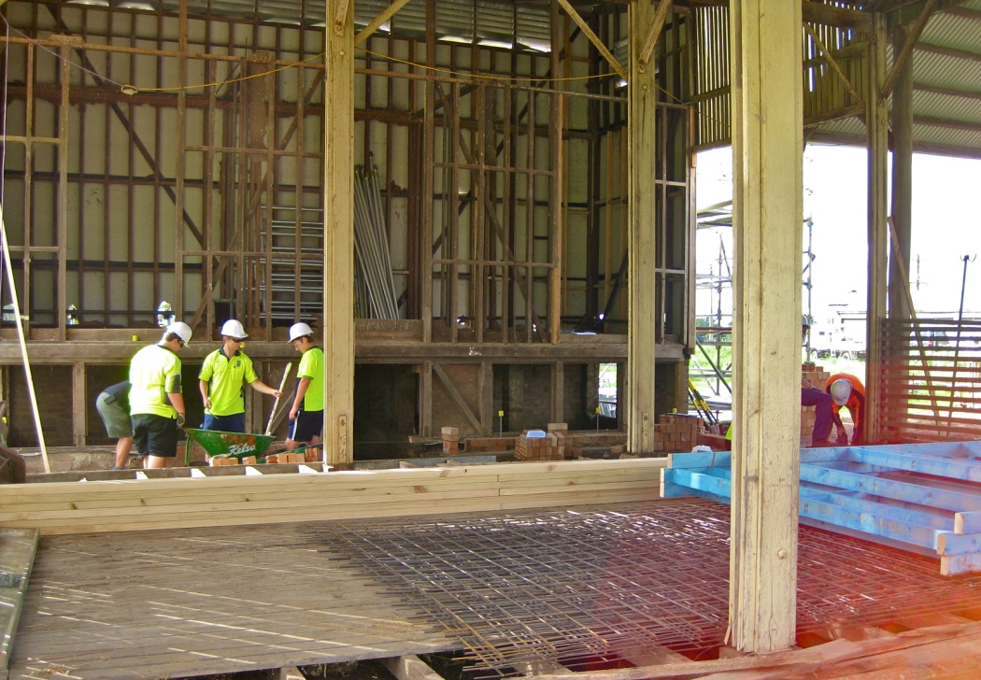

Vocational education students & their teachers renovating the site as a community service project

**Education Strategy**

The Riverfarm is part of a broader engagement and educational strategy underway across the region to encourage the large proportion of talented Low Socio Economic Status (LSES) school students in Western Sydney schools to consider engaging in tertiary study and taking up a professional career, including one that relates to social, economic and environmental sustainability.

The real-world learning approach that underpins the Riverfarm initiative gives focus to optimising relevance, active, real-world learning and peer support. In the photographs above Pre-apprentices in the plumbing, electrical and carpentry trades are renovating the Riverfarm and, as the same, time learning a range of Green Skills as they build a range of sustainability demonstration components into the site.

This approach is based on the observation by William Spohn that people are more likely to act their way into new ways of thinking than think their way into new ways of acting. What is being built into the Riverfarm gives focus to the key national themes for sustainability education in schools set by the Australian Curriculum Assessment and Reporting Authority and, in Vocational Education and Training, set by Australia’s Green Skills Accord Implementation Group.

The facility seeks to offer multidisciplinary education programs for GWS Schools based on a sustainability platform linked to the new national K-12 cross- curriculum focus on sustainability in Australia’s schools (Please refer to Appendix 1). These programs include:

* Science – ecology, water quality, biology, soils and environmental health. (The Chief Scientist has noted the significant drop off in enrolments in Science. This is one practical way to encourage students to consider a career in science and related areas).
* Engineering – environmental, sustainability and risk.
* Heritage and social sustainability.
* Indigenous approaches to sustainability, learning, history and culture.
* Teacher education for sustainability.

Australia’s Higher Education Participation Program (HEPP) activities are being linked to the work of the Riverfarm. They include undertaking research, and monitoring the impact and effectiveness of activities aimed at improving the participation of students from low SES backgrounds in higher education. (Australian Government, Department of Education, Employment and Workplace Relations, 2011)

The Riverfarm LSES program for School Education is being developed in partnership with Margaret Somerville, UWS Professor of Education and colleagues in the University’s School of Education. A key aspect of the partnership includes a study of the effectiveness of the following activities delivered on the site by The NSW Department of Education and Community’s Brewongle Environmental Education Centre to the schools in the newly formed Blacktown Learning Community:

* increase the awareness of university study in targeted schools and communities;
* inform aspiration in relation to university study;
* support students to plan their university pathways;
* mentor and provide extension opportunities for motivated students - the Riverfarm project will have UWS students as guides on what it is all about as part of a community service or other for credit UWS unit of study

The evidence of successful intervention programs of this type elsewhere is being used to identify the optimum support and resourcing strategy necessary for successful and sustained implementation. (See, for example Monash University Schools Engagement Program.)

**Partnerships for implementation**

As noted above, the key implementation partners with RCE-GWS, UWS and WSI TAFE in the River Farm project are the Darug Custodian Aboriginal Corporation, HEN, Blacktown Learning Community and the Brewongle Environmental Education Centre, with the support of the GWS Environmental Network of 200 Schools. All of these partners are members of RCE-GWS.

**Blacktown Learning Community of Schools**

|  |  |  |  |  |
| --- | --- | --- | --- | --- |
| Blacktown Nth | Blacktown West | Crawford | Caddies Creek | Hambledon |
| Lalor Park | Marayong | Marayong Heights | Marayong South | Marsden Park |
| Quakers Hill | Riverstone | Schofields | Seven Hills North | Vardys Road |
| Vineyard | Lynwood Pk | Quakers Hill East | Seven Hills West | Seven Hills |

**Evaluation indicators which are being used as students from these schools become involved in the River Farm project include:**

* 1. Participation rates;
  2. Student exit surveys after each visit;
  3. Follow up in school with associated teachers;
  4. Subsequent enrolment behaviours.

**BIBLIOGRAPHY**

[Australian Curriculum Assessment and Reporting Authority](http://www.acara.edu.au/sustainability.html)

http://www.acara.edu.au/sustainability.html

Australian Government, Department of Education, Employment and Workplace Relations, 2011

<http://www.deewr.gov.au/highereducation/programs/equity/pages/heppprogram.aspx>.

Australia’s [Green Skills Accord Implementation Group](http://www.tda.edu.au/resources/Green_Skills_report.doc).

Monash University Schools Engagement Program): <http://www.monash.edu.au/access/assets/pdf/monash-schoolengagement.pdf>)

Spohn, William (2003): *Reasoning from practice*. Carnegie Foundation for the advancement of teaching, Syllabus Narrative, Stanford, CA.

**APPENDIX 1: School Education Program – UWS Hawkesbury Riverfarm**

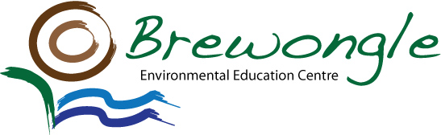

**River Farm Program Opportunities**

The following programs conducted by Brewongle EEC are being adapted for implementation on the River Farm site.

Secondary Schools

Stage 6 Senior Science / Earth and Environmental Science

‘River Ecology’

Partnership with UWS in developing science leaders of the future - available 6 days per year.

Activities include;

* Introduction – an overview of the study site via Google Earth and a discussion of the natural resource management issues facing the Hawkesbury-Nepean Catchment. Outline of the investigation scenario.
* Chemical Analysis on the Kent Reach site of the Hawkesbury River – students access two boats to undertake a riverbank tour and collect data for pH, turbidity, salinity and oxygen levels of the water.
* Riverbank Assessment – students will complete a riverbank erosion condition assessment. Suggested management recommendations will also be discussed.
* Phytoplankton Analysis – back in our Earth Lab the students will view the algal species using a compound microscope. With the assistance of UWS staff and identification charts the students identify the diversity of phytoplankton found in the river system.
* Cost per student $10.00

Onsite facilities will include: a data projector, compound microscope, screen, 3 x power outlets and internet access/capability.

Stage 6 Biology – Ecosystems Topic

* Measuring abiotic and biotic factors
* Examining distribution, diversity and abundance
* Observing adaptation
* Discussing human impact & management strategies
* Conduct soil pH, soil texture and soil NPK tests
* Carry out analysis of water
* Examine riverbank management techniques
* Conduct riverbank erosion assessments

Primary Schools

Aboriginal Education (approximately 2 hour program) Stage 2-3 only

* Aboriginal Artefact Presentation (Brewongle will supply) - students observe Aboriginal artefacts and learn about their traditional names and uses. Aboriginal Educator can be supplied by Brewongle or sourced via UWS.
* Ochre Face Painting - students use the rich colours of ochre to paint their faces in Aboriginal symbols and learn about the significance of these symbols.
* Study of Traditional Indigenous foods growing on the riverbanks and discussions with Aboriginal people about their growth, use, and their approach to river care.

* Sand Art Story - students listen to a story and help to create an artwork on canvas using coloured sands and Aboriginal symbols.

Sustainability Education (approximately 2 hour program) Stage 2-3 only

* Search the trees for insects - investigate a terrestrial micro-environment. Students will utilise a variety of techniques to search for the amazing diversity of insects that live in the forests.
* Water Quality of the Hawkesbury River - water samples taken to outdoor classroom for analysis
* Meet the Locals – phasmids & blue tongue lizards- meet and greet our resident blue tongue lizards. Why do they have a blue tongue? Also meet our phasmids. Discuss and explain the importance of all the elements that are necessary for reptiles and insects to survive
* Mopoke Mystery - is a scientific investigation and a mystery story all rolled into one.

A dynamic curricular process which engages students in learning experiences which have a real life authentic component. Students are presented with information regarding the mysterious death of a Tawny Frogmouth. They must conduct thorough investigations into the three areas of suspicion - food, water and shelter.

587 Chapel Hill Road, Sackville North NSW 2756

Phone: 4579 1136 Fax: 4579 1072

www.brewongle-e.schools.nsw.edu.au